Computer Vision HW#9

B01902040 資訊四 鍾毓安

**Task Description**

Implement zero-crossing on the following 5 types of images to get edge images (choose proper thresholds):

* Laplace mask type-1
* Laplace mask type-2
* Minimum variance Laplacian
* Laplace of Gaussian (LoG)
* Difference of Gaussian (DoG)

**Programming Language & Tool**

1. Python + Numpy
2. OpenCV (for reading and writing image only)

**Work Flow & Results**

I implement a function called “convolve_ing” that reads in an image and a kernel and performs convolution with the specified image and kernel. The required 5 tasks can all be done by calling convolve_img and assign different kernels (the kernels are derived in course slides). My code is very readable and please check for more implementation details.

**Images Generated**

The thresholds come from the course website.

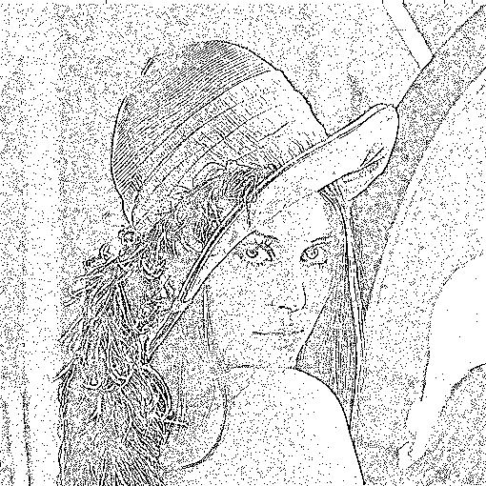 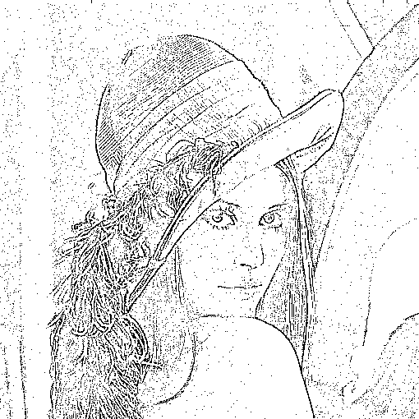

Laplace mask type-1 (15) Laplace mask type-2 (15)

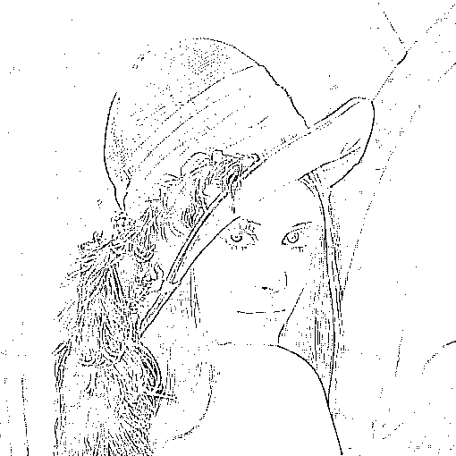 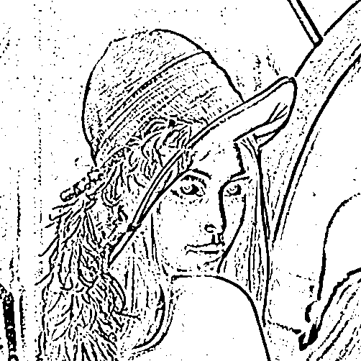

Minimum variance Laplacian (20) Laplace of Gaussian (3000)

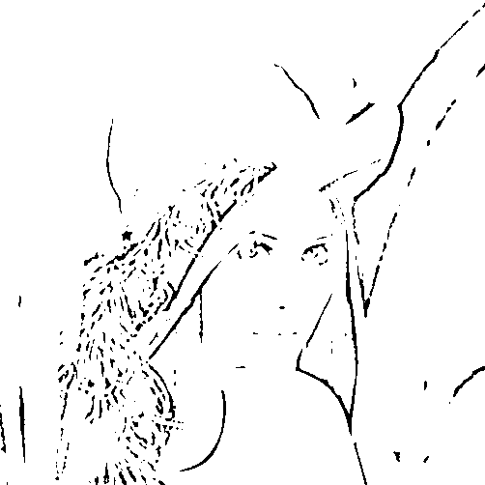

Difference of Gaussian (1)

To reproduce the result, execute the following command:

>> ./task.sh

You can specify different thresholds in file task.sh.