Computer Vision HW#2

B01902040 資訊四 鍾毓安

Task:

Write a program to generate

* a binary image (threshold at 128)
* a histogram
* connected components (with bounding box)

Tools:

Python + numpy + openCV (for reading and writing images only) + matplotlib

Report:

To generate a binary image (threshold at 128), just go through the 2D array with nested two-for loops and check the pixel value one by one. The resulting image is as follows:

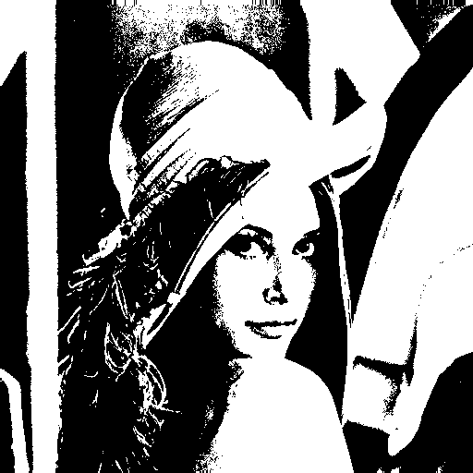

To generate the histogram, again, just go through the 2D array with nested two-for loops and accumulate the distribution of each pixel value (0-255), the program then output the distribution array to a .csv file, which will then be imported into excel and plotted. The histogram is as follows:

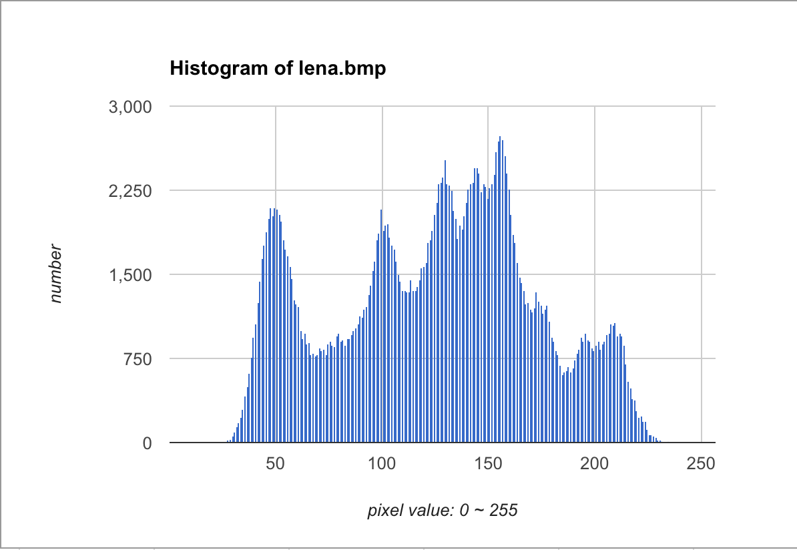

For task 3, I deal with 4-connected components case. I use iterative algorithm. This section is relatively long, but still very simple. The only difficulty I encountered is that I didn’t know how to plot the bounding boxes with color, since I’m not sure whether we are allowed to use function cv2.rectangle() or not. Therefore, I chose to plot the bounding box with pixel value = 128, the resulting image is as follows:

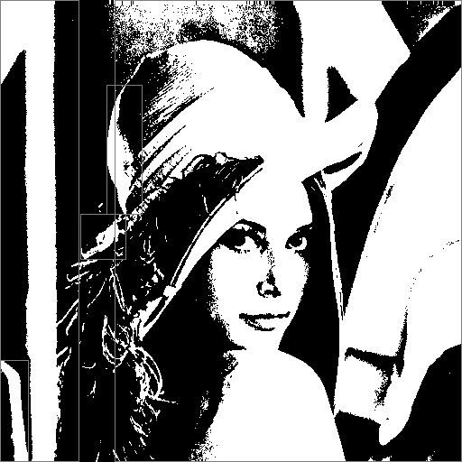

Clearly, there’re 5 regions for 4-connected components case. Please refer to main.py for ore coding details.

To reproduce the result, just enter command: python ./main.py