Computer Vision Homework #3

系級：資訊四

學號：B01902040

姓名：鍾毓安

Task description:

Implement histogram equalization.

Programming language & toolkit:

1. Python
2. Numpy
3. Matplotlib (for plotting histogram figures)
4. OpenCV (for reading and writing images)

Report:

The task is simple, and the procedures are as follows:

1. As usual, we read in the benchmark image (here we use lena.bmp as an example) by function cv2.imread(…) and store the $512×512$ pixel array in variable named `img`.
2. Although the spec doesn’t mention this, the professor asked us to first divide all pixel values by 3, that is img /= img. Here’s the resulting image `lena_divided_3.bmp`:

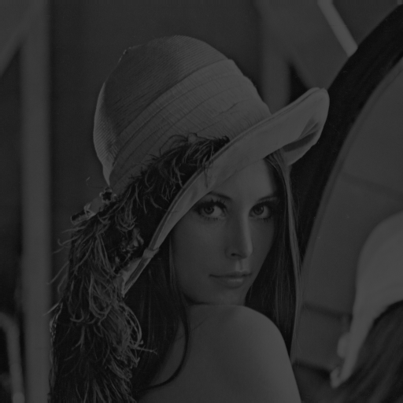

1. We then compute the pixel value distribution and output the histogram of lena_divided_3.bmp, resulting in `histogram-before-equalized.png`:

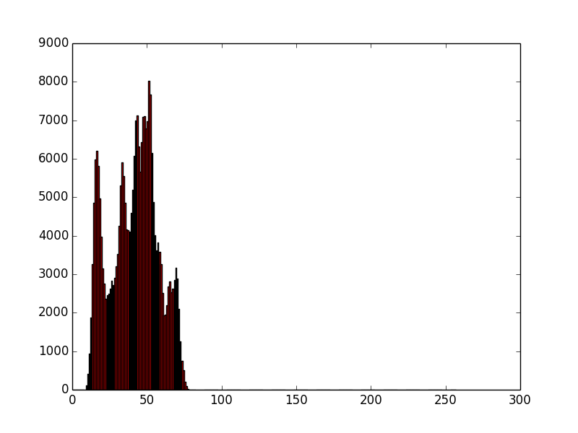

1. Then, we implement histogram equalization. We first calculate $s_{k}$:

$$s_{k}=255\sum_{j=0}^{k}{\frac{n_{j}}{n}} k=0, 1, …, 255$$

where $n$ is the total number of pixels and $n_{j}$ denotes the number of pixels with intensity $j$. Then, for each pixel in the image, we replace the original value with $s_{k}$, that is, if $I\left(i,j\right)=k$, then $I_{HE}\left(i, j\right)=s_{k}$. Here’s the resulting image `lena_equalized.bmp`:

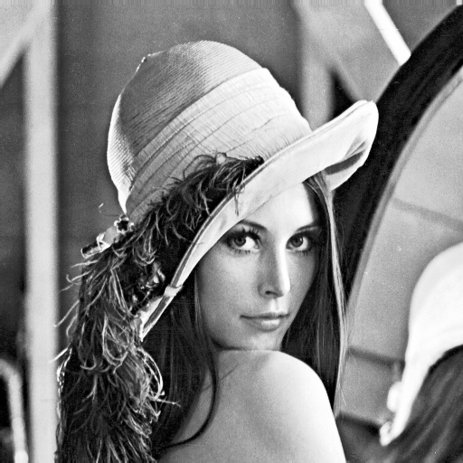

1. Now let’s compute and output the histogram figure after equalization, which is named after `histogram-after-equalized.png`:

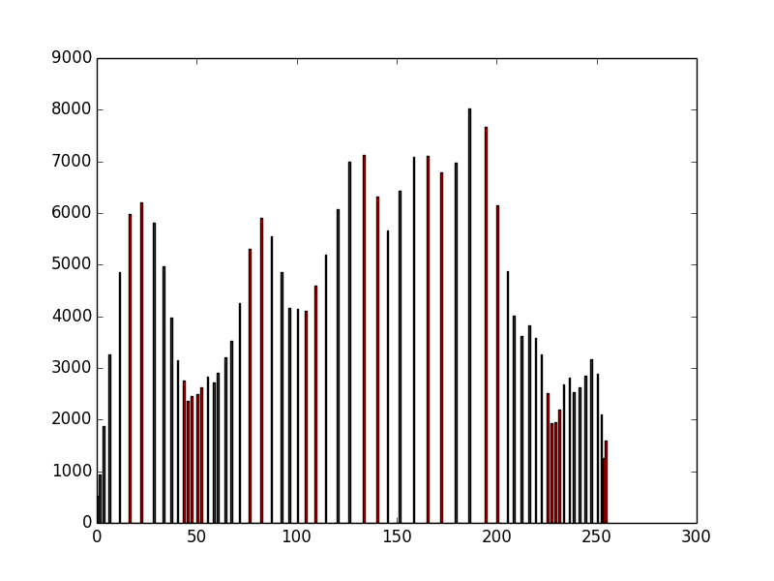

Conclusion:

lena.bmp

lena_divided_3.bmp

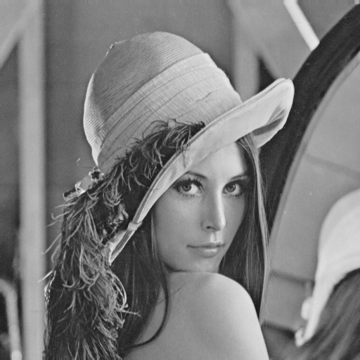



lena_equalized.bmp

Result reproduction:

>> python ./main.py # lena.bmp should be put under the same directory.

# The program should output 4 images, which are:

# lena_divided_3.bmp, histogram-before-equalized.png,

# lena_equalized.bmp, and

# histogram-after-equalized.png