Computer Vision HW#9

B01902040 資訊四 鍾毓安

**Task Description**

Write programs to generate the following gradient magnitude images and choose proper thresholds to get the binary edge images:

1. Roberts operator
2. Prewitt edge detector
3. Sobel edge detector
4. Frei and Chen gradient operator
5. Kirsch compass operator
6. Robinson compass operator
7. Nevatia-Babu 5x5 operator

**Programming Language & Tool**

1. Python + Numpy
2. OpenCV (for reading and writing image only)

**Work Flow & Results**

I implement a function named “convolve” that does the convolution of two given images. Once this function is implemented, the seven operators can be easily done by first specify the filters and call function “convolve” to find the gradient magnitude. Please refer to my source code for more details.

**Images Generated**

The thresholds come from the course website.

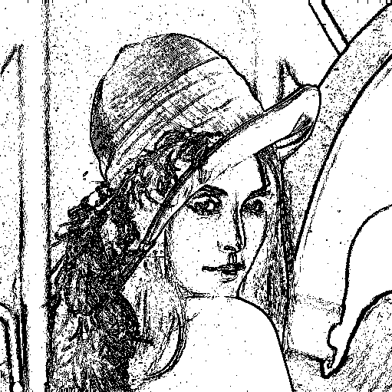 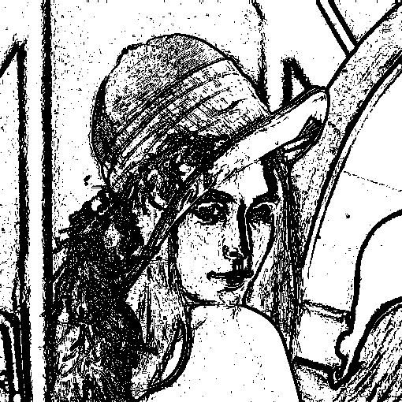

Roberts (12) Prewitt (24)

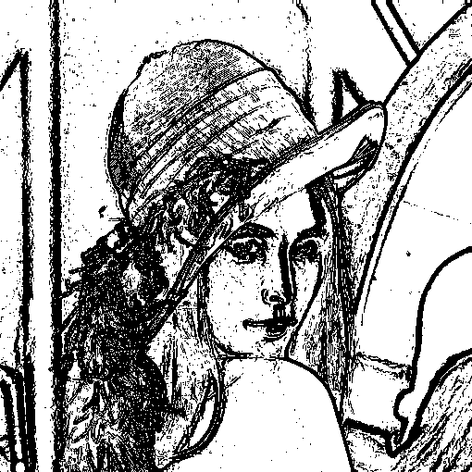 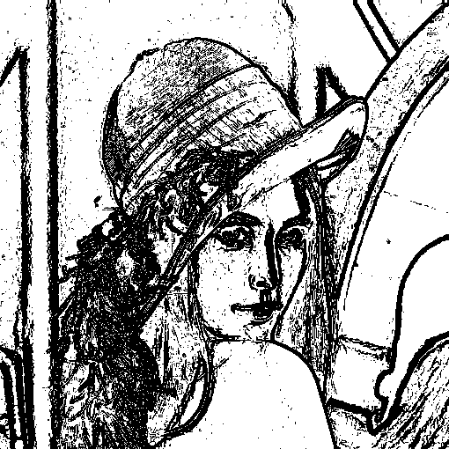

Sobel (38) Frei and Chen (30)

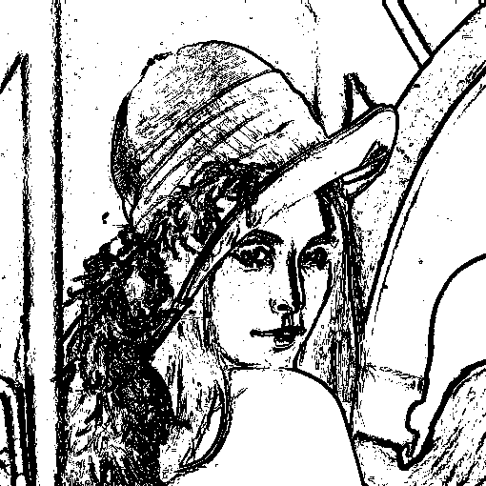 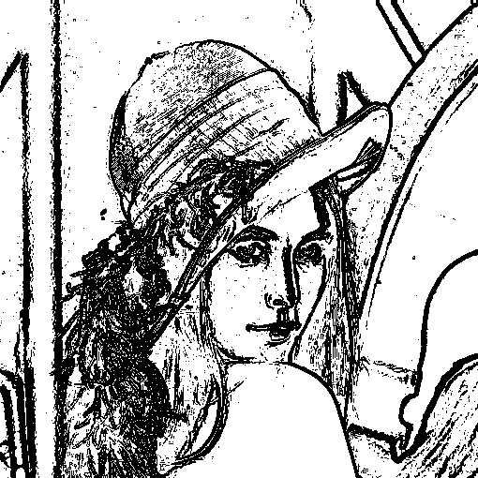

Kirsch (135) Robinson (43)

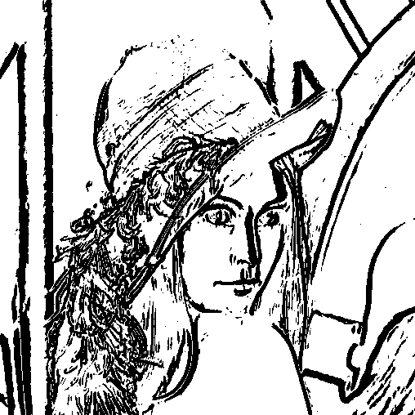

Nevatia-Babu (12500)

To reproduce the result, execute the following command

>> ./task.sh