INDICES BIOCLIMATICOS

## Indice de aridez de Martonne

Permite una primera identificación fitoclimática del mundo, aunque es especialmente efectivo en zonas tropicales y subtropicales. Se usará el IMa, cuya fórmula:

$$IMA=PP/(T+10)$$

#instalando librerias  
library(raster)  
library(rgdal)  
library(maptools)

#definiendo directorio de trabajo   
setwd("E:/R/pp")  
#precipitacion anual mensual  
 pp_ene <- raster("E:/R/pp/wc2.1_2.5m_prec_2015-01.tif")  
 pp_feb <- raster("E:/R/pp/wc2.1_2.5m_prec_2015-02.tif")  
 pp_mar <- raster("E:/R/pp/wc2.1_2.5m_prec_2015-03.tif")  
 pp_abr <- raster("E:/R/pp/wc2.1_2.5m_prec_2015-04.tif")  
 pp_may <- raster("E:/R/pp/wc2.1_2.5m_prec_2015-05.tif")  
 pp_jun <- raster("E:/R/pp/wc2.1_2.5m_prec_2015-06.tif")  
 pp_jul <- raster("E:/R/pp/wc2.1_2.5m_prec_2015-07.tif")  
 pp_ago <- raster("E:/R/pp/wc2.1_2.5m_prec_2015-08.tif")  
 pp_sep <- raster("E:/R/pp/wc2.1_2.5m_prec_2015-09.tif")  
 pp_oct <- raster("E:/R/pp/wc2.1_2.5m_prec_2015-10.tif")  
 pp_nov <- raster("E:/R/pp/wc2.1_2.5m_prec_2015-11.tif")  
 pp_dic <- raster("E:/R/pp/wc2.1_2.5m_prec_2015-12.tif")  
 pp_total <- pp_ene + pp_feb + pp_mar + pp_abr + pp_may + pp_jun + pp_jul + pp_ago + pp_sep + pp_oct + pp_nov + pp_dic

## Precipitacion Total Tnual Perido 2015

plot(pp_total, main="precipitacion total anual 2015")

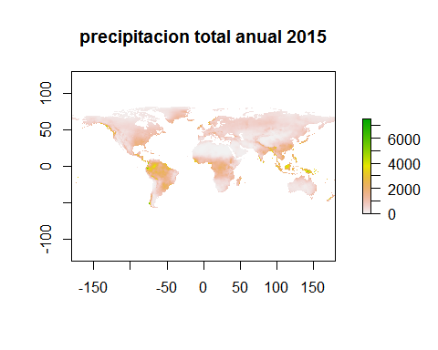

#Temperatua minima periodo 2015  
setwd("E:/R/tmin")  
  
tm_ene <- raster("E:/R/tmin/wc2.1_2.5m_tmin_2015-01.tif")  
 tm_feb <- raster("E:/R/tmin/wc2.1_2.5m_tmin_2015-02.tif")  
 tm_mar <- raster("E:/R/tmin/wc2.1_2.5m_tmin_2015-03.tif")  
 tm_abr <- raster("E:/R/tmin/wc2.1_2.5m_tmin_2015-04.tif")  
 tm_may <- raster("E:/R/tmin/wc2.1_2.5m_tmin_2015-05.tif")  
 tm_jun <- raster("E:/R/tmin/wc2.1_2.5m_tmin_2015-06.tif")  
 tm_jul <- raster("E:/R/tmin/wc2.1_2.5m_tmin_2015-07.tif")  
 tm_ago <- raster("E:/R/tmin/wc2.1_2.5m_tmin_2015-08.tif")  
 tm_sep <- raster("E:/R/tmin/wc2.1_2.5m_tmin_2015-09.tif")  
 tm_oct <- raster("E:/R/tmin/wc2.1_2.5m_tmin_2015-10.tif")  
 tm_nov <- raster("E:/R/tmin/wc2.1_2.5m_tmin_2015-11.tif")  
 tm_dic <- raster("E:/R/tmin/wc2.1_2.5m_tmin_2015-12.tif")  
 tm_total <- tm_ene + tm_feb + tm_mar + tm_abr + tm_may + tm_jun + tm_jul + tm_ago + tm_sep + tm_oct + tm_nov + tm_dic

# Temperatura Minima Anual periodo 2015  
plot(tm_total , main = "temperatura minima anual 2015")

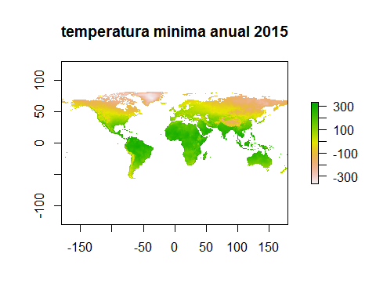

#Temperatua maxima periodo 2015  
setwd("E:/R/tmax")  
  
tmx_ene <- raster("E:/R/tmax/wc2.1_2.5m_tmax_2015-01.tif")  
 tmx_feb <- raster("E:/R/tmax/wc2.1_2.5m_tmax_2015-02.tif")  
 tmx_mar <- raster("E:/R/tmax/wc2.1_2.5m_tmax_2015-03.tif")  
 tmx_abr <- raster("E:/R/tmax/wc2.1_2.5m_tmax_2015-04.tif")  
 tmx_may <- raster("E:/R/tmax/wc2.1_2.5m_tmax_2015-05.tif")  
 tmx_jun <- raster("E:/R/tmax/wc2.1_2.5m_tmax_2015-06.tif")  
 tmx_jul <- raster("E:/R/tmax/wc2.1_2.5m_tmax_2015-07.tif")  
 tmx_ago <- raster("E:/R/tmax/wc2.1_2.5m_tmax_2015-08.tif")  
 tmx_sep <- raster("E:/R/tmax/wc2.1_2.5m_tmax_2015-09.tif")  
 tmx_oct <- raster("E:/R/tmax/wc2.1_2.5m_tmax_2015-10.tif")  
 tmx_nov <- raster("E:/R/tmax/wc2.1_2.5m_tmax_2015-11.tif")  
 tmx_dic <- raster("E:/R/tmax/wc2.1_2.5m_tmax_2015-12.tif")  
 tmx_total <- tmx_ene + tmx_feb + tmx_mar + tmx_abr + tmx_may + tmx_jun + tmx_jul + tmx_ago + tmx_sep + tmx_oct + tmx_nov + tmx_dic

# Temperatura Maxima Anual periodo 2015  
plot(tmx_total , main = "temperatura maxima anual 2015")

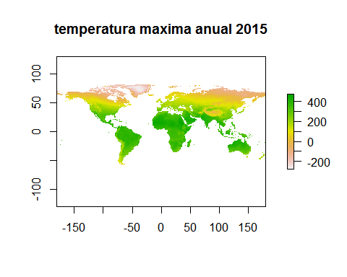

# Calculando la temperaatura media anual 2015   
tm_prm <- (tmx_total + tm_total) / 2  
plot(tm_prm , main = "Temperatura media anual 2015")

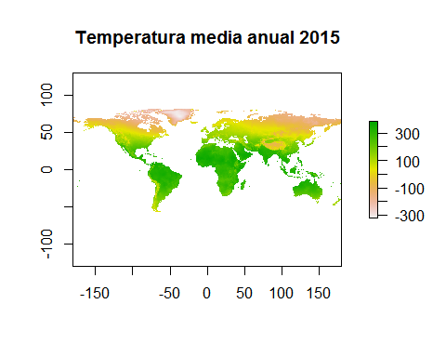

# Cargar mapa del poligono   
hua <- readOGR("E:/QGIS/HUANUCO.shp")

## OGR data source with driver: ESRI Shapefile   
## Source: "E:\QGIS\HUANUCO.shp", layer: "HUANUCO"  
## with 1 features  
## It has 7 fields

plot(hua)

