Hiking Tour Assistant User Manual

**Instructions for using the smartwatch**

**Setting your step length:**

1. Turn on the watch by pressing and holding down the button on the side of the watch.
2. Next, you should see the start screen instructing you to either start a new session by pressing the side button or inputting the step length by **tapping the screen.**
3. A black watch with a blue screen

   Description automatically generated with low confidenceTap the screen, and you should see the following text on the screen:
4. You can press the “+” sign to increase the step length or decrease it by pressing the “-“ sign. The step length can be varied between 0.1 – 2.0m.
5. After setting the correct step length, press the side button to confirm the step length and return to the start screen.

**Starting a session:**

1. If the watch is off, turn it on by pressing and holding down the button on the side of the watch.
2. A picture containing text, monitor, wall, indoor

   Description automatically generatedYou should see the start screen, asking you to either start the session by **pressing the side button** or setting the step length by tapping the screen (If no step length is set the default value of 0.8m is used).
3. Press the side button to start the session (note that starting a new session overwrites the previous session statistics). You should see the following screen.
4. If you walk around for a while, you can see the screen displaying the number of steps and travelled distance:

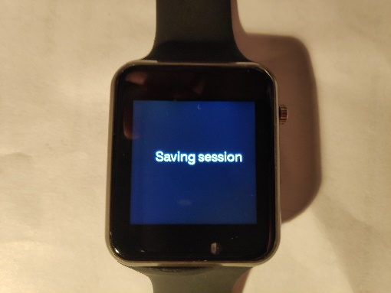**Ending a session:**

1. If a session is currently ongoing, you should see the screen displaying the steps and distance.
2. To end the session, press the side button.
3. You should be prompted to the “Saving session” screen.
4. After saving the session, the watch should return to the start screen.

**Synchronizing with the RPi:**

1. Make sure that there is a session saved to the watch, otherwise the watch will not synchronize with the RPi.
2. Go to the start screen.
3. When on the start screen, the watch tries to connect to the RPi automatically.
4. Run the synchronization application on the RPi (see the RPi instructions). The devices should synchronize automatically, and the session statistics are sent to the RPi. Messages related to the synchronization can be seen in the command line window on the RPi.
5. After synchronization, the watch returns to the start screen and the RPi synchronization application closes.

**Instructions for using the Raspberry Pi**

**General:**

There are two separate applications for the Raspberry Pi: the synchronization application and the web server. To run the applications, open the command line and navigate to the ESD_Project directory with the following command: “cd ESD_Project”.

**Running the web server:**

1. Start the application with the command “python3 app.py”
2. Open the web browser and go to the following address: “127.0.0.1:5000”

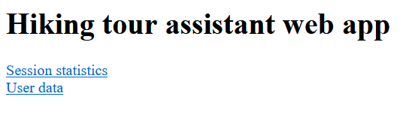

**Changing user weight:**

1. Click the “User data” link on the main page to go to the user data page
2. Input your weight to the text box in kilograms
3. Click save
4. If the weight was saved successfully, the browser will return to the main page. Otherwise, it will ask to input the weight again.

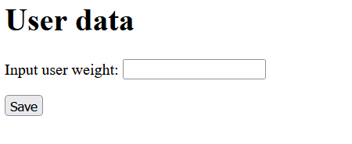

**Displaying saved session data:**

1. Click the “Session statistics” link on the main page to go to the session data page
2. The server will calculate burned calories based on the saved user weight and display them, along with steps taken and distance traveled

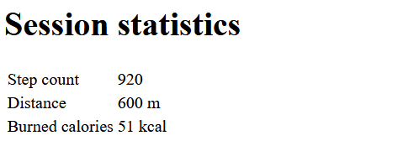

**Test plan:**

1. Try setting the step length. Test that the “+” and “-” buttons work as they should
2. Start a new session
3. Walk for a while to save some data into the watch.
4. End the session
5. Test the synchronization feature by starting the RPi synchronization application
6. When synchronization is complete, run the web server on the RPi
7. Go to the user data page and set the user weight. Try both valid and invalid values.
8. Go to the session statistics page. Check that the ratio between distance and steps matches with the step length set on the smartwatch. Take note of the burned calories.
9. Go back to the user data page and change the user weight to something else. Go back to the session data page and see if the burned calories change as they should
10. Close the web server