# Task One

1. Visualization, average, Minimum, and Maximum values for wind speed and power output.

Table 1: Descriptive statistics

|  | *Power, kW* | *Wind Speed, m/s* |
| --- | --- | --- |
| Minimum | -77.82600403 | 0.887985826 |
| Mean | 1268.036189 | 8.225595513 |
| Maximum | 2946.658691 | 19.51909447 |

Table 1 above shows three descriptive statistics, minimum, maximum, and the mean power output value in KW and windspeed in m/s. From the data, the min, mean, and max for power output and windspeed are (Min = -77.826, M = 1268.036, max = 2946.659), and (Min = 0.888, M = 8.226, max = 19.519), respectively. The data is visualized as shown in fig 1 and 2 below.

Fig 1: Power (kW) descriptive statistics graph

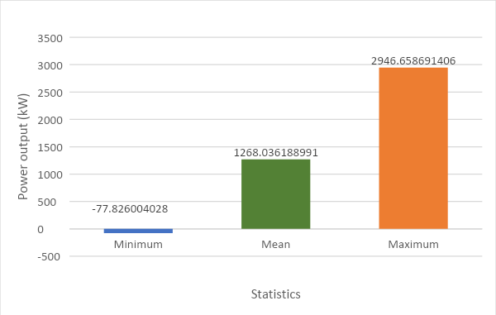

Fig 2: Wind speed (m/s) descriptive statistics graph

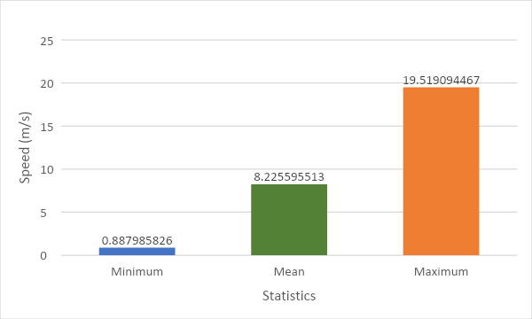

1. Wind speed Vs. Power output plot

Fig 3: Wind vs. power output scatter plot.

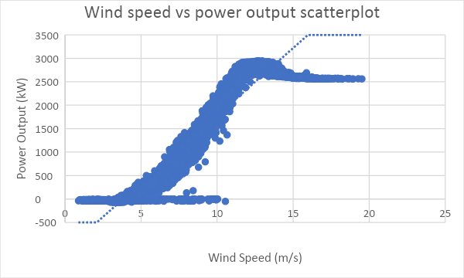

The figure above shows the wind speed and power output scatterplot and their relationship using a trendline. From the data, the correlation coefficient R for the two variables is 0.8996. This indicates a very strong association between wind speed and power output.

The linear regression is; Y = -1100.9 + 287.997 (wind speed). This suggests that for every one-unit increase in wind speed, there is an increase of 287.977 in power output. A constant coefficient of -1100.9 indicates that when wind speed is held constant, then there is a decrease in power output by -1100.9.

1. Histogram of power output

Table 2: Mean and SD of power output

| *Power, kW* | |
| --- | --- |
|  |  |
| Mean | 1268.036 |
| Standard Deviation | 963.4089 |

Power output has a mean and standard deviation (M = 1268.04, SD = 963.41). The high standard deviation indicates that the data is widely spread and is far away from the mean.

Fig 4: Power output Histogram

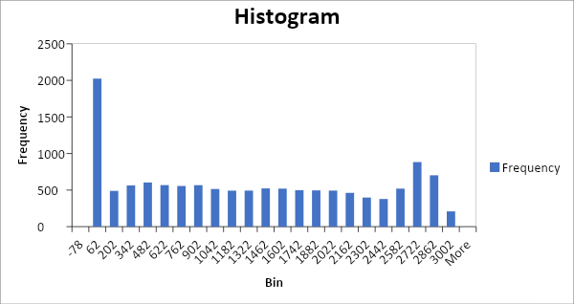

1. The best period of electricity production

| Period | Sum of Power, kW |
| --- | --- |
| Qtr2 | 4421956.41 |
| Qtr1 | 4104398.924 |
| Qtr3 | 4073836.859 |
| Qtr4 | 3824680.563 |

The best period for producing electricity is the second quarter. During this period, 4421956.41 kW are produced. The table above shows the total number of power production per quarter.

1. Based on the data, knowing which turbine produces more electricity is impossible. This is because the information on turbine type is missing.
2. Other trendlines that can be deduced from this data include; power (kW) and generatorRpm (rpm)

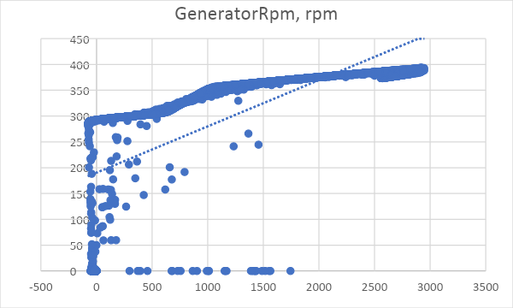

1. Turbine type is vital information that is missing to draw better conclusions. That, we can look at which turbine type produces the most power and has the highest wind speed.

# Task Two

1. The frequency of the failures for each wind farm and the type of failure that occurs most often.

Table 1: Wind-farm frequency distribution table.

| **Wind Farm** | **Frequency of failure** |
| --- | --- |
| 1 | 57 |
| 2 | 173 |
| 3 | 1 |
| 4 | 44 |
| 5 | 27 |
| 6 | 28 |
| 7 | 4 |
| 8 | 6 |
| 9 | 18 |
| 10 | 2 |
| 11 | 54 |
| 12 | 3 |
| 13 | 4 |
| 14 | 138 |
| 15 | 246 |
| 16 | 4 |
| **Grand Total** | **809** |

The table above shows a frequency distribution table of the wind type and their frequency of failure occurrence. There are 16 types of the wind farm. Wind farm type 15 has the highest number of failure occurrences, 246, it is followed by type 2, which has 173 failure occurrences. However, type 3 has the least, 1. At the same time, pursued by type 10 has only two failure numbers of occurrence. The rest is shown in the table above.

1. The wind turbine manufacturer's technology with most problems with components.

Table 2:

| **Wind turbine manufacturer** | **Frequency of component problems** |
| --- | --- |
| 1 | 15 |
| 2 | 33 |
| 3 | 14 |
| 4 | 6 |
| 5 | 40 |
| **Grand Total** | **108** |

From the table, turbine manufacture five has the most problems with component 40. Manufacturer two has 33, manufacturer one has 15, while manufacturer three has 14. Lastly, manufacturer four has 6, the least problem any manufacturer faces.

1. Wind turbines with the most problems for each technology

Table 3:

| **Technology** | **The sum of Wind Turbine** |
| --- | --- |
| Blade bearings | 301 |
| Gearbox | 184 |
| Transformer | 165 |
| Rotor bolts | 46 |
| Generator | 43 |
| Switchgear | 17 |
| Main inverter | 13 |
| Yaw gears | 12 |
| Generator's main circuit breaker | 9 |
| Blade repairs | 8 |
| Rear bearing | 4 |
| Main bearing | 4 |
| Blade bearing | 2 |
| Yaw bearing | 1 |
| **Grand Total** | **809** |

The table above shows each technology's total number of wind turbine problems. From the data, Blade bearings have the most wind turbine problems, 301. It is followed by the gearbox with 184. The table shows the difficulties in descending order.

|  | Wind Turbine | | | | | | | | | | | | | | | | | | | | | |
| --- | --- | --- | --- | --- | --- | --- | --- | --- | --- | --- | --- | --- | --- | --- | --- | --- | --- | --- | --- | --- | --- | --- |
| **Technology** | **1** | **2** | **3** | **4** | **5** | **6** | **7** | **8** | **9** | **10** | **11** | **12** | **13** | **14** | **15** | **16** | **17** | **18** | **19** | **20** | **22** | **24** |
| Blade bearing | 2 |  |  |  |  |  |  |  |  |  |  |  |  |  |  |  |  |  |  |  |  |  |
| Blade bearings | 2 | 4 | 3 | 8 | 5 | 6 | 14 | 8 | 9 | 10 | 22 | 24 | 13 | 14 | 30 | 32 | 17 | 36 |  | 20 |  | 24 |
| Blade repairs |  | 2 |  |  |  | 6 |  |  |  |  |  |  |  |  |  |  |  |  |  |  |  |  |
| Gearbox | 3 | 2 | 9 | 20 | 10 | 24 | 7 | 24 |  |  | 11 | 12 | 13 | 14 |  | 16 |  |  | 19 |  |  |  |
| Generator |  |  |  |  |  |  |  |  |  |  |  |  | 13 | 14 |  | 16 |  |  |  |  |  |  |
| Generator main circuit breaker |  |  |  |  |  |  |  |  | 9 |  |  |  |  |  |  |  |  |  |  |  |  |  |
| Main bearing |  |  |  | 4 |  |  |  |  |  |  |  |  |  |  |  |  |  |  |  |  |  |  |
| Main inverter |  | 2 |  |  | 5 | 6 |  |  |  |  |  |  |  |  |  |  |  |  |  |  |  |  |
| Rear bearing |  |  |  | 4 |  |  |  |  |  |  |  |  |  |  |  |  |  |  |  |  |  |  |
| Rotor bolts |  |  |  |  |  |  |  |  |  |  |  |  |  |  |  |  |  |  |  |  | 22 | 24 |
| Switchgear |  |  |  |  |  |  | 7 |  |  | 10 |  |  |  |  |  |  |  |  |  |  |  |  |
| Transformer | 6 | 10 | 9 | 20 |  | 6 | 14 | 8 |  | 20 | 11 |  | 13 |  | 15 | 16 | 17 |  |  |  |  |  |
| Yaw bearing | 1 |  |  |  |  |  |  |  |  |  |  |  |  |  |  |  |  |  |  |  |  |  |
| Yaw gears | 2 |  |  |  |  |  |  |  |  | 10 |  |  |  |  |  |  |  |  |  |  |  |  |
| **Grand Total** | **16** | **20** | **21** | **56** | **20** | **48** | **42** | **40** | **18** | **50** | **44** | **36** | **52** | **42** | **45** | **80** | **34** | **36** | **19** | **20** | **22** | **48** |

The data above indicate the sum of problematic wind turbines among wind turbine technology. From the data, turbine 16 has the most problems, 80 among all wind turbine technology. Thus, finding the most problematic wind turbine among all turbine technology is possible.

1. Other information about the data.

From the data, we can also find the year with the most and least wind turbine and which component is the most important. The table below shows the information.

| **Year** | **Sum of Wind Turbine** |
| --- | --- |
| 2015 | 165 |
| 2021 | 116 |
| 2018 | 108 |
| 2016 | 100 |
| 2019 | 85 |
| 2017 | 53 |
| 2020 | 51 |
| 2014 | 40 |
| 2013 | 32 |
| 2012 | 25 |
| 2011 | 16 |
| 2009 | 10 |
| 2008 | 8 |

From the table, 2015 had the most wind turbine, 165, followed by 2021, 116. 2008 has the least number of wind turbines with eight. 2009 had the second least, 10.

|  | **Importance** | | | |
| --- | --- | --- | --- | --- |
| **Year** | **High** | **Low** | **Medium** | **Grand Total** |
| Blade bearing |  |  | 2 | 2 |
| Blade bearings |  |  | 29 | 29 |
| Blade repairs |  |  | 2 | 2 |
| Gearbox | 28 |  |  | 28 |
| Generator | 3 |  |  | 3 |
| Generator's main circuit breaker |  | 1 |  | 1 |
| Main bearing |  |  | 1 | 1 |
| Main inverter |  |  | 3 | 3 |
| Rear bearing |  |  | 1 | 1 |
| Rotor bolts | 2 |  |  | 2 |
| Switchgear |  |  | 2 | 2 |
| Transformer | 30 |  |  | 30 |
| Yaw bearing |  | 1 |  | 1 |
| Yaw gears |  | 3 |  | 3 |

The data above shows that the transformer and gearbox are highly rated as important (30 and 28). At the same time, blade bearings are highly rated as of medium importance, 29. On the other hand, yaw gears are rated low.

1. Missing information

The most missing information is the quantity of wind turbine faults per turbine. Also, the type of turbine.