TEAM NAMES: Ankit Bombwal, Daryl “Alex” Boykin, Angel Martinez

ALL DATA FOR THE PROBLEMS CAN BE FOUND IN ANKIT BOMBWAL’S DATABASE

Q1)

SELECT ReportID,

ReportDate,

CompleteDate,

ProblemDescription,

TestID,

TestDate

FROM HWTest AS t

INNER JOIN HWProblemReport AS pr

ON pr.ProblemReportID = t.ReportID

WHERE t.TestDate < pr.ReportDate

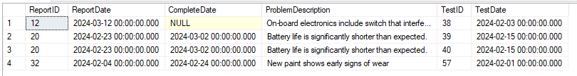

Q2) Wouldn’t sort the output, but the table has all the correct data

SELECT

ProblemReportID,

ReportDate,

CompleteDate,

ProblemDescription,

CONCAT(FirstName,' ',LastName) AS ReporterName,

CASE

WHEN PersonType = 'C'

THEN 'Customer'

WHEN PersonType = 'D'

THEN 'Distributor'

WHEN PersonType = 'E'

THEN 'Employee'

WHEN PersonType = 'O'

THEN 'Other'

END ReporterType,

pr.ModelNumber,

md.ModelName,

md.StandardPrice

FROM HWProblemReport AS PR

INNER JOIN HWPersonTable pt

ON pt.PersonID = pr.ReporterID

INNER JOIN HWModelData AS md

ON md.ModelNumber = pr.ModelNumber

ORDER BY ProblemReportID

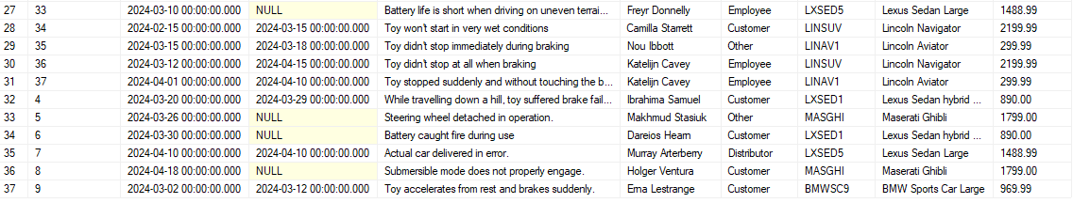

Q3)

SELECT ProblemReportID AS ReportID,

ProblemReportSerialNumber AS SerialNumber,

ReportDate,

CompleteDate,

InjuryYN,

InjuryDescription,

ProblemDescription

FROM HWProblemReport AS pr

LEFT OUTER JOIN HWTest AS t

ON t.ReportID = pr.ProblemReportID

WHERE InjuryYN = 'yes' AND CompleteDate is not null AND (t.ReportID is null AND pr.ProblemReportID is not null)



Q4)

SELECT ProblemReportID AS ReportID,

ProblemReportSerialNumber AS SerialNumber,

ReportDate,

CompleteDate,

pt.LastName AS ReporterLastName,

md.ModelName,

InjuryYN,

InjuryDescription,

ProblemDescription

FROM HWProblemReport AS pr

LEFT OUTER JOIN HWTest AS t

ON t.ReportID = pr.ProblemReportID

INNER JOIN HWPersonTable AS pt

ON pt.PersonID = pr.ReporterID

INNER JOIN HWModelData AS md

ON md.ModelNumber = pr.ModelNumber

WHERE InjuryYN = 'yes' AND CompleteDate is not null AND (t.ReportID is null AND pr.ProblemReportID is not null)



Q5)

CREATE VIEW vw_CountingInjuries AS

SELECT

pt.ProblemTypeID,

COUNT(InjuryYN) AS Yesjuries

FROM HWProblemType AS pt

INNER JOIN HWProblemReport AS pr

ON pt.ProblemTypeID= pr.ProblemTypeID

WHERE InjuryYN LIKE '%Yes%'

Group BY pt.ProblemTypeID

SELECT

pt.ProblemTypeID,

ProblemTypeDescription AS TypeDescription,

COUNT(ProblemReportID) AS CountOfReports,

ISNULL(ci.Yesjuries,0) AS CountOfInjuryReports

FROM HWProblemType AS pt

LEFT OUTER JOIN HWProblemReport AS pr

ON pr.ProblemTypeID = pt.ProblemTypeID

LEFT OUTER JOIN vw_CountingInjuries AS ci

ON pt.ProblemTypeID= ci.ProblemTypeID

GROUP BY ci.Yesjuries, pt.ProblemTypeID, ProblemTypeDescription

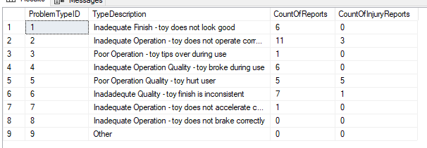

Q6) April 1st Keeps showing up on the top of the list no matter what, but all data is correct.

SELECT DISTINCT CONVERT(VARCHAR, pr.ReportDate, 107) AS ReportDate,

pr.ProblemReportID AS ReportID,

pr.ProblemReportSerialNumber,

CASE

WHEN pr.CompleteDate is not null

THEN CONVERT(VARCHAR, pr.CompleteDate, 107)

WHEN pr.CompleteDate is null

THEN 'Not Complete'

END CompleteDate,

CASE

WHEN pr.CompleteDate is not null

THEN DATEDIFF(DAY,pr.ReportDate, pr.CompleteDate)

WHEN pr.CompleteDate is null

THEN DATEDIFF(DAY,pr.ReportDate, GETDATE())

END DaysInSystem,

pr.ModelNumber,

md.ModelDescription,

pt.LastName +', '+ SUBSTRING(pt.FirstName,0,2)+'.' AS TesterName,

CONVERT(VARCHAR, t.TestDate, 107) AS TestDate,

t.TestDescription,

t.TestComplete

FROM HWProblemReport AS pr

LEFT OUTER JOIN HWModelData AS md

ON md.ModelNumber = pr.ModelNumber

LEFT OUTER JOIN HWTest AS t

ON t.ReportID = pr.ProblemReportID

LEFT OUTER JOIN HWPersonTable AS pt

ON pt.PersonID = t.TesterID

WHERE md.ModelDescription LIKE '%SUV%'

ORDER BY ReportDate

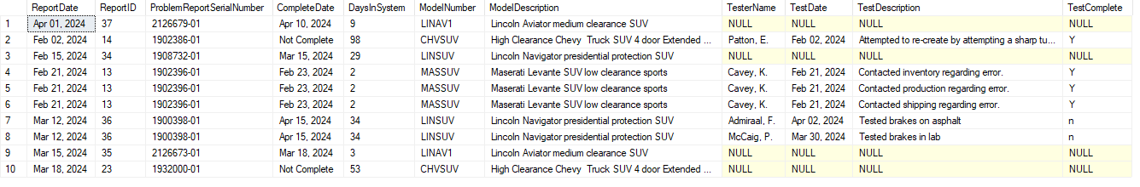

Q7)

SELECT ModelNumber,

COUNT(ModelNumber) AS CountOfProblemReports

FROM HWProblemReport AS pr

GROUP BY ModelNumber

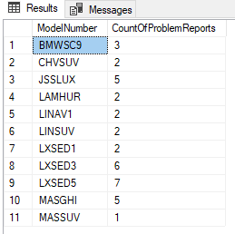

Q8)

CREATE VIEW vw_CountOfProblemReports AS

SELECT pr.ModelNumber,

md.ModelName,

md.ModelDescription,

COUNT(pr.ModelNumber) AS CountOfProblemReports

FROM HWProblemReport AS pr

INNER JOIN HWModelData AS md

ON md.ModelNumber = pr.ModelNumber

GROUP BY pr.ModelNumber, md.ModelName, md.ModelDescription

SELECT *

FROM vw_CountOfProblemReports

WHERE CountOfProblemReports = (SELECT MAX(CountOfProblemReports) FROM vw_CountOfProblemReports)

