CREATE TABLE STATEMENTS

--Employee Table--

CREATE TABLE tblEmployee

(EmpID CHAR(6) PRIMARY KEY NOT NULL,

EmpLastName VARCHAR(30) NOT NULL,

EmpFirstName VARCHAR(30) NOT NULL,

EmpEmail VARCHAR(30),

EmpPhone CHAR(15),

EmpMgrID CHAR(6) FOREIGN KEY REFERENCES tblEmployee(EmpID));

--Vendor Table--

CREATE TABLE tblVendor

(VendorID CHAR(5) PRIMARY KEY NOT NULL,

VendorName VARCHAR(30) NOT NULL,

VendorAddress1 VARCHAR(30) NOT NULL,

VendorAddress2 VARCHAR(30),

VendorCity VARCHAR(30) NOT NULL,

VendorState CHAR(2) NOT NULL,

VendorZip VARCHAR(12) NOT NULL,

VendorEmail VARCHAR(30),

VendorContact VARCHAR(30),

VendorPhone CHAR(15) NOT NULL,

FirstBuyDate DATETIME);

--Purchase Order Table--

CREATE TABLE tblPurchaseOrder

(PONumber CHAR(6) PRIMARY KEY NOT NULL,

PODatePlaced DATETIME NOT NULL,

PODateNeeded DATETIME,

Terms VARCHAR(15),

Conditions VARCHAR(15),

BuyerEmpID CHAR(6) FOREIGN KEY REFERENCES tblEmployee(EmpID),

VendorID CHAR(5) FOREIGN KEY REFERENCES tblVendor(VendorID));

--Product Type Table--

CREATE TABLE tblProductType

(ProductTypeID CHAR(2) PRIMARY KEY NOT NULL,

PDescription VARCHAR(30) NOT NULL);

--Condition Table--

CREATE TABLE tblCondition

(ConditionID CHAR(2) PRIMARY KEY NOT NULL,

ConditionDescription VARCHAR(30) NOT NULL);

--Product Table--

CREATE TABLE tblProduct

(ProductID CHAR(5) PRIMARY KEY NOT NULL,

ProductDescription VARCHAR(30) NOT NULL,

UOM CHAR(10)

CHECK(UOM IN ('each', 'feet', 'inches', 'meters', 'cm', 'sheet', 'case')),

EOQ DECIMAL(6,2),

QOH DECIMAL(8,2) NOT NULL,

QOHDateUpdated DATETIME,

ProductTypeID CHAR(2) FOREIGN KEY REFERENCES tblProductType(ProductTypeID) NOT NULL);

--Purchase Order Line Table--

CREATE TABLE tblPurchaseOrderLine

(POLineID INT PRIMARY KEY NOT NULL,

PONumber CHAR(6) FOREIGN KEY REFERENCES tblPurchaseOrder(PONumber) NOT NULL,

ProductID CHAR(5) FOREIGN KEY REFERENCES tblProduct(ProductID) NOT NULL,

QtyOrdered DECIMAL(6,2) CHECK(QtyOrdered > 0),

Price MONEY NOT NULL,

DateNeeded DATETIME NOT NULL);

--Purchase History Table--

CREATE TABLE tblPurchaseHistory

(HistoryID INT IDENTITY(1,1) PRIMARY KEY,

ProductID CHAR(5) FOREIGN KEY REFERENCES tblProduct(ProductID) NOT NULL,

DatePurchased DATETIME NOT NULL,

Qty DECIMAL(8,2) NOT NULL,

Price MONEY NOT NULL,

QtyReceivedOnTime DECIMAL(8,2),

VendorID CHAR(5) FOREIGN KEY REFERENCES tblVendor(VendorID));

--Vendor Review Table--

CREATE TABLE tblVendorReview

(ReviewID INT IDENTITY(10,10) PRIMARY KEY,

ReviewDate DATETIME NOT NULL,

ReviewTitle VARCHAR(50) NOT NULL,

ReviewRating INT CHECK(ReviewRating > 0 AND ReviewRating < 6),

ReviewComments VARCHAR(500),

ProductID CHAR(5) FOREIGN KEY REFERENCES tblProduct(ProductID),

VendorID CHAR(5) FOREIGN KEY REFERENCES tblVendor(VendorID));

--Receiver Table--

CREATE TABLE tblReceiver

(ReceiverID INT IDENTITY(1,1) PRIMARY KEY,

DateReceived DATETIME NOT NULL,

QtyReceived DECIMAL(6,2) CHECK(QtyReceived > 0),

ConditionID CHAR(2) FOREIGN KEY REFERENCES tblCondition(ConditionID) NOT NULL,

ReceiveEmpID CHAR(6) FOREIGN KEY REFERENCES tblEmployee(EmpID),

POLineID INT FOREIGN KEY REFERENCES tblPurchaseOrderLine(POLineID));

SCREENSHOTS OF TABLES

Employee

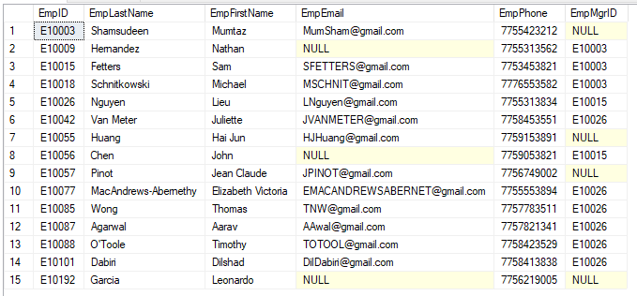

Condition

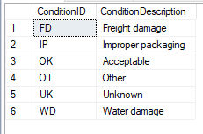

Product

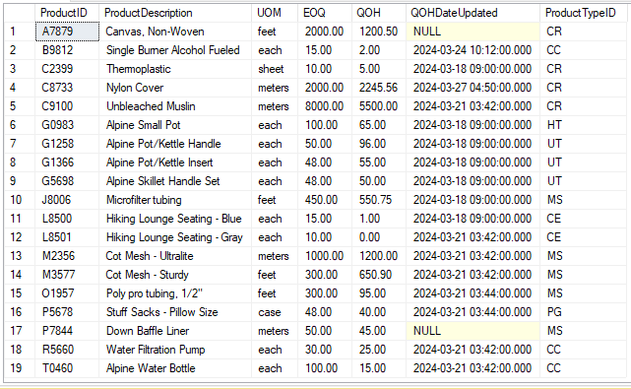

ProductType

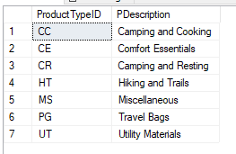

PurchaseHistory

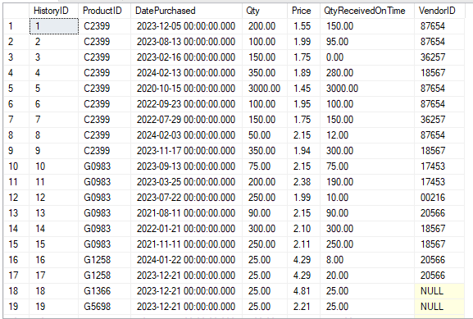

PurchaseOrder

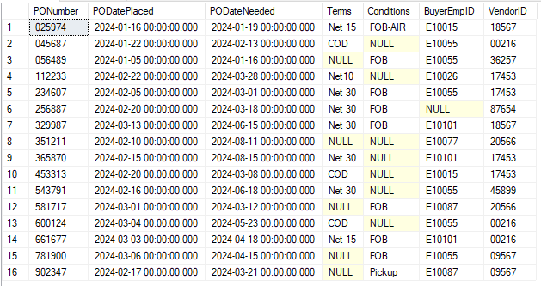

PurchaseOrderLine

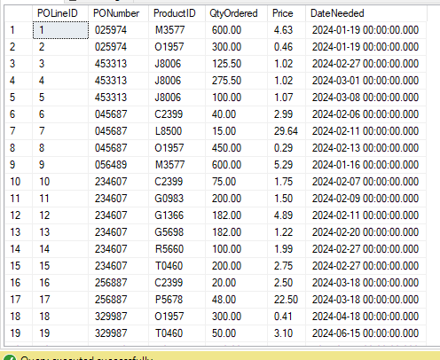

Receiver

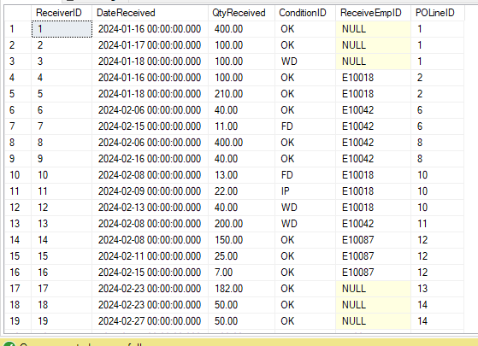

Vendor

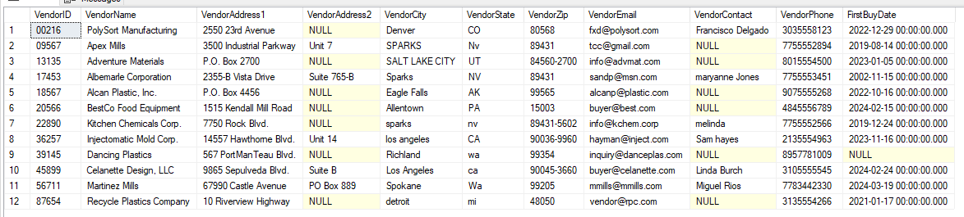

VendorReview

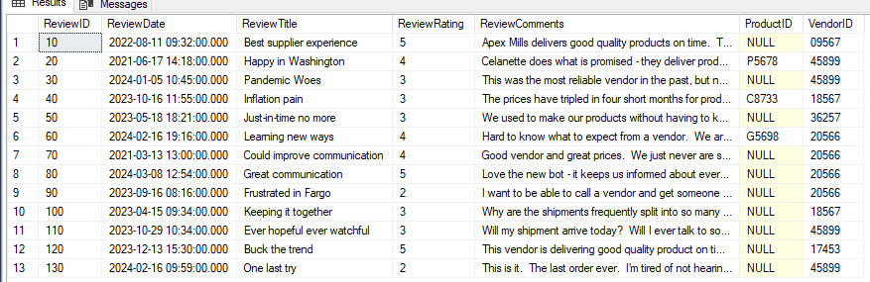

For Importing, we used the Import Wizard to copy the data from the provided Excel Document