Q1)

SELECT \*

FROM tblProduct

WHERE QOH <= 15

ORDER BY ProductDescription;

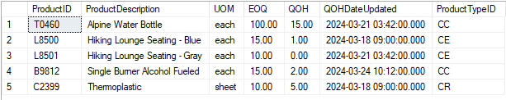

Q2)

SELECT PONumber, ProductID, QtyOrdered, DateNeeded

FROM tblPurchaseOrderLine

WHERE DateNeeded < GETDATE() AND QtyOrdered > 500

ORDER BY PONumber;

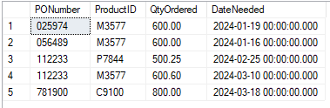

Q3)

SELECT EmpLastName, EmpFirstName, EmpPhone

FROM tblEmployee

WHERE EmpEmail IS NULL

ORDER BY EmpLastName;

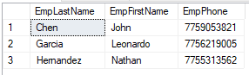

Q4)

SELECT

VendorID,

VendorName,

CASE

WHEN CHARINDEX(' ', VendorCity) > 0

THEN CONCAT(VendorAddress1, ', ', VendorAddress2, ' Los Angeles, ', UPPER(VendorState))

ELSE CONCAT(VendorAddress1, ', ', VendorAddress2, ' Sparks, ', UPPER(VendorState))

END VendorAddress,

VendorPhone = CONCAT('(', SUBSTRING(VendorPhone,1,3), ') ', SUBSTRING(VendorPhone,4,3), '-', SUBSTRING(VendorPhone,7,4)),

DateFirstBuy = CONVERT(VARCHAR, FirstBuyDate, 107)

FROM tblVendor

WHERE VendorState = 'CA' OR VendorState = 'NV'

ORDER BY FirstBuyDate;

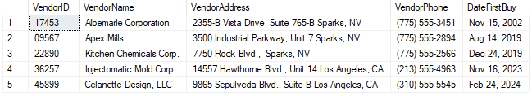

Q5)

SELECT VendorID,

Qty,

QtyReceivedOnTime,

DifferenceBetweenQtyReceivedOnTime = Qty - QtyReceivedOnTime

FROM tblPurchaseHistory

WHERE (Qty - QtyReceivedOnTime) > (Qty \* 0.5)

ORDER BY VendorID;

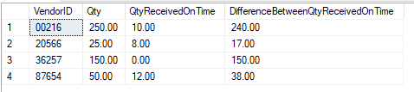

Q6)

SELECT TOP 1

MAX(Price) AS 'Most Expensive Selling Price for Product G0983'

FROM tblPurchaseOrderLine

where ProductID= 'G0983';



Q7)

SELECT

CAST(ROUND(SUM(QtyOrdered \* Price),2) AS MONEY) AS 'Total Order Price for February'

FROM tblPurchaseOrderLine

WHERE MONTH(DateNeeded)=2 AND YEAR(DateNeeded)=YEAR(GETDATE());



Q8)

SELECT

ProductID,

ProductDescription,

EOQ AS EconomicOrderQuantity,

QOH AS QuantityOnHand,

QOH - EOQ AS 'Difference',

CASE

WHEN QOH-EOQ < -50

THEN 'Order Now'

ELSE NULL

END OrderMessage

FROM tblProduct

WHERE QOH<EOQ;

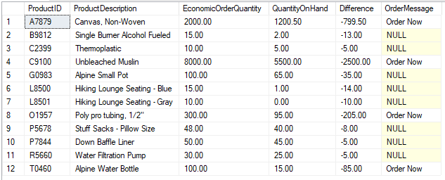

Q9)

SELECT

ProductID,

ProductDescription,

EOQ AS EconomicOrderQuantity,

QOH AS QuantityOnHand,

QOH - EOQ AS 'Difference',

CASE

WHEN QOH=0

THEN 'Order immediately'

WHEN QOH-EOQ >= -5

THEN NULL

WHEN QOH-EOQ >= -10

THEN 'Order next month'

WHEN QOH-EOQ >= -35

THEN 'Order next week'

ELSE 'Order this week'

END OrderMessage

FROM tblProduct

WHERE QOH<EOQ

ORDER BY -EOQ;

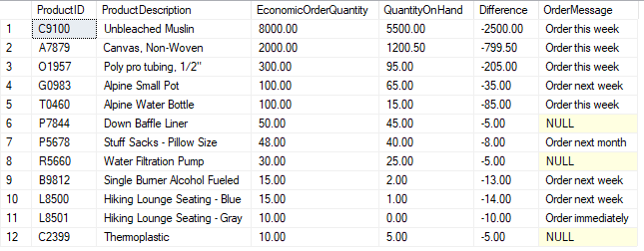

Q10)

SELECT

ProductTypeID,

COUNT(ProductTypeID) CountOfProducts,

CAST(SUM(QOH)AS INT) TotalQuantityonHand ,

CONVERT(DECIMAL(10,2),(ROUND(AVG(QOH),2))) AverageQuantityOnHand

FROM tblProduct

GROUP BY ProductTypeID;

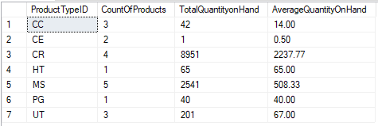

Q11)

SELECT

ProductTypeID,

COUNT(ProductTypeID) CountOfProducts,

CAST(SUM(QOH)AS INT) TotalQuantityonHand ,

CONVERT(DECIMAL(10,2),(ROUND(AVG(QOH),2))) AverageQuantityOnHand

FROM tblProduct

GROUP BY ProductTypeID

HAVING CONVERT(DECIMAL(10,2),(ROUND(AVG(QOH),2))) > 50;

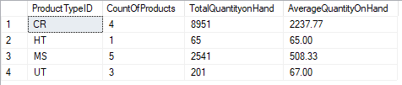

Q12)

SELECT ReviewTitle,

CONVERT(VARCHAR, ReviewDate, 101) AS ReviewDate,

ReviewRating,

SUBSTRING(ReviewComments, 1, 65) AS ShortReviewComments

FROM tblVendorReview

WHERE ReviewRating >= 4 AND VendorID = 20566;



Q13)

SELECT CONVERT(VARCHAR, PODateNeeded, 107) AS 'DateNeeded',

CONVERT(VARCHAR, GETDATE(), 107) AS 'Today''s Date',

DATEDIFF(day, PODateNeeded, GETDATE()) AS 'DaysOverdue',

PONumber AS 'PurchaseOrderNumber',

CONVERT(VARCHAR, PODatePlaced, 107) AS 'DateOrdered',

BuyerEmpID AS 'Buyer',

VendorID

FROM tblPurchaseOrder

WHERE DATEDIFF(day, PODateNeeded, GETDATE()) > 7

ORDER BY PODateNeeded;

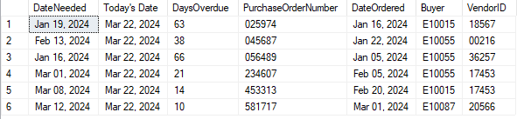

Q14)

SELECT DISTINCT ProductID,

MAX(CONVERT(VARCHAR, DatePurchased, 101)) AS LastDatePurchased,

COUNT(ProductID) AS NumberOfTimesPurchased,

MIN(Price) AS MinimumPurchasePrice,

MAX(Price) AS MaximumPurchasePrice,

MAX(Price) - MIN(Price) AS DifferenceBetweenMaxAndMinPrice

FROM tblPurchaseHistory

GROUP BY ProductID;

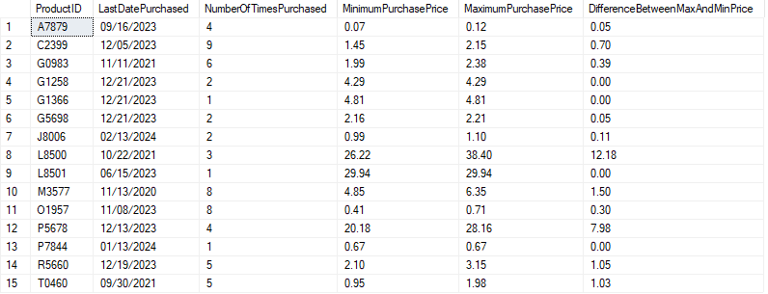

Q15)

SELECT DISTINCT ProductID,

MAX(CONVERT(VARCHAR, DatePurchased, 101)) AS LastDatePurchased,

COUNT(ProductID) AS NumberOfTimesPurchased,

MIN(Price) AS MinimumPurchasePrice,

MAX(Price) AS MaximumPurchasePrice,

MAX(Price) - MIN(Price) AS DifferenceBetweenMaxAndMinPrice

FROM tblPurchaseHistory

GROUP BY ProductID

HAVING (MAX(Price) - MIN(Price)) = 0;

