ALL DATA IS FOUND IN ANKIT BOMBWAL’S DATABASE

Q1)

SELECT ProductID, ProductDescription

FROM tblProduct

WHERE ProductID NOT IN (SELECT DISTINCT ProductID FROM tblPurchaseOrderLine);

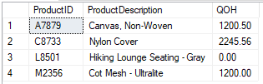

Q2)

SELECT VendorID, VendorName, VendorLocation = CONCAT(VendorCity, ', ', VendorState) , FirstBuyDate = CONVERT(VARCHAR, FirstBuyDate ,101)

FROM tblVendor

WHERE FirstBuyDate = (SELECT MIN(FirstBuyDate) FROM tblVendor);



Q3)

SELECT

CONVERT(varchar,PODateNeeded,107) AS DateofRequiredDelivery,

PONumber,

CONVERT(varchar,PODatePlaced,107) AS DateofPurchaseOrder,

VendorName,

'('+ SUBSTRING(VendorPhone,1,3)+') '+SUBSTRING(VendorPhone,4,3)+'-'+SUBSTRING(VendorPhone,7,4) AS VendorPhoneNumber,

BuyerEmpID AS BuyerID

FROM tblPurchaseOrder

INNER JOIN tblVendor

ON tblPurchaseOrder.VendorID = tblVendor.VendorID

where MONTH(PODateNeeded)=4 OR MONTH(PODateNeeded)=3 AND YEAR(PODateNeeded)=YEAR(GETDATE())

ORDER BY PODateNeeded DESC

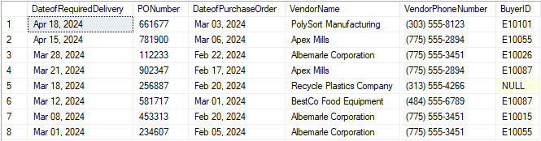

Q4)

SELECT

CONVERT(varchar,PODateNeeded,107) AS DateofRequiredDelivery,

PONumber,

CONVERT(varchar,PODatePlaced,107) AS DateofPurchaseOrder,

VendorName,

'('+ SUBSTRING(VendorPhone,1,3)+') '+SUBSTRING(VendorPhone,4,3)+'-'+SUBSTRING(VendorPhone,7,4) AS VendorPhoneNumber,

CONCAT(ISNULL(EmpFirstName,'No'),' ',ISNULL(EmpLastName,'Buyer')) AS BuyerName

FROM tblPurchaseOrder

INNER JOIN tblVendor

ON tblPurchaseOrder.VendorID = tblVendor.VendorID

LEFT OUTER JOIN tblEmployee

ON tblPurchaseOrder.BuyerEmpID=tblEmployee.EmpID

where MONTH(PODateNeeded)=4 OR MONTH(PODateNeeded)=3 AND YEAR(PODateNeeded)=YEAR(GETDATE())

ORDER BY PODateNeeded DESC

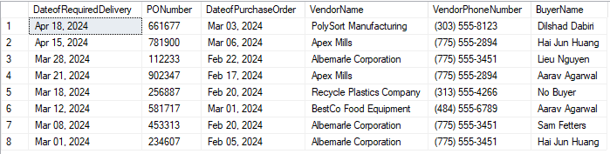

Q5)

SELECT

CONVERT(varchar,PODateNeeded,107) AS DateofRequiredDelivery,

PONumber,

CONVERT(varchar,PODatePlaced,107) AS DateofPurchaseOrder,

VendorName,

'('+ SUBSTRING(VendorPhone,1,3)+') '+SUBSTRING(VendorPhone,4,3)+'-'+SUBSTRING(VendorPhone,7,4) AS VendorPhoneNumber,

CONCAT(ISNULL(worker.EmpFirstName,'No'),' ',ISNULL(worker.EmpLastName,'Buyer')) AS BuyerName,

CONCAT(ISNULL(manager.EmpFirstName,'"No'),' ',ISNULL(manager.EmpLastName,'Manager"')) AS ManagerName

FROM tblPurchaseOrder

INNER JOIN tblVendor

ON tblPurchaseOrder.VendorID = tblVendor.VendorID

LEFT OUTER JOIN tblEmployee worker

ON tblPurchaseOrder.BuyerEmpID=worker.EmpID

LEFT OUTER JOIN tblEmployee manager

ON worker.EmpMgrID = manager.EmpID

where MONTH(PODateNeeded)=4 OR MONTH(PODateNeeded)=3 AND YEAR(PODateNeeded)=YEAR(GETDATE())

ORDER BY PODateNeeded DESC

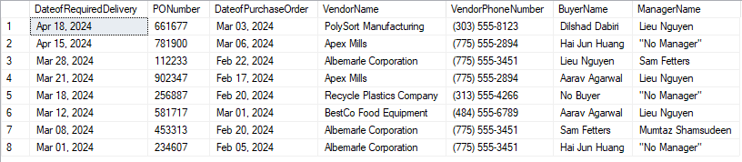

Q6)

SELECT ProductID,

DateReceived,

PONumber AS PurchaseOrderNumber,

QtyReceived AS QuantityReceived,

ConditionDescription AS ConditionReceived

FROM tblPurchaseOrderLine

INNER JOIN tblReceiver

ON tblReceiver.POLineID = tblPurchaseOrderLine.POLineID

INNER JOIN tblCondition

ON tblReceiver.ConditionID = tblCondition.ConditionID

WHERE ConditionDescription LIKE '%damage%'

ORDER BY ProductID, DateReceived;

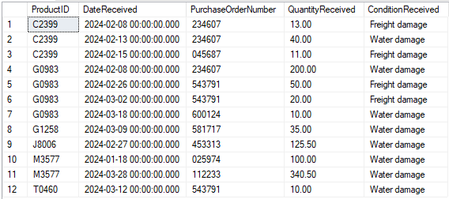

Q7)

SELECT tblPurchaseOrderLine.ProductID,

ProductDescription,

PDescription AS 'ProductType',

DateReceived,

tblPurchaseOrderLine.PONumber,

VendorName,

VendorPhoneNumber = CONCAT('(', SUBSTRING(VendorPhone,1,3), ') ', SUBSTRING(VendorPhone,4,3), '-', SUBSTRING(VendorPhone,7,4)),

QtyReceived AS QuantityReceived,

ConditionDescription AS ConditionReceived

FROM tblProductType

INNER JOIN tblProduct

ON tblProduct.ProductTypeID = tblProductType.ProductTypeID

INNER JOIN tblPurchaseOrderLine

ON tblPurchaseOrderLine.ProductID = tblProduct.ProductID

INNER JOIN tblPurchaseOrder

ON tblPurchaseOrder.PONumber = tblPurchaseOrderLine.PONumber

INNER JOIN tblVendor

ON tblVendor.VendorID = tblPurchaseOrder.VendorID

INNER JOIN tblReceiver

ON tblReceiver.POLineID = tblPurchaseOrderLine.POLineID

INNER JOIN tblCondition

ON tblReceiver.ConditionID = tblCondition.ConditionID

WHERE ConditionDescription LIKE '%damage%'

ORDER BY ProductID, DateReceived;

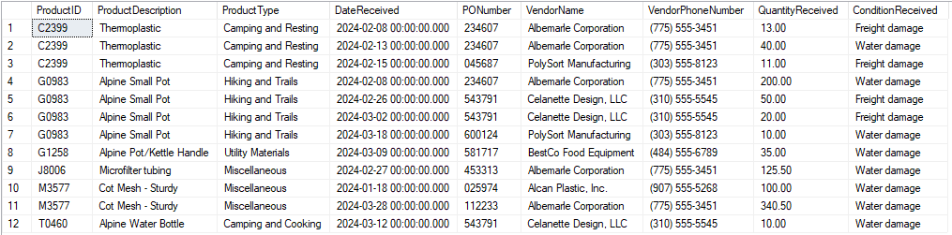

Q8)

SELECT DISTINCT(VendorName),

VendorPhoneNumber = CONCAT('(', SUBSTRING(VendorPhone,1,3), ') ', SUBSTRING(VendorPhone,4,3), '-', SUBSTRING(VendorPhone,7,4))

FROM tblProductType

INNER JOIN tblProduct

ON tblProduct.ProductTypeID = tblProductType.ProductTypeID

INNER JOIN tblPurchaseOrderLine

ON tblPurchaseOrderLine.ProductID = tblProduct.ProductID

INNER JOIN tblPurchaseOrder

ON tblPurchaseOrder.PONumber = tblPurchaseOrderLine.PONumber

INNER JOIN tblVendor

ON tblVendor.VendorID = tblPurchaseOrder.VendorID

INNER JOIN tblReceiver

ON tblReceiver.POLineID = tblPurchaseOrderLine.POLineID

INNER JOIN tblCondition

ON tblReceiver.ConditionID = tblCondition.ConditionID

WHERE ConditionDescription LIKE '%damage%' AND ProductDescription = 'Thermoplastic'

ORDER BY VendorName;



Q9)

SELECT

tblProduct.ProductID,

ProductDescription,

COUNT( tblPurchaseOrderLine.ProductID) AS CountofPurchaseOrders ,

CAST(SUM(ISNULL(QtyOrdered,0))AS int) AS TotalQuantityOrdered,

ROUND(MAX(ISNULL(Price,0)),2) AS MaximumPricePaid,

ROUND(MIN(ISNULL(Price,0)),2) AS MinimumPricePaid,

ROUND(AVG(ISNULL(Price,0)),2) AS AveragePricePaid

FROM tblProduct

LEFT OUTER JOIN tblPurchaseOrderLine

ON tblProduct.ProductID=tblPurchaseOrderLine.ProductID

Group BY tblProduct.ProductID, ProductDescription

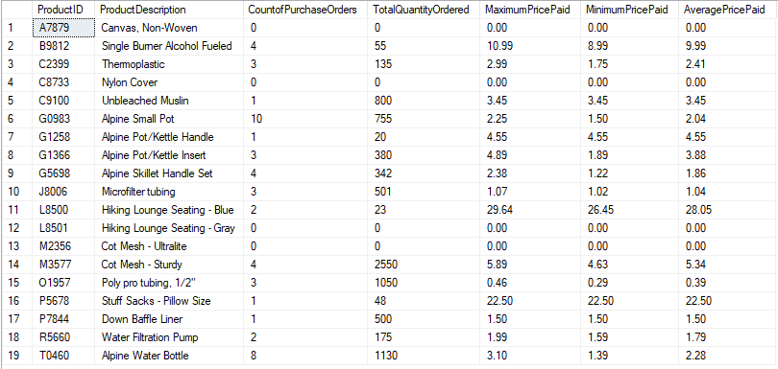

Q10)

SELECT tblPurchaseOrderLine.PONumber,

PODatePlaced,

VendorName,

CONCAT(EmpLastName, '. ', SUBSTRING(EmpFirstName,1,1)) AS Buyer,

tblPurchaseOrderLine.ProductID,

ProductDescription,

DateNeeded AS ProductDateNeeded,

QtyOrdered AS QuantityOrdered,

Price AS UnitPrice,

CONVERT(DECIMAL(10,2),Price \* QtyOrdered) AS ExtendedPrice

FROM tblPurchaseOrder

LEFT OUTER JOIN tblPurchaseOrderLine

ON tblPurchaseOrder.PONumber = tblPurchaseOrderLine.PONumber

INNER JOIN tblVendor

ON tblPurchaseOrder.VendorID = tblVendor.VendorID

LEFT OUTER JOIN tblProduct

ON tblPurchaseOrderLine.ProductID = tblProduct.ProductID

LEFT OUTER JOIN tblEmployee

ON tblPurchaseOrder.BuyerEmpID = tblEmployee.EmpID

ORDER BY PONumber;

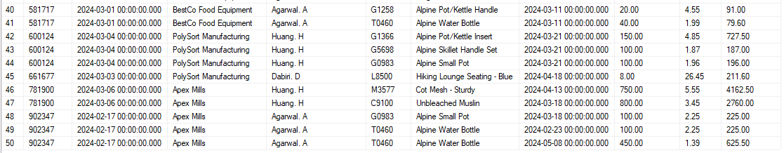

Q11)

SELECT tblPurchaseOrderLine.PONumber,

PODatePlaced,

VendorName,

CONCAT(EmpLastName, '. ', SUBSTRING(EmpFirstName,1,1)) AS Buyer,

tblPurchaseOrderLine.ProductID,

ProductDescription,

DateNeeded AS ProductDateNeeded,

QtyOrdered AS QuantityOrdered,

DateReceived,

QtyReceived

FROM tblPurchaseOrder

LEFT OUTER JOIN tblPurchaseOrderLine

ON tblPurchaseOrder.PONumber = tblPurchaseOrderLine.PONumber

INNER JOIN tblVendor

ON tblPurchaseOrder.VendorID = tblVendor.VendorID

LEFT OUTER JOIN tblProduct

ON tblPurchaseOrderLine.ProductID = tblProduct.ProductID

LEFT OUTER JOIN tblEmployee

ON tblPurchaseOrder.BuyerEmpID = tblEmployee.EmpID

LEFT OUTER JOIN tblReceiver

ON tblPurchaseOrderLine.POLineID = tblReceiver.POLineID

ORDER BY PONumber;

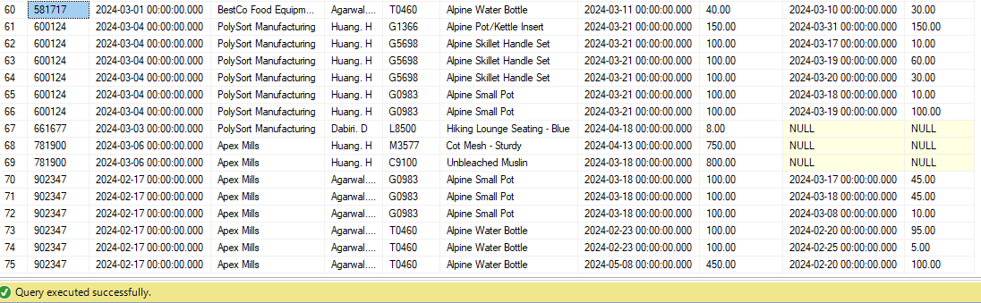

Q12)

SELECT tblPurchaseOrder.PONumber,

VendorName,

tblPurchaseOrderLine.ProductID,

ProductDescription,

DateNeeded AS ProductDateNeeded,

QtyOrdered,

SUM(ISNULL(QtyReceived, 0)) AS TotalQuantityReceived,

QuantityRemainingToBeReceived = QtyOrdered - SUM(ISNULL(QtyReceived, 0)),

CASE

WHEN QtyOrdered - SUM(QtyReceived) = 0

THEN 'Complete'

WHEN QtyOrdered - SUM(QtyReceived) < 0

THEN 'Over Shipment'

WHEN QtyOrdered - SUM(QtyReceived) > 0

THEN 'Partial Shipment'

WHEN SUM(ISNULL(QtyReceived, 0)) = 0

THEN 'Not Received'

END 'Receiving Status'

FROM tblPurchaseOrder

LEFT OUTER JOIN tblPurchaseOrderLine

ON tblPurchaseOrder.PONumber = tblPurchaseOrderLine.PONumber

INNER JOIN tblVendor

ON tblPurchaseOrder.VendorID = tblVendor.VendorID

LEFT OUTER JOIN tblProduct

ON tblPurchaseOrderLine.ProductID = tblProduct.ProductID

LEFT OUTER JOIN tblEmployee

ON tblPurchaseOrder.BuyerEmpID = tblEmployee.EmpID

LEFT OUTER JOIN tblReceiver

ON tblPurchaseOrderLine.POLineID = tblReceiver.POLineID

GROUP BY tblPurchaseOrder.PONumber, VendorName , tblPurchaseOrderLine.ProductID,ProductDescription, DateNeeded, QtyOrdered;

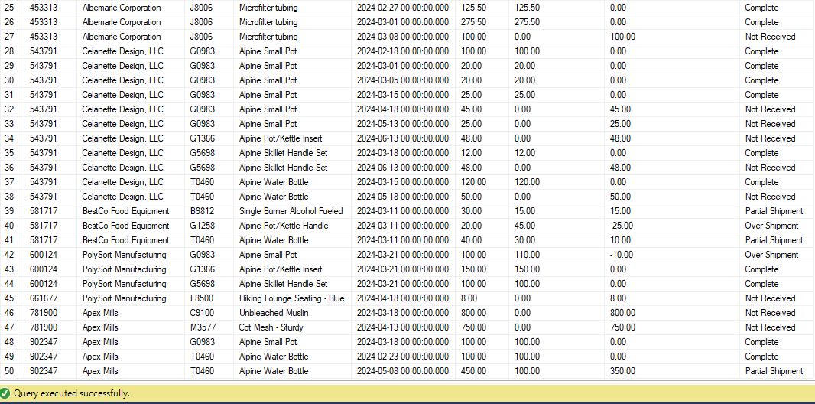

Q13)

This one doesn’t work. Yet.

SELECT tblProduct.ProductID,

ProductDescription,

EOQ AS ProductEconomicOrderQuantity,

ISNULL(CONVERT(VARCHAR, MAX(DatePurchased), 107), 'Not in Purchase History') AS MostRecentPurchaseDate,

ISNULL(Qty,0) AS QuantityPurchased,

ISNULL(Price,0) AS PurchasePrice

FROM tblPurchaseHistory

RIGHT OUTER JOIN tblProduct

ON tblPurchaseHistory.ProductID = tblProduct.ProductID

GROUP BY tblProduct.ProductID, ProductDescription, EOQ, Qty, Price;