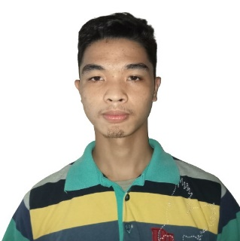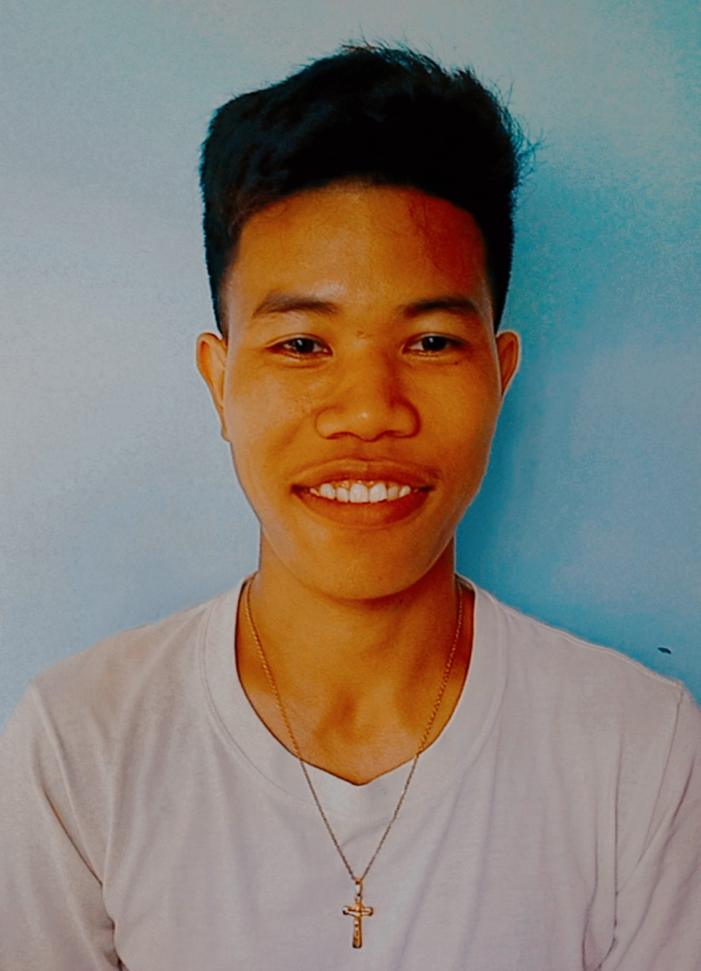

**WORK EXPERIENCE:**

**INTERNSHIP:**

* Experienced making a full stack Desktop application during my internship.

during my Internship.

**EDUCATION**

**COLLEGE: BS in Computer Science** **2019-present**

Bohol Island State University – Bilar Campus

**SHS: SMAW 2017-2019**

Pilar Technical Vocational High School

**JHS: DRAFTING** **2013-2017**

Pilar Technical Vocational High School

**ELEMENTARY 2006-2013**

Estaca Elementary School

**NICOLE N. AMOGUIS**

SKILLS

**OBJECTIVE:**

To acquire valuable knowledge and skills to complement those that I have learned from school in an actual job environment. In return, I offer my service and determination to be an asset to your company.

HOBBIES

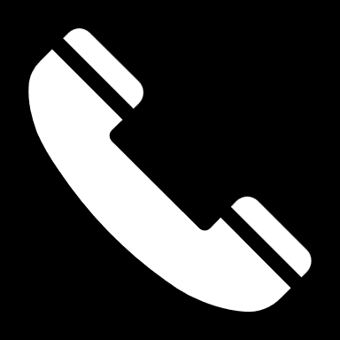

09460320435

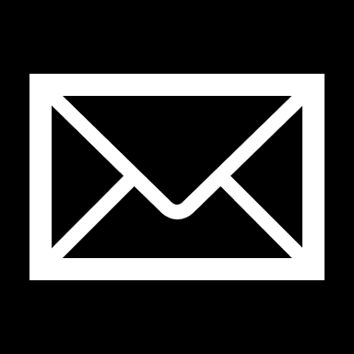

nicoleamoguis15@gmail.com@gmail.com

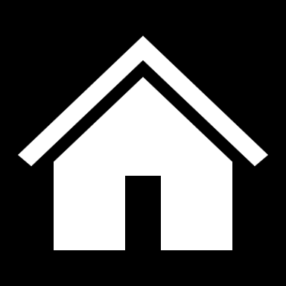

Pilar, Bohol

CONTACT

DOCKER

BOOTSTRAP

MYSQL

PHP

JAVASCRIPT

CSS

HTML

LARAVEL