-- Solution to 1.a

SELECT p.Name AS PropertyName, p.Id AS PropertyID

FROM [dbo].[Property] AS p

JOIN [dbo].[OwnerProperty] AS op

ON p.Id = op.PropertyId

WHERE op.OwnerId = '1426'

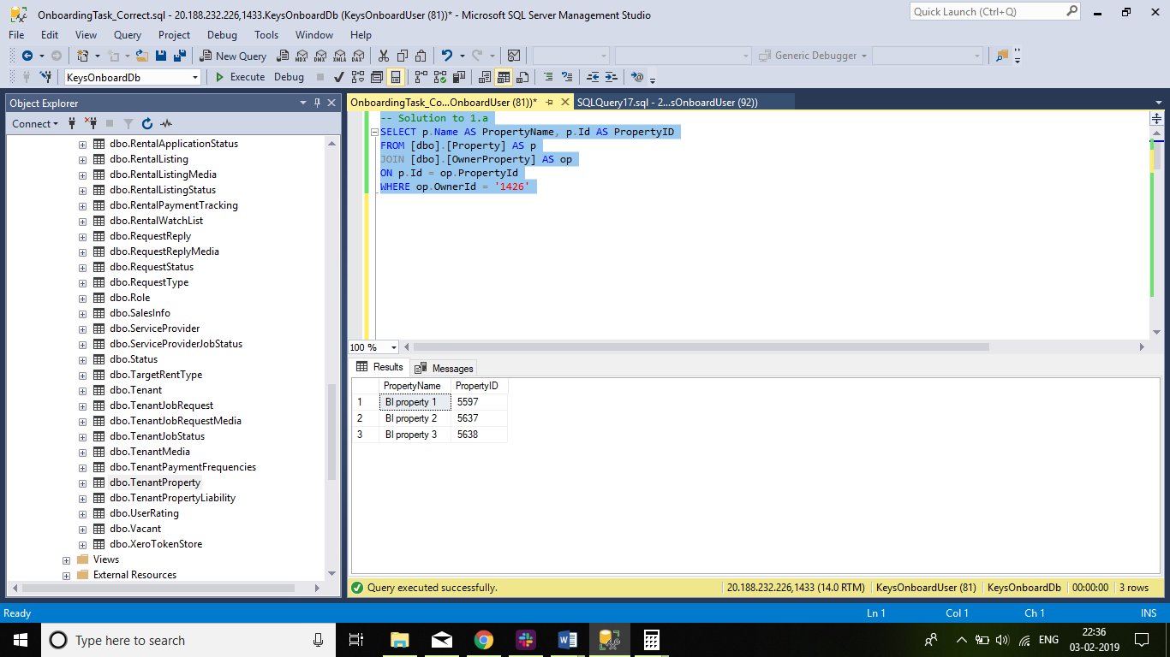

-- Solution to 1.b

SELECT p.Name AS PropertyName, p.Id AS PropertyID, phv.Value

FROM [dbo].[Property] AS p

JOIN [dbo].[OwnerProperty] AS op

ON p.Id = op.PropertyId

JOIN [dbo].[PropertyHomeValue] AS phv

ON p.Id = phv.PropertyId AND phv.IsActive = '1'

WHERE op.OwnerId = '1426'

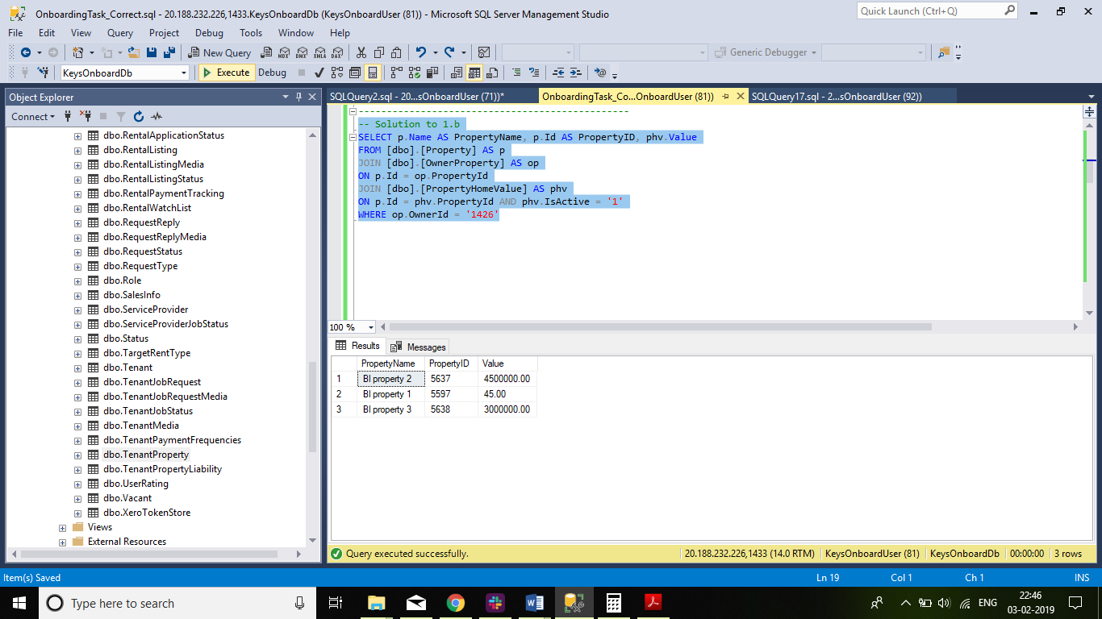

-- Solution to 1.c.i

SELECT tp.PropertyId,tp.PaymentAmount AS RentAmount,tpf.Code AS RentFrequency,

CASE tpf.Code

WHEN 'Weekly' THEN tp.PaymentAmount* DATEDIFF(week,tp.StartDate,tp.EndDate)

WHEN 'Fortnightly' THEN tp.PaymentAmount* (DATEDIFF(week,tp.StartDate,tp.EndDate))/2

WHEN 'Monthly' THEN tp.PaymentAmount* DATEDIFF(month,tp.StartDate,tp.EndDate)

END AS SumOfRentalAmount_Answer,

tp.StartDate,tp.EndDate

FROM [dbo].[TenantPaymentFrequencies] AS tpf

JOIN [dbo].[TenantProperty] AS tp

ON tpf.Id = tp.PaymentFrequencyId

JOIN [dbo].[PropertyRentalPayment] AS prp

ON prp.PropertyId = tp.PropertyId

WHERE prp.PropertyId in (SELECT p.Id AS PropertyID FROM [dbo].[Property] AS p

JOIN [dbo].[OwnerProperty] AS op ON p.Id = op.PropertyId WHERE op.OwnerId = '1426');

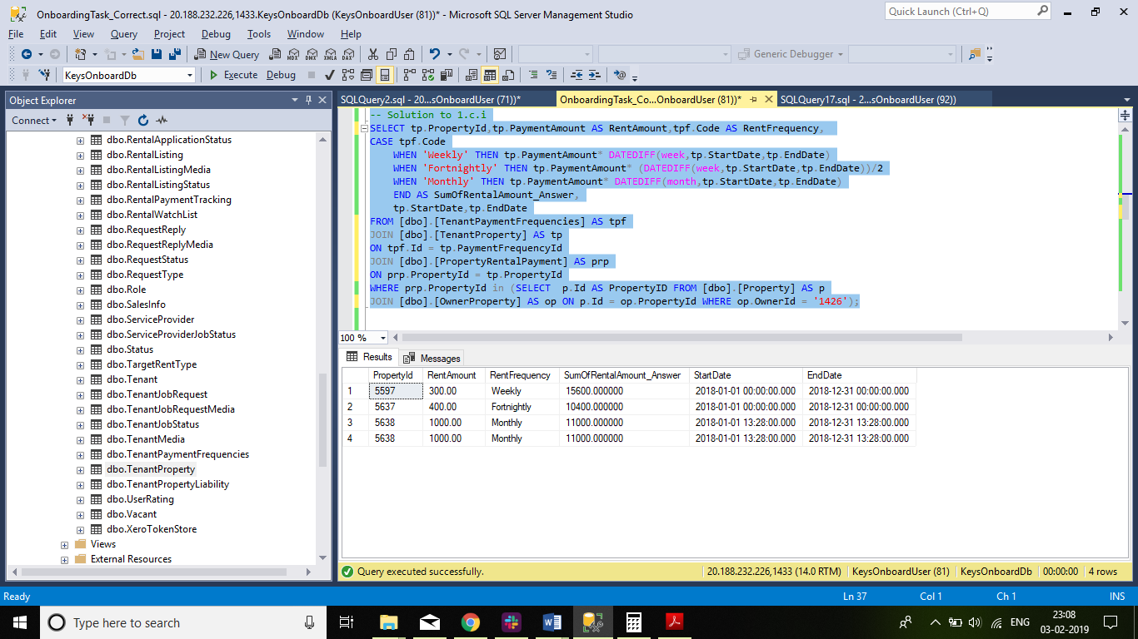

--Enhance to complete 1.c.ii

SELECT prp.PropertyId,

CASE tpf.Code

WHEN 'Weekly' THEN tp.PaymentAmount* DATEDIFF(week,tp.StartDate,tp.EndDate)

WHEN 'Fortnightly' THEN tp.PaymentAmount*(DATEDIFF(week,tp.StartDate,tp.EndDate))/2

WHEN 'Monthly' THEN tp.PaymentAmount*DATEDIFF(month,tp.StartDate,tp.EndDate)

END AS RentalAmount, phv.Value

FROM [dbo].[PropertyRentalPayment] AS prp

JOIN [dbo].[TenantPaymentFrequencies] AS tpf

ON tpf.Id = prp.FrequencyType

JOIN [dbo].[TenantProperty] AS tp

ON prp.PropertyId= tp.PropertyId

JOIN [dbo].[PropertyHomeValue] AS phv

ON prp.PropertyId = phv.PropertyId

WHERE prp.PropertyId in (SELECT p.Id AS PropertyID FROM [dbo].[Property] AS p

JOIN [dbo].[OwnerProperty] AS op ON p.Id = op.PropertyId WHERE op.OwnerId = '1426')

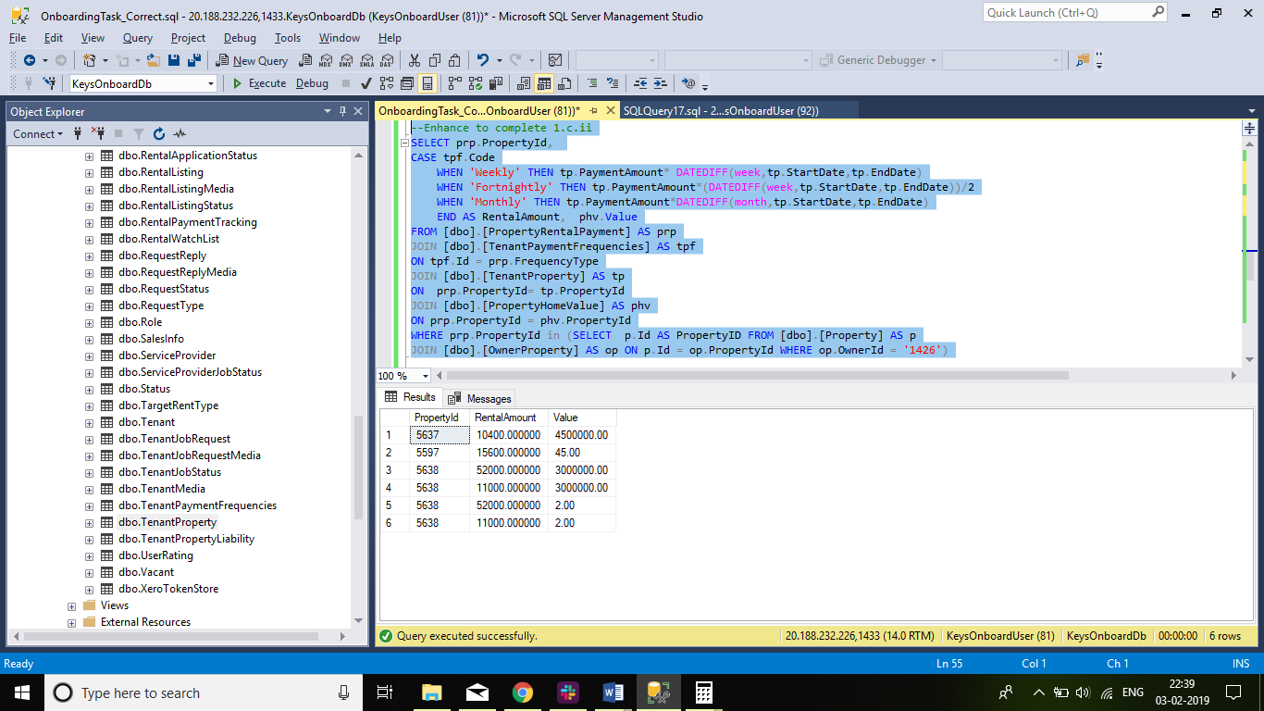

-- Correct Answer to 1.e

SELECT p.Name AS PropertyName, p.Id AS PropertyID, pn.FirstName, pn.LastName, tp.PaymentAmount AS RentAmount, tpf.Code AS Frequency

FROM [dbo].[Property] AS p

JOIN [dbo].[OwnerProperty] AS op

ON p.Id = op.PropertyId

JOIN [dbo].[PropertyRentalPayment] AS prp-- pament frpm tp

ON p.Id = prp.PropertyId

JOIN [dbo].[TenantProperty] AS tp

ON p.Id= tp.PropertyId

JOIN [dbo].[Tenant] AS t

ON tp.TenantId = t.Id

JOIN [dbo].[PERSON] AS pn

ON t.Id = pn.Id

JOIN [dbo].[TenantPaymentFrequencies] AS tpf

ON tpf.Id = prp.FrequencyType

WHERE op.OwnerId = '1426'

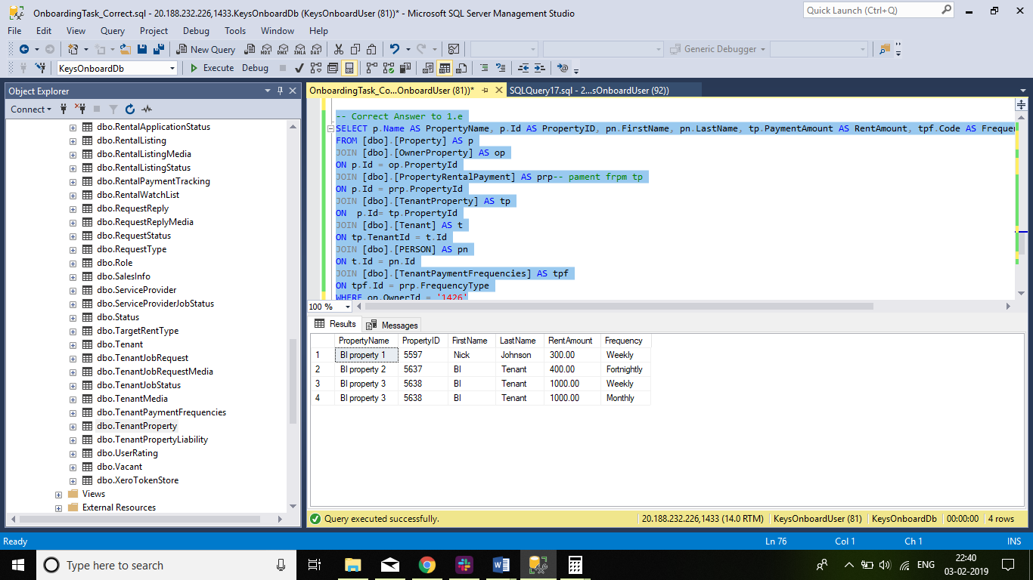

2. Report Builder

