Customer Segmentation Project
Segmenting customers based on behavior and demographics using K-Means clustering
Prepared with Python (pandas, scikit-learn, matplotlib, seaborn) | Dataset: 1,000 customers, 16 attributes

1. Project Overview
This project segments a retail customer base into distinct, actionable groups based on demographic attributes (age, income, tenure) and behavioral signals (purchase frequency, basket size, recency, channel preference, engagement, and satisfaction). The goal is to move beyond a one-size-fits-all view of customers and identify groups that differ meaningfully in value and needs, so that marketing, retention, and product decisions can be targeted rather than generic.
The workflow follows a standard, reproducible customer analytics pipeline: data cleaning → exploratory analysis → feature scaling → optimal cluster selection → K-Means clustering → dimensionality reduction for visualization → segment profiling and business interpretation.

2. Dataset
A dataset of 1,000 customers was used, with the following fields:
- Demographics: age, gender, region, annual income, tenure (months as a customer)
- Purchase behavior: purchase frequency per month, average basket value, total 12-month spend, days since last purchase (recency), returns rate
- Engagement & preference: online purchase ratio, email open rate, loyalty membership, preferred product category, satisfaction score
A small number of missing satisfaction scores (15 records) were imputed using the column median, and all numeric features were standardized (z-scored) before clustering so that no single high-magnitude variable (e.g., income) dominated the distance calculations.

3. Exploratory Analysis: Purchase Patterns & Preferences
Before clustering, the data was explored to understand overall spending distribution, category preferences, and how behavior variables relate to one another.
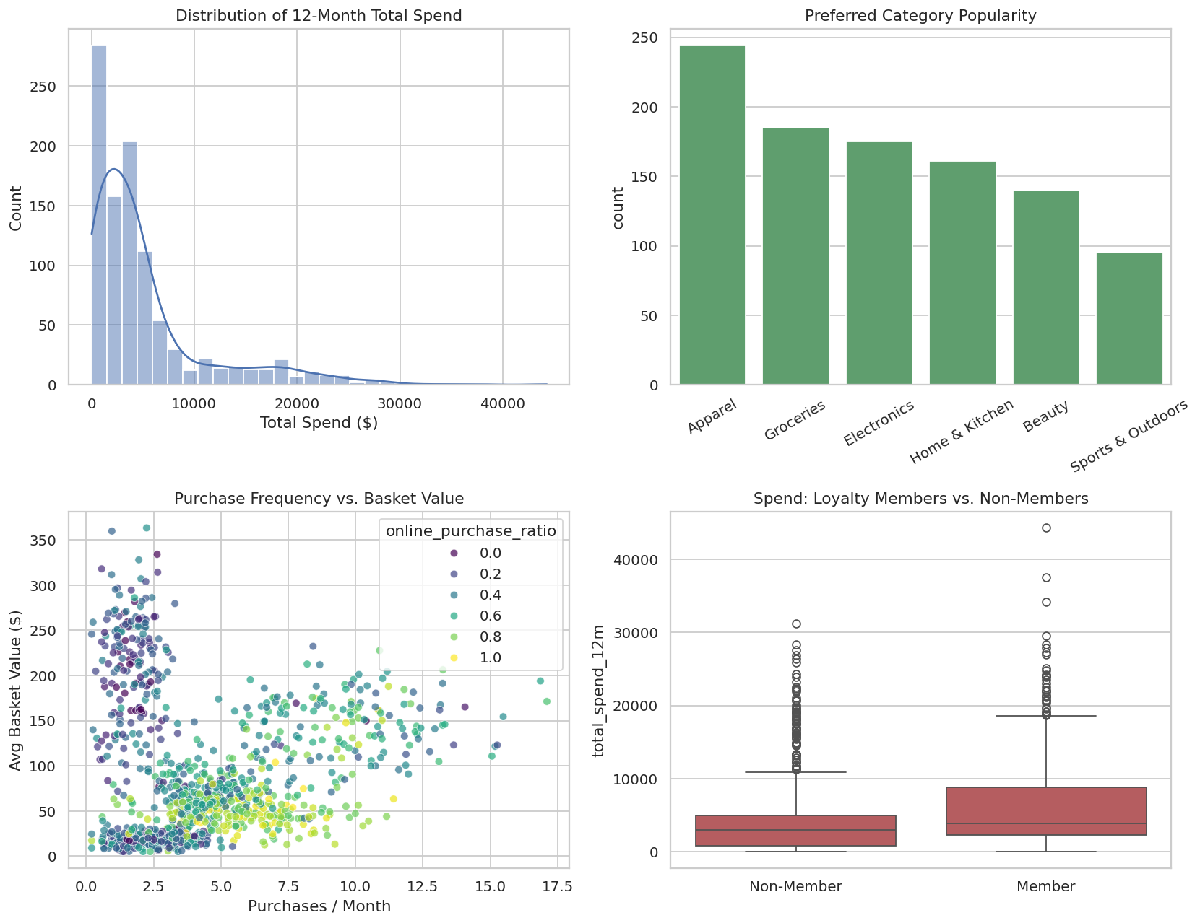
Total spend is right-skewed — most customers spend modestly, with a long tail of high-value buyers. Electronics and Apparel are the most commonly preferred categories. Customers with a higher online purchase ratio tend to buy more frequently, and loyalty members show noticeably higher total spend than non-members.
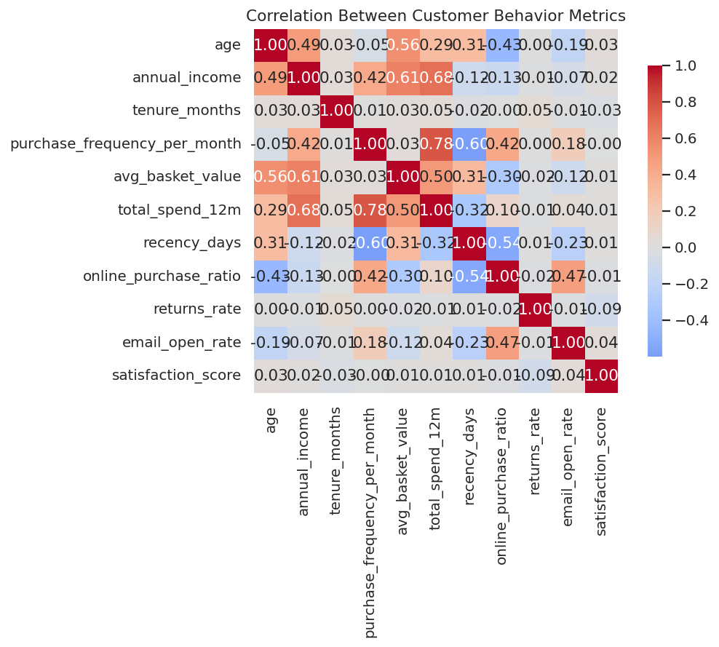
Total 12-month spend correlates strongly with both purchase frequency and average basket value (as expected), while recency (days since last purchase) is negatively associated with spend — more active customers spend more. Income shows a moderate relationship with basket value but not with frequency, hinting that income and shopping habit are separate axes of variation — a key reason clustering (rather than a single ranking) is useful here.

4. Choosing the Number of Segments
Two standard techniques were used together to select the number of clusters (k): the elbow method (looking for the point where adding clusters stops meaningfully reducing within-cluster variance) and the silhouette score (measuring how well-separated and cohesive the clusters are).
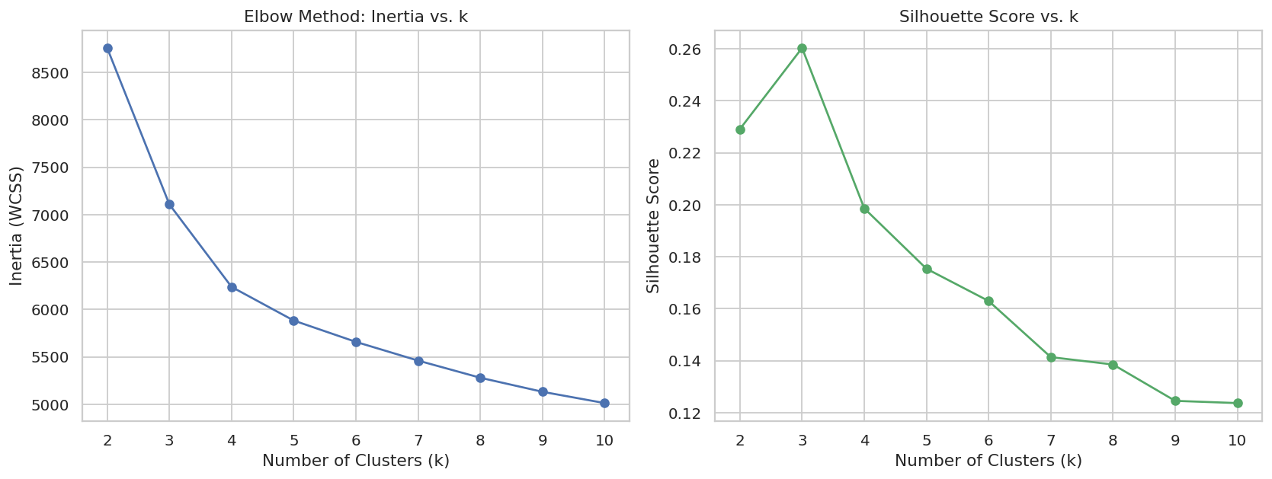
The silhouette curve peaks at k=3, but k=3 collapses several behaviorally distinct groups (e.g., young digital-first buyers and price-sensitive regulars) into one bucket. k=5 was selected as the final model — it sits on a strong secondary elbow, keeps clusters well-balanced in size (17–27% of the base each), and produces segments that are far more actionable for marketing and retention planning than a coarser 3-segment split.

5. Clustering Results
K-Means (k=5) was fit on the standardized behavioral and demographic features. To visualize the five-dimensional-plus segmentation in two dimensions, Principal Component Analysis (PCA) was applied — the two principal components together explain roughly half of the total variance in the data.
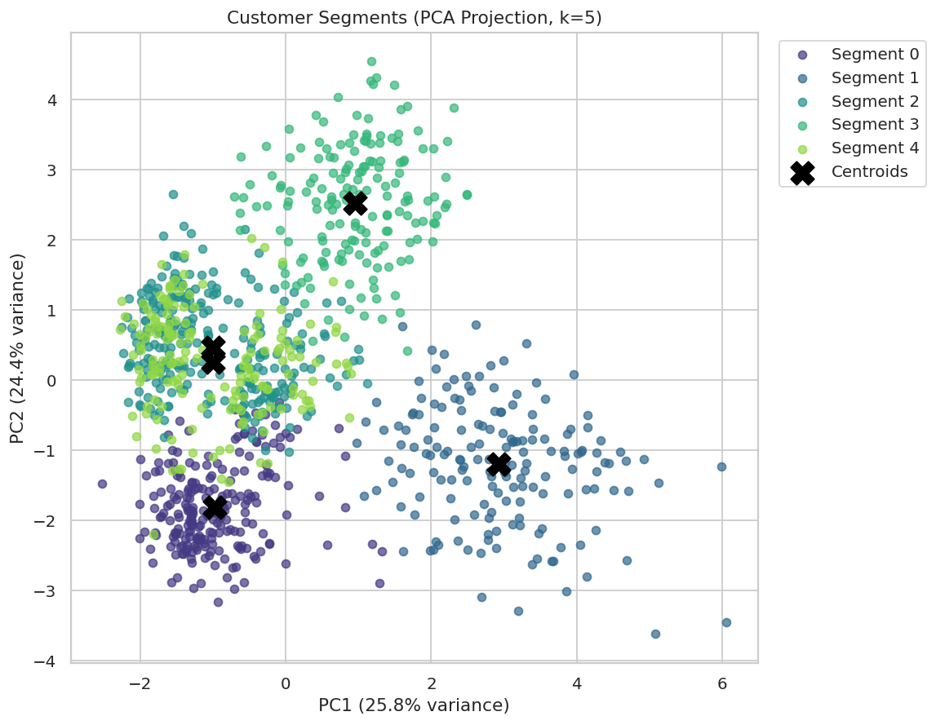
The five segments form largely distinct regions in the PCA projection, with Segment 1 (Premium Loyalists) and Segment 3 (Occasional Big Spenders) clearly separated from the larger, lower-spend clusters — confirming the groups are behaviorally distinct rather than arbitrary splits.

6. Segment Profiles
Each cluster was profiled on its average demographic and behavioral values to interpret and name the segments in business terms:
Segment | Name | Size | Avg Age | Avg Income | Freq/Mo | Avg Basket | 12-Mo Spend | Online %
0 | Young Digital Buyers | 225 (22.5%) | 25.7 | $41,441 | 5.8 | $52.60 | $3,604 | 80%
1 | Premium Loyalists | 167 (16.7%) | 45.3 | $96,773 | 9.4 | $145.10 | $16,531 | 50%
2 | Budget Regulars | 265 (26.5%) | 36.4 | $42,444 | 3.3 | $41.90 | $1,832 | 40%
3 | Occasional Big Spenders | 174 (17.4%) | 50.0 | $67,882 | 1.7 | $216.00 | $4,477 | 20%
4 | Steady Mid-Tier (At Risk) | 169 (16.9%) | 34.6 | $43,503 | 3.3 | $44.80 | $1,994 | 40%

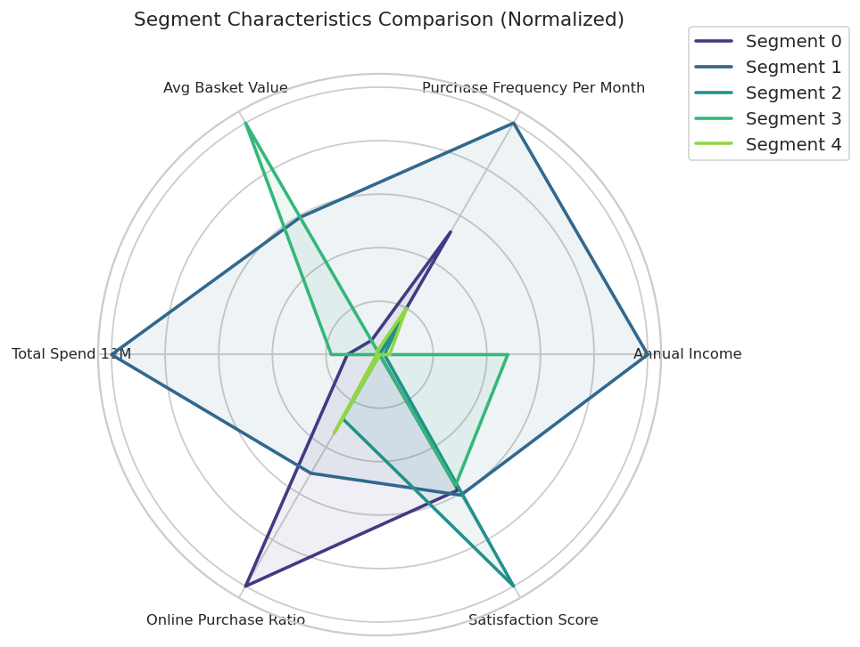

Segment 0 — Young Digital Buyers (22.5%)
Youngest segment (avg. 26 years old), lower income, but highly active online (80% online purchase share) with above-average purchase frequency. Moderate basket size keeps total spend mid-range.
- Opportunity: mobile-first campaigns, app engagement, social commerce, and loyalty program enrollment (currently under-indexed on loyalty membership).

Segment 1 — Premium Loyalists (16.7%)
The clear top-value segment: highest income, highest purchase frequency, largest basket value, and by far the highest 12-month spend ($16,531 on average — roughly 4–9x other segments). Highest loyalty membership rate and most recent purchases.
- Opportunity: white-glove retention, early access to new products, VIP perks — protecting this small but high-revenue group should be a top priority.

Segment 2 — Budget Regulars (26.5%)
The largest segment by count, with modest income, small basket sizes, and the lowest returns rate. Despite low spend, this group reports the highest satisfaction score of all segments (7.9/10).
- Opportunity: volume-based promotions, bundling, and cross-sell — satisfied but low-spend customers are good candidates for frequency-building offers.

Segment 3 — Occasional Big Spenders (17.4%)
Oldest segment on average, buys infrequently (1.7 times/month) but spends the most per basket ($216) of any group, and is the least online (20%). Longest recency gap (76 days since last purchase) signals a churn risk despite high per-visit value.
- Opportunity: reactivation campaigns timed to their natural purchase cycle, and in-store or catalog-style engagement given their low online affinity.

Segment 4 — Steady Mid-Tier, At Risk (16.9%)
Similar spend profile to Budget Regulars but with the lowest satisfaction score across all segments (6.8/10) despite reasonable tenure (40 months average, the longest of any group).
- Opportunity: proactive satisfaction outreach and service-quality review — long-tenured but dissatisfied customers are a retention risk worth investigating directly.

7. Revenue Contribution by Segment
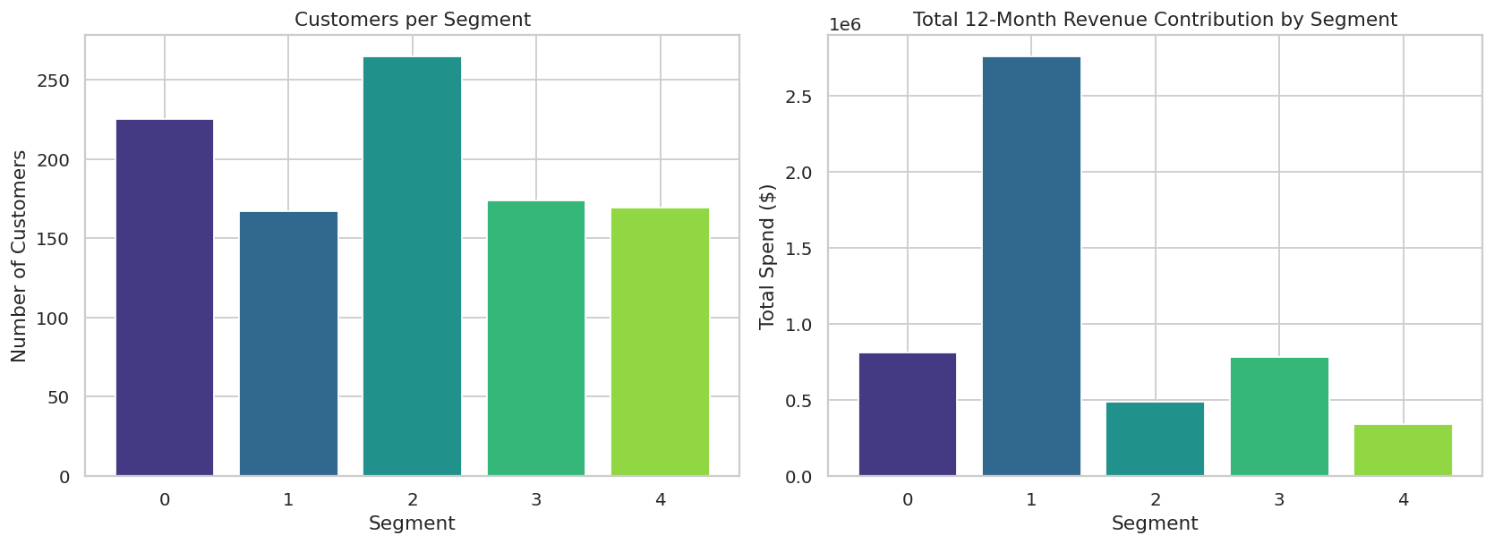
Segment 1 (Premium Loyalists) contributes a disproportionate share of total revenue relative to its size — roughly 17% of customers driving a much larger share of 12-month spend — a classic Pareto pattern that supports prioritizing retention investment there.

8. Category Preferences by Segment
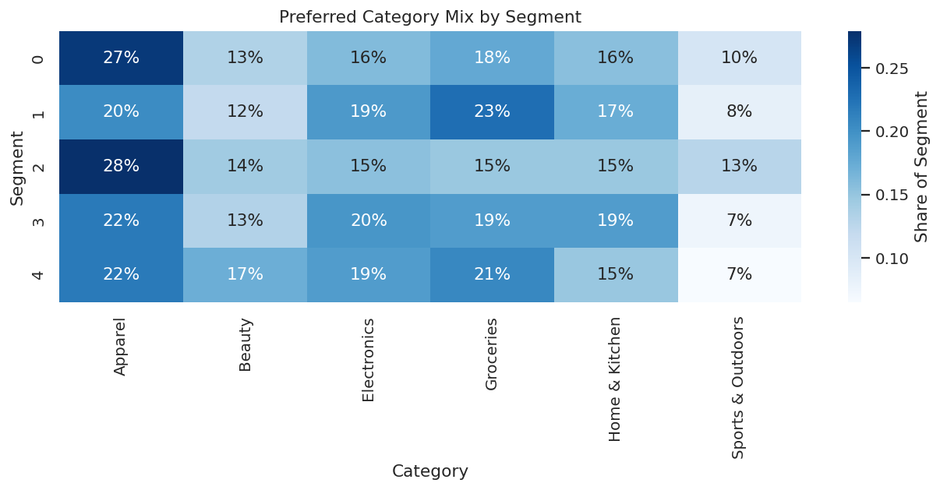
Category mix is fairly evenly spread across segments in this dataset, suggesting that channel and value-tier strategies (online vs. in-store, frequency vs. basket-size offers) are likely to be more differentiating levers than category-specific merchandising alone.

9. Expected Outcome & Business Value
This analysis delivers hands-on experience across the full customer analytics workflow — from raw data to segmentation to targeted business insight:
- Practical experience performing unsupervised clustering (K-Means) with proper feature scaling and model-selection technique (elbow + silhouette).
- Analysis of real purchase-pattern relationships (frequency, basket size, recency, channel) and how they combine to describe customer behavior.
- Visualization of high-dimensional segments (PCA scatter, radar comparison, revenue contribution) in a form usable by non-technical stakeholders.
- Five clearly named, actionable segments — each with a distinct recommended strategy — ready to hand off to marketing, retention, or CRM teams.

10. Methodology Summary
- Tools: Python — pandas, NumPy, scikit-learn (StandardScaler, KMeans, PCA, silhouette_score), matplotlib, seaborn.
- Preprocessing: median imputation for 15 missing satisfaction scores; z-score standardization of 11 numeric features.
- Model selection: k evaluated from 2–10 using inertia (elbow) and silhouette score; k=5 chosen for business interpretability and cluster balance.
- Final model: K-Means, k=5, n_init=10, random_state=42 for reproducibility.
- Deliverables: cleaned & segmented dataset (CSV), full analysis script, 7 charts, and this summary report.

