PROJECT-1: PERSONAL BLOG ON IBM CLOUD STATIC WEB APPS

**Project Title:** Personal Travel Blog website on IBM cloud.

**Phase_3 : DEVELOPMENT PART-1**

**REQUIREMENT GATHERING AND ANALYSIS :**

* Make understand the purpose of the website.
* Gather content of webpage regarding to personal travel blog.
* List the features and functionalities you want to include.
* Researching similar websites or competitors for inspiration.

**PLANNING :**

* Choose the technology stack

1. **HTML**
2. **CSS**

* Planning the website structure.
* Decide on a hosting provider.
* Gather the travel photos and videos you will need.
* Insert navigation bar in the web page for usage of user.

**DESIGN :**

* Decide on a color scheme and typography.
* Create or source any graphics , photos or videos you will need.
* Get feedback on the design and make any necessary adjustment.
* Apply different color effects to the web page for more attraction to website.

**CONTENT CREATION :**

* Write the content for each page
* Ensure it’s clear, concise, and engaging.
* Add images and videos.
* Optimize content for search engines.

**DEVELOPMENT :**

1. Starting with basic structure using HTML.
2. Also using the CSS.

**Total This Website Contain Two Parts :**

* **INDEX page**

1. **Navigation bar.**
2. **Posts on travel blog.**

* **Tourist place spots**

1. **Tirumala**
2. **Kanyakumari**
3. **Taj mahal**

**Code : For INDEX page.**

**Note: code will first executed in the vs code editor then only it will paste in to the MS word.**

|  |
| --- |
| <!DOCTYPE html>  <html>  <head>    <title>Personal Blog Website</title>  <!--Add CSS Style-->  <link rel="stylesheet" href="css\style.css">  <link rel="stylesheet" href="https://cdnjs.cloudflare.com/ajax/libs/font-awesome/4.7.0/css/font-awesome.min.css">    </head>  <body>      <div id="container" class="container">          <!--Navigation bar-->          <nav id="nav" class="nav">              <div class="nav-menu flex-row">                  <div class="nav-brand">                      <h3>-----INDIAN TOURISM-----</h3>                  </div>                  <div>                    <ul class="nav-items">                      <li class="nav-link">                        <a href="#nav">Home</a>                      </li>                      <li class="nav-link">                          <a href="#post">Posts</a>                        </li>                      <li class="nav-link">                        <a href="#about">About me</a>                      </li>                      <li class="nav-link">                        <a href="#contact">Contact</a>                      </li>                    </ul>                   </div>              </div>          </nav>          <header class="welcome">      <figure>      <center><img id="welcome-img" src="/welcome.jpeg" alt="Welcome"></center>      </figure>      </header>          <!--Posts section-->          <section id="post" class="post">              <h1><b>Recent Posts</b></h1>              <div class="flex-container">                  <div class="post-card">                 <h3><center>TIRUMALA</center></h3>    <center><img id="card-img" src="/tirumala.jpeg" alt="Project post"></center>            <p id="hh">Tirumala, set atop the lush Tirumala hills of the Eastern Ghats, is not only a major spiritual hub due to the renowned Venkateswara Swamy Temple dedicated to Lord Venkateswara but also a place of breathtaking natural beauty. As one of the world's richest and most visited religious sites, it holds immense historical significance with its Dravidian architectural marvels, intricate carvings, and a legacy that has been patronized by various rulers over centuries. Managed by the Tirumala Tirupati Devasthanams, the temple and its surroundings blend spiritual, historical, and natural allure seamlessly.</p>       <span class="date-post"><i class="fa fa-calendar"></i>&nbsp;&nbsp; Nov, 15 2020</span><br><br>    <input type="button" onclick="window.open('blog.html', '_blank')" value="Read more" class="btn-button btn-readmore">        </div>        <div class="post-card">        <h3><center>Kanyakumari</center></h3>        <center><img id="card-img" src="/kanya1.jpg" alt="Development post"></center>        <p id="hh"> Kanyakumari is the southern tip of India.This place has been a great center for art, culture, civilization, and pilgrimage for years. It was also a famous center for commerce and trade.                          This gigantic statue was built by the Tamil government in honour of the Saint Thiruvalluvar which is now one of the key attraction in Kanyakumari.</p>          </p>          <span class="date-post"><i class="fa fa-calendar"></i>&nbsp;&nbsp; Nov, 10 2020</span><br><br>   <input type="button" onclick="window.open('blog1.html', '_blank')" value="Read more" class="btn-button btn-readmore">          </div>          <div class="post-card">          <h3><center>Taj Mahal</center></h3>      <center><img id="card-img" src="tajmahalnew.jpg" alt="Agile post"></center>      <p id="hh">Taj Mahal, one of the new 7 wonders of the World.Taj Mahal is situated on the banks of river Yamuna in the North Indian city of Agra.                         It was commissioned by Shah Jahan, the Mughal emperor for housing the tomb of his beloved wife,                          Mumtaz Mahal. Hence, it’s also considered as the ultimate “symbol of love”    </p>     <span class="date-post"><i class="fa fa-calendar"></i>&nbsp;&nbsp; Nov, 01 2020</span><br><br>     <input type="button" onclick="window.open('blog2.html', '_blank')" value="Read more" class="btn-button btn-readmore">     </div>     </div>          </section>          <!--About me section-->          <section id="about" class="about">              <h1>About me</h1>              <div class="about-content-grid">                  <div class="about-box"><br>                      <center><img id="card-img" src="/khushiramit.jpeg" alt="Agile post" width="200" height="200"></center>                    <p id="hh">Hello, This is khushiram from chennai,India. I'm thrilled to have you join me on this journey through the world's most captivating destinations.                      I've always had a deep passion for travel and a curiosity to explore the diverse cultures and landscapes that our planet has to offer. Over the years, I've had the privilege of visiting numerous countries, each with its unique charm and beauty.                        Through this blog, I aim to share my adventures, travel tips, and insights gained from my explorations. Whether you're a seasoned traveler or planning your first big adventure, I hope my experiences and recommendations will inspire and guide you on your own voyages.                      </p>                  </div>              </div>          </section>          <!--Contact me and subscribe by form section-->          <section id="contact" class="contact">              <h1>Contact me and Subscribe</h1>              <form class="form-contact">                  <label class="text-form" for="fullname">* Name: </label><br>                  <input type="text" id="name" name="fullname"  placeholder="Write your lovely name" required><br><br>                  <label class="text-form" for="email">* Email: </label><br>                  <input type="email" id="email" name="email"  placeholder="Email address please" required><br><br>                  <label class="text-form" for="message">Message: </label><br>                  <textarea id="message" name="message"></textarea><br>                  <input class="btn-button btn-submit" type="submit" value="Subscribe">              </form>          </section>          <!--Footer section-->          <footer class="footer">              <div id="footer-grid">                  <div id="follow" class="footer-box">                      <h3>Follow me</h3>            <a href="https://www.facebook.com/lovely.khushiramchoudary" class="fa fa-facebook"></a>            <a href="https://twitter.com/?lang=en-in" class="fa fa-twitter"></a>            <a href="https://www.youtube.com/" class="fa fa-youtube"></a>            <a href="https://www.instagram.com/khushiram_maddina/" class="fa fa-instagram"></a>                  </div>                  <div id="arrow-up">                      <a href="#nav" class="fa fa-arrow-circle-up"></a>               </div>            </div>         </footer>   </div>  </body>  </html> |

**Output :**

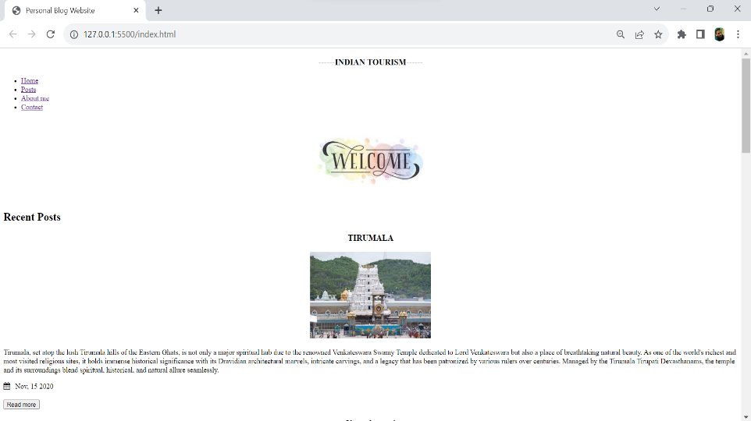

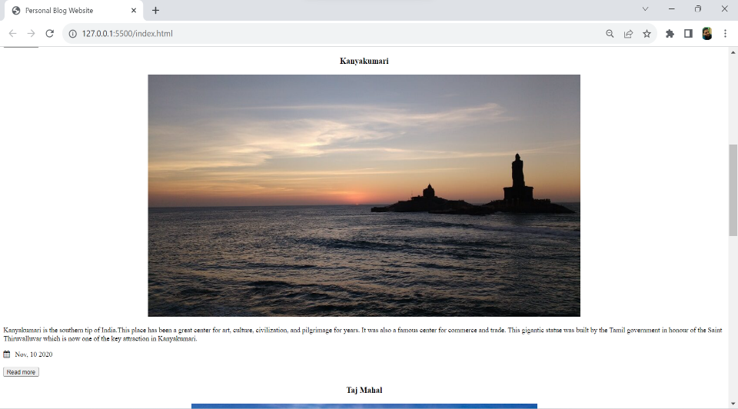

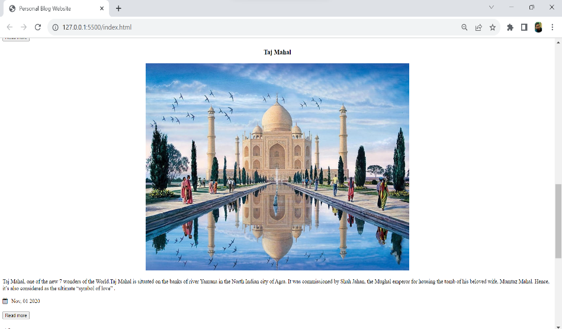

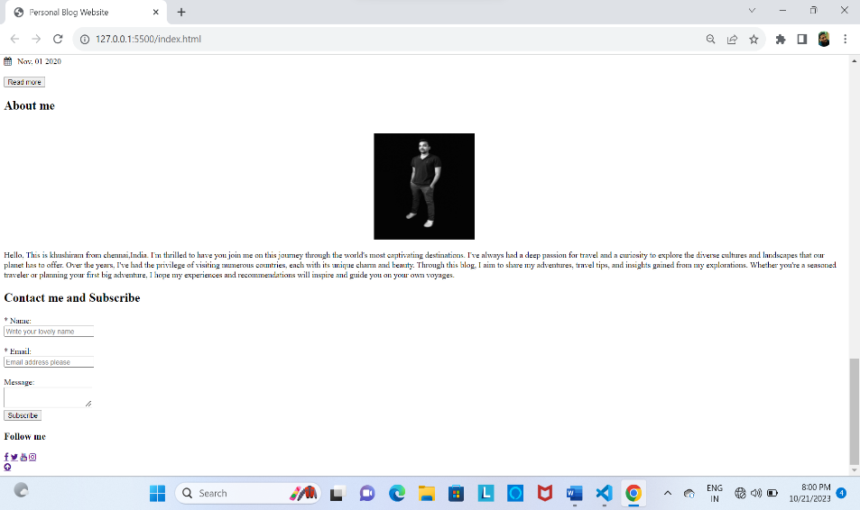

**HTML ,CSS CODE FOR TIRUMALA BLOG :**

* Click The READ MORE button for next page in website

**Code:**

|  |
| --- |
| <!DOCTYPE html>  <html lang>  <head>      <title>TIRUMALA</title>      <!--CSS Blog post-->      <link rel="stylesheet" href="css\post.css">      <!-- Add icon library -->      <link rel="stylesheet" href="https://cdnjs.cloudflare.com/ajax/libs/font-awesome/4.7.0/css/font-awesome.min.css">  </head>  <body>      <div id="container-post" class="container-post">          <!--Navigation bar-->          <nav id="nav"class="nav">              <div class="nav-menu flex-row">                  <div class="nav-brand">                      <h3>Travel diaries</h3>                  </div>                  <div>                    <ul class="nav-items">                      <li class="nav-link">                        <a href="index.html#nav">Home</a>                      </li>                      <li class="nav-link">                          <a href="index.html#post">Posts</a>                        </li>                      <li class="nav-link">                        <a href="index.html#about">About me</a>                      </li>                      <li class="nav-link">                        <a href="index.html#contact">Contact</a>                      </li>                    </ul>                   </div>              </div>          </nav>          <!--Post section-->          <section class="post">                <div class="post-box">                  <h1>TIRUMALA</h1>                  <span class="date-post"><i class="fa fa-calendar"></i>&nbsp;&nbsp; Nov, 15 2020</span><br><br>                  <center><img id="img-post" src="/tirumala1.jpeg" alt="Project"></center>                  <p id="post-p1"><h2>Tirumala is a hill town in the Chittoor district of the southern Indian state of Andhra Pradesh. It is most famous for the Sri Venkateswara Temple, dedicated to Lord Venkateswara (a form of the Hindu god Vishnu). This temple is one of the most visited religious sites in the world. Pilgrims from all over the country and even from abroad come to seek blessings and offer their prayers. The temple complex is managed by the Tirumala Tirupati Devasthanams (TTD) trust. The laddu prasadam offered at this temple is also very popular. The natural beauty of the seven hills surrounding the temple further enhances the spiritual ambiance of the place.</h2>                    <br>                  <h2 id="hello">FOOT PATH FOR TIRUMALA</h2>                  <center><img id="fl1" src="/tirumalafoot.jpeg"></center>                  <center><img id="fl1" src="/tirumalafoot1.jpeg"></center>                  <h3><p id="post-p1">Tirumala has two main footpaths, known as Sopanamargas, that lead to the temple:</p></h3><br>                  <p>1.Alipiri Mettu: This is the older and longer route, starting from Alipiri at the foot of the hills. It's approximately 11 km in length and consists of 3,550 steps. Pilgrims pass through the Galigopuram gateway which has an arch with an emblem of the conch and disc, symbols associated with Lord Vishnu. Many devotees prefer this path as an act of devotion, walking barefoot and often chanting prayers along the way.</p><br>                  <p>2.Srivari Mettu: Located near the village of Srinivasa Mangapuram, this is a shorter route, about 2.1 km long with around 2,400 steps. It's a steeper climb but offers beautiful views of the lush landscape.</p><br>                      <h2>FAMOUS ITEM IN TIRUMALA</h2>                      <center><img id="fl1" src="/tirumalaladdu.jpeg"></center>                      <p id="post-p">The Tirumala laddu is a distinctive prasadam, bestowed upon devotees at the revered Lord Venkateswara temple in Tirumala, Andhra Pradesh. Crafted with ingredients like gram flour, sugar, ghee, cashew nuts, and cardamom, this sizable sweet carries a unique taste rooted in its time-honored preparation method. In 2009, its cultural and regional importance was further highlighted when it received the Geographical Indication (GI) status, ensuring that only laddus made at this temple could bear the prestigious "Tirumala Laddu" label.</p>                        <h2>LORD VENKATESHWARA</h2>                      <center><img id="fl1" src="/lordvenkate.jpeg"></center>                      <p id="post-p">Lord Venkateshwara, also known as Balaji, Srinivasa, and Tirupati Balaji, is a manifestation of the Hindu god Vishnu, predominantly worshipped in South India. He is revered as the "Lord of the Seven Hills" due to his abode on the seventh hill of the Tirumala Hills in Tirupati. A widely-believed legend narrates that he borrowed from Kubera, the god of wealth, for his marriage to Padmavathi. Devotees, in their unwavering faith, continue to offer wealth at the Tirumala temple, which stands as an act of helping the deity repay this ancient debt</p>              </div>              <section id="contact1" class="contact1">                  <h1>Write your review on this blog</h1>                  <form class="form-contact">                      <label class="text-form" for="fullname">* Name: </label><br>                      <input type="text" id="name" name="fullname"  placeholder="Write your lovely name" required><br><br>                      <label class="text-form" for="email">* Email: </label><br>                      <input type="email" id="email" name="email"  placeholder="Email address please" required><br><br>                      <label class="text-form" for="message">Feedback </label><br>                      <textarea id="message" name="message"></textarea><br>                      <input class=" btn-submit" type="submit" value="Submit">                  </form>              </section>              <br>              <footer class="footer">                  <div id="footer-grid">                      <div id="follow" class="footer-box">                          <h3>Follow me</h3>                          <a href="https://en-gb.facebook.com/login.php" class="fa fa-facebook"></a>                          <a href="https://twitter.com/?lang=en-in" class="fa fa-twitter"></a>                          <a href="https://www.youtube.com/" class="fa fa-youtube"></a>                          <a href="https://instagram.com/its__praveen_here_?igshid=NGVhN2U2NjQ0Yg==" class="fa fa-instagram"></a>                      </div>                      <br>                      <div id="arrow-up">                          <a href="#nav" class="fa fa-arrow-circle-up"></a>                      </div>                  </div>              </footer>  </section>  <!--Footer section-->  </div>  </body>  </html> |

**Output :**

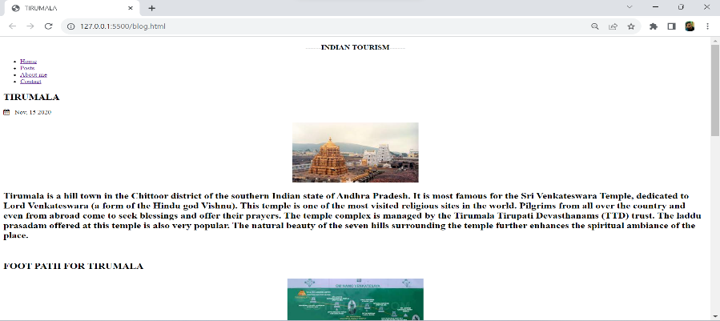

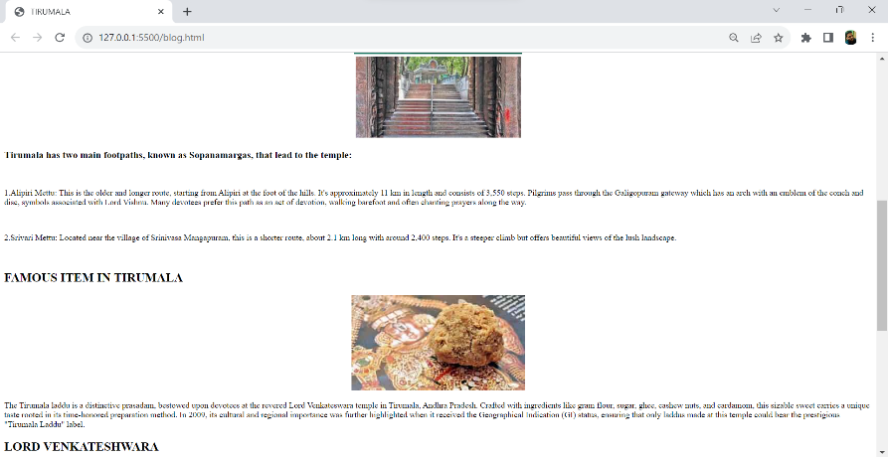

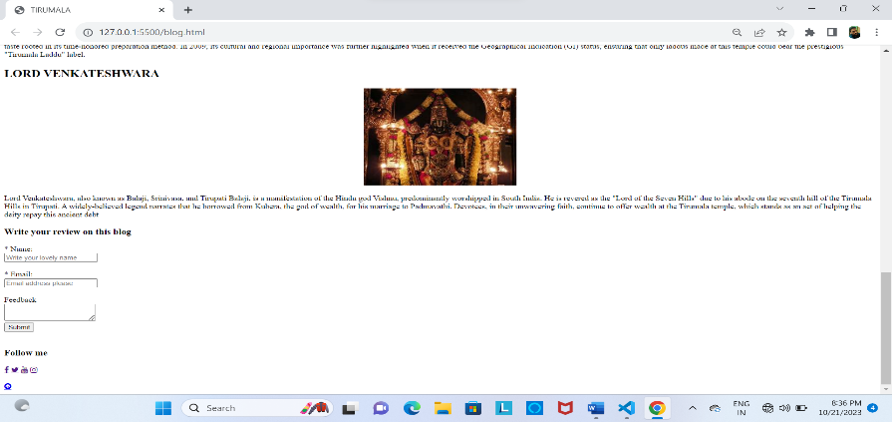

**HTML , CSS code for Kanyakumari blog:**

**Code:**

|  |
| --- |
| <!DOCTYPE html>  <html lang>  <head>      <title>Kanyakumari</title>      <!--CSS Blog post-->      <link rel="stylesheet" href="css\post.css">      <!-- Add icon library -->      <link rel="stylesheet" href="https://cdnjs.cloudflare.com/ajax/libs/font-awesome/4.7.0/css/font-awesome.min.css">  </head>  <body>      <div id="container-post" class="container-post">          <!--Navigation bar-->          <nav id="nav"class="nav">              <div class="nav-menu flex-row">                  <div class="nav-brand">                      <h3>Travel diaries</h3>                  </div>                  <div>                    <ul class="nav-items">                      <li class="nav-link">                        <a href="index.html#nav">Home</a>                      </li>                      <li class="nav-link">                          <a href="index.html#post">Posts</a>                        </li>                      <li class="nav-link">                        <a href="index.html#about">About me</a>                      </li>                      <li class="nav-link">                        <a href="index.html#contact">Contact</a>                      </li>                    </ul>                   </div>              </div>          </nav>          <!--Post section-->          <section class="post">                <div class="post-box">                  <h1>Kanyakumari </h1>                  <span class="date-post"><i class="fa fa-calendar"></i>&nbsp;&nbsp; Nov, 15 2020</span><br><br>                  <center><img id="img-post" src="/kanya.jpeg" alt="Project"></center>                  <p id="post-p1">Kanyakumari District takes its name from the town of Kanyakumari, at the southern tip of India.This place has been a great center for art, culture, civilization, and pilgrimage for years. It was also a famous center for commerce and trade.                      This gigantic statue was built by the Tamil government in honour of the Saint Thiruvalluvar which is now one of the key attraction in Kanyakumari.                      Kanyakumari offers the marvellous confluence of the Bay of Bengal, the Arabian Sea and the Indian ocean meeting together at a point. But, this is not a miracle, the miracle lies in the beauty that the water of three seas does not mix, you can clearly distinguish between the turquoise blue, deep blue and sea green waters of the three seas. To enjoy the best view of sunset and sunrise, you can visit the Triveni Sangam point and the famous View towers                      The town has a mountainous terrain with elevated patches of hills, coconut trees and lined with paddy fields. Kanyakumari is also the only place in India where you can observe the sunrise and sunset at the same beach.                      The town is not only popular for its unique phenomenon but also its temples and the Vivekananda Rock Memorial among other iconic monuments.                  </p>                  <h2 id="hello">Best Places to Visit in Kanyakumari</h2>                  <p id="post-p1">Kanyakumari is a vibrant and culturally rich destination, offering a variety of attractions and activities for visitors. While it may be smaller than some other Indian cities, there is still plenty to see and do. The most famous attraction is undoubtedly Kanyakumari Beach, where you can witness the mesmerizing confluence of the Arabian Sea, Bay of Bengal, and Indian Ocean. The Vivekananda Rock Memorial and Thiruvalluvar Statue, located on a small island, are iconic landmarks with stunning sea views. You can also explore the historical places.</p>                  <h2 id="hello"><ol><li>Kanyakumari Beach</li>                      <center><img id="fl1" src="/oceanview.jpeg"></center>                      <p id="post-p">The Kanyakumari beach is a beautiful sight with multi-coloured sand. The beach here does not really offer one the opportunity to sunbathe on soft golden sands, or to frolic in the waves either. The seashore is rocky and dangerous, and there is a manmade wall running along it. People are warned to stay off the rocks, and when if someone ventures out of bounds, he or she is quickly and severely reprimanded by a watchful policeman. There is a lighthouse from where one can get a panoramic view.                          The sea is fairly rough, so it is entertaining to watch it beat itself against the rocks and then subside, before it gathers itself up for another attack. With long stretches of sands of many hues, the beach offers a welcome change. The place is also famous for its distinctly beautiful (reddish) sunrise and sunset. The confluence of three ocean bodies - the Bay of Bengal, the Indian Ocean, and the Arabian Sea - makes the sunrise and sunset even more special. On balmy, full-moon evenings one can also see the moon-rise and sunset at the same time - on either side of the horizon. A variety of shells are on sale on the Kanyakumari beach.                          Tamil Nadu State Transport Corporation runs a circular bus to visit tourist sports. Circular bus route - Kanyakumari to Kanyakumari via Vattakottai, Padmanabhapuram palace, Thottipalam, Pechipparai dam, Thirparappu Falls, Muttom beach and Suchindrum Sthanumalayan temple. The bus will start at 7 a.m. just after sunrise and return to Kanyakumari by 6 p.m. so that tourists can also view sunset on sea. The fare per trip is Rs. 200/- for adults and Rs. 100/- for children.</p>                  <li>Mukkudal Reservoir</li>                      <center><img id="fl1" src="/resovior.jpeg"></center>                      <p id="post-p">Mukkadal dam is built across the Vambaru River, 10 km from Nagercoil. It was built by Sree Chithira Thirunal Balarama Varma in 1945, the King of Travancore. The dam is constructed of clay and granite stones. The depth of water behind the dam is approximately 50 feet. The Mukkadal reservoir supplies water for Nagercoil Municipality, but ironically, not the people living near the dam, and it is also proposed to get water from here for Suchindrum and Kanyakumari. The dam and reservoir are surrounded by hills on three sides.                          It is a scenic place, favored as a picnic location among local residents. The forest are highly enhancing with pleasant shoals, hill top forests, beautiful grasslands, panoramic valleys, top hillocks, singing streams, vast stretches of rubber plantations, valuable Teak plantations and excellent climate. Nobody should miss seeing the enchanted view of this place.</p>                      <li>Wildlife Sanctuary</li>                      <center><img id="fl1" src="/forest.jpeg"></center>                      <p id="post-p">Kanyakumari Wildlife Sanctuary is a 402.4 km2 protected area in Kanyakumari district, Tamil Nadu South India declared in February 2008. The area is a tiger habitat. The area is a wildlife corridor with high biodiversity, and in addition to tigers, is home to the threatened species :Indian Bison, elephant, Indian Rock Python, Lion-tailed Macaque, Mouse deer, Nilgiri Tahr and Sambar deer. There are a few tribal villages in the sanctuary and adjoining reserve forests.                          Variety of wildlife can be seen in this division as follows:                          Bonnet Macaque, Common Langur or Hanuman Langur, Nilgiri Langur, Slender Loris, Tiger, Leopard or Panther, Jungle Cat, Small Indian Civet, Mangoose, Jackal, Indian Fox, Dhole or Indian Wild Dog, Sloth Bear, Otter, Large Brown Flying Squirrel, Flying Fox, Indian Giant Squirrel, Indian Porcupine, India Hare, Indian Elephant, Gaur or India Bison, Nilgiri Tahr, Chital or spotted Deer, Black Buck or Indian Antelope, Sambar, Barking Deer, Mousse Deer or India Chevrotain, Wild Boar, Pangolin.</p>  <li>Gandhi Memorial</li>                      <center><img id="fl1" src="/gandhi.jpg"></center>                    <p id="post-p">Gandhi Memorial or Gandhi Mandapam was built in the memory of the ‘Father of the nation’ in 1956. Mohandas Karamchand Gandhi was shot in 1948 and after cremation his ashes were to be sprinkled over different regions of the country. And the Gandhi Memorial at Kanyakumari was the place where the ashes were kept for public viewing before being immersed into the sea.                          Interestingly, the height of the central dome of the memorial is 79 feet, the age of Gandhiji at the time of his assassination. It was constructed in such a manner that the sun's rays falls on the exact spot where his ashes were once laid. This occurs every year on his birthday on 2nd of October at 12 noon. Take the staircase to the terrace for a sweeping view of the sea and the town spanning the shores. Gandhi Mandapam will be open from 9:00 A.M to 6:00 P.M.</p>  <li>Vivekananda Rock Memorial</li>                      <center><img id="fl1" src="/vivekananda.jpeg"></center>                      <p id="post-p">Vivekananda Rock Memorial is located about about 500 meters off the mainland. The views from here are fabulous – you can see the Kanyakumari town spread out on the banks and the colorful fishing boats moored in one part. The sea around has an overpowering presence, its roar blurs every other sound in the backdrop.                          It was built in 1970 by the Vivekananda Rock Memorial Committee in honor of their spiritual leader Swami Vivekananda. There is a ferry service to and from the rock memorial from Kanyakumari beach. The terrace is extremely windy and you will have to cross it to get into the various mandapams.                          Photography is not allowed and you need to take off your shoes outside the halls. It will be open from 9:00 A.M to 5:30 P.M. Entrance Fee: Rs.20/- for both child and adult.</p>  </ol></h2>              </div>  <section id="contact1" class="contact1">                  <h1>Write your review on this blog</h1>                  <form class="form-contact">                      <label class="text-form" for="fullname">* Name: </label><br>                      <input type="text" id="name" name="fullname"  placeholder="Write your lovely name" required><br><br>                      <label class="text-form" for="email">* Email: </label><br>                      <input type="email" id="email" name="email"  placeholder="Email address please" required><br><br>                      <label class="text-form" for="message">Feedback </label><br>                      <textarea id="message" name="message"></textarea><br>                      <center><input class=" btn-submit" type="submit" value="Submit"></center>                  </form>              </section>  <footer class="footer">                  <div id="footer-grid">                      <div id="follow" class="footer-box">                          <h3>Follow me</h3>                          <a href="https://en-gb.facebook.com/login.php" class="fa fa-facebook"></a>                          <a href="https://twitter.com/?lang=en-in" class="fa fa-twitter"></a>                          <a href="https://www.youtube.com/" class="fa fa-youtube"></a>                          <a href="https://instagram.com/its__praveen_here_?igshid=NGVhN2U2NjQ0Yg==" class="fa fa-instagram"></a>                      </div>                      <div id="arrow-up">                          <a href="#nav" class="fa fa-arrow-circle-up"></a>                      </div>                  </div>              </footer>  </section>          <br><br><br>        </div>  </body>  </html> |

**Output:**

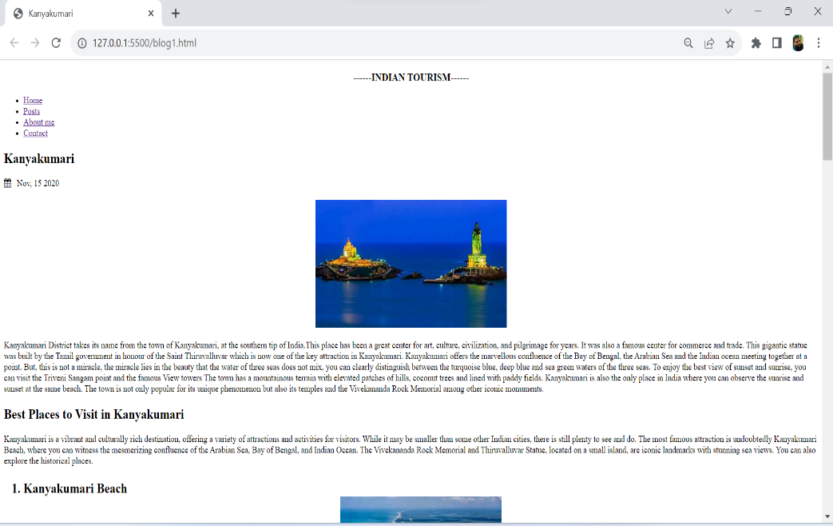

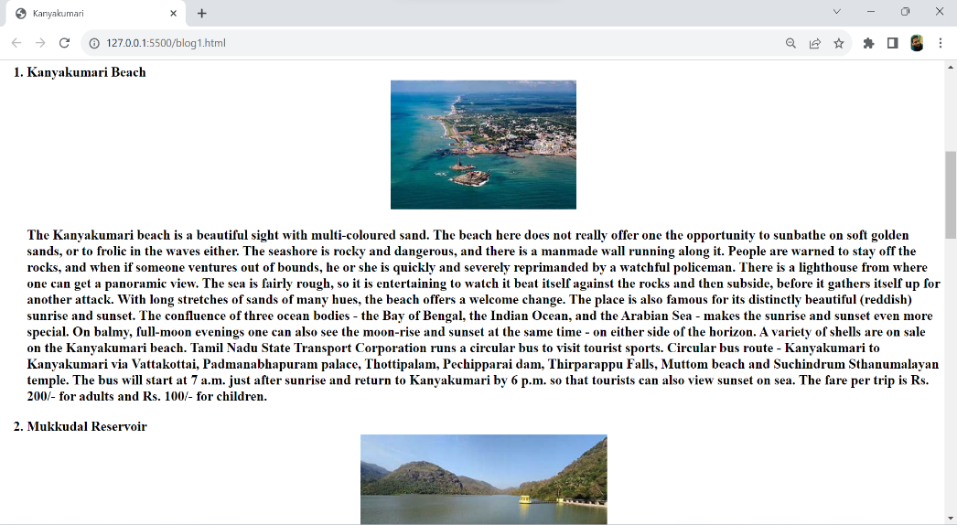

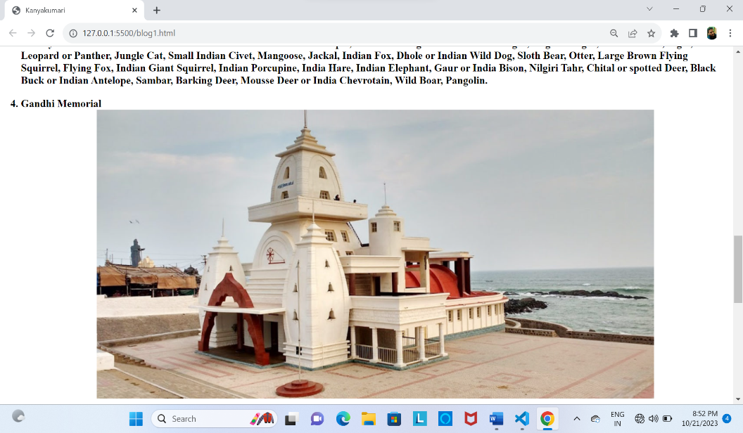

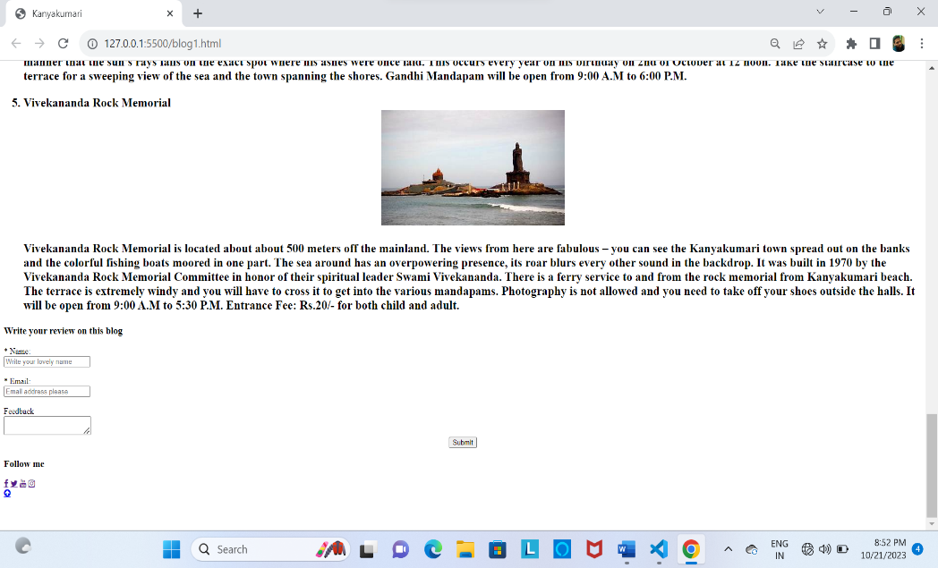

**HTML , CSS Code for TAJMAHAL blog :**

**Code:**

|  |
| --- |
| <!DOCTYPE html>  <html lang>  <head>      <title>Taj Mahal</title>  <!--CSS Blog post-->      <link rel="stylesheet" href="css\post.css">  <!-- Add icon library -->      <link rel="stylesheet" href="https://cdnjs.cloudflare.com/ajax/libs/font-awesome/4.7.0/css/font-awesome.min.css">  </head>  <body>      <div id="container-post" class="container-post">          <!--Navigation bar-->          <nav id="nav"class="nav">              <div class="nav-menu flex-row">                  <div class="nav-brand">                      <h3>Travel diaries</h3>                  </div>                  <div>                    <ul class="nav-items">                      <li class="nav-link">                        <a href="index.html#nav">Home</a>                      </li>                      <li class="nav-link">                          <a href="index.html#post">Posts</a>                        </li>                      <li class="nav-link">                        <a href="index.html#about">About me</a>                      </li>                      <li class="nav-link">                        <a href="index.html#contact">Contact</a>                      </li>                    </ul>                   </div>              </div>          </nav>          <!--Post section-->          <section class="post">             <div class="post-box">                  <h1>Taj Mahal </h1>                  <span class="date-post"><i class="fa fa-calendar"></i>&nbsp;&nbsp; Nov, 15 2020</span><br><br>                  <center><img id="img-post" src="tajmahalnew1.jpeg" alt="Project"></center>                  <p id="post-p1">The Taj Mahal is an iconic and world-renowned monument, showcasing the pinnacle of Mughal architecture and a symbol of eternal love. This breathtaking mausoleum was commissioned by Emperor Shah Jahan in memory of his beloved wife, Mumtaz Mahal, who passed away in 1631. Built in the 17th century, the Taj Mahal is an architectural masterpiece of pristine white marble adorned with intricate floral and geometric patterns. The central dome is its most striking feature, beautifully reflecting light throughout the day. Designated as a UNESCO World Heritage Site in 1983, the Taj Mahal attracts millions of visitors worldwide. Besides its architectural grandeur, the site includes a mosque and a guest house, both constructed of red sandstone. A visit to the Taj Mahal is a profound experience, symbolizing love, craftsmanship, and history, and it's a must-see destination for anyone exploring India.</p>                  <h2 id="hello">BEST WAY TO VISIT TAJ MAHAL</h2>                  <center><img id="fl1" src="besttaj.jpg"></center><br>                  <center><img id="fl1" src="besttaj1.jpeg"></center><br>                  <p id="post-p1">Most travelers plan to visit Taj Mahal during the famous India’s Golden Triangle trip. While it may seem appropriate, I would suggest not to do a day trip to Taj Mahal or same day tour from cities like New Delhi, Noida. Technically it’s feasible and you will get a good glimpse of this marvelous destination. However, to have a holistic travel experience of visiting Taj Mahal, at least spend 2 days and 1 night in the city of Agra. Witnessing the Taj Mahal is once in a lifetime’s experience. So while planning my trip to Agra, I did not want bad weather, rush hour, harsh afternoon lighting and humidity or crowded atmosphere to dampen my Taj Mahal travel experience. So I found it ideal to stay two nights in Agra. This gave me ample time & opportunity to make my visit to Taj Mahal truly memorable.</p>                  <h2 id="hello">TAJ MAHAL ENTRANCE TICKETS</h2>                  <center><img id="fl1" src="/tajticket.jpg"></center>                  <center><img id="fl1" src="/tajticket1.jpeg">                  <p id="post-p1">There are three gates; East, West and the South. Tickets are available for purchase at the East and West gates, one hour before sunrise upto 45 minutes before sunset. Currently South gate is only used for exit. West Gate is mostly used by locals and Indian visitors and is generally very crowded. East gate is used by foreigners as its close to famous hotels and guesthouses and therefore less crowded. The Taj Mahal entrance fee are priced at INR 1100 (~USD 15) for foreigners and INR 540 (~USD 7) for citizens of SAARC and BIMSTEC countries. Indian citizens need pay only INR 50 while children below 15 years enter for free. If you wish to visit the mausoleum, you have to pay an additional INR 200 (~USD 3) . Although you can purchase ticket at the gate, I would highly recommend to obtain online tickets to save you time early morning. With online purchase, you can avail discount of INR 50 for foreigners and INR 5 for Indian citizens. You can use your mobile for scanning e-tickets during entrance.</p>                  <h2 id="hello">MY FIRST SIGHTING OF THE TAJ MAHAL </h2>                  <center><img id="fl1" src="/firstsighttaj.jpeg"></center>                  <center><img id="fl1" src="/firstsight2.jpeg"></center>                  <p id="post-p1">The Taj Mahal is seemingly everywhere in Agra. You’ll spot it from most of the tourist attractions, restaurants, and guesthouses.                      I caught my first glimpse from Agra Fort, which was surprisingly quiet when we visited after lunch. The fort provides a hell of a lot of wonderful viewpoints, often with nobody else around. I was surprised by how peaceful it was to walk around and was wowed by the structure as much as I was its views.                      Later on in the day, we ventured to Mehhtab Bagh Garden on the Yamuna River’s north bank to see the Taj Mahal from a different angle, and it was one of my favourite spots in the city. There was nobody else around when we visited — just me and Dave snapping a ton of photos.                      We returned to our rickshaw and asked our driver to take us to the East Gate. There are three entrances to the Taj Mahal — each with their pros and cons (more on that below) — and I’d decided the East Gate would be best for us.                      Everybody says that Taj Mahal gets busier and busier throughout the day, but there were few foreigners opting to visit at 3 p.m. on a Tuesday. In fact, there was nobody at all in the foreigner queue for tickets. We paid our entrance fee, separated to head through the male- and female-designated lines, then met back up at the gate.</p>  <h2 id="hello">VISITING TAJ MAHAL DURING FULL MOON NIGHTS</h2>                  <center><img id="fl1" src="/nighttaj.jpeg"></center>                  <center><img id="fl1" src="/nighttaj1.jpeg"></center>                  <p id="post-p1">If you truly seek an unforgettable romantic moment, plan your Taj Mahal visit during the full moon nights. Night viewing of Taj Mahal is available on five days in a month i.e. on full moon night and two nights before and two nights after the full moon. Night Viewing of the Taj Mahal is closed on every Friday & in the month of Ramadan.  Every night only 400 visitors are allowed to enter Taj Mahal premises for night viewing. The tickets must be purchased one day before the night view date from the counter at ASI office, 22 Mall Road, Agra from 10:00 a.m. to 6:00 p.m. The tickets are priced at INR 500 (~USD 7) for Indians and INR 750 (~USD 10) for foreigners. If you are a lover of night photography, definitely plan your visit around the dates of full moon. For each night viewing of Taj Mahal, one gets only 30 minutes. So be sure to plan your shoot during your morning visit and make it quick while you’re in there!</p>  <h2 id="hello">PROHIBITED ITEMS</h2>                  <center><img id="fl1" src="/finaltaj.jpeg"></center>                  <p id="post-p1">There are many items that are prohibited to carry inside the Taj Mahal complex. Please make sure you carry none of the items mentioned below:  Batteries,Drone,Tripod of any kind,Portable chargers,Paints and color pencils,Cigarettes and lighters,Flammable materials, Books,Food (Any kind).              </p>              </div>  <section id="contact" class="contact">                  <h1>Write you review on this blog</h1>                  <form class="form-contact">                      <label class="text-form" for="fullname">* Name: </label><br>                      <input type="text" id="name" name="fullname"  placeholder="Write your lovely name" required><br><br>                      <label class="text-form" for="email">* Email: </label><br>                      <input type="email" id="email" name="email"  placeholder="Email address please" required><br><br>                      <label class="text-form" for="message">Feedback </label><br>                      <textarea id="message" name="message"></textarea><br>                      <input class=" btn-submit" type="submit" value="Submit">                  </form>              </section>              <footer class="footer">                  <div id="footer-grid">                      <div id="follow" class="footer-box">                          <h3>Follow me</h3>                          <a href="https://en-gb.facebook.com/login.php" class="fa fa-facebook"></a>                          <a href="https://twitter.com/?lang=en-in" class="fa fa-twitter"></a>                          <a href="https://www.youtube.com/" class="fa fa-youtube"></a>                          <a href="https://instagram.com/its__praveen_here_?igshid=NGVhN2U2NjQ0Yg==" class="fa fa-instagram"></a>                      </div>                      <div id="arrow-up">                          <a href="#nav" class="fa fa-arrow-circle-up"></a>                      </div>                  </div>              </footer>          </section>  <!--Footer section-->          </div>  </body>  </html> |

**Output:**

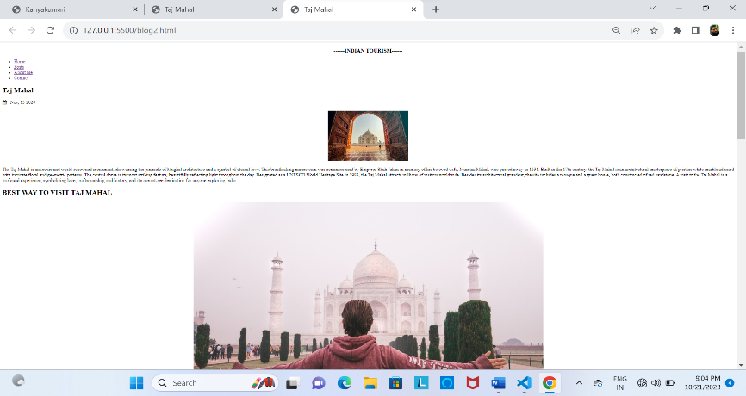

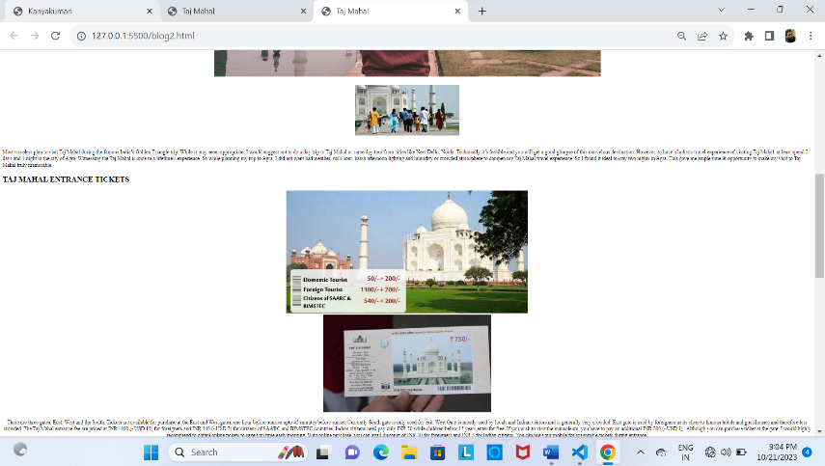

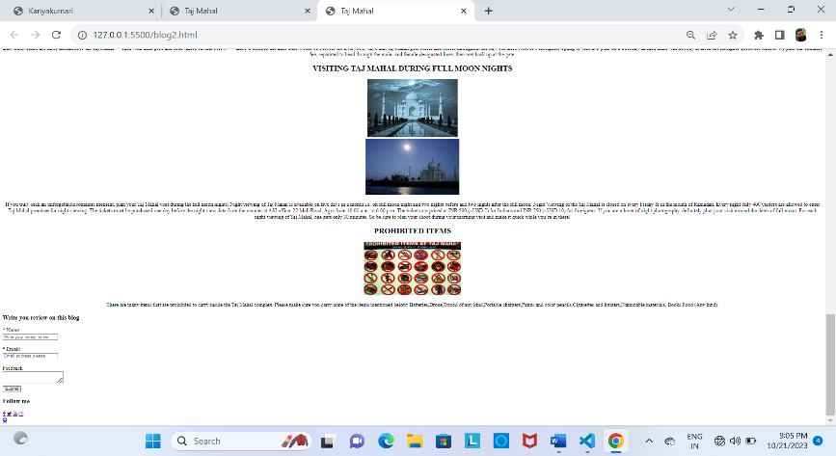

**Phase_3 - Conclusion :**

In developing our travel blog website, we've crafted more than just a digital recounting of adventures; it's a vibrant showcase of the world's cultures, landscapes, and experiences. Designed with rich visuals, compelling narratives, and interactive features, our site serves as both inspiration and a resource for travelers. As technology and travel needs evolve, our platform will adapt, ever-focused on connecting a global community of explorers. Beyond being a mere collection of tales, this website is a gateway to the world's wonders, urging all to venture out, share their stories, and discover the beauty that lies beyond familiar horizons. Safe travels and happy blogging!