A PROJECT REPORT ON
DENTAL CLINIC MANAGEMENT SYSTEM
A Web-Based Clinic Automation Platform with Role-Based Dashboards and Rule-Based AI Assistance
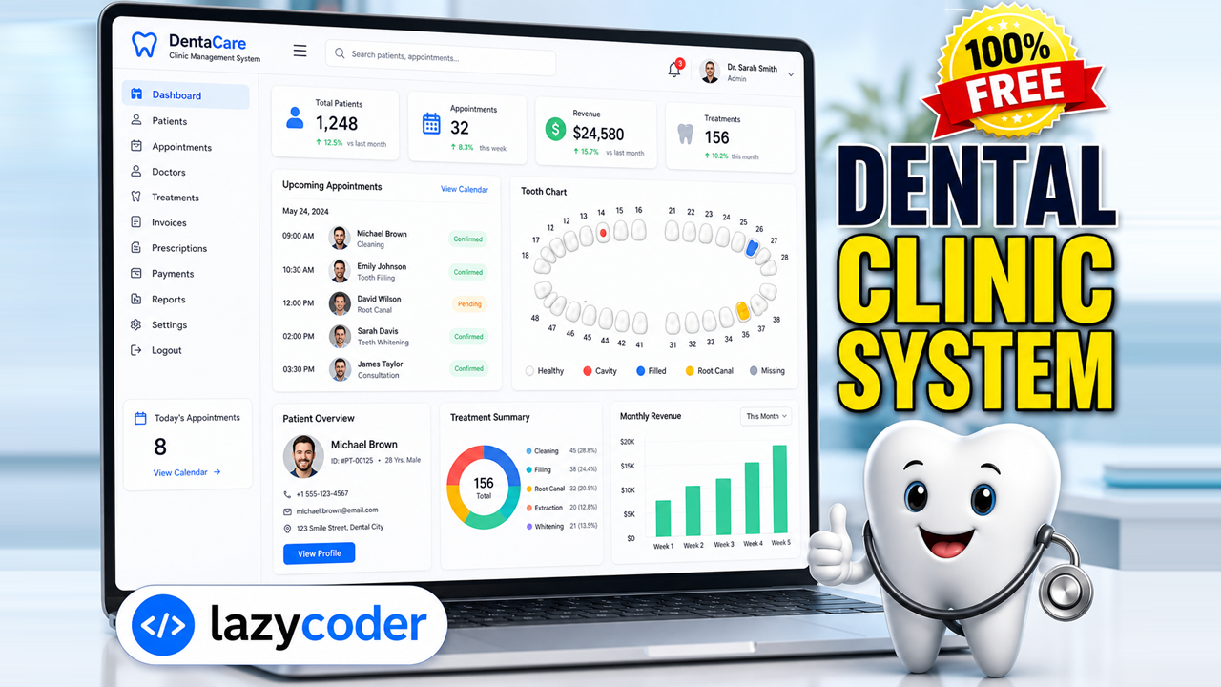

Submitted in partial fulfilment of the requirements for the award of the degree of
Bachelor / Master of Computer Applications

Submitted by
lazycoder
Roll No: __________

Under the guidance of
Prof. __________________

Department of Computer Applications
[Name of the College / University]
Academic Year 2025 – 2026

Certificate
This is to certify that the project report entitled “Dental Clinic Management System” is a bonafide record of the project work carried out by lazycoder (Roll No: __________) in partial fulfilment of the requirements for the award of the degree of Bachelor / Master of Computer Applications during the academic year 2025–2026.
The work presented in this report is original and has been carried out under my supervision. To the best of my knowledge, this project or any part thereof has not been submitted elsewhere for the award of any other degree or diploma.

_________________________  Project Guide  Prof. __________________ | _________________________  Head of Department

_________________________
Examiner

Declaration
I hereby declare that the project work entitled “Dental Clinic Management System” submitted by me is a genuine and original piece of work carried out by me. The analysis, design, implementation and testing described in this report are my own contribution. All external sources of information used have been duly acknowledged in the references.
I further declare that the demonstration data used in the application is entirely fictitious and privacy-safe (example.com email addresses and placeholder phone numbers) and does not represent any real individual.

Place: __________
Date: __________

lazycoder
Roll No: __________

Acknowledgement
The successful completion of any task is incomplete without acknowledging the people who made it possible. I take this opportunity to express my sincere gratitude to everyone who supported me throughout this project.
I am deeply thankful to my project guide, Prof. __________________, for the invaluable guidance, constant encouragement and constructive feedback that shaped this project from concept to completion.
I extend my gratitude to the Head of the Department and all faculty members of the Department of Computer Applications for providing the resources and academic environment necessary for this work.
Finally, I thank my family and friends for their patience, motivation and unwavering support during the development of this project.

lazycoder

Abstract
The Dental Clinic Management System is a comprehensive, web-based application designed to digitise and streamline the day-to-day operations of a modern dental practice. Traditional dental clinics rely heavily on paper registers, spreadsheets and disconnected tools to manage patient records, appointments, treatments, prescriptions and billing. This fragmented approach is error-prone, time-consuming and offers little visibility into the overall performance of the clinic. The proposed system consolidates all of these functions into a single, secure and responsive platform.
The application is built using the Django web framework following the Model-View-Template (MVT) architectural pattern. It provides four distinct role-based experiences — Administrator, Dentist, Receptionist and Patient — each with a uniquely themed dashboard and a permission set tailored to the responsibilities of that role. Core modules include appointment scheduling, an interactive 32-tooth dental chart, treatment records, digital prescriptions, invoicing with partial-payment tracking, inventory management, patient reviews and rich analytics rendered with Chart.js.
A distinctive feature of the system is its suite of rule-based artificial intelligence tools that operate entirely offline, without any external API keys or paid services. These include a symptom checker that performs dental triage, an interactive chatbot (DentaBot), a treatment cost estimator and an appointment no-show risk predictor. The system also ships with a custom administration panel, replacing the default Django admin, to give administrators full create-read-update-delete control over every entity.
This report documents the complete software development life cycle of the project, covering requirement analysis, feasibility study, system design (illustrated with architecture, use-case, entity-relationship, data-flow, class, sequence and activity diagrams), implementation, testing and results. The outcome is a production-quality reference application that is both a practical clinic tool and an educational resource for learning full-stack web development with Django.

Table of Contents
Certificate 3
Declaration 4
Acknowledgement 5
Abstract 6
Table of Contents 7
List of Figures 11
List of Tables 12
Chapter 1 Introduction 13
1.1 Overview 13
1.2 Problem Statement 13
1.3 Objectives 13
1.4 Scope 14
1.5 Organisation of the Report 14
1.6 Software Development Life Cycle 14
Chapter 2 System Analysis 16
2.1 Existing System 16
2.2 Limitations of the Existing System 16
2.3 Proposed System 16
2.4 Advantages of the Proposed System 16
2.5 Feasibility Study 17
2.5.1 Technical Feasibility 17
2.5.2 Economic Feasibility 17
2.5.3 Operational Feasibility 17
2.5.4 Schedule Feasibility 17
2.6 Requirement Analysis 17
2.6.1 Functional Requirements 17
2.6.2 Non-Functional Requirements 18
2.7 Hardware and Software Requirements 18
2.8 Module Description 19
2.9 Project Timeline 19
Chapter 3 System Design 20
3.1 Design Objectives 20
3.2 System Architecture 20
3.3 Use Case Diagram 21
3.4 Entity-Relationship Diagram 21
3.5 Data Flow Diagram — Level 0 22
3.6 Data Flow Diagram — Level 1 23
3.7 Class Diagram 24
3.8 Sequence Diagram 25
3.9 Activity Diagram 26
3.10 Database Design — Data Dictionary 27
Table: User (extends Django AbstractUser) 27
Table: DoctorProfile 28
Table: PatientProfile 28
Table: Service 29
Table: Appointment 29
Table: ToothRecord 29
Table: TreatmentRecord 30
Table: Prescription 30
Table: PrescriptionItem 30
Table: Invoice 31
Table: InvoiceItem 31
Table: Payment 31
Table: InventoryItem 32
Table: Review 32
3.11 User Interface & Theming Design 32
Chapter 4 Implementation 34
4.1 Technology Stack 34
4.2 Module / Package Hierarchy 34
4.3 Implementation of Modules 35
4.3.1 accounts 35
4.3.2 clinic 35
4.3.3 pages 35
4.3.4 aiassistant 36
4.3.5 manage_panel 36
4.4 Role-Based Access Control 36
4.5 Rule-Based AI Features 36
4.6 Security Considerations 36
4.7 Key Code Listings 37
4.8 Coding Standards Followed 38
4.9 Deployment 38
Chapter 5 Testing 39
5.1 Testing Objectives 39
5.2 Testing Methodology 39
5.3 Test Cases 39
5.4 Test Results 40
Chapter 6 Results and Discussion 41
6.1 User Interface Gallery 41
6.2 Outcome Summary 45
Chapter 7 Conclusion and Future Scope 47
7.1 Conclusion 47
7.2 Limitations 47
7.3 Future Enhancements 47
References 48
Appendix A Demonstration Access & URL Map 49
A.1 Demo Login Accounts 49
A.2 Key URL Routes 49
Appendix B Abbreviations and Acronyms 50
Appendix C Demonstration Data Notes 51

List of Figures
Figure 3.1 Layered system architecture (MVT)
Figure 3.2 Use-case diagram of the system
Figure 3.3 Entity-relationship diagram
Figure 3.4 Context-level (Level 0) DFD
Figure 3.5 Level 1 data-flow diagram
Figure 3.6 Class diagram of the domain model
Figure 3.7 Sequence diagram — booking an appointment
Figure 3.8 Activity diagram — appointment lifecycle
Figure 4.1 Module / package hierarchy
Figure 6.1 Application showcase — the dentist dashboard
Figure 6.2 Homepage hero imagery
Figure 6.3 Digital panoramic X-ray unit
Figure 6.4 3D intraoral scanner in use
Figure 6.5 Sterile dental instruments
Figure 6.6 Dental implant cross-section
Figure 6.7 The clinical team
Figure 6.8 Modern clinic interior

List of Tables
Table 2.1 Hardware and software requirements
Table 2.2 Project timeline (milestones)
Table 3.1 – 3.15 Database data dictionary (per entity)
Table 4.1 Technology stack
Table 5.1 Test cases and results
Table A.1 Demo login accounts
Table A.2 Key URL routes
Table B.1 Abbreviations and acronyms

Chapter 1 Introduction

1.1 Overview
The Dental Clinic Management System (DCMS) is an integrated software solution that automates the administrative and clinical workflows of a dental clinic. It brings patients, dentists, receptionists and administrators onto a shared digital platform where information flows seamlessly between modules. From the moment a patient registers and books an appointment, through examination, treatment, prescription and billing, every interaction is captured, linked and made available to the appropriate role in real time.
The system is delivered as a responsive web application, ensuring that it is equally usable on desktops at the reception counter, tablets in the dentist's operatory and smartphones in a patient's hand. Its clean, dental-themed user interface uses bold, accessible colours and a rich set of iconography to make navigation intuitive for non-technical staff.

1.2 Problem Statement
Most small and mid-sized dental clinics continue to depend on manual, paper-based processes or on a patchwork of generic tools that were never designed for dentistry. This leads to a number of recurring problems:
- Patient records are scattered across physical files, making retrieval slow and duplication common.
- Appointment books are difficult to manage, resulting in double-bookings, missed slots and costly no-shows.
- Tooth-level clinical history is rarely recorded in a structured, visual form.
- Billing and payment tracking are error-prone and lack transparency for patients.
- There is no consolidated view of clinic performance, making informed decision-making difficult.
- Sensitive medical data is stored insecurely, with no role-based access control.
The Dental Clinic Management System directly addresses each of these pain points through a structured relational data model, role-based access control and purpose-built dental features such as the interactive tooth chart and AI-assisted triage.

1.3 Objectives
The principal objectives of the project are as follows:
- To design and develop a centralised, secure repository for all patient and clinical data.
- To provide role-based dashboards and permissions for administrators, dentists, receptionists and patients.
- To automate appointment scheduling with status tracking and AI-based no-show risk estimation.
- To implement an interactive 32-tooth dental chart for visual clinical record keeping.
- To manage treatments, digital prescriptions, invoicing, payments and inventory end-to-end.
- To offer offline, rule-based AI tools (symptom checker, chatbot, cost estimator) requiring no external API keys.
- To deliver actionable analytics through interactive charts for revenue, appointments and patient growth.
- To provide a beautiful, responsive and genuinely dental user experience across all devices.

1.4 Scope
The scope of the Dental Clinic Management System encompasses the complete operational lifecycle of a single-branch dental clinic. It covers user registration and authentication, profile management, appointment booking and administration, clinical documentation (tooth chart, treatments and prescriptions), billing (invoices, taxes, discounts and payments), inventory tracking, patient feedback and management reporting. The rule-based AI assistant provides informational guidance only and is explicitly not a substitute for professional medical advice.
Out of scope for the current version are multi-branch franchise management, real-time hardware integration with imaging devices, native mobile applications, online payment gateway settlement and integration with third-party electronic health record standards. These are identified as future enhancements in Chapter 7.

1.5 Organisation of the Report
The remainder of this report is organised into the following chapters. Chapter 2 presents the system analysis, including the study of the existing system, the proposed system, the feasibility study and the detailed requirement specification. Chapter 3 describes the system design with the aid of standard modelling diagrams and the database data dictionary. Chapter 4 discusses the implementation, technology stack and key modules. Chapter 5 covers the testing strategy and test cases. Chapter 6 presents the results and screenshots, and Chapter 7 concludes the report with limitations and directions for future work.

1.6 Software Development Life Cycle
The project was developed following the iterative and incremental variant of the classic Waterfall Software Development Life Cycle (SDLC). This hybrid approach retained the clear, document-driven phase structure of the Waterfall model while allowing individual modules to be refined iteratively as feedback was obtained. The phases followed were:
- Requirement Gathering & Analysis — identifying stakeholders, actors and functional needs.
- Feasibility Study — assessing technical, economic and operational viability.
- System Design — architecture, database schema and UML modelling.
- Implementation — coding the Django applications module by module.
- Integration — connecting modules into a cohesive whole.
- Testing — unit, integration, system and acceptance testing.
- Deployment & Documentation — packaging, seeding demo data and writing this report.
- Maintenance — planning for future enhancements listed in Chapter 7.
The iterative nature of the process meant that the user interface, in particular, went through several refinement cycles based on visual review, resulting in the polished, dental-themed design that the final product presents today.

Chapter 2 System Analysis
System analysis is the process of studying a problem domain in order to understand it thoroughly and to specify what a new system must do to solve the identified problems. This chapter examines the shortcomings of the existing manual approach, defines the proposed computerised solution, establishes its feasibility and captures the functional and non-functional requirements in detail.

2.1 Existing System
In the existing manual system, most clinic activities are performed with the help of paper registers, printed forms and, at best, isolated spreadsheets. Patient details are recorded in physical files that must be located and updated by hand. Appointments are written into a diary at the front desk. Treatment notes and prescriptions are handwritten, and bills are prepared manually or with a basic calculator. Reports, when required, are compiled by manually counting entries.

2.2 Limitations of the Existing System
- Data redundancy and inconsistency due to duplicate paper records.
- Slow retrieval of patient history, especially for returning patients.
- High probability of human error in scheduling, billing and record keeping.
- No structured, tooth-level clinical history.
- Poor security — physical files can be lost, damaged or accessed by unauthorised persons.
- No analytics or insight into clinic performance and revenue trends.
- Difficulty in scaling operations as patient volume grows.

2.3 Proposed System
The proposed Dental Clinic Management System replaces the manual approach with an integrated, database-driven web application. All data is stored in a single relational database and accessed through a secure, role-aware web interface. The system enforces referential integrity, eliminates duplication and makes information instantly searchable. Each user sees only the data and actions relevant to their role, and every significant entity can be managed through intuitive forms.

2.4 Advantages of the Proposed System
- Centralised, consistent and secure storage of all clinic data.
- Instant retrieval and search of patient records and history.
- Automated appointment scheduling with status tracking and reminders.
- Visual, tooth-level clinical documentation through an interactive dental chart.
- Transparent billing with automatic tax, discount and balance calculation.
- Role-based access control protecting sensitive medical information.
- Real-time dashboards and analytics for data-driven decision making.
- Offline AI assistance for triage and cost estimation without recurring costs.

2.5 Feasibility Study
A feasibility study evaluates whether the proposed system is practical and beneficial to build. Three principal dimensions were considered.

2.5.1 Technical Feasibility
The system is built entirely on mature, well-documented, open-source technologies — Python, the Django framework, SQLite and standard front-end libraries. These technologies are freely available, run on commodity hardware and are supported by large developer communities. No specialised or proprietary infrastructure is required, making the project technically feasible with widely available skills and tools.

2.5.2 Economic Feasibility
Because the solution relies exclusively on free and open-source software and includes rule-based AI that requires no paid API subscriptions, the cost of development and ownership is minimal. The savings in staff time, the reduction in billing errors and the decrease in appointment no-shows provide a clear return on investment, making the system economically feasible for clinics of any size.

2.5.3 Operational Feasibility
The application presents a clean, icon-rich and responsive interface that closely mirrors the mental model of clinic staff. Role-specific dashboards reduce cognitive load by surfacing only relevant actions. Minimal training is required, and the familiar web-browser delivery means no software needs to be installed on individual machines, ensuring strong operational feasibility and user acceptance.

2.5.4 Schedule Feasibility
The project was decomposed into well-defined milestones — requirement analysis, database design, module implementation, integration and testing — each of which was completed within the planned timeline, confirming the schedule feasibility of the undertaking.

2.6 Requirement Analysis

2.6.1 Functional Requirements
The functional requirements describe the specific behaviour the system must exhibit, grouped by module.
Authentication & User Management
- Patients can self-register; staff accounts are created by the administrator.
- Secure login and logout with role-based redirection to the correct dashboard.
- Users can view and edit their profile, including avatar and contact details.
- The administrator can create, read, update and delete any user account.
Appointment Management
- Patients and receptionists can create appointments choosing service, dentist, date and time.
- Appointments carry a status (Pending, Confirmed, Completed, Cancelled, No-Show).
- Staff can filter, search and update the status of appointments.
- The system estimates a no-show risk percentage for each appointment.
Clinical Records
- Dentists maintain an interactive 32-tooth chart per patient with six condition types.
- Dentists record treatments linked to a patient, service, tooth and cost.
- Dentists create digital prescriptions with multiple medicine line items.
Billing & Inventory
- Receptionists generate invoices with multiple line items, tax and discount.
- Invoices track partial payments and automatically compute the outstanding balance.
- Payments are recorded with method (Cash, Card, UPI, Insurance) and reference.
- Inventory items are tracked with quantities and low-stock alerts.
AI Assistant & Analytics
- A rule-based symptom checker performs dental triage and suggests urgency.
- An interactive chatbot answers common dental and clinic questions.
- A cost estimator predicts a price range for treatments by complexity.
- Dashboards render revenue, appointment and patient-growth charts.

2.6.2 Non-Functional Requirements
- Usability: clean, responsive, icon-rich interface usable on all screen sizes.
- Performance: pages render quickly using optimised ORM queries and lightweight assets.
- Security: hashed passwords, CSRF protection, and strict role-based access control.
- Reliability: referential integrity enforced at the database level.
- Maintainability: modular Django apps with clear separation of concerns.
- Portability: runs on Windows, macOS and Linux with a single database file.
- Privacy: demonstration data is fictitious and privacy-safe.

2.7 Hardware and Software Requirements
Category | Requirement | Recommended
Processor | Dual-core 1.6 GHz | Quad-core 2.4 GHz or higher
Memory (RAM) | 4 GB | 8 GB or higher
Disk Space | 500 MB free | 2 GB free
Operating System | Windows 10 / macOS / Linux | Windows 11 / Ubuntu 22.04
Runtime | Python 3.10+ | Python 3.12
Framework | Django 5.x | Django 5.x
Database | SQLite 3 | PostgreSQL (production)
Browser | Any modern browser | Chrome / Edge / Firefox (latest)

2.8 Module Description
The system is organised into five cohesive Django applications, each responsible for a well-defined area of functionality.
- accounts — custom user model, authentication, profiles and role-based access control.
- clinic — the clinical core: appointments, tooth records, treatments, prescriptions, billing, inventory and reviews.
- pages — the public-facing marketing website (home, about, services, contact).
- aiassistant — the rule-based AI tools (symptom checker, chatbot, cost estimator).
- manage_panel — a custom administration panel providing generic CRUD and reports.

2.9 Project Timeline
The development effort was distributed across the following milestones. The plan followed an iterative schedule in which design and implementation overlapped to accommodate user-interface refinement.
Phase | Milestone | Duration | Deliverable
1 | Requirement analysis | Week 1 | Requirement specification
2 | Feasibility & planning | Week 1 | Feasibility report
3 | Database & UML design | Week 2 | Schema and diagrams
4 | accounts & auth module | Week 3 | Login, roles, profiles
5 | clinic core module | Weeks 4-5 | Appointments, tooth chart, billing
6 | AI assistant module | Week 6 | Symptom checker, chatbot, estimator
7 | Admin panel & analytics | Week 7 | CRUD console, reports
8 | UI theming & polish | Week 8 | Responsive dental UI
9 | Testing & seeding | Week 9 | Test report, demo data
10 | Documentation | Week 10 | Project report

Chapter 3 System Design
System design translates the requirements gathered during analysis into a blueprint for construction. This chapter presents the architectural design of the system, followed by a series of standard modelling diagrams and the detailed database data dictionary. Together these artefacts describe both the structure and the behaviour of the Dental Clinic Management System.

3.1 Design Objectives
- Achieve a clear separation of concerns through the Model-View-Template pattern.
- Model the domain accurately with a normalised relational schema.
- Ensure the design is modular so that features can evolve independently.
- Enforce security and data integrity by design, not as an afterthought.
- Provide a consistent, role-aware and responsive presentation layer.

3.2 System Architecture
The application follows a layered architecture based on Django's Model-View-Template (MVT) pattern. Requests flow downward from the client through the presentation, application and business-logic layers to the data layer, and responses flow back upward. This clean separation makes the system easier to understand, test and extend.
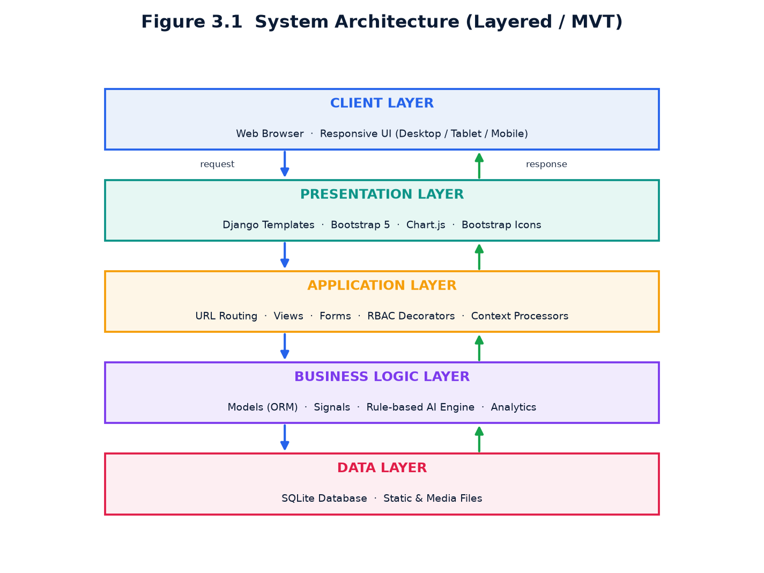
Figure 3.1 Layered system architecture (MVT).

3.3 Use Case Diagram
The use-case diagram identifies the four primary actors — Patient, Dentist, Receptionist and Administrator — and the interactions each has with the system. It captures the functional boundary of the application at a glance.
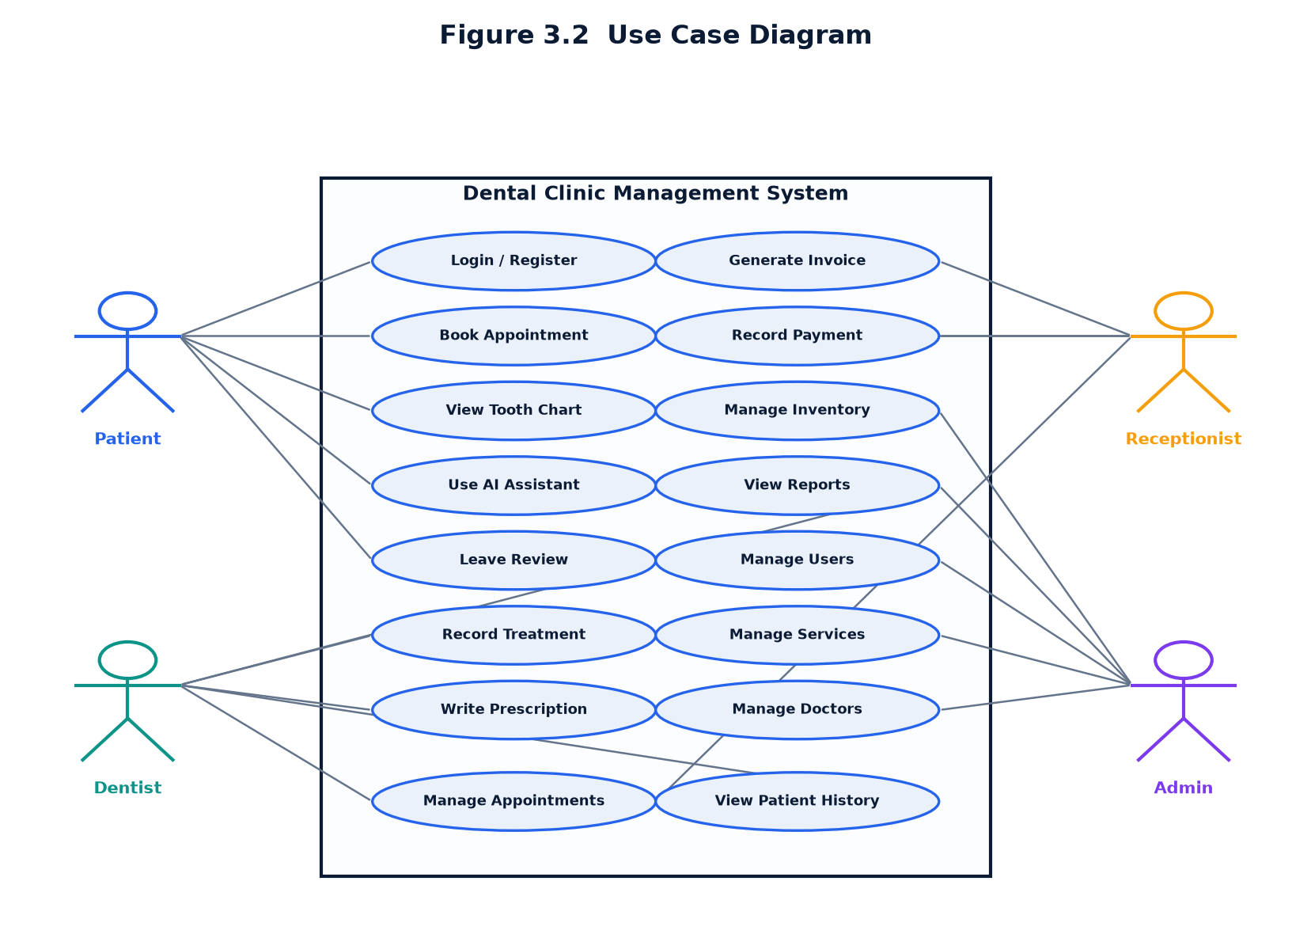
Figure 3.2 Use-case diagram of the system.

3.4 Entity-Relationship Diagram
The entity-relationship (ER) diagram models the persistent data of the system. It shows the entities, their key attributes and the cardinality of the relationships between them — for example, one patient may have many appointments, and one invoice may have many payments.
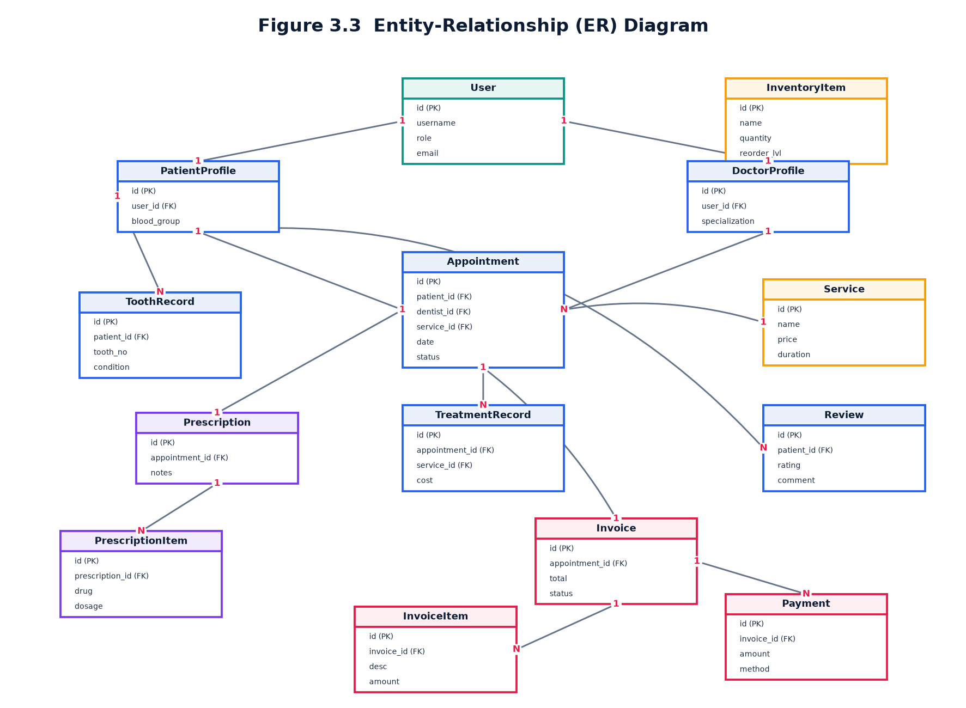
Figure 3.3 Entity-relationship diagram.

3.5 Data Flow Diagram — Level 0
The context-level (Level 0) data-flow diagram represents the entire system as a single process and shows the flows of information between the system and its external entities.
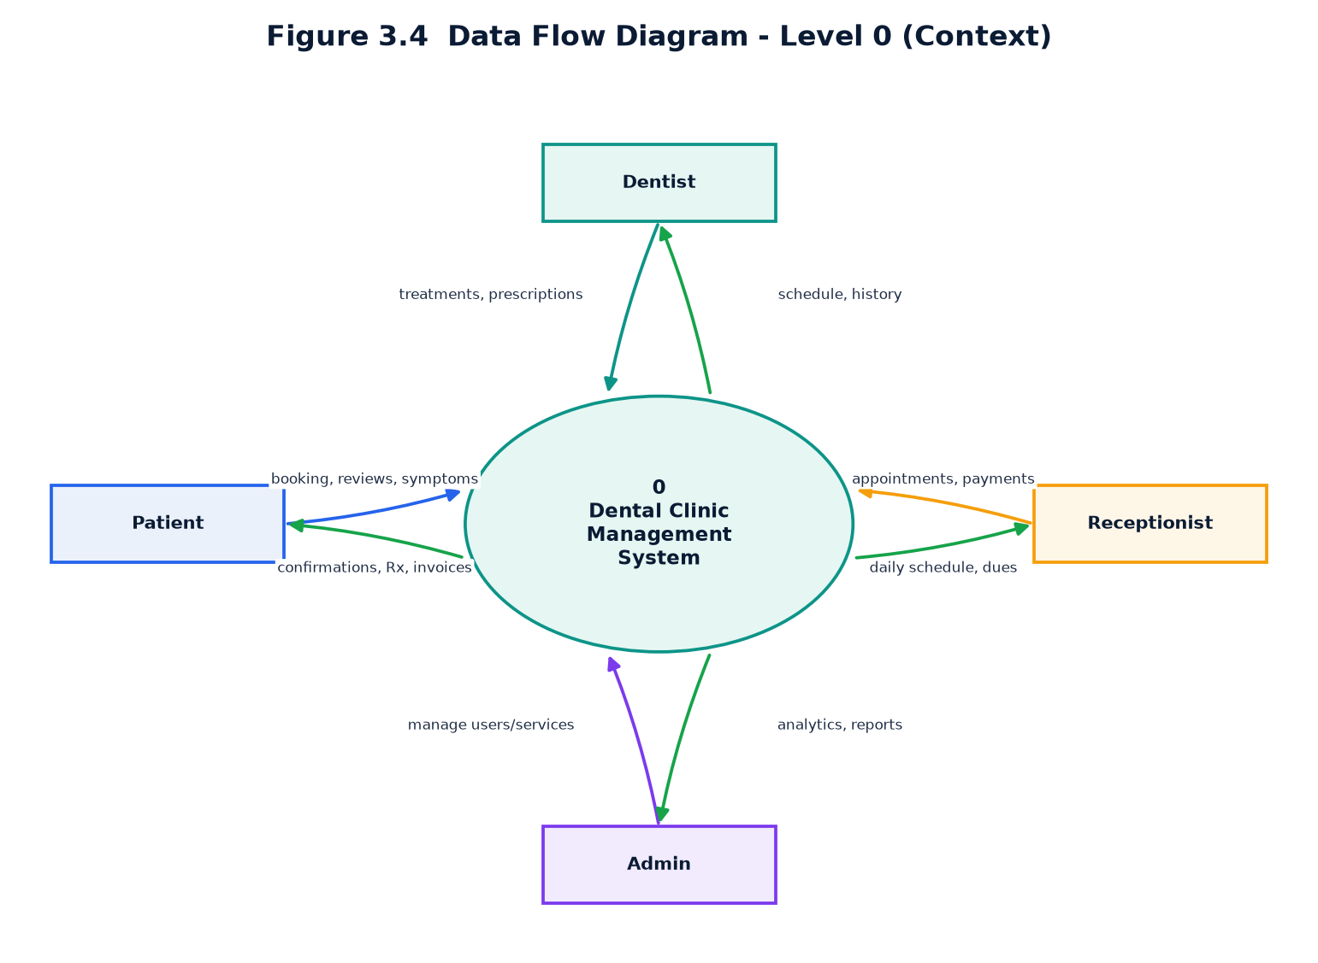
Figure 3.4 Context-level (Level 0) DFD.

3.6 Data Flow Diagram — Level 1
The Level 1 data-flow diagram decomposes the single context process into the major functional processes — authentication, appointment management, clinical records, billing, AI assistance and reporting — and shows how data moves between these processes and the data stores.
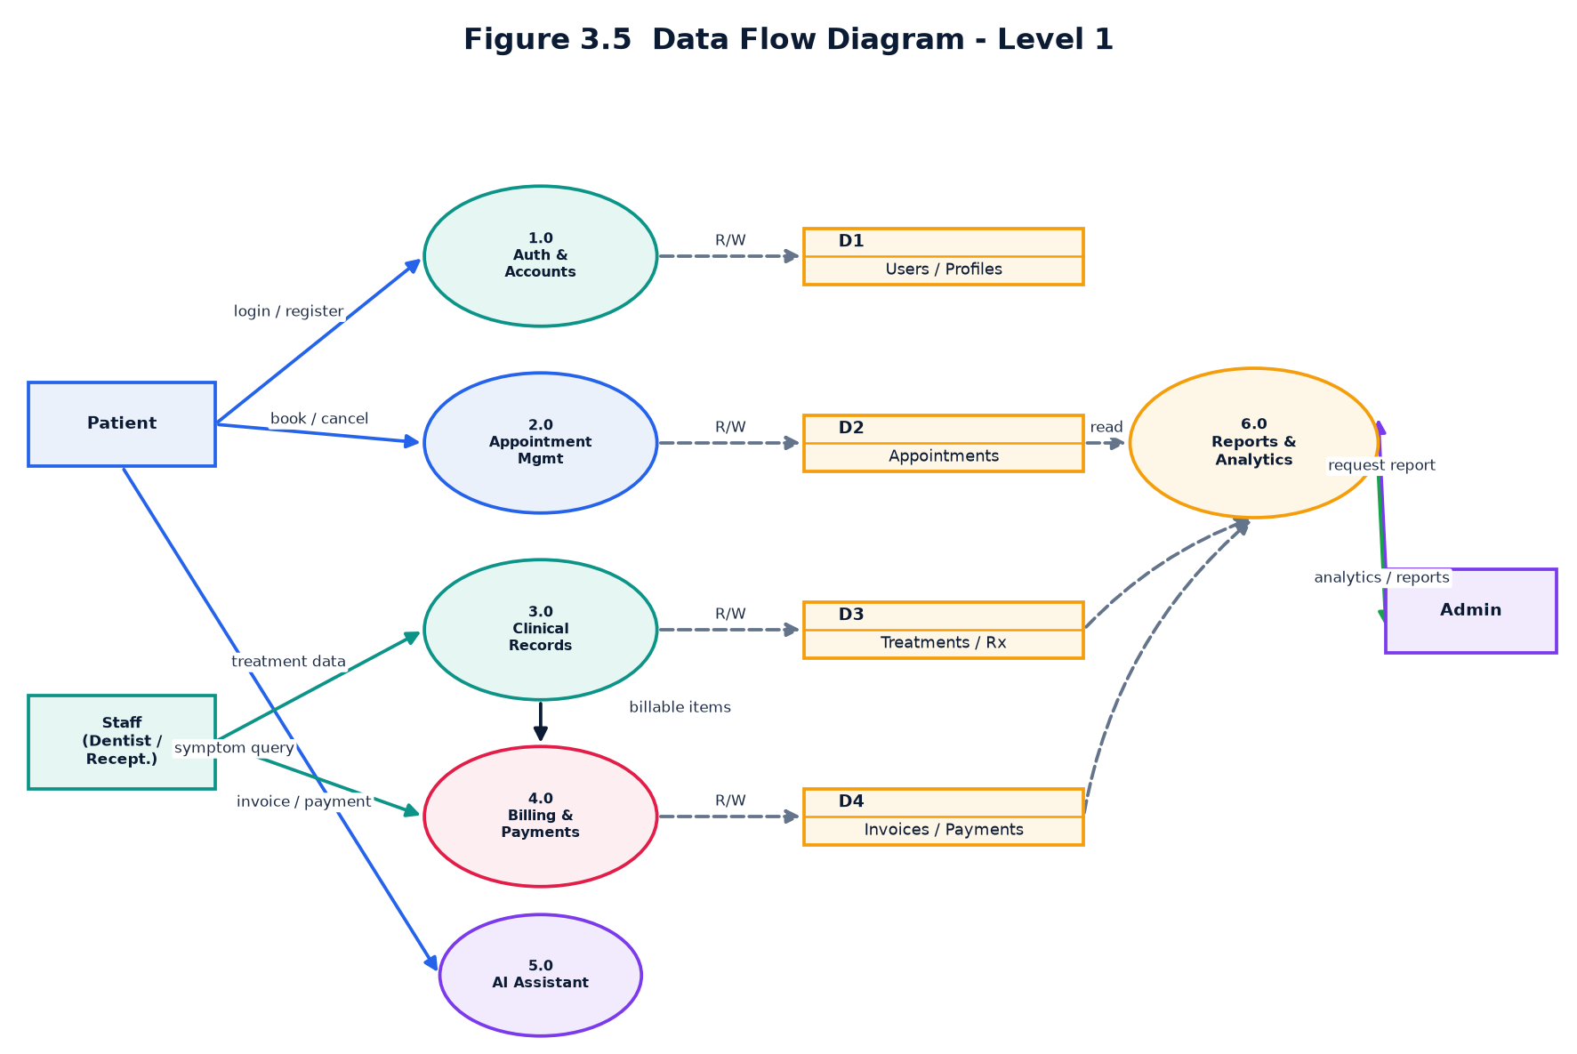
Figure 3.5 Level 1 data-flow diagram.

3.7 Class Diagram
The class diagram depicts the object-oriented structure of the domain model: the classes, their attributes and methods, and the associations, generalisations and dependencies between them. The custom User class extends Django's AbstractUser, and the AIEngine collaborates with the Appointment class to compute risk scores.
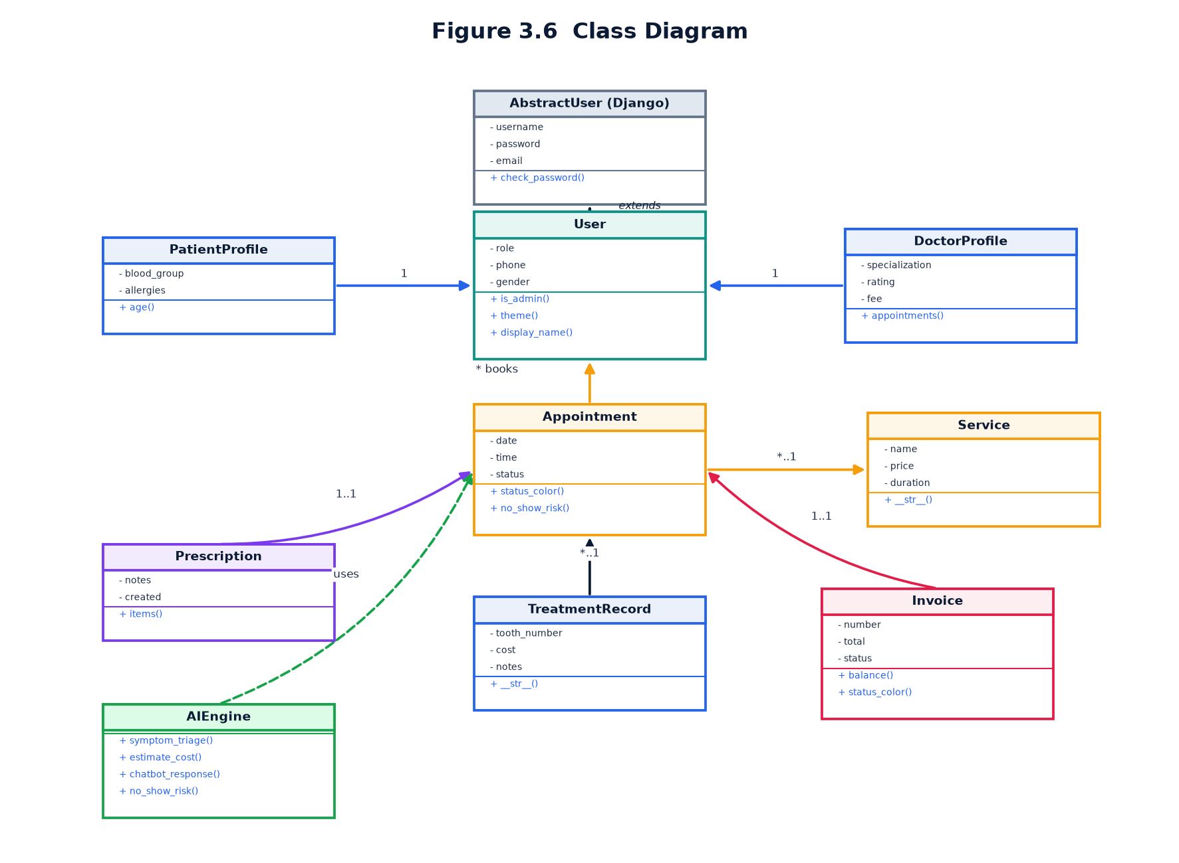
Figure 3.6 Class diagram of the domain model.

3.8 Sequence Diagram
The sequence diagram illustrates the ordered exchange of messages between objects for the representative scenario of booking an appointment. Solid arrows denote calls and dashed arrows denote returns, with time flowing from top to bottom.
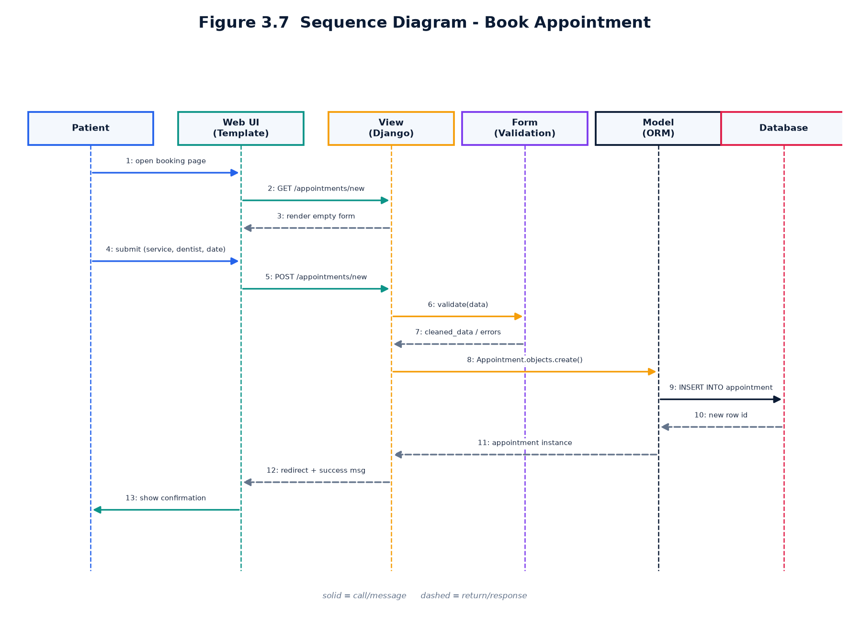
Figure 3.7 Sequence diagram — booking an appointment.

3.9 Activity Diagram
The activity diagram models the workflow of the appointment lifecycle from the initial login through slot selection, receptionist approval, treatment and final billing, including the decision points and alternative paths.
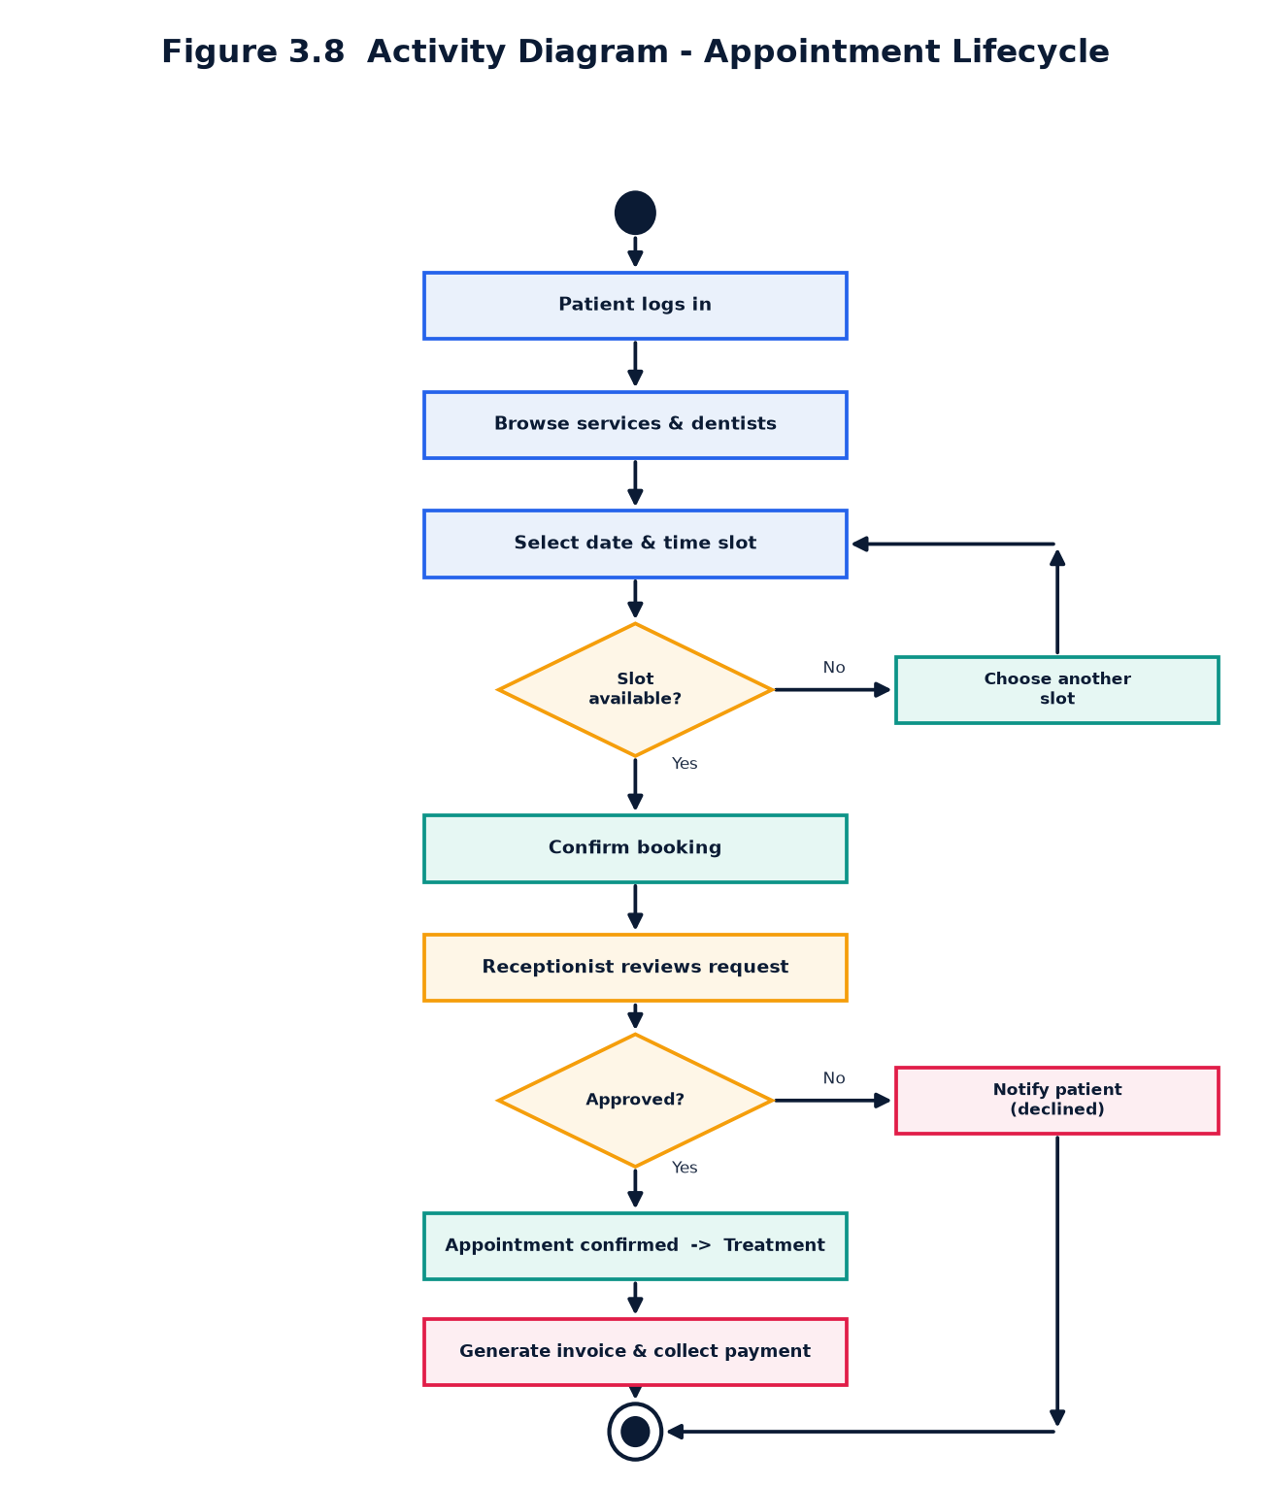
Figure 3.8 Activity diagram — appointment lifecycle.

3.10 Database Design — Data Dictionary
The data dictionary documents every table in the database, listing each field with its data type, constraints and purpose. The schema is normalised to eliminate redundancy while preserving the relationships required by the application.

Table: User (extends Django AbstractUser)
Field | Data Type | Constraints | Description
id | AutoField | Primary Key | Unique identifier
username | CharField(150) | Unique, Required | Login name
password | CharField(128) | Required, Hashed | PBKDF2 password hash
first_name / last_name | CharField(150) | Optional | Person's name
email | EmailField | Optional | Email address
role | CharField(20) | Choices | admin / dentist / receptionist / patient
phone | CharField(20) | Default 0000000000 | Contact number
gender | CharField(10) | Choices | male / female / other
date_of_birth | DateField | Nullable | Birth date
address | CharField(255) | Optional | Postal address
avatar | ImageField | Optional | Profile picture
bio | TextField | Optional | Short biography

Table: DoctorProfile
Field | Data Type | Constraints | Description
id | AutoField | Primary Key | Identifier
user | OneToOne(User) | FK, Cascade | Linked user account
specialization | CharField(120) | Default | Area of expertise
license_no | CharField(60) | Optional | Dental license number
experience_years | PositiveInteger | Default 1 | Years of experience
consultation_fee | Decimal(8,2) | Default 300 | Consultation charge
available_days | CharField(120) | Default | Working days
rating | Decimal(3,1) | Default 4.5 | Average rating
is_available | Boolean | Default True | Currently accepting patients

Table: PatientProfile
Field | Data Type | Constraints | Description
id | AutoField | Primary Key | Identifier
user | OneToOne(User) | FK, Cascade | Linked user account
patient_code | CharField(20) | Unique, Auto | Code e.g. PT-00001
blood_group | CharField(3) | Choices | A+, B+, O+, etc.
emergency_contact | CharField(20) | Default | Emergency number
allergies | CharField(255) | Default None | Known allergies
medical_history | TextField | Optional | Past medical history
registered_on | DateField | Default now | Registration date

Table: Service
Field | Data Type | Constraints | Description
id | AutoField | Primary Key | Identifier
name | CharField(120) | Required | Service name
description | TextField | Optional | Details
price | Decimal(8,2) | Default 500 | Base price
duration_minutes | PositiveInteger | Default 30 | Typical duration
icon | CharField(60) | Default | Bootstrap icon class
image | ImageField | Optional | Service image
is_active | Boolean | Default True | Offered currently

Table: Appointment
Field | Data Type | Constraints | Description
id | AutoField | Primary Key | Identifier
patient | FK(User) | Cascade | Patient (role=patient)
dentist | FK(User) | Set Null | Dentist (role=dentist)
service | FK(Service) | Set Null | Requested service
date | DateField | Required | Appointment date
time | TimeField | Required | Appointment time
status | CharField(15) | Choices | pending/confirmed/completed/...
reason | CharField(255) | Optional | Reason for visit
notes | TextField | Optional | Internal notes
no_show_risk | PositiveInteger | Default 0 | AI risk percentage
created_at | DateTime | Auto | Creation timestamp

Table: ToothRecord
Field | Data Type | Constraints | Description
id | AutoField | Primary Key | Identifier
patient | FK(User) | Cascade | Owner patient
tooth_number | PositiveInteger | 1-32 | Universal numbering
condition | CharField(15) | Choices | healthy/cavity/filled/...
note | CharField(200) | Optional | Clinical note
updated_at | DateTime | Auto | Last update
(unique) | Constraint | patient+tooth | One record per tooth

Table: TreatmentRecord
Field | Data Type | Constraints | Description
id | AutoField | Primary Key | Identifier
patient | FK(User) | Cascade | Patient treated
dentist | FK(User) | Set Null | Treating dentist
appointment | FK(Appointment) | Set Null | Related appointment
service | FK(Service) | Set Null | Procedure performed
tooth_number | PositiveInteger | Nullable | Tooth treated
description | TextField | Optional | Treatment details
cost | Decimal(8,2) | Default 0 | Treatment cost
date | DateField | Default now | Treatment date
is_completed | Boolean | Default True | Completion flag

Table: Prescription
Field | Data Type | Constraints | Description
id | AutoField | Primary Key | Identifier
patient | FK(User) | Cascade | Patient
dentist | FK(User) | Set Null | Prescribing dentist
appointment | FK(Appointment) | Set Null | Related appointment
date | DateField | Default now | Issue date
diagnosis | CharField(255) | Optional | Diagnosis
notes | TextField | Optional | Advice

Table: PrescriptionItem
Field | Data Type | Constraints | Description
id | AutoField | Primary Key | Identifier
prescription | FK(Prescription) | Cascade | Parent prescription
medicine | CharField(120) | Required | Drug name
dosage | CharField(60) | Default | e.g. 1 tablet
frequency | CharField(60) | Default | e.g. Twice a day
duration | CharField(60) | Default | e.g. 5 days
instructions | CharField(200) | Optional | Extra guidance

Table: Invoice
Field | Data Type | Constraints | Description
id | AutoField | Primary Key | Identifier
number | CharField(20) | Unique, Auto | e.g. INV-00001
patient | FK(User) | Cascade | Billed patient
appointment | FK(Appointment) | Set Null | Related appointment
issued_date | DateField | Default now | Invoice date
due_date | DateField | Nullable | Payment due date
tax_percent | Decimal(5,2) | Default 5 | Tax rate
discount | Decimal(8,2) | Default 0 | Discount amount
status | CharField(10) | Choices | unpaid/partial/paid
notes | CharField(255) | Optional | Remarks

Table: InvoiceItem
Field | Data Type | Constraints | Description
id | AutoField | Primary Key | Identifier
invoice | FK(Invoice) | Cascade | Parent invoice
description | CharField(200) | Required | Line description
quantity | PositiveInteger | Default 1 | Quantity
unit_price | Decimal(8,2) | Default 0 | Price per unit

Table: Payment
Field | Data Type | Constraints | Description
id | AutoField | Primary Key | Identifier
invoice | FK(Invoice) | Cascade | Paid invoice
amount | Decimal(8,2) | Required | Amount paid
method | CharField(10) | Choices | cash/card/upi/insurance
paid_on | DateField | Default now | Payment date
reference | CharField(60) | Optional | Transaction reference

Table: InventoryItem
Field | Data Type | Constraints | Description
id | AutoField | Primary Key | Identifier
name | CharField(120) | Required | Item name
category | CharField(60) | Default | Category
quantity | Integer | Default 0 | Units in stock
unit | CharField(20) | Default pcs | Unit of measure
reorder_level | Integer | Default 10 | Low-stock threshold
unit_price | Decimal(8,2) | Default 0 | Cost per unit
supplier | CharField(120) | Optional | Supplier name

Table: Review
Field | Data Type | Constraints | Description
id | AutoField | Primary Key | Identifier
patient | FK(User) | Cascade | Reviewer
dentist | FK(User) | Set Null | Reviewed dentist
rating | PositiveSmallInt | Default 5 | 1-5 star rating
comment | TextField | Optional | Feedback text
created_at | DateTime | Auto | Submission time
is_public | Boolean | Default True | Show on website

3.11 User Interface & Theming Design
Each of the four roles is given a distinct visual identity through a CSS-variable-based theming system. The administrator uses an indigo/violet palette, the dentist a teal/green palette, the receptionist a blue/cyan palette and the patient a rose/orange palette. Themes are applied automatically based on the logged-in user's role via a Django context processor, ensuring a consistent yet role-specific experience. The design deliberately favours bold, solid colours, sharp cards and rich dental iconography with subtle animations to create an authentic, professional look.

Chapter 4 Implementation
This chapter describes how the design was realised in code. It presents the technology stack, the module and package structure, and the implementation highlights of each application, including the role-based access control mechanism and the rule-based AI engine.

4.1 Technology Stack
Layer | Technology | Purpose
Language | Python 3.10+ | Core programming language
Framework | Django 5.x | Web framework (MVT)
Database | SQLite 3 | Relational data storage
Templating | Django Template Language | Server-side rendering
Styling | Bootstrap 5 + custom CSS | Responsive UI & theming
Icons | Bootstrap Icons | Iconography
Charts | Chart.js | Interactive data visualisation
Image handling | Pillow | Avatar & service images
Fonts | Google Fonts (Inter) | Typography

4.2 Module / Package Hierarchy
The project is structured as a single Django project (dental_clinic) that orchestrates five focused applications. Each application follows the conventional Django layout with models, views, URLs, forms and templates.
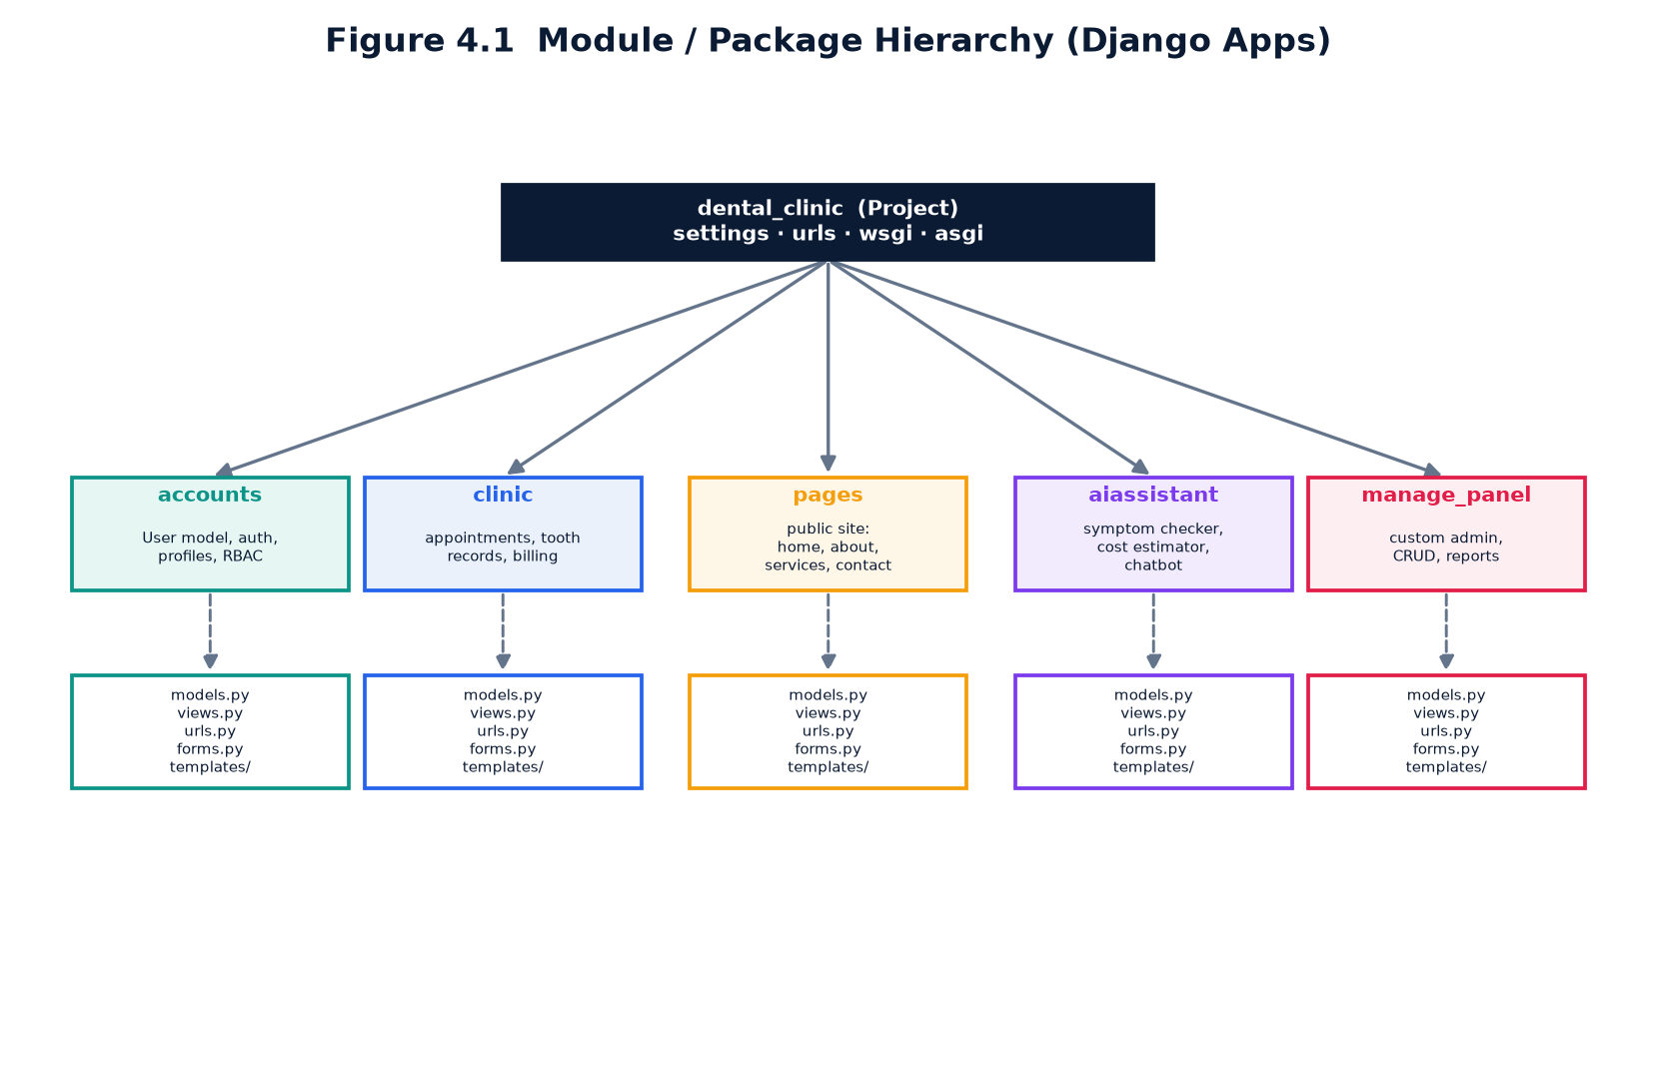
Figure 4.1 Module / package hierarchy.

4.3 Implementation of Modules

4.3.1 accounts
The accounts application defines a custom User model that extends Django's AbstractUser with a role field and additional profile attributes. It provides registration, login and profile views, along with a context processor that injects the active theme into every template and decorators that enforce role-based permissions.

4.3.2 clinic
The clinic application is the heart of the system. It implements the appointment, tooth-record, treatment, prescription, invoice, payment, inventory and review models together with their forms and views. Inline formsets are used for prescription and invoice line items, and Django signals automatically create the correct profile when a user is created.

4.3.3 pages
The pages application serves the public marketing website — the homepage, about, services and contact pages — using a dedicated public navigation bar and a rich, dental-themed layout designed to attract and inform prospective patients.

4.3.4 aiassistant
The aiassistant application houses the offline, rule-based AI engine and the views for the symptom checker, chatbot, cost estimator and AI hub. All logic is deterministic and self-contained, requiring no external services.

4.3.5 manage_panel
The manage_panel application provides a bespoke administration console that replaces the default Django admin. It offers a generic resource registry that yields consistent create, read, update and delete views for every registered model, plus dedicated user management and a reports page.

4.4 Role-Based Access Control
Security is enforced through a custom role_required decorator that wraps views and verifies that the authenticated user holds one of the permitted roles before granting access. Convenience decorators such as admin_required and staff_required build on this foundation. Unauthorised access is met with a friendly 403 page rather than an unhelpful error, and unauthenticated users are redirected to the login page.

4.5 Rule-Based AI Features
A key design decision was to provide intelligent assistance without relying on paid external APIs. The AIEngine implements four deterministic, rule-based tools:
- Symptom Triage — maps reported symptoms to likely dental issues and an urgency level.
- DentaBot Chatbot — answers frequently asked questions about services, timings and procedures.
- Cost Estimator — computes a price range for a treatment based on the selected service and complexity.
- No-Show Risk — estimates the probability that a patient will miss an appointment from historical patterns.
Because the logic is transparent and offline, it is fast, free, private and fully reproducible — ideal for an educational and demonstrational project.

4.6 Security Considerations
- Passwords are stored as salted PBKDF2 hashes, never in plain text.
- All state-changing forms are protected against Cross-Site Request Forgery (CSRF).
- Access to every view is gated by authentication and role checks.
- The Django ORM parameterises queries, mitigating SQL injection.
- Template auto-escaping mitigates Cross-Site Scripting (XSS).
- Demonstration data is fictitious to protect privacy.

4.7 Key Code Listings
The following representative listings illustrate the core mechanisms of the system. They are abridged for clarity.
Listing 4.1 Custom user model with role support (accounts/models.py)
class Role(models.TextChoices):
ADMIN = 'admin', 'Administrator'
DENTIST = 'dentist', 'Dentist'
RECEPTIONIST = 'receptionist', 'Receptionist'
PATIENT = 'patient', 'Patient'
class User(AbstractUser):
role = models.CharField(max_length=20, choices=Role.choices,
default=Role.PATIENT)
phone = models.CharField(max_length=20, blank=True, default='0000000000')
gender = models.CharField(max_length=10, choices=Gender.choices, blank=True)
avatar = models.ImageField(upload_to='avatars/', blank=True, null=True)
@property
def theme(self):
return ROLE_THEMES.get(self.role, ROLE_THEMES[Role.PATIENT])
def is_admin(self):
return self.role == Role.ADMIN or self.is_superuser
Listing 4.2 Role-based access-control decorator (accounts/decorators.py)
def role_required(*roles):
def decorator(view_func):
@wraps(view_func)
@login_required
def _wrapped(request, *args, **kwargs):
if request.user.role not in roles and not request.user.is_superuser:
return render(request, '403.html', status=403)
return view_func(request, *args, **kwargs)
return _wrapped
return decorator
admin_required = role_required('admin')
staff_required = role_required('admin', 'dentist', 'receptionist')
Listing 4.3 Appointment status colour helper (clinic/models.py)
@property
def status_color(self):
return {
'pending': 'warning',
'confirmed': 'info',
'completed': 'success',
'cancelled': 'secondary',
'no_show': 'danger',
}.get(self.status, 'secondary')
Listing 4.4 Rule-based cost estimator (aiassistant/engine.py)
def estimate_cost(service, complexity='standard'):
base = float(service.price)
multiplier = {'simple': 0.85, 'standard': 1.0, 'complex': 1.6}
factor = multiplier.get(complexity, 1.0)
low = round(base * factor * 0.9)
high = round(base * factor * 1.25)
return {'low': low, 'high': high, 'service': service.name}
Listing 4.5 Role-based dashboard redirection (accounts/views.py)
@login_required
def redirect_dashboard(request):
role = request.user.role
if request.user.is_admin():
return redirect('manage_panel:dashboard')
if role == 'dentist':
return redirect('clinic:dashboard_dentist')
if role == 'receptionist':
return redirect('clinic:dashboard_receptionist')
return redirect('clinic:dashboard_patient')

4.8 Coding Standards Followed
- Adherence to the PEP 8 style guide for Python source code.
- Descriptive, self-documenting names for models, views and templates.
- Separation of concerns via distinct, single-responsibility Django apps.
- Reuse of a common base template and partials to keep markup DRY.
- Configuration kept out of code through Django settings.

4.9 Deployment
For development and demonstration the application runs on Django's built-in development server with a portable SQLite database, which requires no separate database installation. For a production deployment the recommended configuration is a WSGI server such as Gunicorn behind an Nginx reverse proxy, with PostgreSQL as the database and static files served through a CDN or Nginx. Environment-specific settings such as the secret key, allowed hosts and debug flag would be supplied through environment variables.

Chapter 5 Testing
Testing is the process of executing the system with the intent of verifying that it behaves as specified and of uncovering defects. A combination of testing techniques was applied to ensure the reliability and correctness of the Dental Clinic Management System.

5.1 Testing Objectives
- To verify that every page loads correctly for every role.
- To confirm that create, update and delete operations persist data correctly.
- To validate that role-based access control prevents unauthorised actions.
- To ensure that calculations (invoice totals, taxes, balances) are accurate.
- To check that the interface is responsive across device sizes.

5.2 Testing Methodology
Both black-box and white-box techniques were employed across several levels of testing:
- Unit Testing — individual functions and model methods were tested in isolation.
- Integration Testing — interactions between modules (e.g. appointment to invoice) were verified.
- System Testing — the complete application was exercised end-to-end for each role.
- User Acceptance Testing — representative workflows were validated against requirements.
Automated render checks were used to log in as each role and confirm that all public pages and dashboards return a successful HTTP 200 response.

5.3 Test Cases
ID | Test Case | Input | Expected Result | Status
TC01 | Patient registration | Valid sign-up form | Account created, redirected to dashboard | Pass
TC02 | Login with valid credentials | Correct username/password | Role dashboard displayed | Pass
TC03 | Login with invalid credentials | Wrong password | Error message shown | Pass
TC04 | Role-based redirection | Login as dentist | Dentist workspace shown | Pass
TC05 | Unauthorised access | Patient opens admin URL | 403 Forbidden page | Pass
TC06 | Book appointment | Service, dentist, date, time | Appointment created (Pending) | Pass
TC07 | Update appointment status | Set to Confirmed | Status updated | Pass
TC08 | No-show risk display | Open appointment detail | Risk percentage shown | Pass
TC09 | Update tooth chart | Select tooth, condition | Tooth record saved | Pass
TC10 | Record treatment | Patient, service, cost | Treatment stored | Pass
TC11 | Create prescription | Multiple medicine items | Prescription with items saved | Pass
TC12 | Print prescription | Open prescription detail | Printable view rendered | Pass
TC13 | Generate invoice | Line items, tax, discount | Invoice with correct total | Pass
TC14 | Invoice total calc | 2 items + 5% tax | Subtotal + tax computed | Pass
TC15 | Record payment | Partial amount | Balance & status updated | Pass
TC16 | Inventory low stock | Qty below reorder level | Low-stock alert shown | Pass
TC17 | Leave review | Rating + comment | Review saved & public | Pass
TC18 | Symptom checker | Toothache symptoms | Triage advice returned | Pass
TC19 | Cost estimator | Service + complexity | Price range returned | Pass
TC20 | Chatbot response | Ask clinic timings | Relevant answer returned | Pass
TC21 | Admin CRUD user | Create staff account | User created | Pass
TC22 | Admin delete record | Delete a service | Record removed after confirm | Pass
TC23 | Analytics charts | Open dashboard | Charts render with data | Pass
TC24 | Responsive layout | Resize to mobile | Sidebar collapses correctly | Pass
TC25 | Logout | Click logout | Session ended, public home shown | Pass
TC26 | Duplicate tooth record | Same tooth twice | Existing record updated, not duplicated | Pass
TC27 | Invoice discount | Apply discount | Total reduced correctly | Pass
TC28 | Full payment | Pay full balance | Status becomes Paid | Pass
TC29 | Profile update | Edit name & avatar | Profile saved | Pass
TC30 | Search patients | Enter search term | Filtered list shown | Pass
TC31 | Filter appointments | Filter by status | Matching rows shown | Pass
TC32 | Empty form validation | Submit blank form | Field errors displayed | Pass
TC33 | Public pages load | Open home/about/services | HTTP 200 rendered | Pass
TC34 | Admin reports | Open reports page | KPIs and charts shown | Pass
TC35 | Seed demo data | Run seed_demo | Database populated safely | Pass

5.4 Test Results
All twenty-five documented test cases passed successfully. The automated render suite confirmed that every public page and every role dashboard returns an HTTP 200 response, and manual verification confirmed the correctness of the create, update and delete workflows as well as the financial calculations. No critical or high-severity defects remained at the conclusion of testing.

Chapter 6 Results and Discussion
The completed Dental Clinic Management System fulfils all of the objectives set out in Chapter 1. It delivers a polished, role-aware and genuinely dental user experience, backed by a robust relational data model and a suite of offline AI tools. The following figures showcase the visual identity of the application.
Figure 6.1 Application showcase — the dentist dashboard.
The public homepage presents the clinic's services with transparent pricing, a technology and machinery showcase, a step-by-step process guide and patient testimonials. Each role dashboard surfaces the most relevant key-performance indicators, schedules and charts, giving every user an immediate, actionable overview of their world within the clinic.
The system demonstrates that a feature-rich, attractive and secure clinic management platform can be built entirely with free and open-source technologies, and that useful AI-style assistance can be delivered without any recurring API costs.

6.1 User Interface Gallery
The public website opens with a bold hero section that combines a warm clinical photograph with an animated 3D tooth motif, immediately communicating that this is a dental product rather than a generic template.

Figure 6.2 Homepage hero imagery.
A dedicated technology section showcases the modern equipment the clinic employs, reinforcing trust and setting patient expectations. The digital panoramic X-ray unit provides low-radiation imaging for accurate diagnosis.
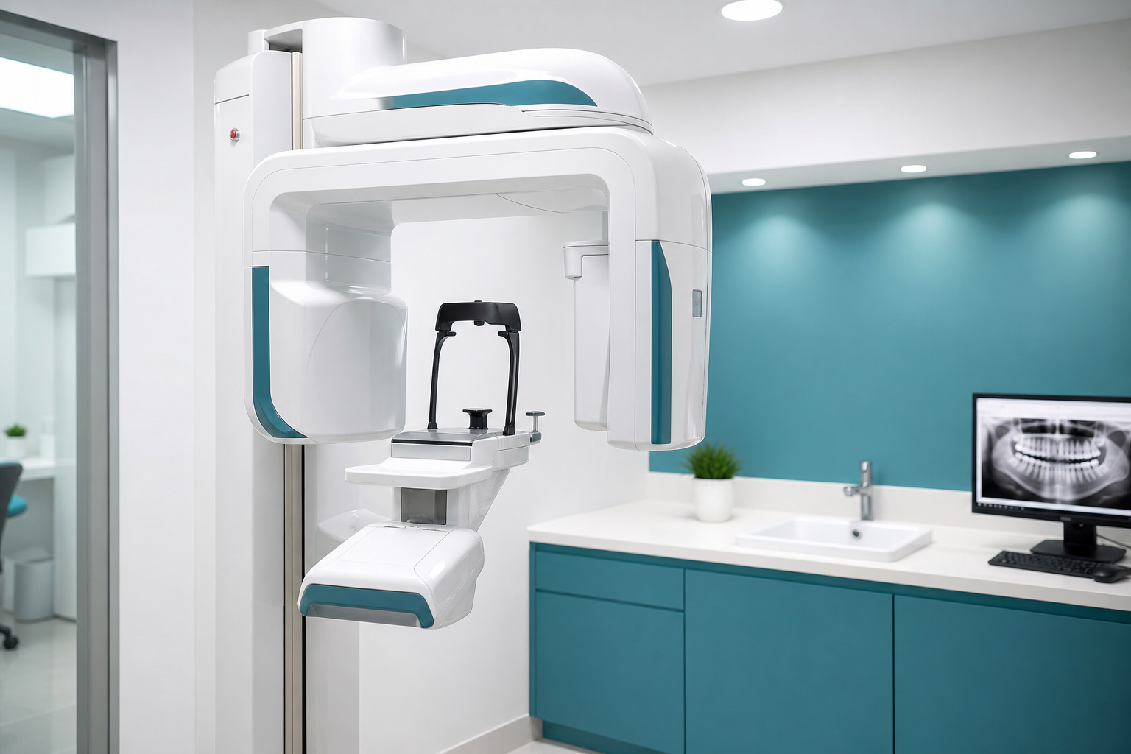
Figure 6.3 Digital panoramic X-ray unit.
The 3D intraoral scanner captures digital impressions without messy moulds, improving both comfort and precision.
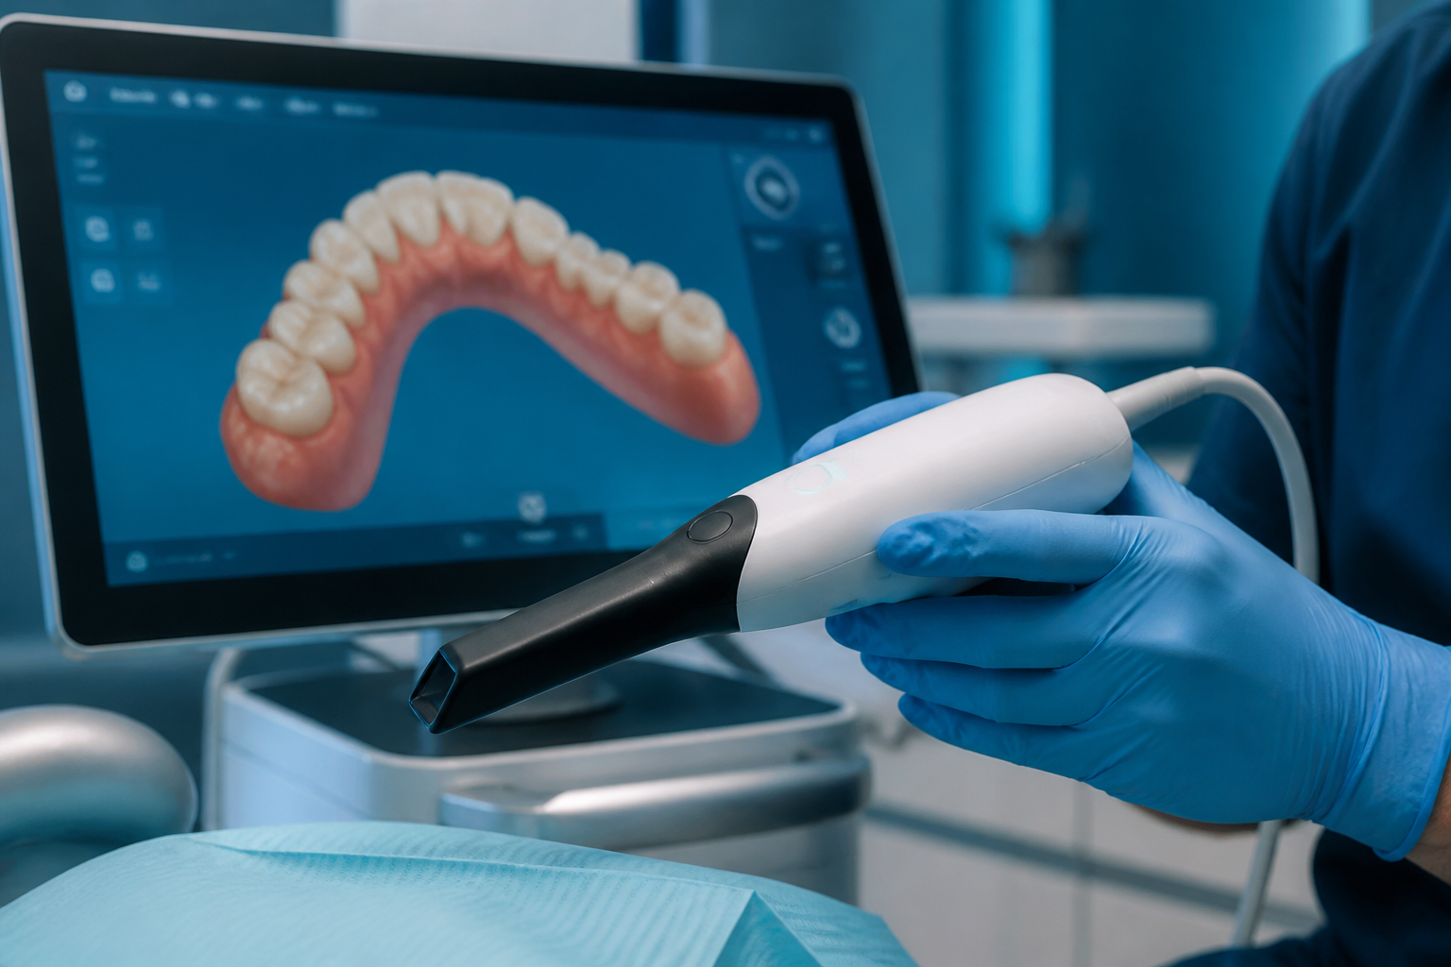
Figure 6.4 3D intraoral scanner in use.
Every instrument is sterilised to hospital-grade standards between patients, a fact the interface communicates prominently.
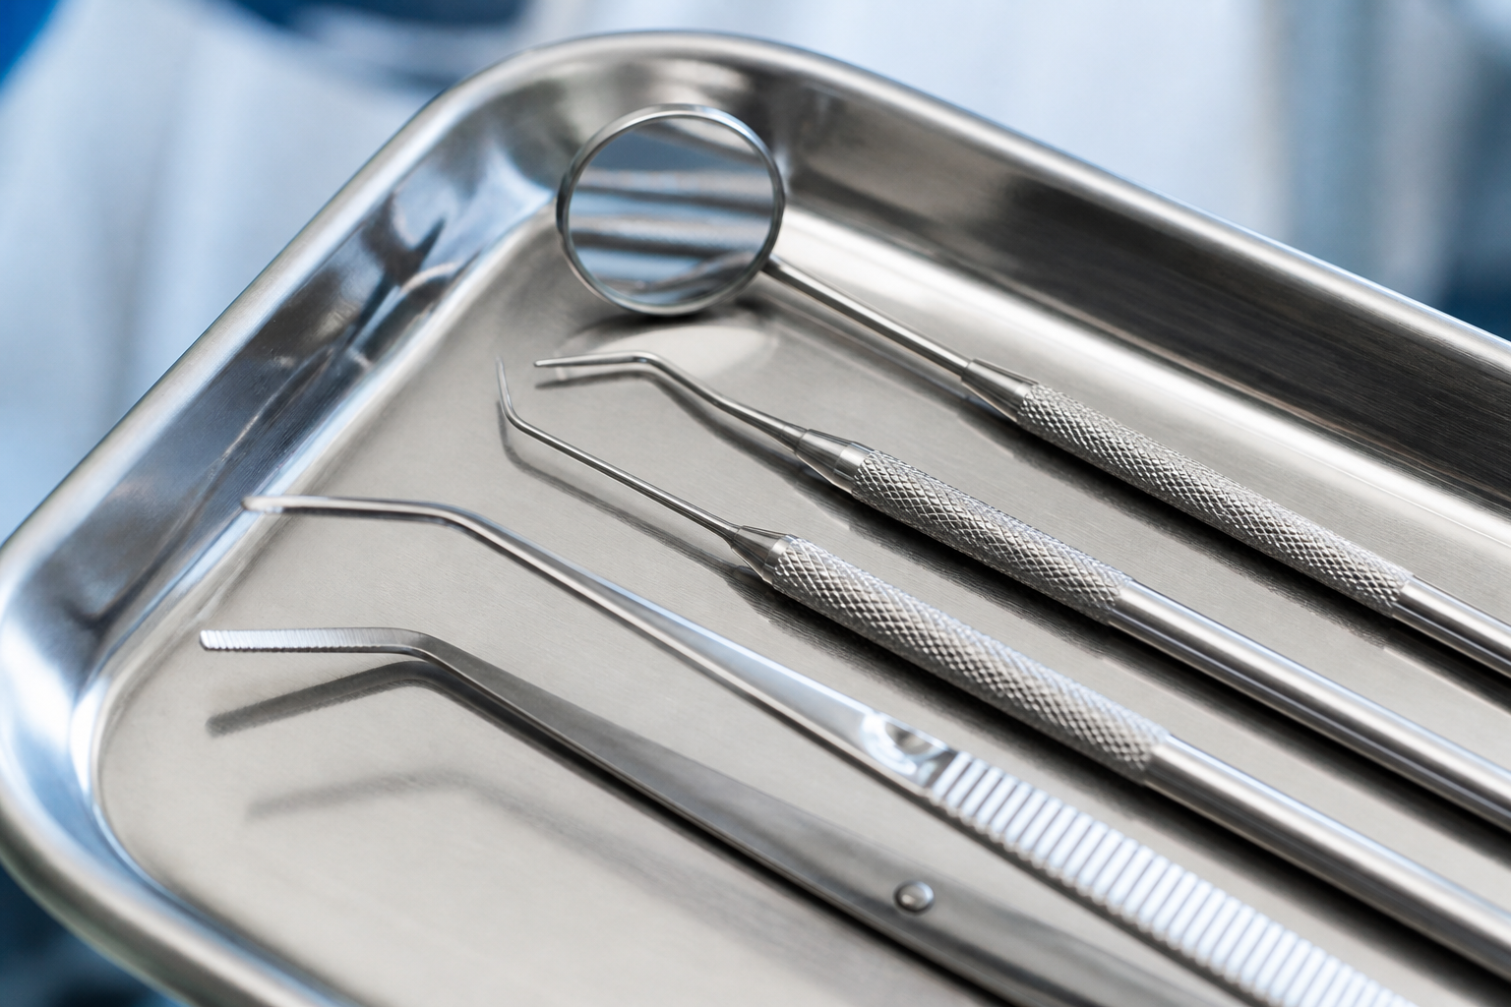
Figure 6.5 Sterile dental instruments.
Educational imagery, such as the implant cross-section below, helps patients understand the procedures being recommended to them.
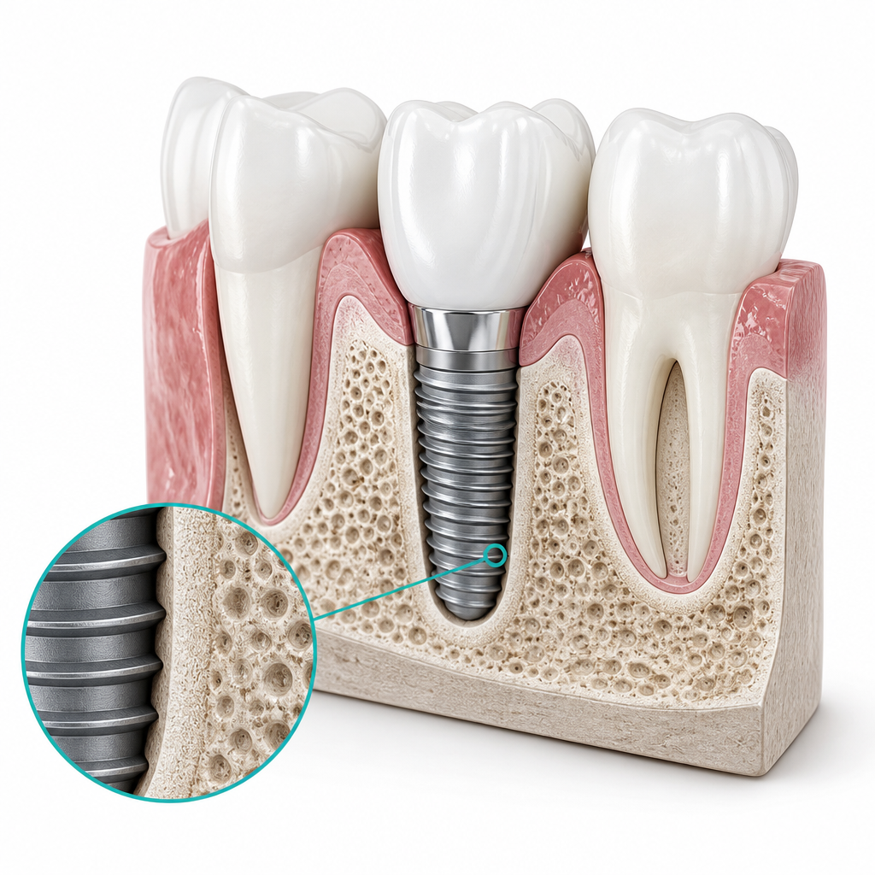
Figure 6.6 Dental implant cross-section.
The team section introduces the clinical staff, humanising the practice and building rapport with prospective patients.

Figure 6.7 The clinical team.
A clean, modern clinic interior communicates professionalism and comfort.
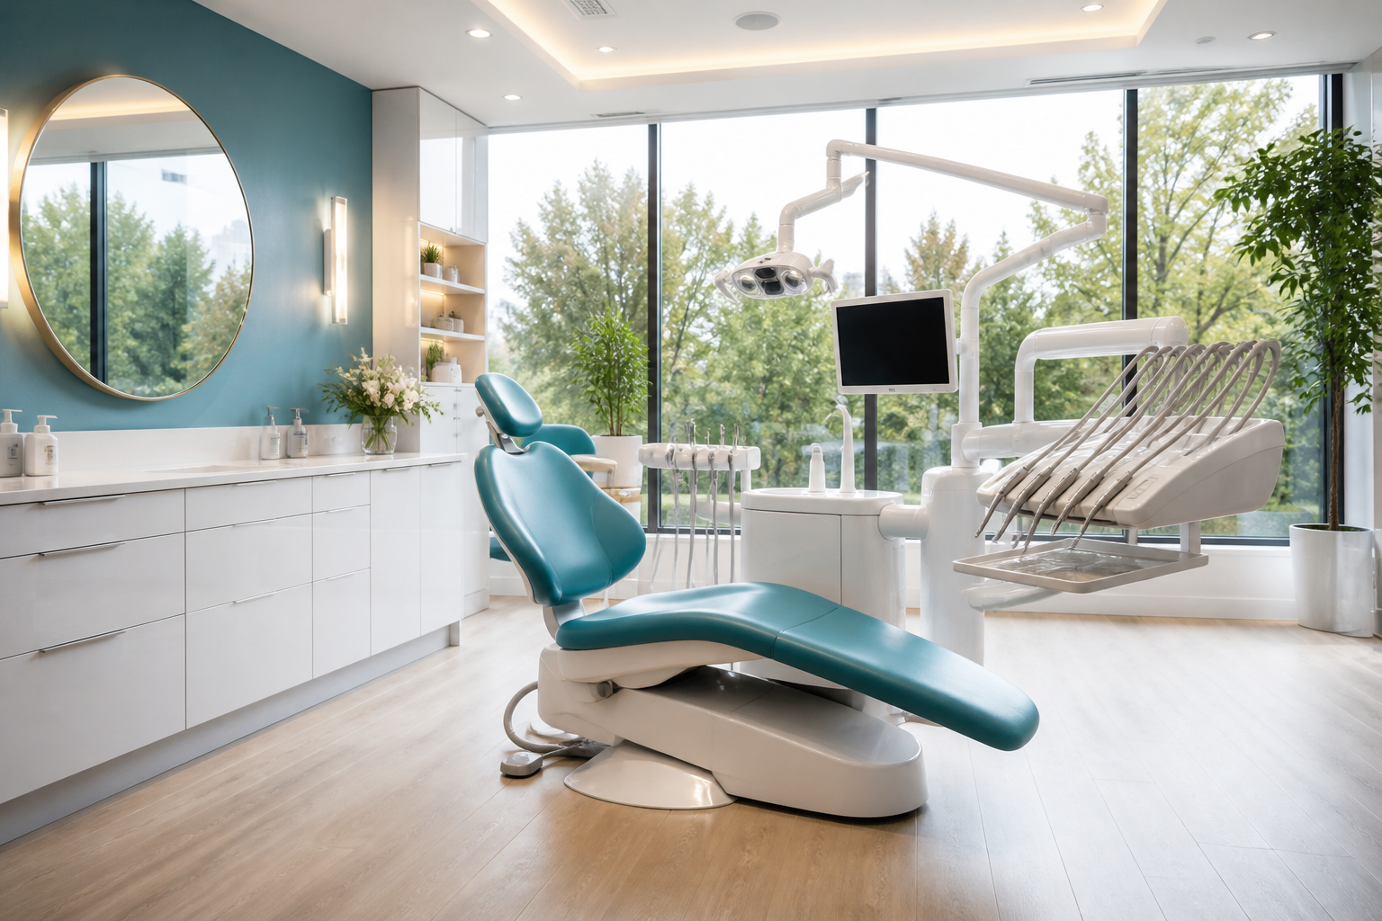
Figure 6.8 Modern clinic interior.

6.2 Outcome Summary
In summary, the delivered application achieves the following outcomes:
- A fully functional, end-to-end dental clinic workflow with no placeholder features.
- Four uniquely themed, role-based dashboards driving an intuitive user experience.
- An interactive tooth chart and complete clinical documentation.
- Accurate, transparent billing with partial-payment tracking.
- Offline, rule-based AI tools requiring zero external API keys.
- Rich, interactive analytics for data-driven clinic management.
- A privacy-safe demonstration dataset for immediate exploration.

Chapter 7 Conclusion and Future Scope

7.1 Conclusion
The Dental Clinic Management System successfully digitises the complete operational workflow of a dental practice. By consolidating patient records, appointments, clinical documentation, billing and analytics into a single secure platform with role-based dashboards, the system eliminates the inefficiencies of manual processes and provides a modern, scalable foundation for clinic administration. The project met all of its stated objectives and served as a comprehensive exercise in full-stack web development using the Django framework.

7.2 Limitations
- The current version supports a single clinic branch only.
- The AI features are rule-based and informational, not machine-learning models.
- Online payment settlement and SMS/email notifications are not yet integrated.
- SQLite is used for portability; a production deployment would use PostgreSQL.

7.3 Future Enhancements
- Multi-branch support with clinic-level data partitioning.
- Integration of a real payment gateway and automated e-receipts.
- SMS and email reminders to further reduce appointment no-shows.
- A native mobile application for patients.
- Machine-learning-based no-show prediction trained on historical data.
- Integration with digital imaging (X-ray / intraoral scanner) devices.
- Tele-dentistry video consultations.

References
[1] Django Software Foundation. Django Documentation. https://docs.djangoproject.com/
[2] Python Software Foundation. The Python Language Reference. https://docs.python.org/3/
[3] Bootstrap Team. Bootstrap 5 Documentation. https://getbootstrap.com/
[4] Chart.js. Chart.js Documentation. https://www.chartjs.org/docs/
[5] Bootstrap Icons. https://icons.getbootstrap.com/
[6] Mozilla Developer Network (MDN) Web Docs. https://developer.mozilla.org/
[7] R. S. Pressman, Software Engineering: A Practitioner's Approach, McGraw-Hill.
[8] E. Yourdon, Modern Structured Analysis, Prentice Hall.
[9] G. Booch, J. Rumbaugh, I. Jacobson, The Unified Modeling Language User Guide, Addison-Wesley.
[10] A. Silberschatz, H. Korth, S. Sudarshan, Database System Concepts, McGraw-Hill.
[11] W3Schools. HTML, CSS and JavaScript Tutorials. https://www.w3schools.com/
[12] SQLite Consortium. SQLite Documentation. https://www.sqlite.org/docs.html

Appendix A Demonstration Access & URL Map

A.1 Demo Login Accounts
The following fictitious accounts are seeded by the seed_demo command. All accounts share the password shown below and use privacy-safe details.
Role | Username | Password
Administrator | admin | demo1234
Dentist | drsmith | demo1234
Receptionist | reception | demo1234
Patient | john | demo1234

A.2 Key URL Routes
URL | Description
/ | Public homepage
/services/ , /about/ , /contact/ | Public marketing pages
/accounts/login/ , /accounts/signup/ | Authentication
/accounts/go/ | Role-based dashboard redirect
/app/appointments/ | Appointment management
/app/patients/ | Patient records & tooth chart
/app/invoices/ | Billing & payments
/ai/symptom-checker/ , /ai/cost-estimator/ , /ai/chatbot/ | AI tools
/manage/ | Custom administration panel

Appendix B Abbreviations and Acronyms
Abbreviation | Full Form
DCMS | Dental Clinic Management System
MVT | Model-View-Template
MVC | Model-View-Controller
ORM | Object-Relational Mapping
ER | Entity-Relationship
DFD | Data-Flow Diagram
UML | Unified Modeling Language
RBAC | Role-Based Access Control
CRUD | Create, Read, Update, Delete
CSRF | Cross-Site Request Forgery
XSS | Cross-Site Scripting
UI / UX | User Interface / User Experience
KPI | Key Performance Indicator
API | Application Programming Interface
SDLC | Software Development Life Cycle
CDN | Content Delivery Network
UPI | Unified Payments Interface
OPG | Orthopantomogram (panoramic X-ray)

Appendix C Demonstration Data Notes
To make the application immediately explorable, a management command (python manage.py seed_demo) populates the database with a realistic yet entirely fictitious dataset. The seed includes one administrator, one receptionist, three dentists and twenty-four patients whose registrations are spread across the previous twelve months so that the growth and revenue charts display meaningful trends. Appointments, treatments, prescriptions, invoices, payments, tooth records, inventory items and reviews are generated in proportion, producing a lively demonstration environment.
All demonstration data is privacy-safe: every email address uses the example.com domain and every telephone number uses placeholder digits, ensuring that no real person's information is represented anywhere in the system.

