1. Difference between Abstract classes vs. Interface in Java 8
→ Though I certainly agree that difference between abstract class and the interface has reduced with the introduction of default methods, as well as allowing static methods inside interface and their usage will evolve once Java 8 become a mainstream Java development version, but you must remember that an abstract class is a class and an interface is an interface.
The key difference is that abstract class can maintain state but the interface cannot, and an abstract class can also have a constructor which is not allowed inside interface even in Java 8. If you are designing API then use interface and if you are abstracting both state and behaviour then use an abstract class.

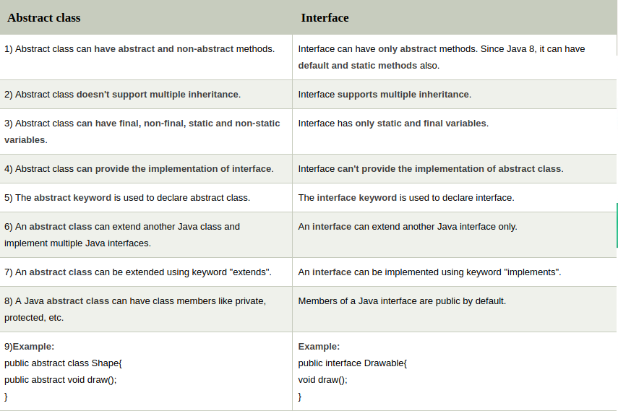
2. Can we call run() directly to start a new thread?
→ No you can not directly call run() to start a thread. You need to call start() to create a new thread. If you call run() directly it will not create a new thread and it will be in the same stack as main.

