Adding Syntax Parameters to the Sweet.JS Macro Library for JavaScript

A Project

Presented to

The Faculty of the Department of Computer Science

San Jose State University

In Partial Fulfillment

of the Requirements for the Degree

Master of Science

by

Vimal Kumar

May 2015

*○*c 2015

Vimal Kumar

ALL RIGHTS RESERVED

The Designated Project Committee Approves the Project Titled

Adding Syntax Parameters to the Sweet.JS Macro Library for JavaScript by

Vimal Kumar

APPROVED FOR THE DEPARTMENTS OF COMPUTER SCIENCE SAN JOSE STATE UNIVERSITY

May 2015

Dr. Thomas H. Austin Department of Computer Science Dr. Chris Pollett Department of Computer Science Dr. Ronald Mak Department of Computer Science

ABSTRACT

Adding Syntax Parameters to the Sweet.JS Macro Library for JavaScript by Vimal Kumar

Lisp and Scheme have demonstrated the power of macros to enable programmers to evolve and craft languages. Mozilla Sweet.JS provides a way for developers to enrich their JavaScript code by adding new syntax to the language through the use of macros. Sweet.JS provides the possibility to define hygienic macros inspired by Scheme.

In this paper I present the implementation of a “syntax parameter” feature for the Sweet.JS library.A syntax parameter is a mechanism for rebinding a macro definition within the dynamic context of a macro expansion. Some time hygienic macro binding is insufficient example of which is “anaphoric conditionals" where the value of the tested expression is available as an it bindings. Syntax parameter are a great tool for solving the problem of macro that need to bind a known name.In my implementation I define the “syntaxparam,” which defines and binds the syntax parameter part of the compiler; “syntaxLocalValue,” which pull the syntax parameter definition in the de- fined scope and “replaceSyntaxParamTransform,” which expand the syntax parameter macro definition defined within the macro body using “syntaxLocalValue”.

ACKNOWLEDGMENTS

This project would not have been possible without the kind support and help of many individuals. I would like to extend my sincere thanks to all of them.

I am highly indebted to Dr. Thomas Austin, and Tim Disney, for their guidance and constant supervision as well as for providing necessary information regarding the project & also for their support in completing the project. I would like to thank my thesis committee members Dr.Chris Pollett and Dr.Ronald Mak for their encourage- ment, insightful comments, and hard questions.

TABLE OF CONTENTS

CHAPTER

1

|  |  |  |  |  |  |  |  |  |  |  |  |  |  |  |  |  |  |  |  |  |  |  |  |  |  |  |  |
| --- | --- | --- | --- | --- | --- | --- | --- | --- | --- | --- | --- | --- | --- | --- | --- | --- | --- | --- | --- | --- | --- | --- | --- | --- | --- | --- | --- |
| 1 | Introduction . . . . . . | . | . | . | . | . | . | . | . | . | . | . | . | . | . | . | . | . | . | . | . | . | . | . | . | . | . |

|  |  |  |  |  |  |  |  |  |  |  |  |  |  |  |  |  |  |  |  |  |  |  |  |  |  |  |  |  |
| --- | --- | --- | --- | --- | --- | --- | --- | --- | --- | --- | --- | --- | --- | --- | --- | --- | --- | --- | --- | --- | --- | --- | --- | --- | --- | --- | --- | --- |
| 1.1 | What are macros? . | . | . | . | . | . | . | . | . | . | . | . | . | . | . | . | . | . | . | . | . | . | . | . | . | . | . | 1 |
| 1.2 | Hygiene . . . . . . | . | . | . | . | . | . | . | . | . | . | . | . | . | . | . | . | . | . | . | . | . | . | . | . | . | . | 5 |
| 1.3 | Syntax Parameters | . | . | . | . | . | . | . | . | . | . | . | . | . | . | . | . | . | . | . | . | . | . | . | . | . | . | 6 |

9

|  |  |  |  |  |  |  |  |  |  |  |  |  |  |  |  |  |  |  |  |  |  |  |  |  |  |  |  |
| --- | --- | --- | --- | --- | --- | --- | --- | --- | --- | --- | --- | --- | --- | --- | --- | --- | --- | --- | --- | --- | --- | --- | --- | --- | --- | --- | --- |
| 2 | Basics of Sweet.JS . . | . | . | . | . | . | . | . | . | . | . | . | . | . | . | . | . | . | . | . | . | . | . | . | . | . | . |

2.1 Type of macros in Sweet.JS . . . . . . . . . . . . . . . . . . . . . 9

|  |  |  |  |  |  |  |  |  |  |  |  |  |  |  |  |  |  |  |  |  |  |  |  |  |  |
| --- | --- | --- | --- | --- | --- | --- | --- | --- | --- | --- | --- | --- | --- | --- | --- | --- | --- | --- | --- | --- | --- | --- | --- | --- | --- |
| 2.2 | How Sweet.JS work? . . | . | . | . | . | . | . | . | . | . | . | . | . | . | . | . | . | . | . | . | . | . | . | . | 12 |
| 2.3 | Problem trying to solve? | . | . | . | . | . | . | . | . | . | . | . | . | . | . | . | . | . | . | . | . | . | . | . | 15 |

|  |  |  |  |  |  |  |  |  |  |  |  |  |  |  |  |  |  |  |  |  |  |  |  |  |  |  |  |  |  |
| --- | --- | --- | --- | --- | --- | --- | --- | --- | --- | --- | --- | --- | --- | --- | --- | --- | --- | --- | --- | --- | --- | --- | --- | --- | --- | --- | --- | --- | --- |
| 3 | Syntax parameters . | . | . | . | . | . | . | . | . | . | . | . | . | . | . | . | . | . | . | . | . | . | . | . | . | . | . | . | 19 |
|  | 3.1 Approach 1 . . . | . | . | . | . | . | . | . | . | . | . | . | . | . | . | . | . | . | . | . | . | . | . | . | . | . | . | . | 19 |
|  | 3.2 Approach 2 . . . | . | . | . | . | . | . | . | . | . | . | . | . | . | . | . | . | . | . | . | . | . | . | . | . | . | . | . | 22 |

LIST OF FIGURES

|  |  |  |  |  |  |  |  |  |  |  |  |  |  |  |  |  |  |  |  |  |  |  |  |  |  |
| --- | --- | --- | --- | --- | --- | --- | --- | --- | --- | --- | --- | --- | --- | --- | --- | --- | --- | --- | --- | --- | --- | --- | --- | --- | --- |
| 1 | Sweet.JS anatomy. . . . | . | . | . | . | . | . | . | . | . | . | . | . | . | . | . | . | . | . | . | . | . | . | . | 12 |
| 2 | Token tree. . . . . . . . | . | . | . | . | . | . | . | . | . | . | . | . | . | . | . | . | . | . | . | . | . | . | . | 13 |
| 3 | Final AST from parser. . | . | . | . | . | . | . | . | . | . | . | . | . | . | . | . | . | . | . | . | . | . | . | . | 13 |

|  |  |  |  |  |  |  |  |  |  |  |  |  |  |  |  |  |  |  |  |  |  |  |  |  |  |  |  |  |
| --- | --- | --- | --- | --- | --- | --- | --- | --- | --- | --- | --- | --- | --- | --- | --- | --- | --- | --- | --- | --- | --- | --- | --- | --- | --- | --- | --- | --- |
| 4 | Macro Expansion. | . | . | . | . | . | . | . | . | . | . | . | . | . | . | . | . | . | . | . | . | . | . | . | . | . | . | 14 |
| 5 | Term tree. . . . . . | . | . | . | . | . | . | . | . | . | . | . | . | . | . | . | . | . | . | . | . | . | . | . | . | . | . | 14 |
| 6 | Breaking hygiene. . | . | . | . | . | . | . | . | . | . | . | . | . | . | . | . | . | . | . | . | . | . | . | . | . | . | . | 16 |
| 7 | Macro expansion. . | . | . | . | . | . | . | . | . | . | . | . | . | . | . | . | . | . | . | . | . | . | . | . | . | . | . | 17 |
| 8 | Approach 1. . . . . | . | . | . | . | . | . | . | . | . | . | . | . | . | . | . | . | . | . | . | . | . | . | . | . | . | . | 20 |

9

|  |  |  |  |  |  |  |  |  |  |  |  |  |  |  |  |  |  |  |  |  |  |  |  |  |  |  |
| --- | --- | --- | --- | --- | --- | --- | --- | --- | --- | --- | --- | --- | --- | --- | --- | --- | --- | --- | --- | --- | --- | --- | --- | --- | --- | --- |
| Calling unless macro | . | . | . | . | . | . | . | . | . | . | . | . | . | . | . | . | . | . | . | . | . | . | . | . | . | 20 |

10 it identifier is correctly bounded to $cond.. Of an anaphoric-if . . 21

11 Approach 2.Syntax parameter implementation contd.. . . . . . . . 23

12 Approach 2. Syntax parameter expansion . . . . . . . . . . . . . 23

13 Approach 2. Implementation . . . . . . . . . . . . . . . . . . . . 24

CHAPTER 1

Introduction

1.1 What are macros?

A macro is a rule or pattern that specifies how a certain input sequence should be mapped to an output sequence according to some defined procedure. Using a macro system a programmer can introduce new syntactic elements to the programming language. Macros found in a program are expanded by a macro expander and allow a programmer to enable code reuse. There are two types of macro systems

1. Lexical macro systems, such as the C preprocessor, transform the codes before compilation. Lexical macros are ignorant of the grammar of the core programming language and therefore sometimes result in ill-formed programs and in accidental capture of identifiers [3]. They only require lexical analysis; that is they operate on the source text prior to any parsing, using simple substi- tution of tokenized character sequences for other tokenized character sequences, according to user-defined rules. Consider this example

#d e f i n e INCI ( i ) { i n t a =0; ++i ; }

i n t main ( v o i d ) {

i n t a = 0 , b = 0 ; INCI ( a ) ;

INCI ( b ) ;

p r i n t f ( " a i s now %d , b i s now %d \ n " , a , b ) ;

r e t u r n 0 ;

}

Running through C preprocessor result in

i n t main ( v o i d )

{

i n t a = 0 , b = 0 ;

{ i n t a =0; ++a ; } ;

{ i n t a =0; ++b ; } ;

p r i n t f ( " a i s now %d , b i s now %d \ n " , a , b ) ;

r e t u r n 0 ;

}

The variable a declared in the top scope is shadowed by the a variable in the

macro, which introduces a new scope.The output of the compiled program is:

a i s now 0 , b i s now 1

The solution is to give the macro’s variables names that do not conflict with

any variable in the current program:

#d e f i n e INCI ( i ) { i n t INCIa =0; ++i ; }

i n t main ( v o i d )

{

i n t a = 0 , b = 0 ; INCI ( a ) ;

INCI ( b ) ;

p r i n t f ( " a i s now %d , b i s now %d \ n " , a , b ) ;

r e t u r n 0 ;

}

this solution produces the correct output:

a i s now 1 , b i s now 1

The problem is solved for the current program, but this solution is not robust. This is where we require hygiene macro system which help in preserving the lexical scoping of all identifiers.

2. Syntatic macro systems, like those in the Lisp and Scheme [12] programming languages are aware of the grammar of the core programming language. They transform the syntax tree according to a number of user-defined rules. Rules can be written in the same programming language as the program or another language that relies on a fully external language to define the transformation, such as the XSLT preprocessor for XML [3]. Below is an example of a syntatic macro in scheme that swaps the values.

( d e f i n e *−*s y n t a x *−*r u l e ( swap x y ) ( l e t ( [ tmp x ] )

( s e t ! x y )

( s e t ! y tmp ) ) )

The define-syntax-rule is the template, used in place of a form that matches the pattern, except that each instance of a pattern variable in the template is

replaced with the part of that macro use the pattern variable matched.

( l e t ( [ tmp 5 ]

[ o t h e r 6 ] )

( swap tmp o t h e r )

( l i s t tmp o t h e r ) )

The result of the above expression should be (6 5). The naive expansion of this

use of swap, however, is

( l e t ( [ tmp 5 ]

[ o t h e r 6 ] )

( l e t ( [ tmp tmp ] )

( s e t ! tmp o t h e r )

( s e t ! o t h e r tmp ) ) ( l i s t tmp o t h e r ) )

whose result is (5 6). The problem is that the naive expansion confuses the tmp

in the context where swap is used with the tmp that is in the macro template. Instead it produces

( l e t ( [ tmp 5 ]

[ o t h e r 6 ] )

( l e t ( [ tmp_1 tmp ] ) ( s e t ! tmp o t h e r )

( s e t ! o t h e r tmp_1 ) )

( l i s t tmp o t h e r ) )

with the correct result of (6 5). Racket’s [14] pattern-based macros automati- cally maintain lexical scope, so macro implementors can reason about variable references in macros and macro uses in the same way as for functions and func- tion calls.

1.2 Hygiene

Hygienic macros are macros whose expansion does not cause the accidental cap- ture of identifiers introduced by the macro expander. Hygiene prevents variable names inside the macros from clashing with the variables in the surrounding code. Hygienic macro systems are a feature of programming languages such as Scheme.

There are occasions when traditional hygienic binding is insufficient: one example is the "anaphoric if condition" (version of the if-then-else construct which introduces an anaphor it which is bound to the result of the test clause), where expanding the macro definition at compile time may introduce new variable bindings, that capture variables in your own code. That is, the new binding might shadow a variable that you have already created. Example

( d e f i n e *−*s y n t a x o r

( s y n t a x *−*r u l e s ( ) ( (_ e 1 e 2 )

( l e t ( ( t e 1 ) )

( i f t t e 2 ) ) ) ) )

We can call the above macro as shown below:

( l e t ( ( t 5 ) )

( o r #f t ) )

The macro call is expanded to:

( l e t ( ( t 5 ) )

( l e t ( ( t #f ) )

( i f t t t ) ) )

This program evaluates to #f, which is not the desired output. On expanding the macro the binding “t” is shadowed to #f. If you run this in the scheme REPL, the output will be 5. One way to work around this, which was a common trick for LISP programmers of yore is to choose variable names that a programmer is unlikely to guess. We could modify the macro expander to automatically rename any variables bound by a macro expansion. In this case, our simple test program would expand as

follows, using our first definition of “or”:

( l e t ( ( t 5 ) )

( l e t ( ( t . 1 #f ) )

( i f t . 1 t . 1 t ) ) )

This program evaluates as expected.

1.3 Syntax Parameters

Syntax parameters are a mechanism for rebinding a macro definition within the dynamic extent of a macro expansion. The ability to write functions that instead of accepting and returning values, accept and return pieces of source code, allows for abstractions and extensions that just simply aren’t possible in other languages. Below example shows how to define a syntax parameter in Racket:

#l a n g r a c k e t

( r e q u i r e r a c k e t / s t x p a r a m )

( d e f i n e *−*s y n t a x *−*p a r a m e t e r e x a m p l e*−*s t x *−*p a r a m e t e r

( lambda ( s t x )

# ’( d i s p l a y l n " I ’m a s y n t a x p a r a m e t e r ! " ) ) )

All macros are functions that take as input a syntax object representing the piece of the program where it was located, and return a new syntax object to replace the old one within the program. So with the following syntax parameter defined, this code

( e x a m p l e*−*s t x *−*p a r a m e t e r )

The expanded code is

( d i s p l a y l n " I ’m a s y n t a x p a r a m e t e r ! " )

Remember that this transformation happens at compile time before the code is run. The purpose of a syntax parameter is to be modified by other macros with the syntax- parameterize form, which looks like this

( s y n t a x *−*p a r a m e t e r i z e

( [ e x a m p l e*−*s t x *−*p a r a m e t e r ( lambda ( s t x )

# ’( d i s p l a y l n " I ’m p a r a m e t e r i z e d ! " ) ) ] ) ( e x a m p l e*−*s t x *−*p a r a m e t e r ) )

( e x a m p l e*−*s t x *−*p a r a m e t e r )

The syntax-parameterize form "renames" the parameter, giving it a new value that applies only in the code inside the syntax-parametrize form. So when the above

code is expanded, it produces

( d i s p l a y l n " I ’m p a r a m e t e r i z e d ! " )

( d i s p l a y l n " I ’m a s y n t a x p a r a m e t e r ! " )

The occurence of “example-stx-parameter” inside the syntax-parameterize form used the function defined in syntax-parameterize to transform the code instead of the original function.

In this paper,I present the example of a macro that breaks hygienie in Sweet.JS and propose a solution taking inspiration from Scheme’s syntax parameters. The problem and solution discussed in up-coming chapters.

CHAPTER 2

Basics of Sweet.JS

Sweet.JS [6] is a hygienic macro compiler for JavaScript that takes JavaScript macros and produces normal JavaScript code which one can run in a browser or using a standalone interpreter like Node.JS. The idea is that you define a macro with a name and a list of patterns. Whenever a macro is invoked, the code is matched and expanded at compile time and produces the expanded source that can be run in any JavaScript environment.

2.1 Type of macros in Sweet.JS

1. Rule macros Rule macros work by matching a syntax pattern and generating new syntax based on the template. To define a rule base macro the grammar is

macro <name> {

r u l e { <p a t t e r n > } => { <t e m p l a t e > }

}

The following macro defines swapping two values:

macro swap {

r u l e { ( $x , $y ) } => {

v a r tmp = $x ;

$x = $y ; $y = tmp ;

}

}

v a r f o o = 5 ;

v a r tmp = 6 ;

swap ( f o o , tmp ) ;

When the compiler hits "swap", it invokes the macro and runs each rule against the code after it. When a pattern is matched, it returns the code within the rule. You can bind identifiers & expressions within the matching pattern and use them within the code.

if Sweet.JS did not support hygiene, this macro might expand to

v a r f o o = 5 ;

v a r tmp = 6 ;

v a r tmp = f o o ;

f o o = tmp ;

tmp = tmp ;

The tmp created from the macro collides with my local tmp. This is a serious problem, but macros solve this issue by implementing hygiene. Basically they track the scope of variables during expansion and rename them to maintain the correct scope. Sweet.js fully implements hygiene so it never generates the code

you see above. It would actually generate the following code

v a r f o o = 5 ;

v a r tmp$1 = 6 ;

v a r tmp$2 = f o o ; f o o = tmp$1 ; tmp$1 = tmp$2 ;

Notice how two different "tmp" variables are created. This makes it extremely powerful to create complex macros elegantly.

2. Case macros Case macro are analogous to syntax-case in Scheme. Case macros allow the macro author to use JavaScript code to procedurally create and manipulate the syntax. To define case macros, the grammar is

macro <name> {

c a s e { <p a t t e r n > } => { <body> }

}

The following macro adds syntax for generating random numbers:

macro r a n d {

c a s e { _ $x } => {

v a r r = Math . random ( ) ;

l e t s t x $ r = [ makeValue ( r ) ] ;

r e t u r n #{ v a r $x = $ r }

}

}

r a n d x ;

The above code expand to

v a r x $ 1 2 3 = 0 . 8 3 6 7 5 0 1 5 3 3 1 6 1 1 7 7 ;

The body of a macro contains a mixture of templates and normal JavaScript that can create and manipulate syntax The code within the “case” is run at

expand-time and you use #{} to create "templates" that construct code just like the syntax in the rule macros.

2.2 How Sweet.JS work?

Sweet.JS includes a separate reader that converts a sequence of tokens into a sequence of token trees, analogous to s-expressions in scheme, without feedback from the parser [2].

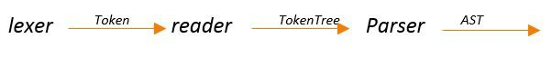

Figure 1: Sweet.JS anatomy.

The parser gives structure to unstructured source code. The lexer converts a character stream to a token stream and the parser converts the token stream into an abstract syntax tree (AST) according to a context free grammar [2]. The macro expander must sit in between the lexer and the parser. Here the reader records sufficiently history information in the form of token trees in order to decide how to parse the token, which is required to decide if token is a divisor or a regular expression. In traditional JavaScript compilers, the parser and lexer are intertwined; rather than running the entire program through the lexer once to get a sequence of tokens, the parser calls out to the lexer from a given grammatical context with a flag to indicate if the lexer should accept a regular expression or a divide operator and the input character are tokenized accordingly [2].

Example

macro i d {

c a s e {_ $x } => {

r e t u r n #{ $x }

}

}

i d 4 2

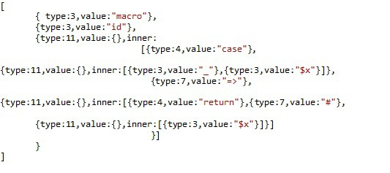

Figure 2: Token tree.

Reader convert string of token to token tree , A token tree is similar to tokens produced by the standard esprima lexer [7] but with the critical difference being that token trees match delimiters.

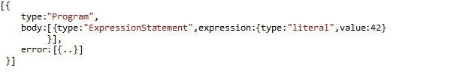

Figure 3: Final AST from parser.

The parser give structure to unstructured source code, In parsers without macro systems, this is usually accomplished by a lexer that convert a character stream to a token stream and a parser that convert the token stream into an AST according to a context-free grammar.

The approach used in Sweet.JS is Enforestation, first pioneered by Honu [4]. Enforestation means ,extracts the sequence of terms produced by the reader to create a term tree. Consider following let example

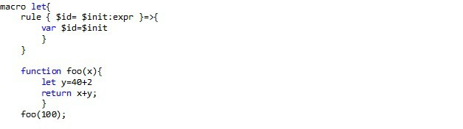

Figure 4: Macro Expansion.

Enforestation begins by loading the let macro into the macro environment and converting the function declaration into a term tree.

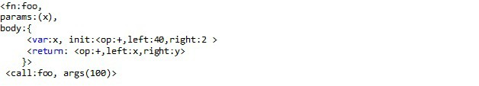

Figure 5: Term tree.

A term tree is a kind of proto-AST that represent a partial parse of the program. As the expander passes through the token trees, it creates term trees that contain unexpanded sub trees that will be expanded once all macro definition have been discovered in the current scope.

2.3 Problem trying to solve?

Although the benefits of hygienic macros are well established, there are occasions when traditional hygienic bindings are insufficient. The classic example is "anaphoric conditionals" where the value of the tested expression is available as an it bind- ings.When the condition is true, an it identifier is automatically created and set to the value of the condition. An anaphoric macro is a type of programming macro that deliberately captures some form supplied to the macro which may be referred to by an anaphor (an expression referring to another).

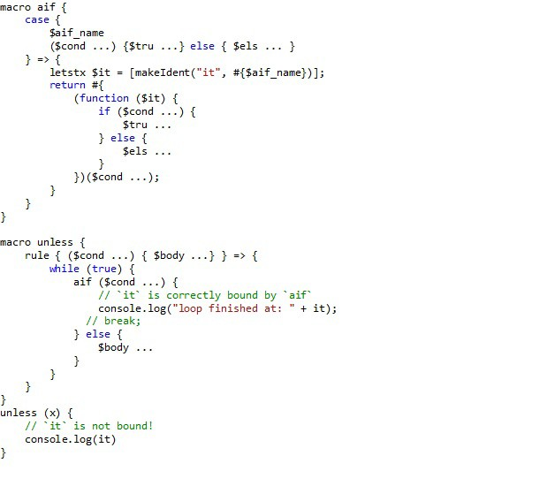

Figure 6: Breaking hygiene.

In above example, I define the "unless" macro which executes code if conditional is false. If the conditional is true, code specified in the else clause is executed. Here we used anaphoric-if condition which introduces an anaphor it which should bound to the result of the test clause.

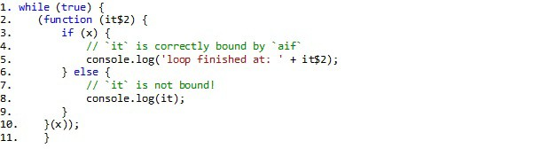

Figure 7: Macro expansion.

In Figure 7, at line (8) the identifier it is not defined. Here we wish to introduce the identifiers deliberately breaking hygiene.

The same unhygienic macros are possible in Scheme as shown in the below ex- ample,

( d e f i n e *−*s y n t a x *−*r u l e ( a i f c o n d i t i o n t r u e *−*e x p r f a l s e *−*e x p r ) ( l e t ( [ i t c o n d i t i o n ] )

( i f i t

t r u e *−*e x p r

f a l s e *−*e x p r ) ) )

( a i f #t ( d i s p l a y l n i t ) ( v o i d ) )

i t : u n d e f i n e d ;

c a n n o t r e f e r e n c e an i d e n t i f i e r b e f o r e i t s d e f i n i t i o n i n module : ’ p r o g r a m

When using syntax-parameterize, it acts as an alias for tmp. The alias behavior is created by make-rename-transformer. define-syntax-parameter, binds the key- word to the value obtained by evaluating the transformer. The transformer provides

the default expansion for the syntax parameter. syntax-parameterize adjusts the keyword to use the values obtained by evaluating their transformer in the expansion

of the expression.

( r e q u i r e r a c k e t / s t x p a r a m )

( d e f i n e *−*s y n t a x *−*p a r a m e t e r i t

( lambda ( s t x )

( r a i s e *−*s y n t a x *−*e r r o r ( s y n t a x *−*e s t x ) " c a n o n l y b e u s e d i n s i d e a i f " ) ) )

( d e f i n e *−*s y n t a x *−*r u l e ( a i f c o n d i t i o n t r u e *−*e x p r f a l s e *−*e x p r ) ( l e t ( [ tmp c o n d i t i o n ] )

( i f tmp

( s y n t a x *−*p a r a m e t e r i z e ( [ i t ( make*−*rename*−*t r a n s f o r m e r #’tmp ) ] )

t r u e *−*e x p r )

f a l s e *−*e x p r ) ) )

"define-syntax-parameter," binds the keyword to the value obtained by evaluat- ing the transformer. The transformer provides the default expansion for the syntax parameter."syntax-parameterize," adjust keyword to use the values obtained by evaluating their transformer in the expansion of the expression.

CHAPTER 3

Syntax parameters

Syntax parameter are a mechanism for rebinding a macro definition within the dynamic extent of a macro expansion. With syntax parameters instead of introducing the unhygienic binding each time we instead create a binding for the keyword, which we can adjust later when we want the keyword to have a different meaning. As no new binding is introduced so hygiene is preserved, This is similar to the dynamic binding mechanism that we have at run time, except that the dynamic binding only occurs during macro expansion.

3.1 Approach 1

In this approach I tried to use pre-processing approach similar to C, where I transform the code before the main compiler gets hold of it. “SyntaxParameter" replaces and binds the parameter with its mapped value in the particular defined macro scope. Here the macro transformation happens during the parse phase by matching the pattern. To define syntax parameters in Sweet.JS, the programmer provides a new keyword that looks something like this:

S y n t a x P a r a m e t e r (< p a r a m e t e r >,<Mapped t o > ,

<S c o p e / Macro Name>,<Macro d e f i n i t i o n >)

“parameter" an identifier that is defined as a syntax parameter in the macro def- inition, “Mapped to" is the macro input variable that will be mapped to “parameter", “Scope’ define the context of the macro definition.

An example of its usage is shown below:

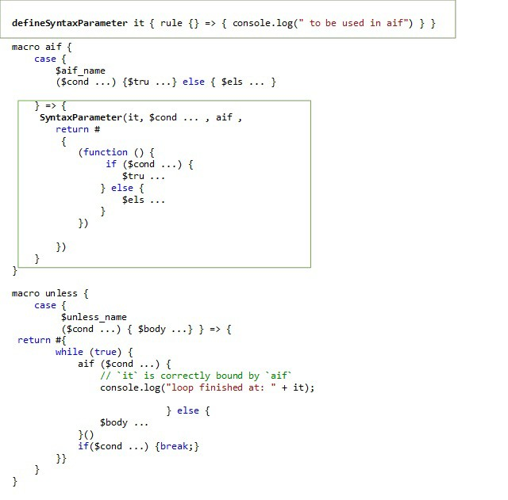

Figure 8: Approach 1.

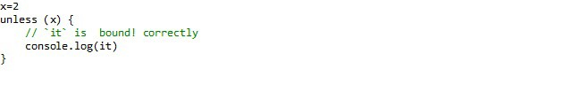

Figure 9: Calling unless macro

The expanded code looks like:

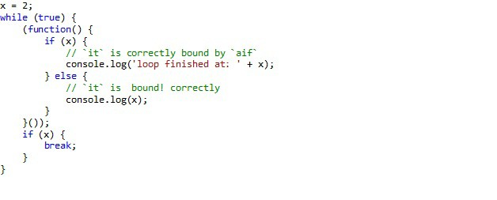

Figure 10: it identifier is correctly bounded to $cond.. Of an anaphoric-if

As the example in Figure 10 shows, ‘it’ is correctly bounded to $cond.. as desired, However this approach has certain disadvantages, since this won‘t allow users to define macros named “SyntaxParameter”

At the moment in Sweet.JS the only way to create a syntax transformer is by defining a macro. A macro is really just a function that takes syntax and returns syntax (thus a syntax transformer). To fix this we first need to implement some primitive function that help us to create and manipulate the arbitrary compile time syntax transformation. Macros are compile time syntax transformation , So when the “expander” encounters a macro definition it converts the body of the macro into a function and loads it into the compile time environment.

3.2 Approach 2

In this approach I, defined “syntaxparam” similar to define-syntax-parameter in Scheme, which loads the primitive function in compile time environ- ment,”syntaxLocalValue,” which load the compile time primitive function from the environment and “replaceSyntaxParam,” which transforms the identifier with the com- pile time value from the environment returned by ”syntaxLocalValue,” within the defined scope of the macro. Example shown below

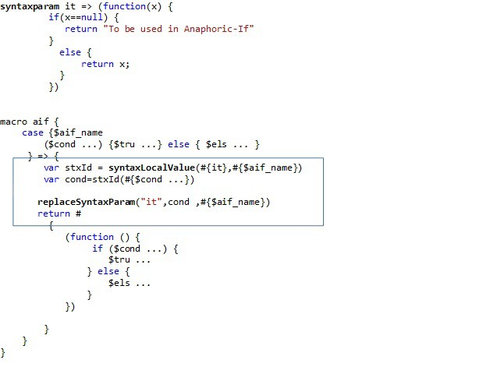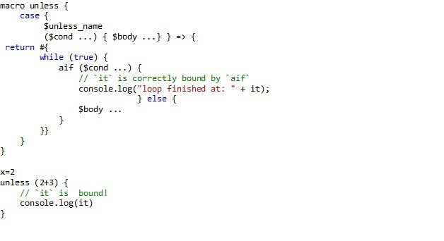

Figure 11: Approach 2.Syntax parameter implementation contd..

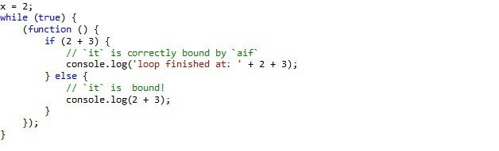

Figure 12: Approach 2. Syntax parameter expansion

The main entry point into the expander is appropriately enough, expand function is primarily responsible for handling hygiene. The env param is a mapping from identifier to macro definitions and ctx is a mapping of names to names. The expand function delegates to expandToTermTree, responsible for converting the syntax to TermTrees and loading any macro definitions it finds into the new env map.

Its in the “expandToTermTree,” it call enforest repeatedly until the entire token tree has been converted into a term tree. its in enforest function where “syntaxparam”

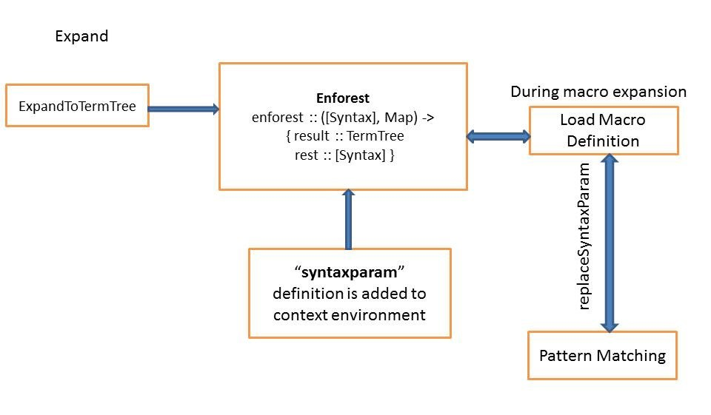

Figure 13: Approach 2. Implementation

definition loaded to context env map. When macro call is invoked it load the macro definition from the env in “loadmacrodef ” function and during pattern matching “re- placeSyntaxParam” which bind the identifier with the value.

LIST OF REFERENCES

[1] Eli, B., Culpepper, R., & Flatt, M. (2011, 11 05). Keep it Clean with Syntax Parameters, <http://scheme2011.ucombinator.org/papers/Barzilay2011.pdf>

[2] Disney, T., Faubion, N., & Herman, D. (2014, 8 21). Sweeten Your JavaScript: Hygienic Macros for ES5,

<http://disnetdev.com/papers/sweetjs.pdf>

[3] Arai, H., & Wakita, K. (2012). An Implementation of A Hygienic Syntatic Macro System for JavaScript: A Preliminary Report, [http://www.is.titech.ac.jp/~wakita/files/arai-s3.pdf](http://www.is.titech.ac.jp/%7Ewakita/files/arai-s3.pdf)

[4] Rafkind, J., & Flatt, M. (2012, 9 26). Honu: Syntactic Extension for Algebraic Notation through Enforestation, <http://www.cs.utah.edu/plt/publications/gpce12-rf.pdf>

[5] Flatt, M., Culpepper, R., & Findler, R. B. (2012, 3 27). Macros that Work

Together,

<http://www.cs.utah.edu/plt/publications/jfp12-draft-fcdf.pdf>

[6] Disney, T. (2014, 8 21). Retrieved from Sweet.JS Documentation,

<http://sweetjs.org/doc/main/sweet.html>

[7] The Esprima JavaScript Parser.

<http://esprima.org/>

[8] T. Disney, N. Faubion, D. Herman, and C. Flanagan. The Sweet.js Appendix. [https://github.com/mozilla/sweet.js/blob/master/doc/dls2014/ sweetjs-appendix.pdf](https://github.com/mozilla/sweet.js/blob/master/doc/dls2014/sweetjs-appendix.pdf)

[9] R. Kent Dybvig , Robert Hieb , Carl Bruggeman,

Syntactic abstraction in Scheme, Lisp and Symbolic Computation, v.5 n.4, p.295-

326, Dec. 1992.

[10] E. Kohlbeker, D.p. Friedman, M.Felleisen, and B. Duba. Hygienic macro ex- pansion. In LFP ’86: Proceedings of the 1986 ACM Conference on LISP and Functional Programming, 151-161, New York, NY, USA, 1986. ACM.

[11] Fear of Macrp.

<http://www.greghendershott.com/fear-of-macros/index.html>

[12] R. Kent Dybvig.

The Scheme Programming Language. The MIT Press, fourth edition, 2009b.

[13] Scheme Syntax Parameters

<http://download.plt-scheme.org/doc/html/reference/stxparam.html>

[14] Racket Syntax Transformers

<http://docs.racket-lang.org/reference/stxtrans.html>

[15] Racket Syntax Parameters

<http://docs.racket-lang.org/reference/stxparam.html>