**SPECTROGRAM**

* 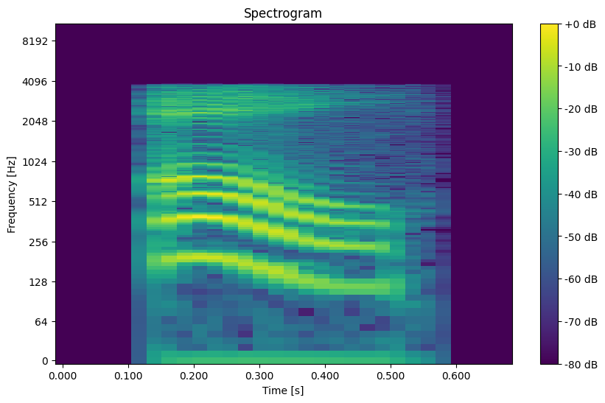Spectrogram when an audio file of sound “a” is given as input is

**CODE 1**

import numpy as np

import librosa

import librosa.display

import matplotlib.pyplot as plt

from scipy.io.wavfile import write

# Load the audio file

filename = 'your_audio_file.wav'  # Replace with the path to your audio file

y, sr = librosa.load(filename)

# Generate the spectrogram

S = librosa.stft(y)  # Short-time Fourier transform

S_db = librosa.amplitude_to_db(np.abs(S), ref=np.max)  # Convert to decibel scale

# Display the spectrogram (optional)

plt.figure(figsize=(10, 6))

librosa.display.specshow(S_db, sr=sr, x_axis='time', y_axis='log', cmap='viridis')

plt.colorbar(format='%+2.0f dB')

plt.title('Spectrogram')

plt.xlabel('Time [s]')

plt.ylabel('Frequency [Hz]')

plt.show()

# Convert the spectrogram back to audio

S_inverse = librosa.db_to_amplitude(S_db)  # Convert from dB back to amplitude

y_reconstructed = librosa.istft(S_inverse)  # Inverse Short-time Fourier transform

# Save the reconstructed audio to a file

output_filename = 'reconstructed_audio.wav'

write(output_filename, sr, y_reconstructed.astype(np.float32))

print(f'Reconstructed audio saved as {output_filename}')

* 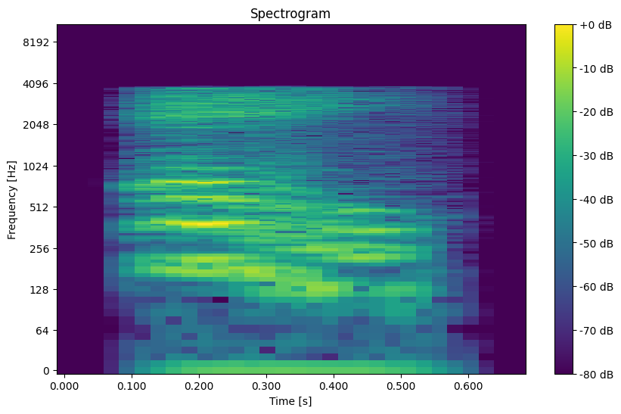Spectrogram when the output of audio file of the above mentioned spectrogram is

**CODE 2**

import numpy as np

import librosa

import librosa.display

import matplotlib.pyplot as plt

from scipy.io.wavfile import write

# Load the audio file

filename = '/content/reconstructed_audio.wav'  # Replace with the path to your audio file

y, sr = librosa.load(filename)

# Generate the spectrogram

S = librosa.stft(y)  # Short-time Fourier transform

S_db = librosa.amplitude_to_db(np.abs(S), ref=np.max)  # Convert to decibel scale

# Display the spectrogram (optional)

plt.figure(figsize=(10, 6))

librosa.display.specshow(S_db, sr=sr, x_axis='time', y_axis='log', cmap='viridis')

plt.colorbar(format='%+2.0f dB')

plt.title('Spectrogram')

plt.xlabel('Time [s]')

plt.ylabel('Frequency [Hz]')

plt.show()

# Convert the spectrogram back to audio

S_inverse = librosa.db_to_amplitude(S_db)  # Convert from dB back to amplitude

y_reconstructed = librosa.istft(S_inverse)  # Inverse Short-time Fourier transform

# Save the reconstructed audio to a file

output_filename = 'reconstructed_audio.wav'

write(output_filename, sr, y_reconstructed.astype(np.float32))

print(f'Reconstructed audio saved as {output_filename}')