**DISASTER RECOVERY USING IBM WITH IBM CLOUD VIRTUAL SERVER**

**DESCRIPTION:**

Disaster recovery with IBM Cloud Virtual Server involves implementing strategies and processes to ensure business continuity in the event of a disaster. IBM Cloud Virtual Server is a cloud computing service that allows users to create and manage virtual servers on the IBM Cloud platform.

**OBJECTIVES:**

Disaster recovery planning involves strategizing, planning, deploying appropriate technology, and continuous testing. Maintaining backups of your data is a critical component of disaster recovery planning, but a backup and recovery process alone does not constitute a full disaster recovery plan.



**TYPES:**

* Analysis
* implementation
* testing.

**RECOVERY POINT OBJECTIVE:**

Recovery point objective (RPO) is the point in time relative to the failure to which you need preservation of data. Data changes preceding the failure or disaster by at least this time period are preserved by recovery processing. Zero is a valid value and is equivalent to a “zero data loss” requirement

**GOALS:**

* Assessment and Planning:

critical systems and data that need to be protected.

* Create Backup and Replication Strategy:

Use IBM Cloud’s backup and snapshot features to create regular backups of your virtual servers.

Consider setting up asynchronous or synchronous replication for real-time data replication to your disaster recovery site.

* Provision Disaster Recovery Site:

Create a secondary virtual server environment in a different IBM Cloud data center region.

Ensure that this environment is prepared to take over in case of a disaster.

* Automate Failover:

Implement automated failover mechanisms that can detect failures in your primary site and trigger the switch to the disaster recovery site.

Utilize automation tools and scripts for this purpose.

* Test and Document:

Regularly test your disaster recovery setup to ensure it works as expected.

Document your disaster recovery plan, including the step-by-step procedures for failover and recovery.

* Security and Access Control:

Ensure that your disaster recovery environment has appropriate security measures in place, such as firewalls, access control lists, and encryption.

Restrict access to authorized personnel.

* Monitoring and Alerting:

Implement continuous monitoring of your primary and disaster recovery environments.

Set up alerting systems to notify you of any issues or potential disasters.

* Regular Maintenance:

Keep your disaster recovery environment up-to-date with the latest configurations and software updates.

Perform periodic tests and drills to validate your disaster recovery plan.

* Communication and Notification:

Establish communication protocols to notify relevant teams or individuals in the event of a disaster.

* Documentation and Reporting:

. Maintain detailed documentation of your disaster recovery setup, testing results, and any incidents.

Regularly review and update your disaster recovery plan based on changing requirements or technology.

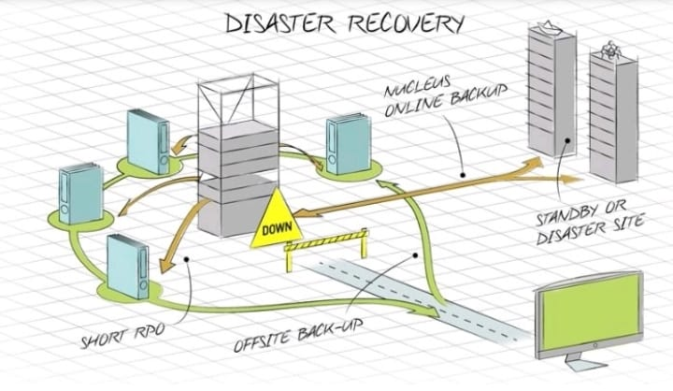

REFERENCE :

IBM Cloud offers various tools and services that can help you implement disaster recovery, including features like Cloud Virtual Servers, IBM Cloud Virtual Private Cloud (VPC), and IBM Cloud Object Storage for data backup and recovery. Be sure to consult IBM Cloud’s documentation and support resources for specific guidance on implementing disaster recovery in their fields.

KEY BENEFITS:

Cloud-based disaster recovery offers three key benefits: flexibility, reduced complexities, and most importantly, reduced downtime.

**Disaster recovery with IBM cloud server**

Disaster recovery with IBM Cloud servers typically involves setting up a plan to ensure that your data and applications are protected and can be quickly restored in case of a disaster. Here are the general steps to implement disaster recovery on IBM Cloud servers:

1. A**ssessment:**

Start by assessing your business's critical applications and data. Identify what needs to be protected and prioritize them based on their importance to your operations.

1. Backup and Replication:

Utilize IBM Cloud's backup and replication services to regularly back up your data and server configurations. You can use tools like IBM Cloud Backup or third-party solutions for this purpose.

1. Failover Planning:

Plan for how you will handle failovers in case of a disaster. IBM Cloud offers features like Virtual Server Recovery, which can automate failovers to a secondary location.

1. Secondary Data Center:

Set up a secondary data center or location in a different geographic region. This is essential for redundancy. IBM Cloud offers multiple data centers in various regions.

1. Network Configuration:

Ensure that network configurations are in place to redirect traffic to the secondary location when a failover occurs. This might involve using a global load balancer or DNS management.

6.Testing:

Regularly test your disaster recovery plan to ensure it works as expected. Simulate different disaster scenarios to validate your recovery procedures.

1. Monitoring and Alerts:

Implement monitoring and alerting systems to be notified of any issues with your primary server environment. IBM Cloud provides monitoring tools for this purpose.

1. Documentation:

Document your disaster recovery plan comprehensively, including step-by-step procedures, contact information, and recovery time objectives (RTOs).

1. Security:

Ensure that your disaster recovery environment is as secure as your primary environment. This includes access controls, encryption, and compliance with security best practices.

1. Staff Training:

Train your IT staff on the disaster recovery plan, and make sure they are familiar with the procedures to follow during a disaster.

1. Regular Updates:

Continuously update and refine your disaster recovery plan to adapt to changes in your infrastructure, applications, and business needs.

1. Compliance:

Ensure that your disaster recovery plan complies with any regulatory or industry-specific requirements that apply to your business.

* IBM Cloud provides various services and tools to assist with disaster recovery, including virtual servers, storage options, and networking capabilities. You can tailor your disaster recovery strategy to your specific needs and budget using these resources.
* Remember that disaster recovery is a critical aspect of business continuity, and it's essential to invest the necessary time and resources to implement a robust plan that can minimize downtime and data loss during unexpected events.

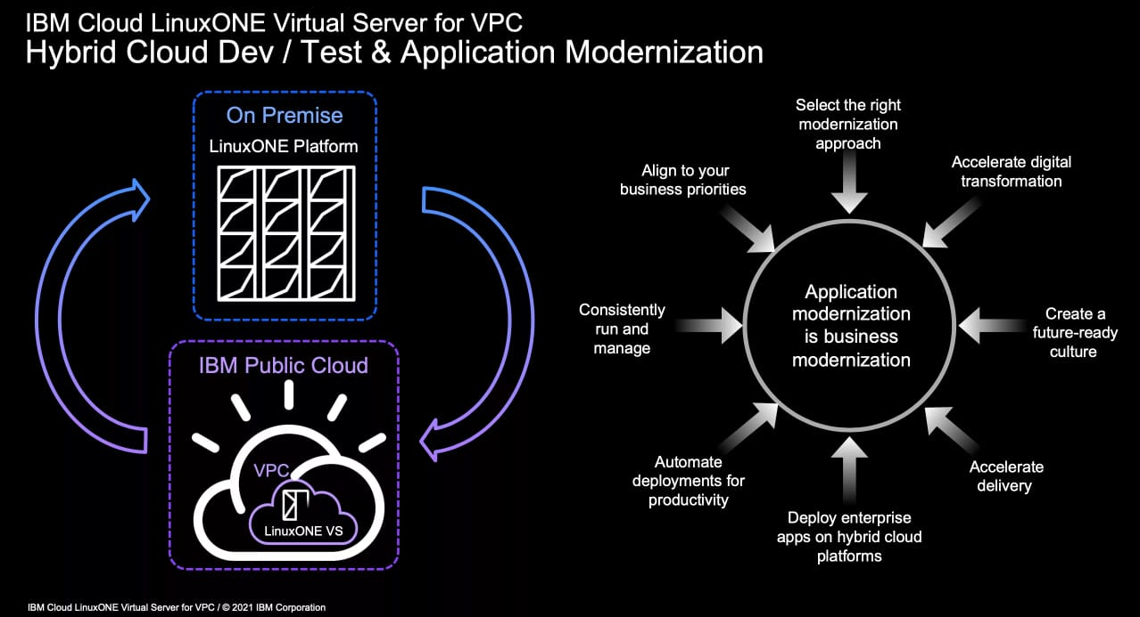Ft

**LINKS:**

* **https://cloud.ibm.com**
* [**https://www.ibm.com/support/pages/ibm-i-support-**](https://www.ibm.com/support/pages/ibm-i-support-)
* 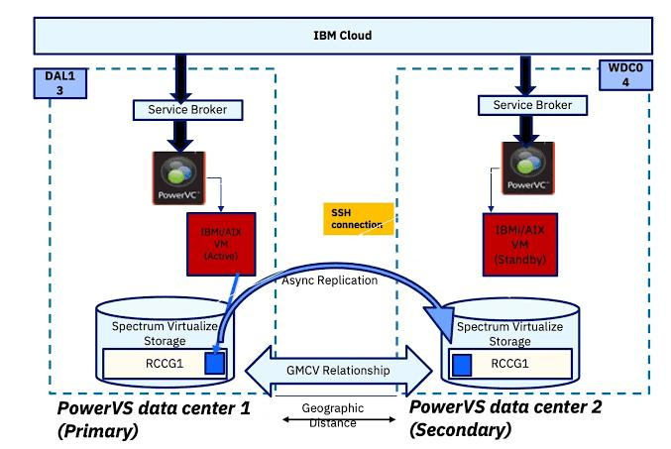

**Disaster recovery by IBM virtual service into innovation:**

* + **IBM offers disaster recovery solutions that leverage virtualization technology to ensure business continuity. Disaster recovery solutions provided by IBM Cloud servers offer a crucial foundation for business resilience and innovation. In an era where unexpected disruptions can derail operations, having a robust disaster recovery strategy in place is paramount. IBM’s Cloud servers, with their advanced capabilities and infrastructure, enable organizations to not only safeguard their critical data and systems but also drive innovation.**

**Solutions :**

* + **Resilience**
  + **Cost Savings**
  + **Agility**
  + **Data Analytics**
  + **Security**

**Resilience:**

**Virtualized disaster recovery services can help businesses quickly recover from disruptions, enabling them to maintain operations and innovate without significant downtime.**

**Cost savings:**

**By virtualizing disaster recovery, companies can reduce the need for physical infrastructure, leading to cost savings that can be reinvested in innovative projects.**

**Agility:**

**Virtualized disaster recovery allows for greater flexibility in managing and scaling resources, which is essential for adapting to changing business needs and driving innovation**

**Data Analytics:**

**Disaster recovery services often involve data backup and replication, which can provide a valuable dataset for analytics, helping organizations uncover insights and opportunities for innovation.**

**Security:**

**IBM’s disaster recovery solutions often include security features, safeguarding critical data and ensuring compliance, which is essential for innovation in industries with strict regulatory requirements**

**TECHNOLOGY ASSOCIATED :**

[**https://www.ibm.com/cloud/architecture/content/course/advanced**](https://www.ibm.com/cloud/architecture/content/course/advanced)

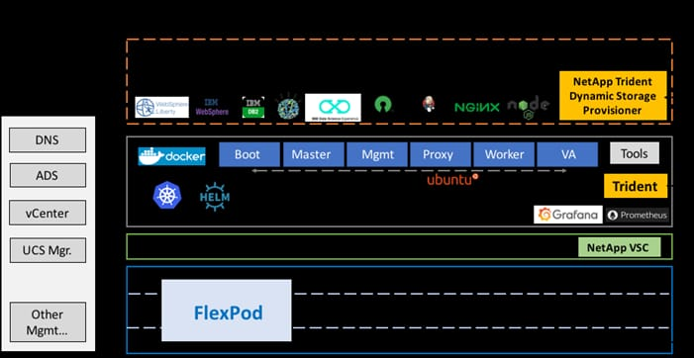

**CONCLUSION:**

**In conclusion, utilizing IBM Cloud Virtual Server for disaster recovery offers a robust and reliable solution for businesses. With its scalable infrastructure, high availability, and efficient backup and recovery capabilities, IBM Cloud Virtual Server ensures that businesses can quickly and effectively restore their operations in the event of a disaster. By leveraging IBM’s advanced technology and cloud services, organizations can enhance their disaster recovery strategies, minimize downtime, and safeguard their critical data and applications, ultimately ensuring business continuity and resilience in the face of unforeseen events.**

***COLLEGE:NANDHA COLLEGE OF TECHNOLOGY***

***TEAM MEMBERS:***

* ***R.KAVIYA(team leader)***
* ***N.VIMALA DEVI***
* ***R.SANDHIYA***
* ***K.SANDHIYA SREE***