**CHAPTER 1**

**INTRODUCTION**

The Farmers Friend is a portal that maintains the rainfall records, seed availability records, fertilizer details, animal husbandry department records and diseases details. On the other end the admin can also view the queries of the farmers and the public in spreadsheet.

Through this web application the farmers, and other users can access all information with a single platform and avoids the time to wait in government offices. This web application is also connected with many government portals for getting much more information.

This web application will cover many farmers and beginners by providing many information which is collected and stored in this webpage. The purpose of project is entitled as “FARMERS FRIEND” IS TO develop an applications which is user friendly, simple, fast, and cost effective. It deals with the collection of queries and other details. Keeping the farmers satisfaction as utmost priority, the query system will increase the communication between the user and admin. This is the best way to manage the farmer’s information and to answer their queries on time.

**CHAPTER 2**

**PROJECT DESCRIPTION**

**2.1 PROJECT PERSPECTIVE:**

Government offices are less in number which leads to queues if there is any schemes announced and many people are not aware the news and missing their opportunity. In today’s world farmers are not given importance and not treated properly in government offices. They should be treated properly and good service should be provided. Government is seeking this type of solution which can meet these expectations. Managing data related to every department of agriculture like this can be helpful to handle special cases. Until now managing the forms and documents require manual intervention along with an agricultural field operator’s assistance.

* This web application contains documents related to animal husbandry for downloading and easily accessed
* And this contains the data of the reservoirs which is updated periodically.
* And a separate column is added for feedback and queries which is connected to Google form and the data is stored in Google drive.
* This system helps the farmer to gather many knowledge.
* Price details for fertilizers and pesticides is also given in this page.

**2.2 DATABASE INFORMATION:**

The queries of farmer is collected using a form created using Html and Google, this information is saved in spreadsheet. Admin can see the queries and give response to the queries asked by the user. This is the main part of this page which brings a good communication between the user and admin.

**2.3 PROJECT OBJECTIVE:**

This webpage comprised of Html, CSS codes. The aim of this page is to provided information and data of different categories. This will be useful for the formers and beginners to farming of this time period. We made many different attributes in this webpage. This webpage help the admin to check the feedbacks/queries asked by the users in this webpage and they can clarify the doubts they have. The main intention of this application is to save farmers time. Farmers can download the documents related to diseases which attack the cattle.

**2.4 PROJECT SCOPE:**

The main scope of this application is to provide knowledge about many different category and to provide a platform to farmers to clarify their queries and they can be aware of every programme announced by the government. And to be updated with the rainfall details and reservoir details.

**CHAPTER 3**

**SYSTEM REQUIREMENTS**

**3.1 HARDWARE REQUIREMENTS:**

Processor : 2.5 GHz

Hare Disk : 20 GB

RAM : 2 GB

**3.2 SOFTWARE REQUIREMENTS:**

Operating Systems : Windows 7

Front End : Html, CSS

Platform : Notepad, Notepad++, Sublime Text.

**CHAPTER 4**

**ANALYSIS AND SYSTEM DESIGN**

**4.1 EXISTING SYSTEM:**

A common scenario in front of government offices is people standing in long queues .These people cannot do any other activity until they are served. Especially farmers are affected by this more, it is better to develop a portal which contain every services for a farmer to develop their farmland. And they can clarify their queries in this web application. The documents added to this web application can be downloaded and printed easily.

**4.2 PROPOSED SYSTEM:**

In proposed system the disadvantages of existing method can be handled efficiently by connecting a server and a database. The modules involved to this system are:

**Admin Module:**

1. Including documents
2. Updating the information

**Farmer Module:**

1. Document download
2. Viewing market prices
3. Filling forms
4. Access to government portals
5. Queries

**CHAPTER 5**

**IMPLEMENTATION**

**5.1 SOURCE CODE:**

**NAVIGATION BAR:**

<div class="w3-top">

<div class="w3-bar w3-theme-d2 w3-right-align">

<a class="w3-bar-item w3-button w3-hide-medium w3-hide-large w3-right w3-hover-white w3-theme-d2" href="javascript:void(0);" onclick="openNav()"><i class="fa fa-bars"></i></a>

<a href="#team" class="w3-bar-item w3-button w3-hide-small w3-hover-white">INDIA </a>

<a href="#work" class="w3-bar-item w3-button w3-hide-small w3-hover-white">Work</a>

<a href="#pricing" class="w3-bar-item w3-button w3-hide-small w3-hover-white">Offer</a>

<a href="#contact" class="w3-bar-item w3-button w3-hide-small w3-hover-white">Queries & Feedback</a>

<a href="gallery.html"target="_blank"class="w3-bar-item w3-button">Gallery</a>

<a href="animal husbandry.html"target="_blank"class="w3-bar-item w3-button">Animal Husbandry</a>

<div class="w3-dropdown-hover w3-hide-small">

<button class="w3-button" title="Notifications">More Options <i class="fa fa-caret-down"></i></button>

</div>

</div>

**DROPDOWN DATAS:**

<h3>State Wise Data:</h3>

<div class="btn-group">

<div class="w3-dropdown-hover w3-hide-small">

<button class="w3-button" title="Notifications">TAMILNADU <i class="fa fa-caret-down"></i></button>

<div class="w3-dropdown-content w3-card-4 w3-bar-block">

<a href="http://122.15.179.102/ARS/home/rainfall" target="_blank"class="w3-bar-item w3-button">Rainfall Info</a>

<a href="http://122.15.179.102/seed_private/public_seed" target="_blank" class="w3-bar-item w3-button">Seed Availability</a>

<a href="http://122.15.179.102/ARS/fert_stock_position/index/en" target="_blank" class="w3-bar-item w3-button">Fertilizer Details</a>

<a href="http://tnagrisnet.tn.gov.in/ARS/home/reservoir" target="_blank"class="w3-bar-item w3-button">Reservoir Details</a>

<a href="http://www.aed.tn.gov.in/" target="_blank"class="w3-bar-item w3-button">Agri Department</a>

</div>

</div>

**CSS FOR HOME PAGE:**

a

{

color:#4285f4;

cursor:pointer;

text-decoration-style: monospace;

}

body

{

font-family:'GoogleSans',arial,sans-serif;

font-size:14px;

line-height:1.4286;

margin:0px

}

.icon

{

height:10px;

width:10px

}

.dialog-modal

{

background-color:rgba(0,0,0,0.2)

}

**CODE FOR OFFER BOX:**

<div class="w3-row-padding w3-center w3-padding-64" id="pricing">

<h2>PRICING</h2>

<p>Choose a pricing plan that fits your needs.</p><br>

<div class="w3-third w3-margin-bottom">

<ul class="w3-ul w3-border w3-hover-shadow">

<li class="w3-theme">

<p class="w3-xlarge">Pesticides</p>

</li>

<li class="w3-padding-16"><b>10 l glycel</b> </li>

<li class="w3-padding-16"><b>5 l nutrient</b> </li>

<li class="w3-padding-16"><b>1 l protien</b> </li>

<li class="w3-padding-16"><b>Offer</b></li>

<li class="w3-padding-16">

<h2 class="w3-wide"><i class="fa fa-rupee"></i> 1000</h2>

<span class="w3-opacity"></span>

</li>

</ul>

**CHAPTER 6**

**EXPERIMENTAL RESULTS**

**6.1 SCREENSHOTS:**

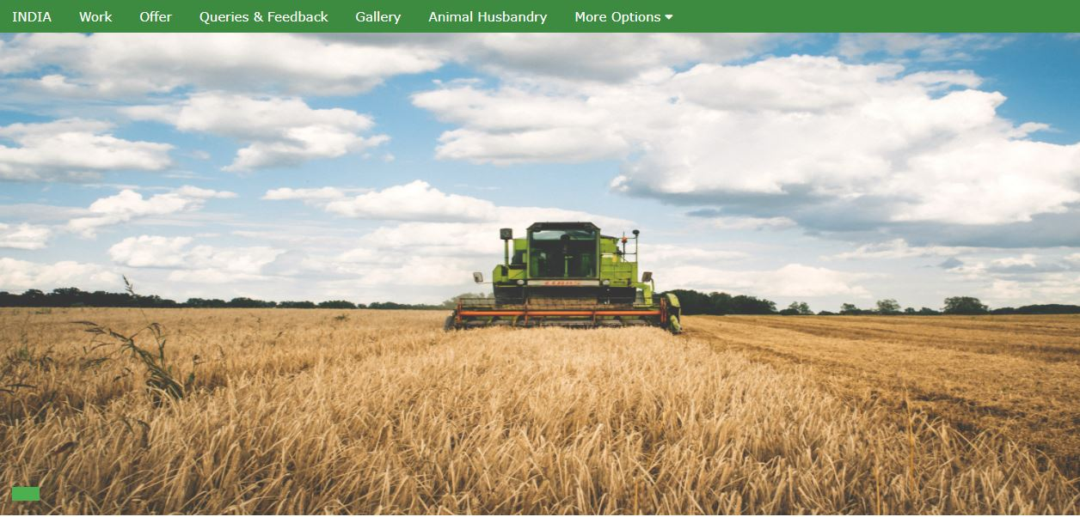

**Fig 6.1:** Home page

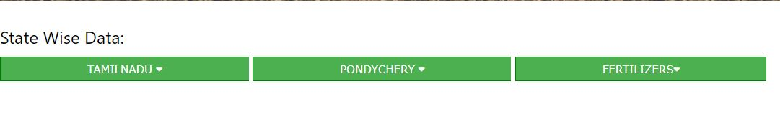

**Fig 6.2:** Drop down data’s.

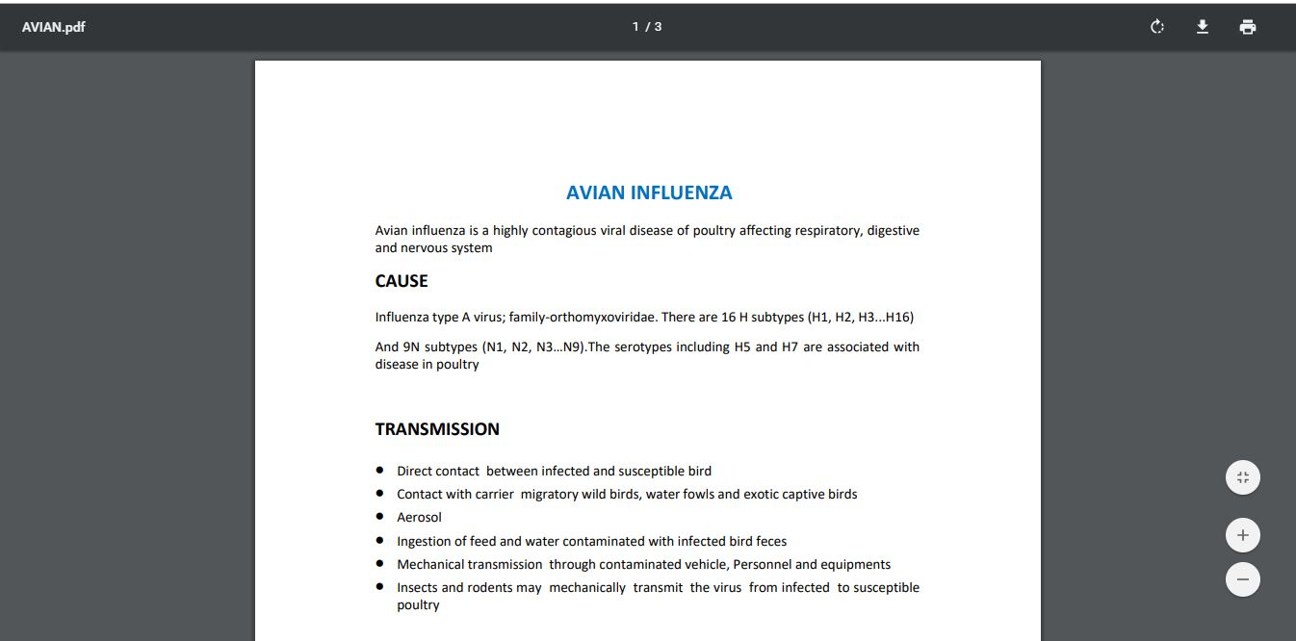

**Fig 6.3:** Documents downloading page

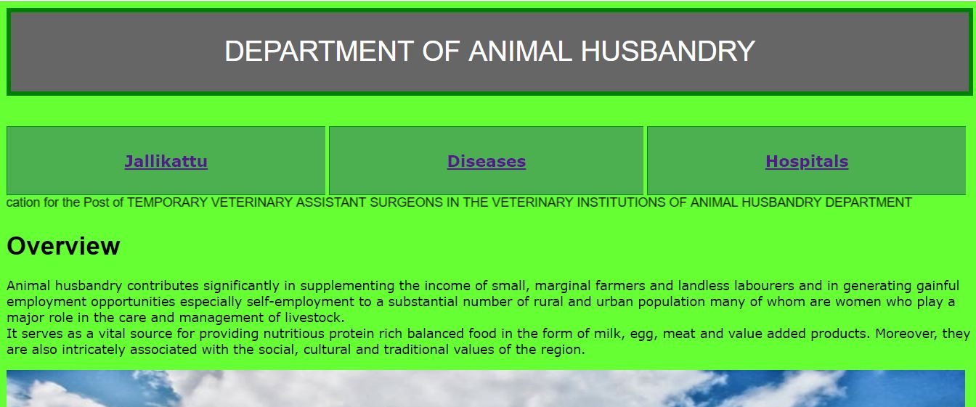

**Fig 6.4:** Animal Husbandry page

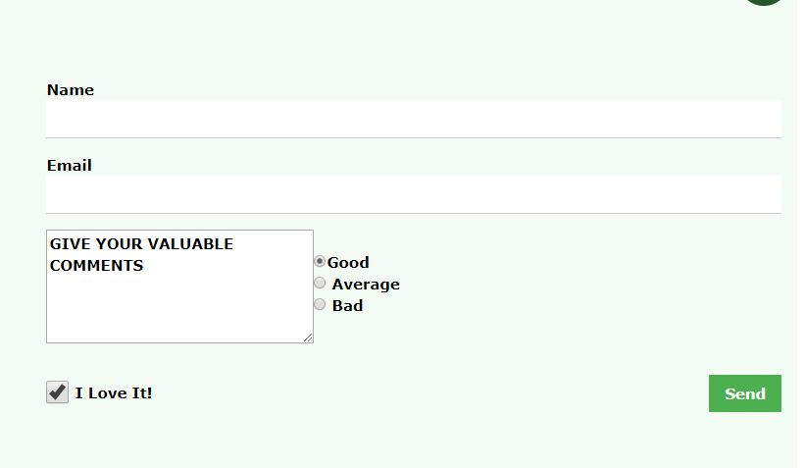

Fig 6.5: Query form page

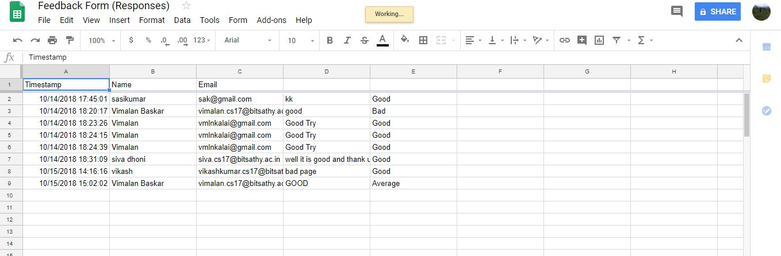

Fig 6.6 Sample Responses

**CHAPTER 7**

**CONCLUSION AND FUTURE WORK**

This webpage is completely free and Accessed by everyone. Every pdf documents here are verified content and developed by understanding the problems and difficulties. Government portal can be accessed from this page. Give better interface to the farmers. Better way is added for communication. The queries added by the farmers is stored in spreadsheet. And can be accessed any time. By sharing this page with the public we can make good awareness about agriculture. Connecting spreadsheet to this saves time helps the admin to keep the data safe and it can be handled from anywhere. Government can also follow this idea for providing good service to farmers. This type of web page can increase job opportunity for agriculturists and graduates. Document can be updated frequently for more convenience. In future connecting veterinary hospital records and data’s will be helpful for farmers and researchers. And connecting the doctor’s information can be helpful for maintaining the livestock’s. Adding information about the hardware shops will be helpful for buying hardware’s and equipment’s.

**REFERENCES**

1. W3schools-for tags.

2. Central government portal for agriculture.

3. Tamilnadu and Government portal for agriculture.

4. Just dial for the rates and shops.

5. YOUTUBE for home page references.