Task 2: Create and Query a Materialized View ● Scenario: Generate a report summarizing the average hospital stay duration for each diagnosis using a materialized view.

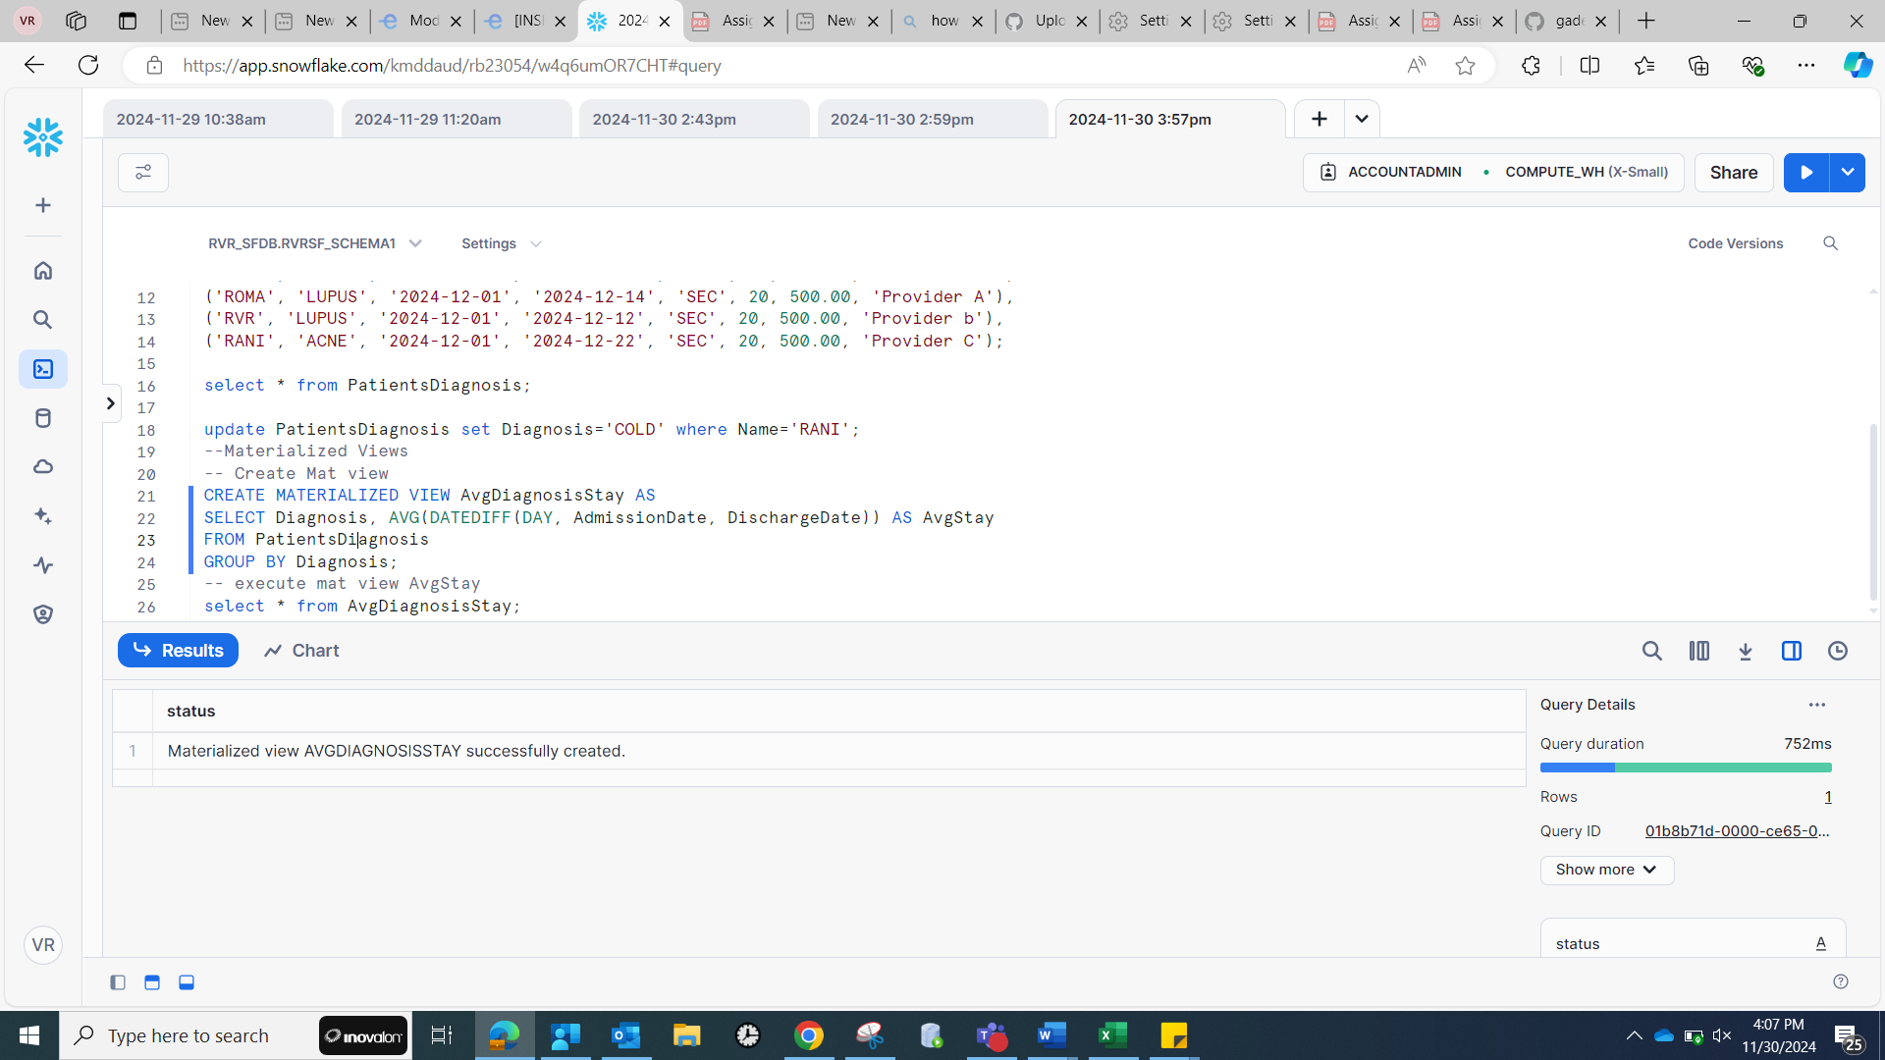

code used:

|  |
| --- |
| Create table PatientsDiagnosis (Name varchar2, Diagnosis varchar2, AdmissionDate date, DischargeDate date,  Region varchar2, Age number, TotalBill number, InsuranceProvider varchar2)  Insert into PatientsDiagnosis (Name , Diagnosis , AdmissionDate, DischargeDate,  Region, Age, TotalBill, InsuranceProvider)  VALUES ('Jane Doe', 'Flu', '2024-12-01', '2024-12-05', 'South', 30, 900.00, 'Provider A');  Insert into PatientsDiagnosis (Name , Diagnosis , AdmissionDate, DischargeDate,  Region, Age, TotalBill, InsuranceProvider)  VALUES ('Vimala', 'Flu', '2024-12-01', '2024-12-10', 'South', 30, 900.00, 'Provider A'),  ('BHEEM', 'COLD', '2024-12-01', '2024-12-02', 'SEC', 20, 500.00, 'Provider b'),  ('RANA', 'Fever', '2024-12-01', '2024-12-20', 'SEC', 20, 500.00, 'Provider A'),  ('ROMA', 'LUPUS', '2024-12-01', '2024-12-14', 'SEC', 20, 500.00, 'Provider A'),  ('RVR', 'LUPUS', '2024-12-01', '2024-12-12', 'SEC', 20, 500.00, 'Provider b'),  ('RANI', 'ACNE', '2024-12-01', '2024-12-22', 'SEC', 20, 500.00, 'Provider C');  select * from PatientsDiagnosis;  update PatientsDiagnosis set Diagnosis='COLD' where Name='RANI';  --Materialized Views  -- Create Mat view  CREATE MATERIALIZED VIEW AvgDiagnosisStay AS  SELECT Diagnosis, AVG(DATEDIFF(DAY, AdmissionDate, DischargeDate)) AS AvgStay  FROM PatientsDiagnosis  GROUP BY Diagnosis;  -- execute mat view AvgStay  select * from AvgDiagnosisStay; |