**CLOUD COMPUTING USING MICROSOFT AZURE**

**ASSIGNMENT 1: Set Up a Virtual Machine (VM):**

1. Create Resource group in the subscription

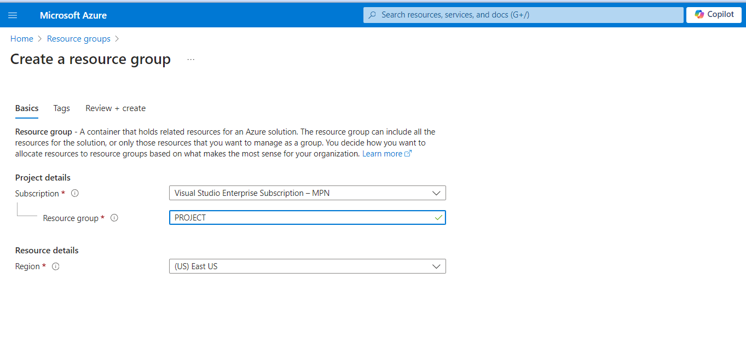

1. Click Review + Create.
2. Create Virtual machine, Select Resource group, Select Windows 2016 OS, Set Username & Password

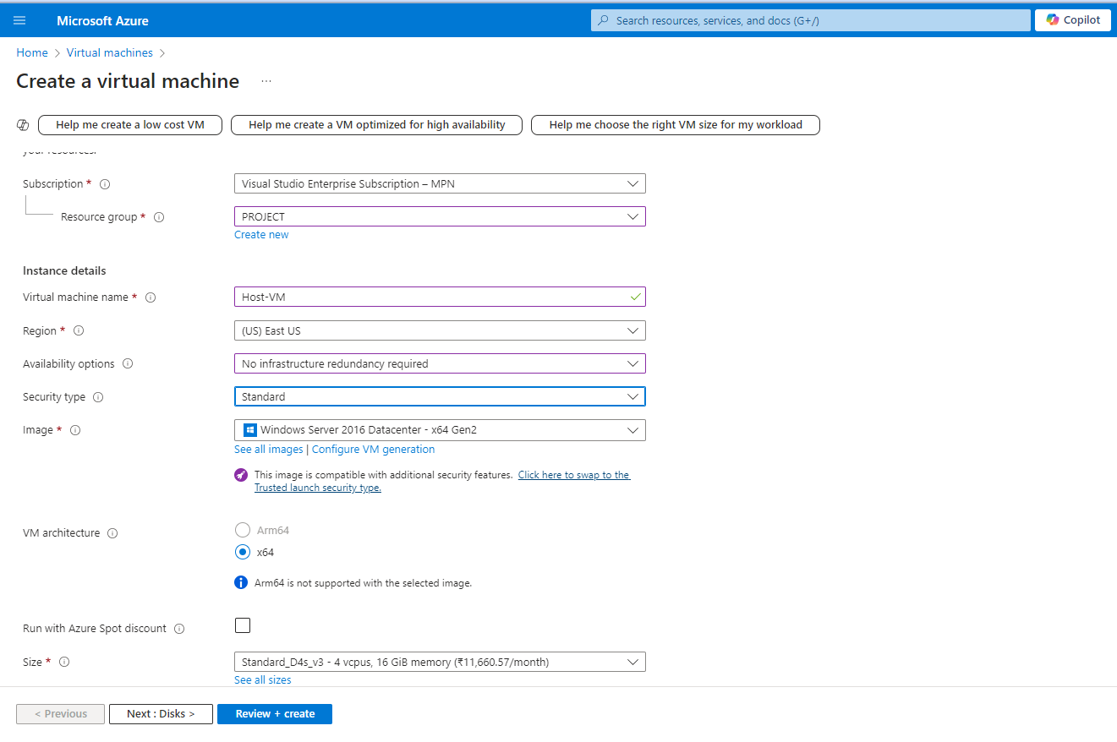

1. Select Default Disk size.

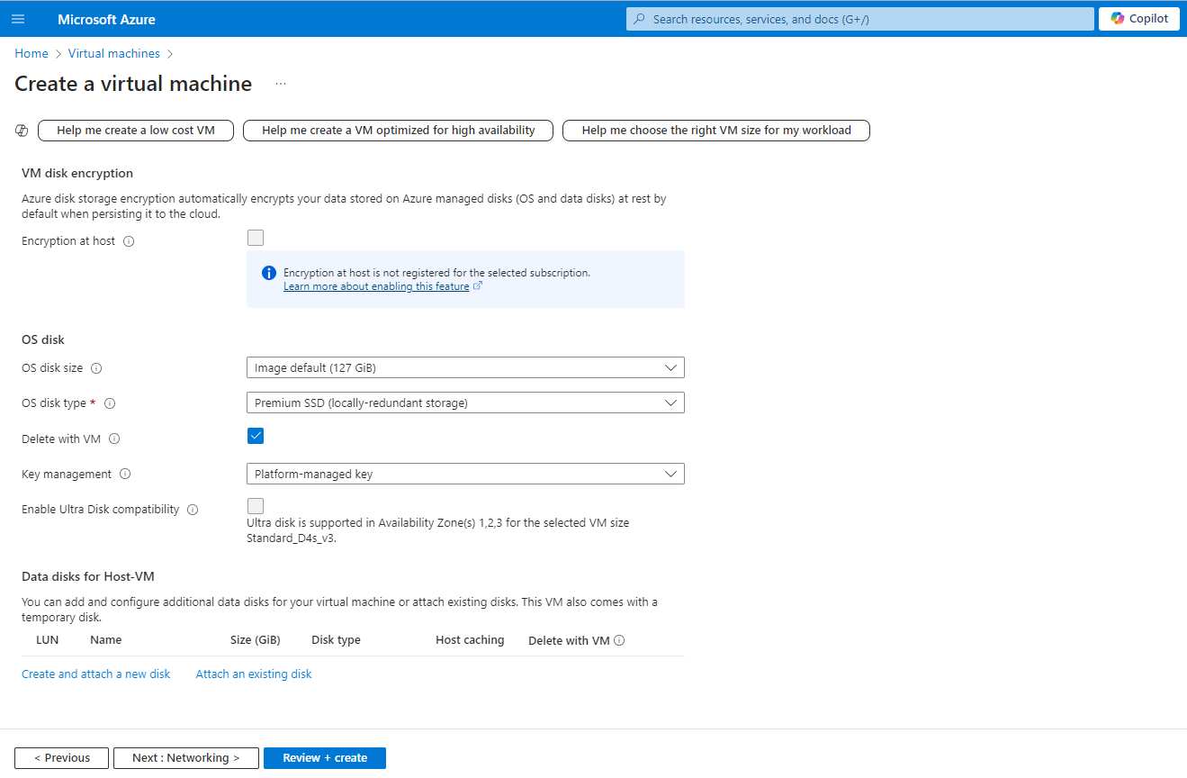

1. Select Default network setting and enable HTTP (80), HTTPS (443) ports.

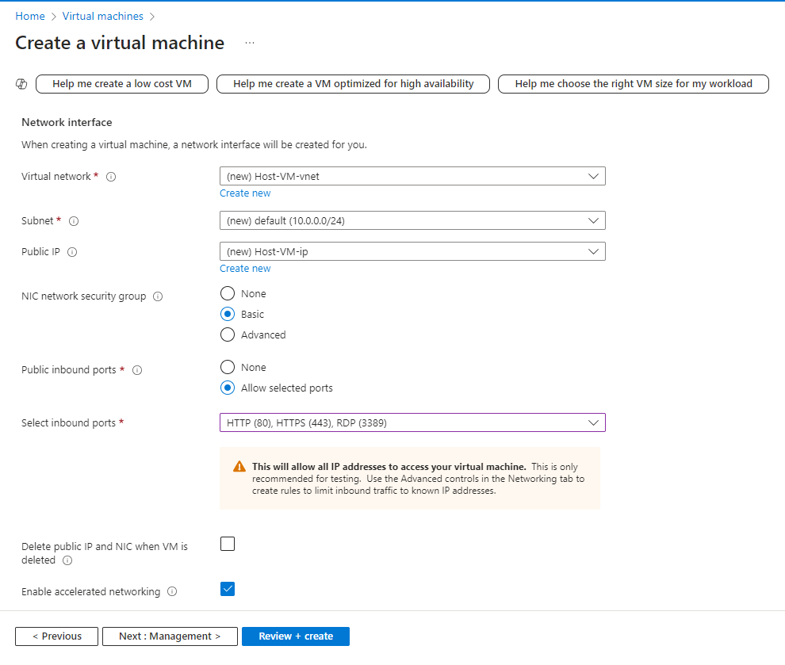

1. Click Review + Create.
2. After creating the VM, in overview copy the Public IP to access VM using RDP.

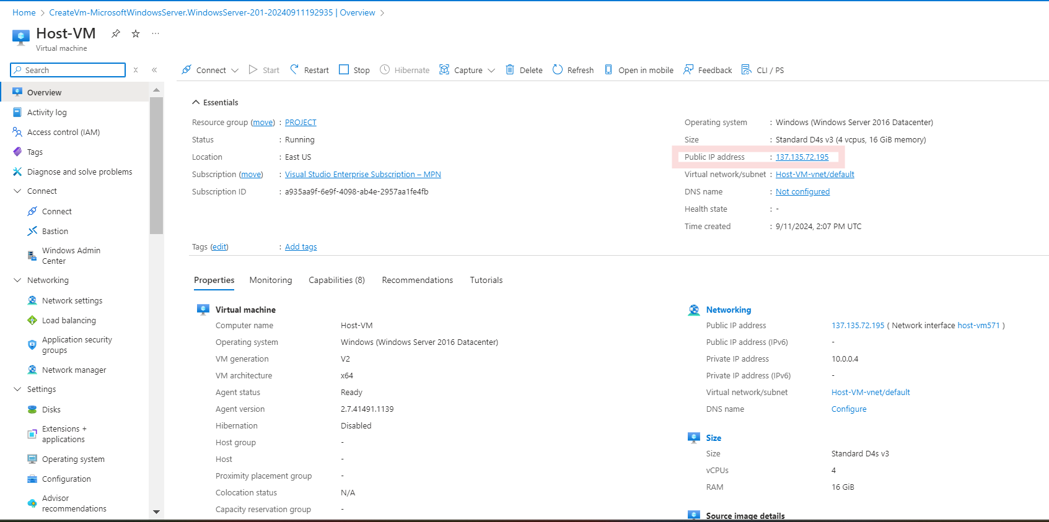

1. Access the VM using RDP. Enter the Username and Password.

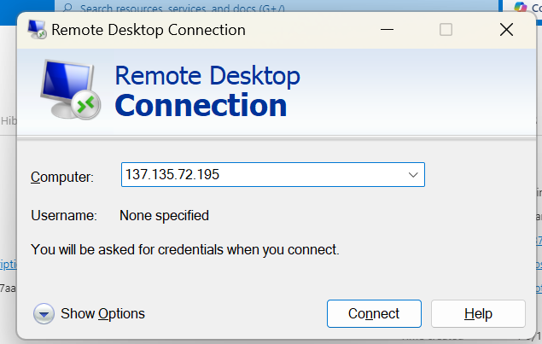

**ASSIGNMENT 2: Create and Configure a simple website**:-

1. Select server manager – Add roles and Features

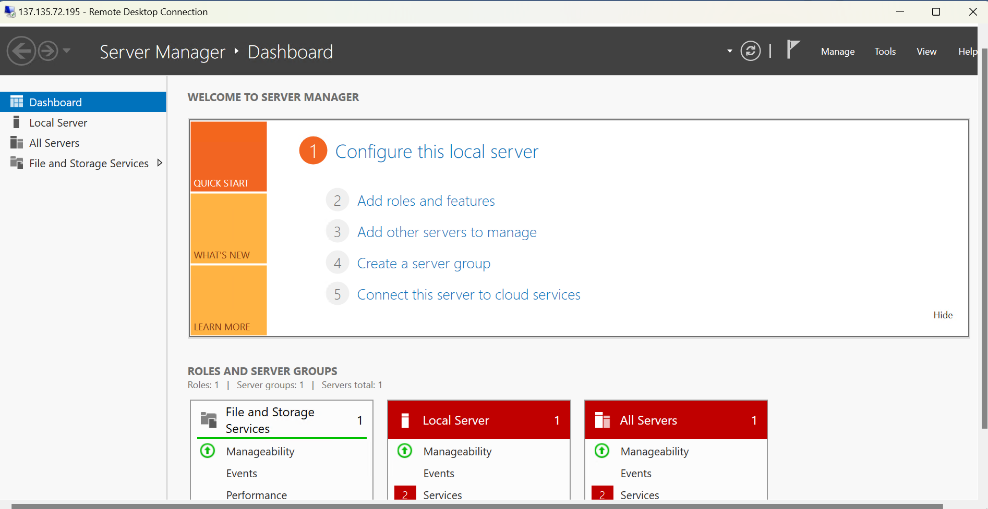

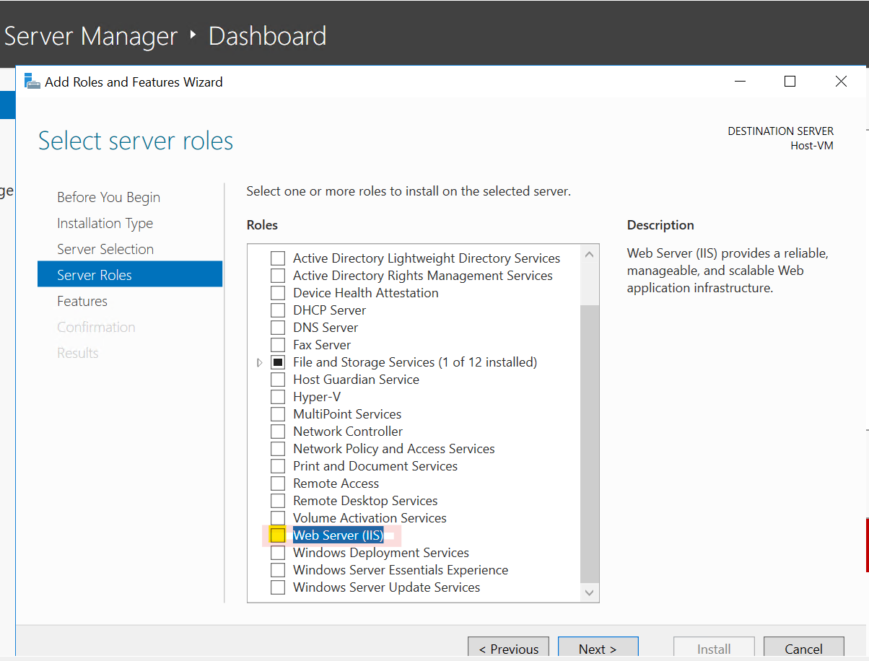

Install Web Server (IIS)

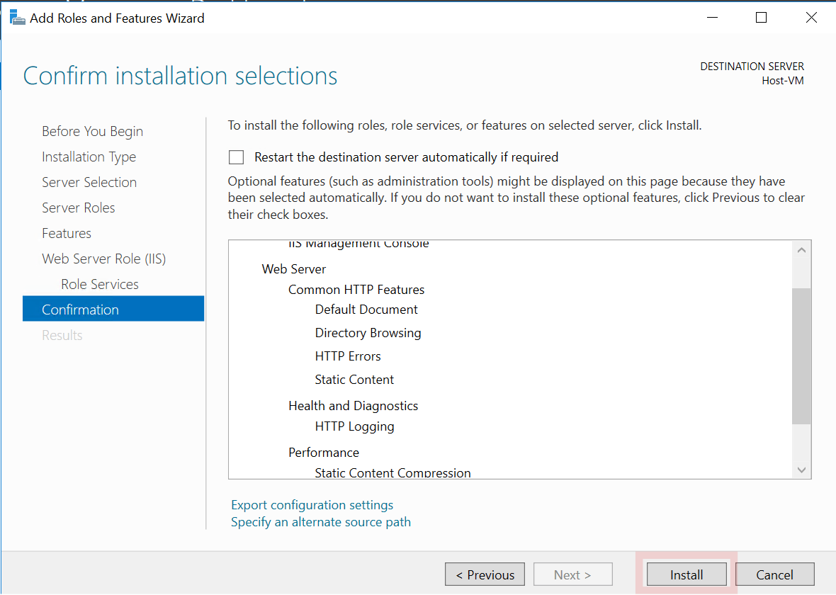

1. Select C: folder –> Inetpub –> [wwwroot](http://www.root). Modify the HTML file.

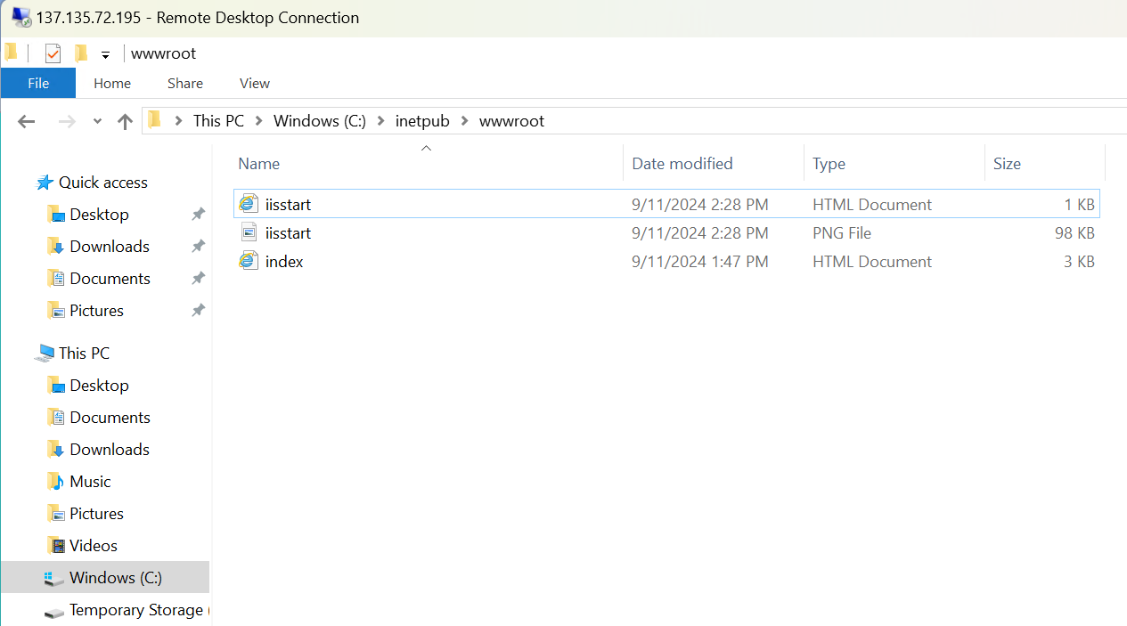

1. Then check in the browser (google, edge) using public IP/DNS. Add DNS entry in public IP.

Output:

