**Write a query to fetch all employees who also hold the managerial position.**

**SELECT** E.EmpFname, E.EmpLname, P.EmpPosition

**FROM** EmployeeInfo E **INNER** JOIN EmployeePosition P **ON**

E.EmpID = P.EmpID AND P.EmpPosition IN ('Manager');

**Write a query to retrieve the list of employees working in the same department.**

**Select** **DISTINCT** E.EmpID, E.EmpFname, E.Department

**FROM** EmployeeInfo E, Employee E1

**WHERE** E.Department = E1.Department AND E.EmpID != E1.EmpID;

**Write a query to display the first and the last record from the EmployeeInfo table.**

**SELECT** * **FROM** EmployeeInfo **WHERE** EmpID = (**SELECT** **MIN**(EmpID) **FROM** EmployeeInfo);

**SELECT** * **FROM** EmployeeInfo **WHERE** EmpID = (**SELECT** **MAX**(EmpID) **FROM** EmployeeInfo);

**Write a query to add email validation to your database**

**SELECT** Email **FROM** EmployeeInfo **WHERE** NOT REGEXP_LIKE(Email, ‘[A-Z0-9._%+-]+@[A-Z0-9.-]+.[A-Z]{2,4}’, ‘i’);

**first name and the last name  
SELECT** CONCAT(EmpFname, ' ', EmpLname) **AS** 'FullName' **FROM** EmployeeInfo;

**Write a query to fetch only the place name(string before brackets) from the Address column of EmployeeInfo table.**

**SELECT** SUBSTRING(Address, 1, CHARINDEX('(',Address)) **FROM** EmployeeInfo;

[**how to repeat each row twice**](https://stackoverflow.com/questions/26717224/how-to-repeat-each-row-twice)

Select Id, name from Table1 **union all** select Id, name from Table1

**SQL Cumulative Sum**

|  |
| --- |
| select hire_date, salary, |
|  | sum ( salary ) over ( |
|  | order by hire_date |
|  | ) cumul_sal |
|  | from employees |
|  | fetch first 5 rows only; |

**write a query to retrieve the first four characters of Empname from the Emp_Info table**

SELECT SUBSTRING(NAME , 1,4) FROM EMP

**should be replaced with N and N should be replaced by Y for all rows(case statement**

SELECT CASE Flag

WHEN 'Y' THEN 'Yes'

ELSE 'No'

END AS Flag

FROM TableName

**PIVOT Table**

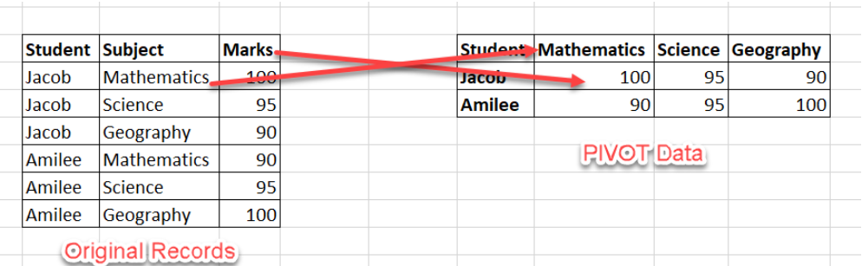

SELECT * FROM (

  SELECT [Student],[Subject],[Marks]

  FROM Grades

) StudentResults

PIVOT (

  SUM([Marks])

  IN ([Mathematics],    [Science],    [Geography]

  )

) AS PivotTable