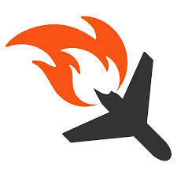AIR CRASH ANALYSIS

BOEING VS AIRBUS

# A. Introduction

### A.1. Description & Discussion of the Background

## 

In our day to day life we encounter several accidents. Accidents may happen on road, water and air. However, Air accidents cause severe damages and brings more risks for whom travel by air. Statistically, air travel is safer than other source but when something goes wrong during air travel, it can be catastrophic with hundreds of lives at stake.

Since there are plenty of aircrafts, **Boeing and Airbus are considered for this study**. Boeing and Airbus are the most powerful commercial jets in the world. Even these aircraft manufacturers have different types of aircrafts with lots of safety measurements, Accidents are been reported every year. When there is a 0% reported air accidents over the certain period, it can be considered as 100% growth in aircraft technology.

From **1990 to 2020,** there were many major accidents happened due to many reasons. In this analysis, The Cause of the accident, damages, Airlines and other facts are been analyzed. From the analyzed data, Safest airlines and aircrafts can be found using data science.

### A.2. Data Description

Collected data are from below sources.

* Accident data source - aviation-safety.net
* Aircraft Registrations - Wikipedia.com

Accident rates between Boeing and airbus aircrafts, accident rates between each types of aircraft, locations where accident happened, reasons for the accidents are analyzed in this study.

Below tools are been used for the analysis,

* geocoder to get location address, latitude and longitude.
* Folium to point the places in the map.
* Foursquare to find near airport.