Core Java Skills
Object: entity that has state and behavior. Class is the blueprint for object.
Default constructor: no-args constructor that the Java compiler inserts.
Parameterize constructor: constructor which has a specific number of parameters. Used to provide different values to the distinct objects.
Constructor Overloading: having more than one constructor with different parameter lists. 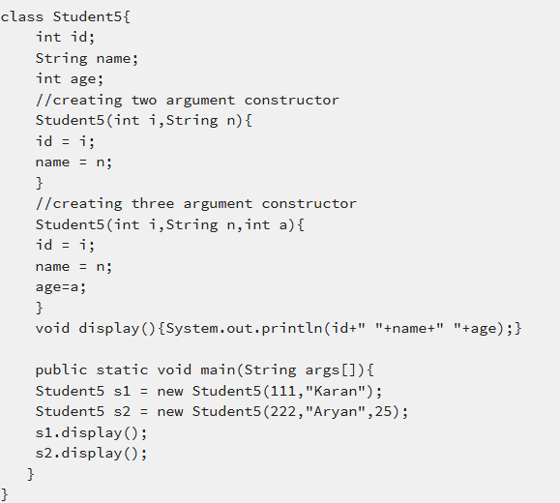
Constructor vs Method:
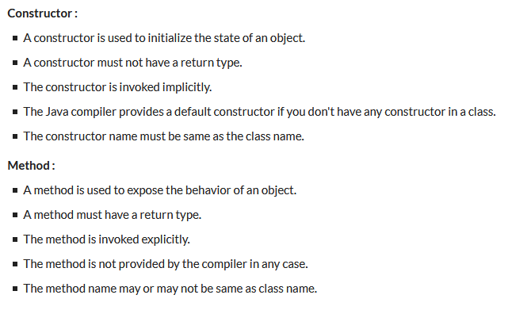
Explicit casting: type casting that is done by programmers.
Implicit casting: type casting done by compiler.
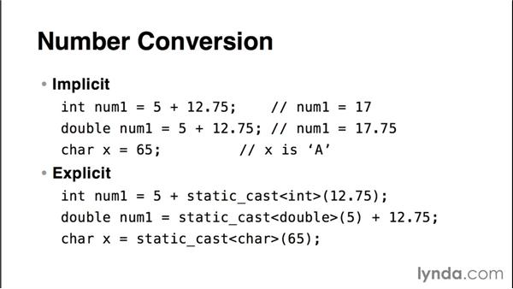
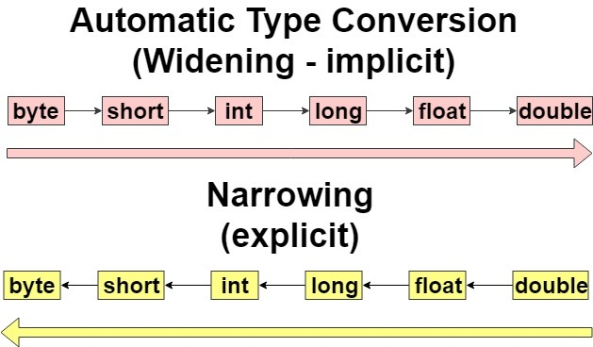

OOP
Inheritance: mechanism in which one object acquires all the properties and behaviors of a parent object. (Most important part of polymorphism and Is-a relationship).
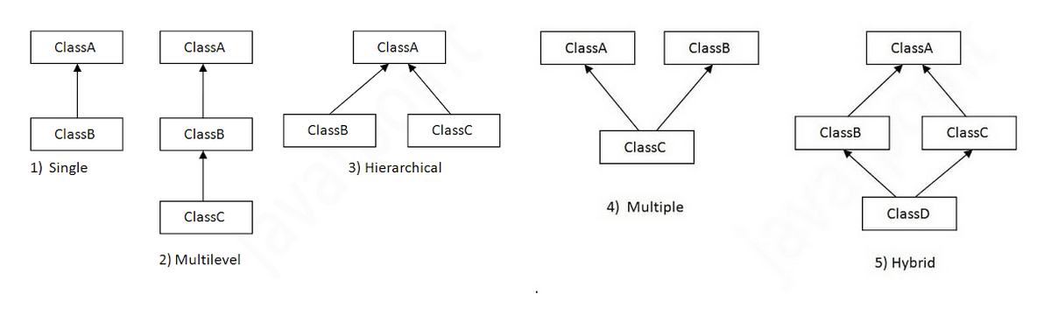
Why multiple inheritance is not supported in Java? To reduce the complexity and simplify the language, multiple inheritance is not supported in java.
Polymorphism: Ability of an object to take on many forms. The most common use of polymorphism in OOP occurs when a parent class reference is used to refer to a child class object.
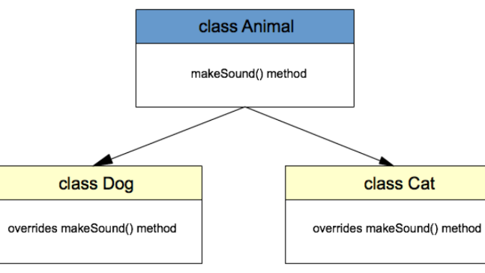
Method Overloading: If multiple methods having same name but different in parameters.
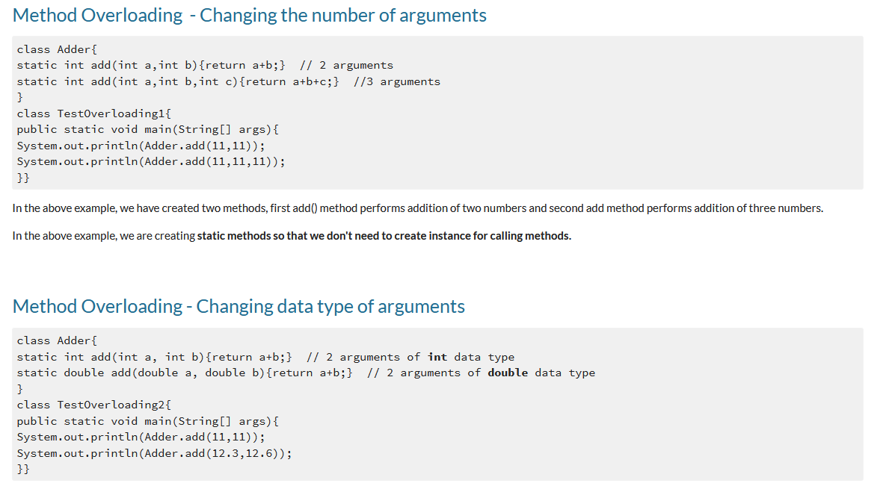
Method Overriding: subclass (child class) has the same method as declared in the parent class.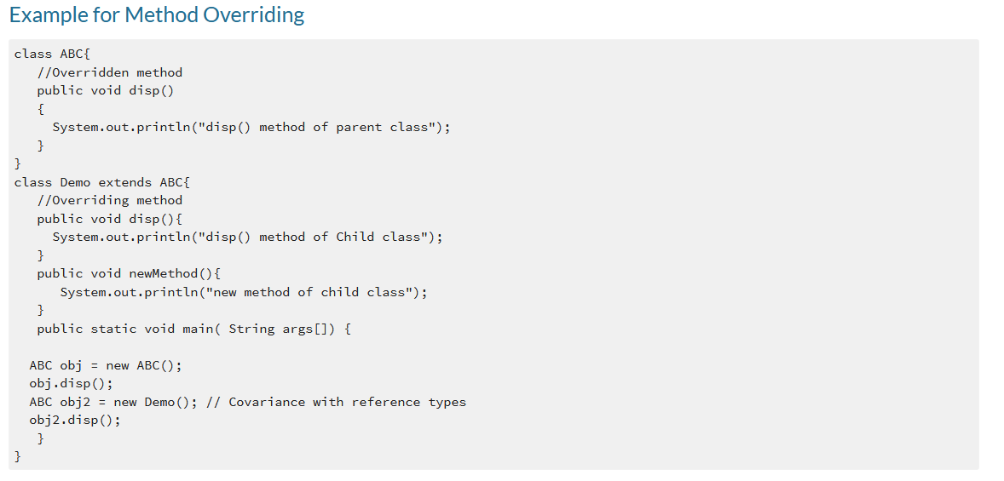.
Static method cannot be overridden.
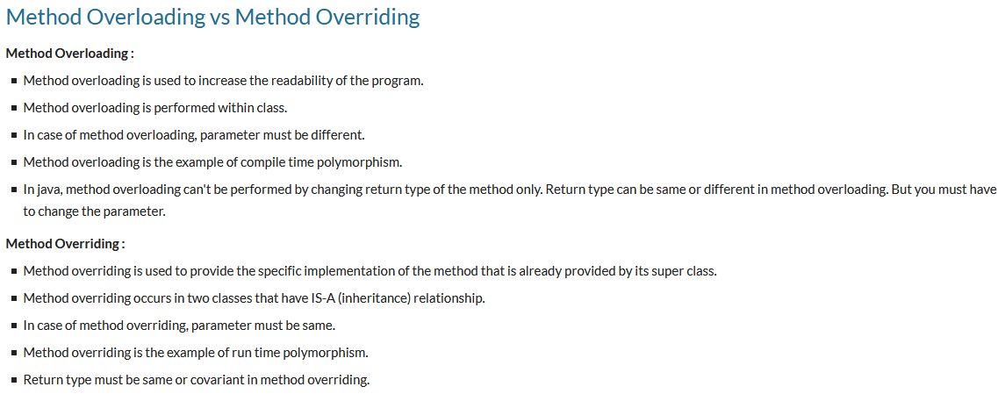
Encapsulation: process of wrapping code and data together into a single unit.
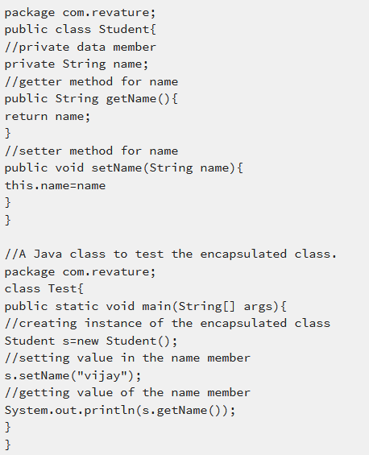
Abstraction: process of hiding the implementation details and showing only functionality to the user.
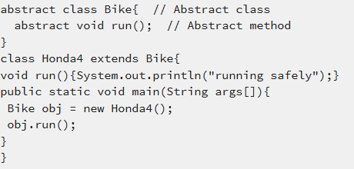
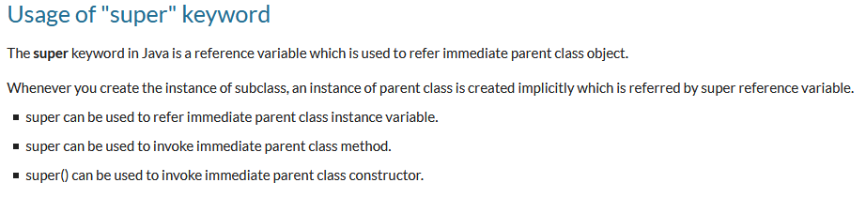
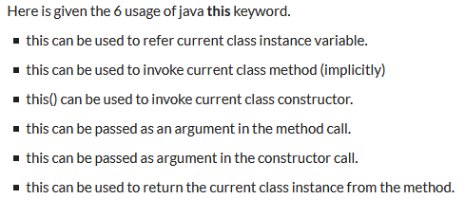
The static keyword in Java is used for memory management mainly.
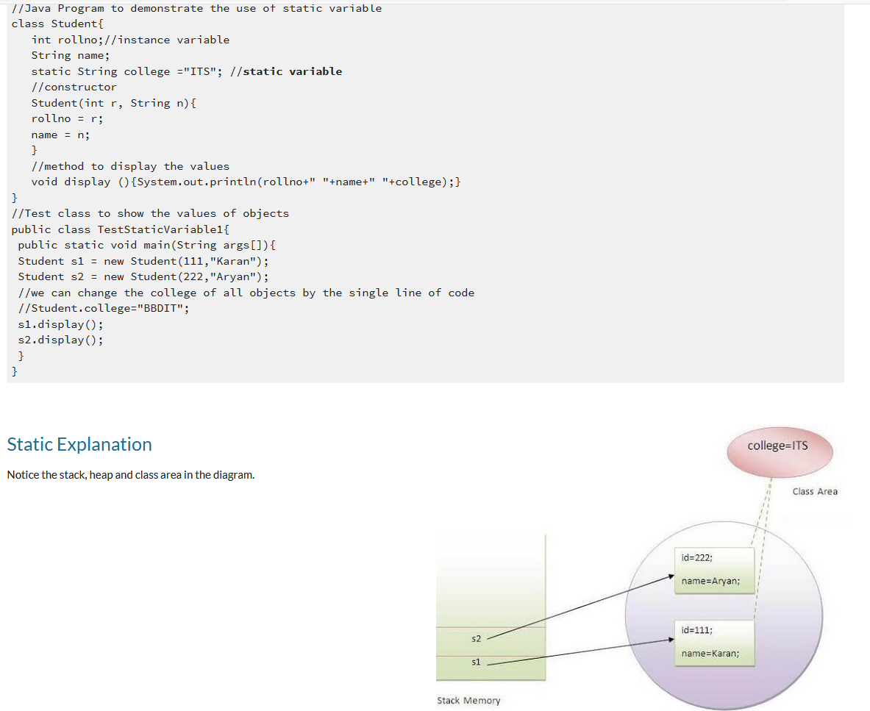
An interface is a reference type in Java. It is similar to class. It is a collection of abstract methods. A class implements an interface, thereby inheriting the abstract methods of the interface.
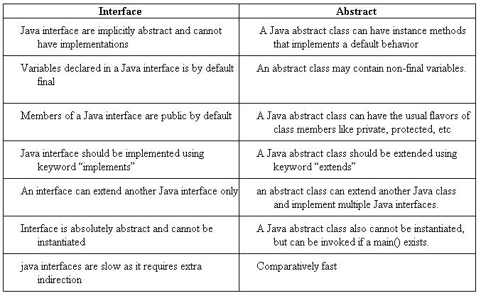
Class can only extend one abstract class while class can extend as many interfaces
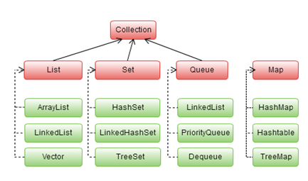
Java garbage collection is the process by which Java programs perform automatic memory management. When Java programs run on the JVM, objects are created on the heap, which is a portion of memory dedicated to the program. Eventually, some objects will no longer be needed. The garbage collector finds these unused objects and deletes them to free up memory.
Difference between Array and Linked List: an array is a set of similar data objects stored in sequential memory locations under a common heading or a variable name. While a linked list is a data structure which contains a sequence of the elements where each element is linked to its next element.
Every thread has a priority. Threads with higher priority are executed in preference to threads with lower priority. Each thread may or may not also be marked as a daemon.
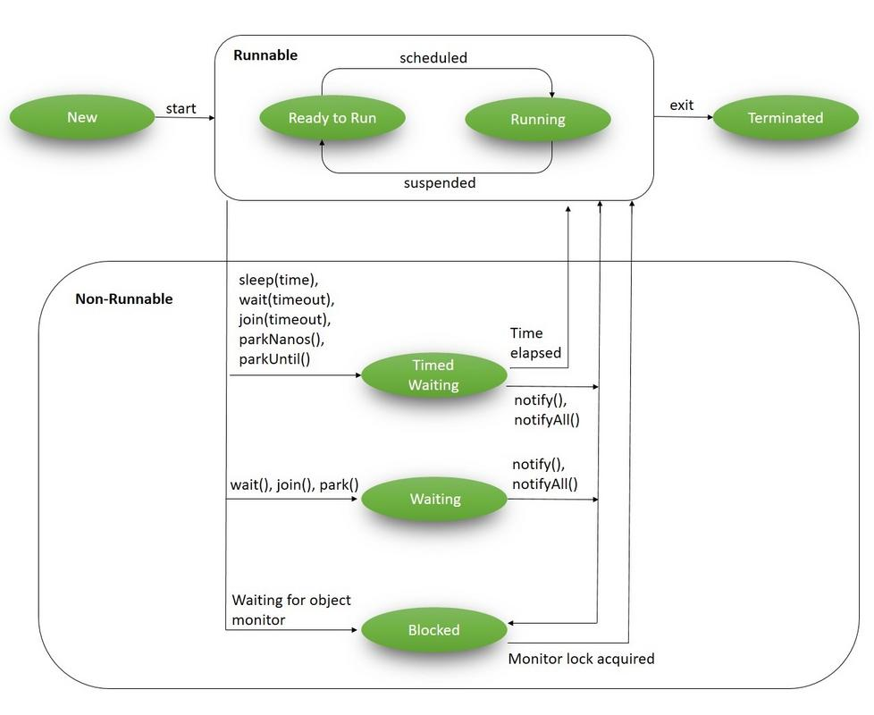
The difference is in which lock is being acquired: synchronized method acquires a lock on the whole object. Synchronized blocks acquires a lock in the object between parentheses after the synchronized keyword. Meaning no other thread can acquire a lock on the locked object until the synchronized block exits.
OS
A process is an instance of program execution. ... Modern operating systems allow a process to be divided into multiple threads of execution, which share all process management information except for information directly related to execution.
Interprocess communication (IPC) is a set of programming interfaces that allow a programmer to coordinate activities among different program processes that can run concurrently in an operating system.
Data Structures
A stack is a structure where insertion and deletion of items takes place at one end called top of the stack (Last in First Out).
Queue is an abstract data structure, somewhat similar to Stacks. Unlike stacks, a queue is open at both its ends. One end is always used to insert data (enqueue) and the other is used to remove data (dequeue). (First in First Out)
A linked list is a linear data structure where each element is a separate object.
Linked list elements are not stored at contiguous location; the elements are linked using pointers.
A map is a data structure and its majorly used for fast look ups or searching data. It stores data in the form of key and value pairs where every key is unique
A set is a data structure that can store any number of unique values in any order you so wish.
Algorithm
A hash function is any function that can be used to map data of arbitrary size to fixed-size values. The values returned by a hash function are called hash values, hash codes, digests, or simply hashes (cryptography).
Binary search is an efficient algorithm for finding an item from a sorted list of items. It works by repeatedly dividing in half the portion of the list that could contain the item, until you've narrowed down the possible locations to just one.
Sorting Algo
Selection Sort: repeatedly finding the minimum element (considering ascending order) from unsorted part and putting it at the beginning. O(n^2) worst case
Bubble Sort: sorting algorithm that works by repeatedly swapping the adjacent elements if they are in wrong order. O(n^2)
Insertion Sort: is a simple sorting algorithm that builds the final sorted array (or list) one item at a time. O(n^2)
Merge Sort: It divides input array in two halves, calls itself for the two halves and then merges the two sorted halve. O(nlogn)
Heap sort is a comparison based sorting technique based on Binary Heap data structure. It is similar to selection sort where we first find the maximum element and place the maximum element at the end. We repeat the same process for remaining element. O(nlogn)
Quick Sort: picks an element as pivot and partitions the given array around the picked pivot. O(n^2) Worst case
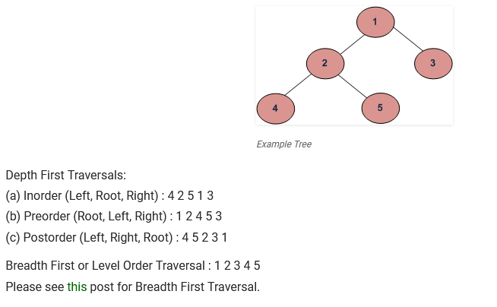

SQL
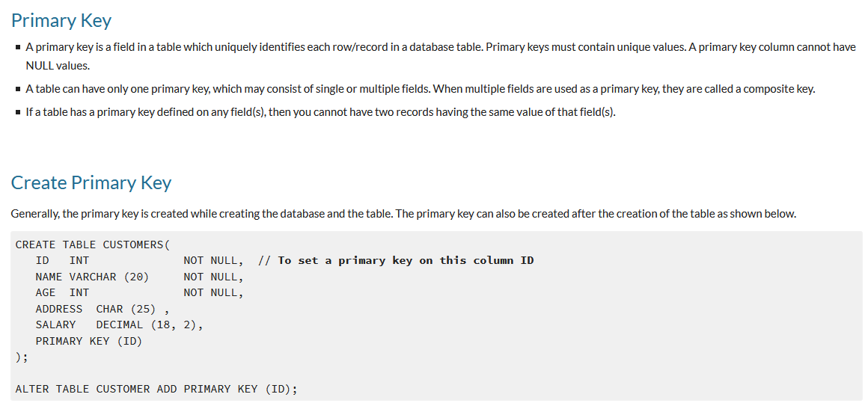
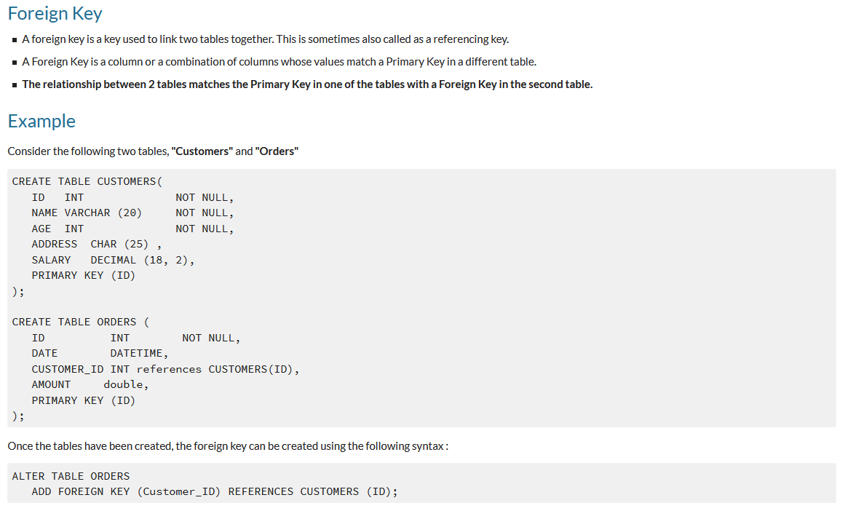

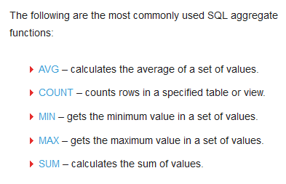
JDK is a software development kit whereas JRE is a software bundle that allows Java program to run, whereas JVM is an environment for executing bytecode. The full form of JDK is Java Development Kit, while the full form of JRE is Java Runtime Environment, while the full form of JVM is Java Virtual Machine

KEY DIFFERENCES
- JDK is a software development kit whereas JRE is a software bundle that allows Java program to run, whereas JVM is an environment for executing bytecode.
- The full form of JDK is Java Development Kit, while the full form of JRE is Java Runtime Environment, while the full form of JVM is Java Virtual Machine.
- JDK is platform dependent, JRE is also platform dependent, but JVM is platform independent.
- JDK contains tools for developing, debugging, etc. JRE contains class libraries and other supporting files, whereas software development tools are not included in JVM.
- JDK comes with the installer, on the other hand, JRE only contains the environment to execute source code whereas JVM bundled in both software JDK and JRE.

