Report | Module 3
Hypothesis Testing Analysis

Probability Theory and Introductory Statistics

ALY6010



Submitted by: Vimlesh Vilas Sonawane
Instructor: Professor Tom Breur

College of Professional Studies
Northeastern University
June 2025

- Introduction
This report explores employment and unemployment trends in Maryland using monthly labor data from 2007 to 2019. The dataset includes 152 observations and contains key variables such as employment rate, unemployment rate, and labor force participation rate. The aim is to test two assumptions using statistical methods.
First, it checks whether the average employment rate is equal to sixty-five percent. Second, it examines whether more than one-fourth of the months had an unemployment rate above six percent. To explore these questions, a one-sample t-test and a proportion test are used. The results are supported by clear visualizations and interpretations to help understand whether these patterns reflect true trends or could have occurred by chance.

Description of the Data
The data for this report comes from the Maryland Department of Labor. It includes labor statistics collected each month between January two thousand seven and December two thousand nineteen. There are a total of one hundred fifty-two rows in the dataset, with each row representing one month. The information gives a detailed view of how the labor force in Maryland changed over time.
Some of the key columns in the dataset are:
- Date: The month and year of each record
- Civilian Non-Institutional Population: The number of people aged sixteen and above who are not in the military or in institutions
- Civilian Labor Force: The number of people working or actively looking for work
- Labor Force Participation Rate: The percentage of the non institutional population involved in the labor force
- Employed: The total number of people with jobs
- Employment Rate: The percentage of the population that was employed
- Unemployed: The number of people without jobs who were looking for work
- Unemployment Rate: The percentage of the labor force that was unemployed

Test Results and What They Mean

3.1. One-Sample t-Test: Is the Employment Rate 65%?
- Null Hypothesis (H₀): The average employment rate is 65%.
- Alternative Hypothesis (H₁): The average employment rate is not 65%.
Test output:
- t = -10.218
- Degrees of freedom = 151
- p-value < 0.0001
- 95% Confidence Interval: 63.91% to 64.27%
- Sample Mean: 64.09%
Interpretation:
The p-value is very small, so the result is statistically significant. This means we can reject the idea that the average employment rate is 65%. Instead, the data suggests it is actually a little lower, around 64%. The confidence interval backs this up, as it does not include 65%.

3.2. Proportion Test: Were More Than 25% of Months Over 6% Unemployment?
- Null Hypothesis (H₀): 25% of the months had unemployment over 6%.
- Alternative Hypothesis (H₁): The proportion is different from 25%.
Test output:
- 61 out of 152 months had unemployment over 6%
- Proportion = 40.1%
- p-value = 0.000025
- 95% Confidence Interval: 32.4% to 48.4%
Interpretation:
Again, the p-value is very small, so we reject the idea that only 25% of the months had high unemployment. In reality, about 40% of the months had rates over 6%, showing that high unemployment was more common than originally assumed.

Visuals That Help Tell the Story
To support the statistical findings, three visualizations were created using the ggplot2 package in R. Each one helps to clarify the trends observed in the data and provides a clearer picture of Maryland’s labor market over the 152-month period.
- Employment Rate in Maryland
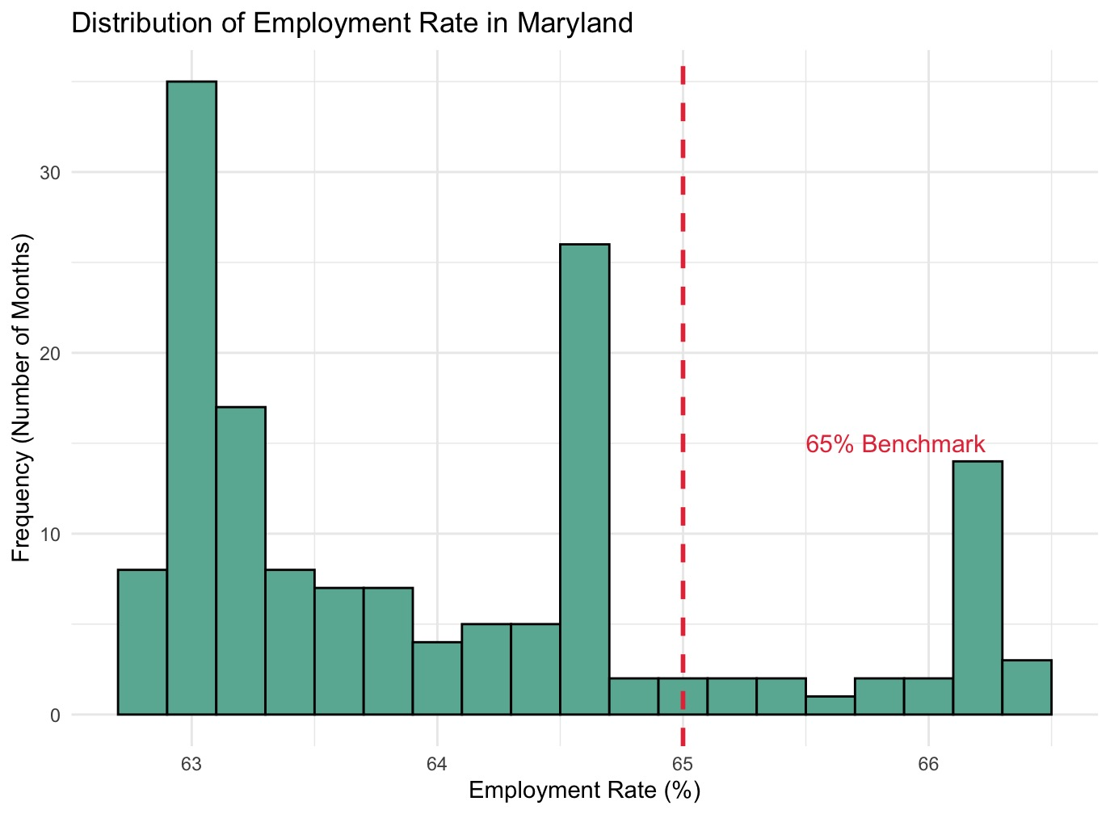

Figure 1: Histogram of Employment Rate in Maryland
This histogram shows the distribution of monthly employment rates in Maryland. The bars represent how often different employment rate percentages appeared in the data. Most months cluster around a range slightly below 65 percent. A red dashed line marks the 65 percent reference value used in the one-sample t-test. This line helps the viewer visually assess how often the employment rate met or exceeded that benchmark. The fact that many values fall to the left of this line gives an early indication that the actual average employment rate is below 65 percent, which aligns with the t-test results.

Labor Market Indicators

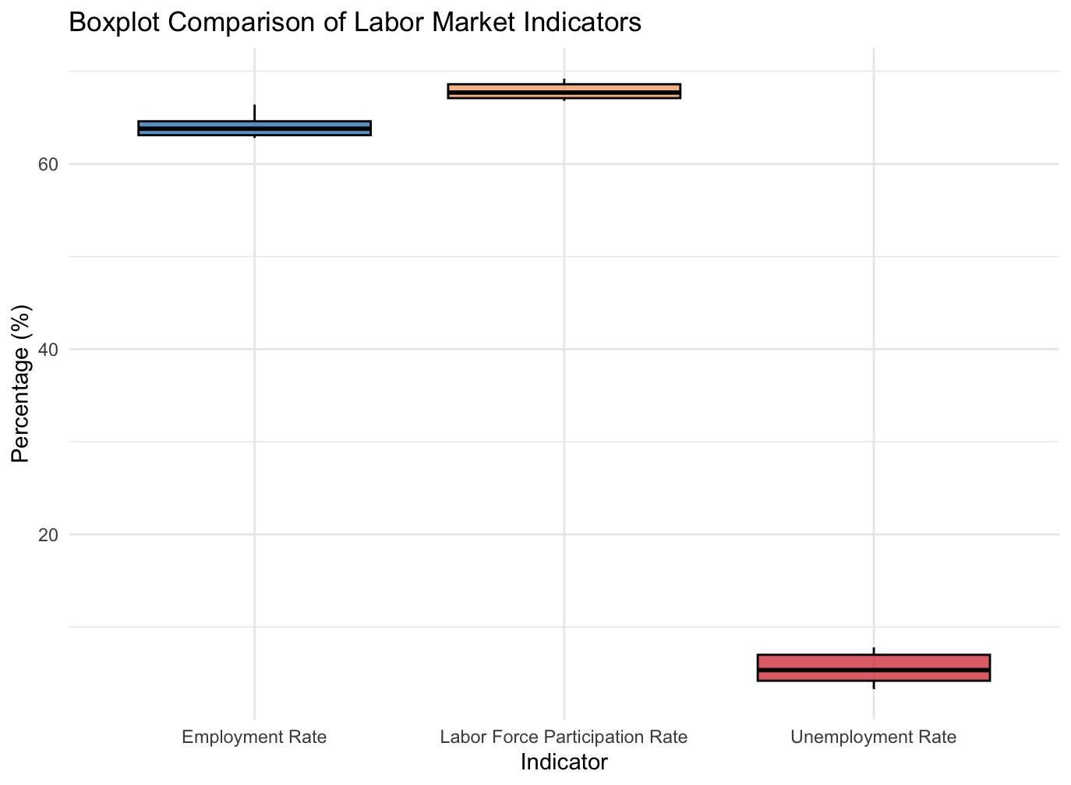

Figure 2: Boxplot Comparison of Labor Market Indicators
This boxplot combines three important indicators: employment rate, unemployment rate, and labor force participation rate, into one visual. Each box represents the spread of values for that indicator, showing the median, upper and lower quartiles, and any potential outliers. This comparison allows the viewer to quickly see which indicators were more variable and which remained relatively stable. For example, the unemployment rate typically has a wider spread, reflecting its sensitivity to economic conditions. By contrast, the labor force participation rate may appear more stable. These insights offer valuable context for interpreting the results of the proportion and t-tests.

Unemployment Rate in Maryland

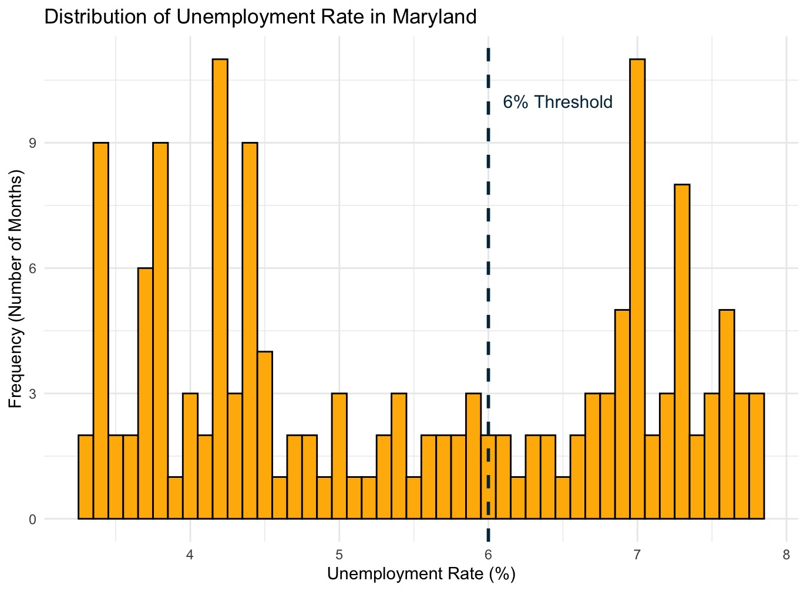

Figure 3: Histogram of Unemployment Rate in Maryland
This chart displays the frequency of different unemployment rate values across the observed months. The bars illustrate how often Maryland experienced various levels of unemployment. A dashed blue line marks the 6 percent threshold, which was the basis of the proportion test. The chart helps identify how common it was for the unemployment rate to exceed this level. A noticeable number of months fall above this line, supporting the test’s conclusion that more than 25 percent of the months had high unemployment. The visual makes this conclusion more intuitive and easier to communicate.

Findings
In this analysis, I used two types of hypothesis tests to explore Maryland’s labor data from 2007 to 2019. The goal was to find out whether the average employment rate was 65 percent and if more than one-fourth of the months had high unemployment (above 6 percent). Based on the test results and the visual charts, here is what I found:

Main Findings:

    - Employment Rate Was Not 65 Percent
  - I used a one-sample t-test to check if the average employment rate was 65 percent.
  - The result showed a very small p-value, which means it is very unlikely that the average was exactly 65 percent.
  - So, I rejected the assumption that the employment rate was 65 percent.
  - The histogram and boxplot also showed that many months had rates below this benchmark.
    - Unemployment Was High More Often Than Expected
  - I then tested if more than 25 percent of the months had an unemployment rate over 6 percent.
  - The p-value was again quite small, which means it is very likely that more than one-fourth of the months had high unemployment.
  - The histogram helped confirm this by showing how many months crossed the 6 percent line.
    - General Trends in the Labor Market
  - The employment rate did not stay at expected levels across the years.
  - There were several months where unemployment spiked, showing that the job market faced tough times.
  - Labor force participation stayed more stable but still showed some changes over time.

6. Conclusion

This report aimed to analyze Maryland’s labor force data from 2007 to 2019 using hypothesis testing methods in R. The analysis included a one-sample t-test to examine whether the average employment rate was sixty-five percent, and a proportion test to check if more than twenty-five percent of the months experienced high unemployment rates above six percent.
Both tests led to the rejection of their null hypotheses, suggesting that the employment rate was significantly different from the assumed value and that high unemployment was more common than expected. These conclusions were supported by clear visualizations, including histograms and boxplots, which made the results easier to interpret.
Overall, the report demonstrates how statistical methods can provide valuable insights into real-world labor patterns and how R can be used effectively for data analysis and visualization in public policy or economic contexts.

References

Data.gov. (n.d.). Employment, Unemployment, and Labor Force Data [Dataset]. U.S. Government Open Data Portal. Retrieved June 4, 2025, from https://catalog.data.gov/dataset?res_format=CSV&organization_type=State+Government&tags=unemployment
Huynh, Y. W. (2019). Guide to R. Bookdown. https://bookdown.org/yih_huynh/Guide-to-R-Book/
Wickham, H. (2016). ggplot2: Elegant Graphics for Data Analysis. Springer-Verlag New York.
https://ggplot2.tidyverse.org

