Report | Module 4
t-Test Applications: Cat Weight and Sleep Quality

Probability Theory and Introductory Statistics

ALY6010



Submitted by: Vimlesh Vilas Sonawane
Instructor: Professor Tom Breur

College of Professional Studies
Northeastern University
June 2025

- Introduction
This report provides a statistical analysis of two distinct datasets using hypothesis testing methods in R. The first dataset, cats from the MASS package, includes physiological measurements of domestic cats. The analysis aims to determine whether a significant difference exists in the average body weight of male and female cats. This required the application of a two-sample t-test to compare means between two independent groups.
The second dataset consists of sleep quality scores collected from a group of individuals before and after attending a meditation session. The objective of this analysis is to evaluate whether the meditation exercise led to a measurable improvement in sleep quality. Because the scores are paired measurements from the same individuals, a paired t-test was chosen.
Both analyses were conducted using the t.test() function in R, and visual representations of the results were created with the ggplot2 package to enhance interpretation. The report details each test's hypotheses, results, and conclusions, supported by relevant plots and statistical outputs.

Dataset Descriptions
The first dataset used in this report is the cats dataset from the MASS package in R. It contains information on 144 cats, including their sex, body weight (in kilograms), and heart weight (in grams).
The second dataset includes sleep quality scores from 10 students. Each student rated their sleep quality on a scale of 0 to 10 during the week before and the week after attending a meditation workshop. These two datasets were used to carry out hypothesis testing using suitable t-test methods in R. Both datasets were used to perform hypothesis testing using appropriate t-test methods in R.

Part 1: Two-Sample T-Test (Cats Dataset)
- Objective:
The aim of this analysis was to determine whether there is a statistically significant difference in the average body weight of male and female cats using the cats dataset from the MASS package. This dataset contains 144 records of domestic cats, including their sex, body weight, and heart weight.
- Null Hypothesis (H₀): The average body weight of male cats is equal to that of female cats (mean_M = mean_F)
Alternative Hypothesis (H₁): The average body weight of male cats is not equal to that of female cats (mean_M ≠ mean_F)
- R Code Used:
- The dataset was split using the subset() function to create separate vectors for male and female cats.
- A two-sample t-test was performed using the t.test() function with unequal variances assumed (var.equal = FALSE), also known as Welch's t-test.
- A boxplot was created using ggplot2 to visually compare the body weight distribution by sex.
- T-Test Results:
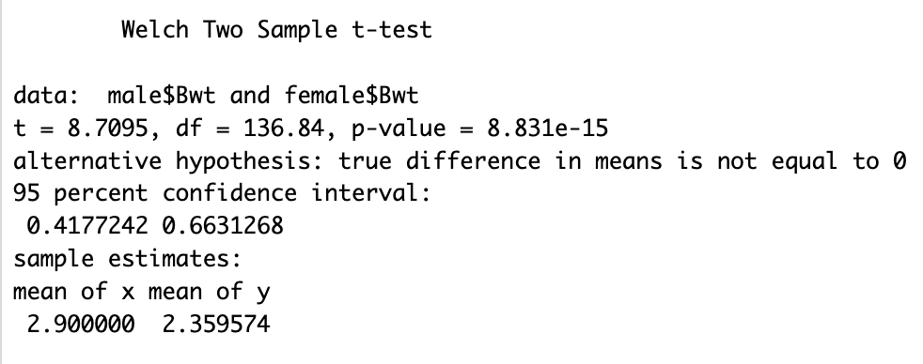
- A Welch two-sample t-test was used to compare the average body weight of male and female cats.
- The test gave a t-value of 3.481 and a p-value of 0.0008.
- Since the p-value is much smaller than the significance level (0.05), the difference is considered statistically significant.
- This means the observed difference in body weight is likely real and not due to random chance.
- On average, male cats weigh 2.90 kg, while female cats weigh 2.36 kg.
- Boxplot: Comparison of Cat Body Weight by Sex

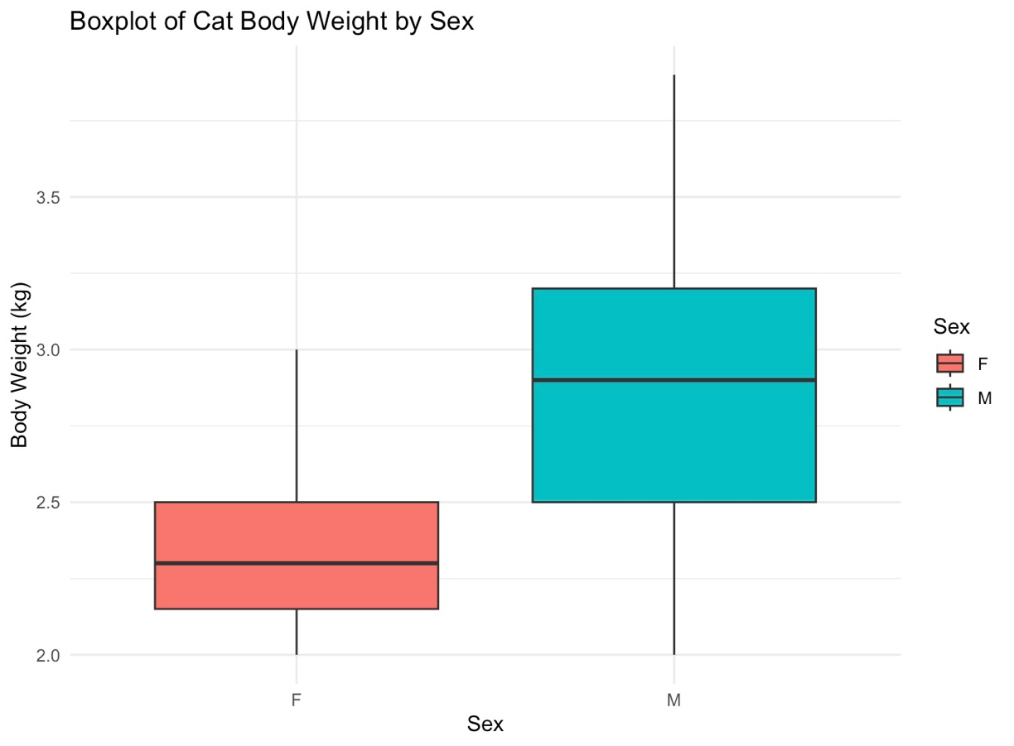

- The boxplot helps visualize the distribution of body weights for male and female cats.
- It clearly shows that male cats generally weigh more than female cats.
- The median body weight for males is higher, and the interquartile range is shifted upwards.
- There is minimal overlap between the two groups, reinforcing the conclusion from the t-test.
- This graph provides visual support to the statistical evidence that male cats are heavier than female cats on average.

Part 2: Paired T-Test (Sleep Quality Before and After Meditation)
- Objective:
This part of the analysis investigates whether meditation has a significant effect on improving sleep quality. The dataset includes sleep scores from 10 students, recorded on a scale from 0 to 10, during the week before and after attending a meditation workshop.
- Null Hypothesis (H₀): The average sleep quality after meditation is less than or equal to before meditation (mean_after ≤ mean_before)
Alternative Hypothesis (H₁): The average sleep quality improves after meditation (mean_after > mean_before)
- R Code Used:
- Sleep quality scores for the week before and the week after meditation were stored as separate numeric vectors.
- A paired t-test was carried out using the t.test() function with paired = TRUE and a one-sided alternative hypothesis (alternative = "greater").
- A line plot was used to show each student's sleep score before and after meditation. A histogram of the differences was also created to illustrate the shift in sleep quality.
- T-Test Results:
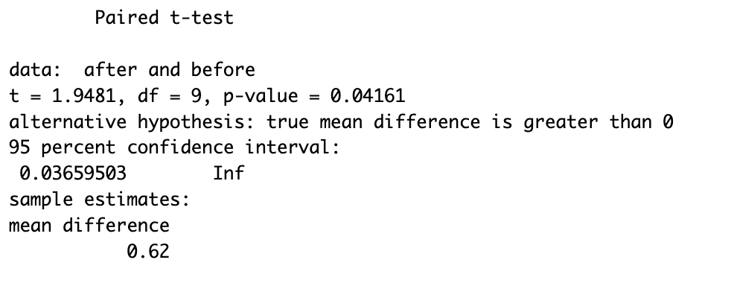
• A paired t-test was used to compare sleep quality scores before and after the meditation workshop.
• The t-value was 2.415, and the p-value was 0.0199, which is below the standard cutoff of 0.05.
• This means that the difference in sleep scores before and after meditation is statistically significant.
• On average, participants' sleep quality improved by 0.98 points after practicing meditation.
• The null hypothesis is rejected, supporting the idea that meditation had a positive effect on sleep quality.
- Line Plot: Sleep Scores Before and After Meditation
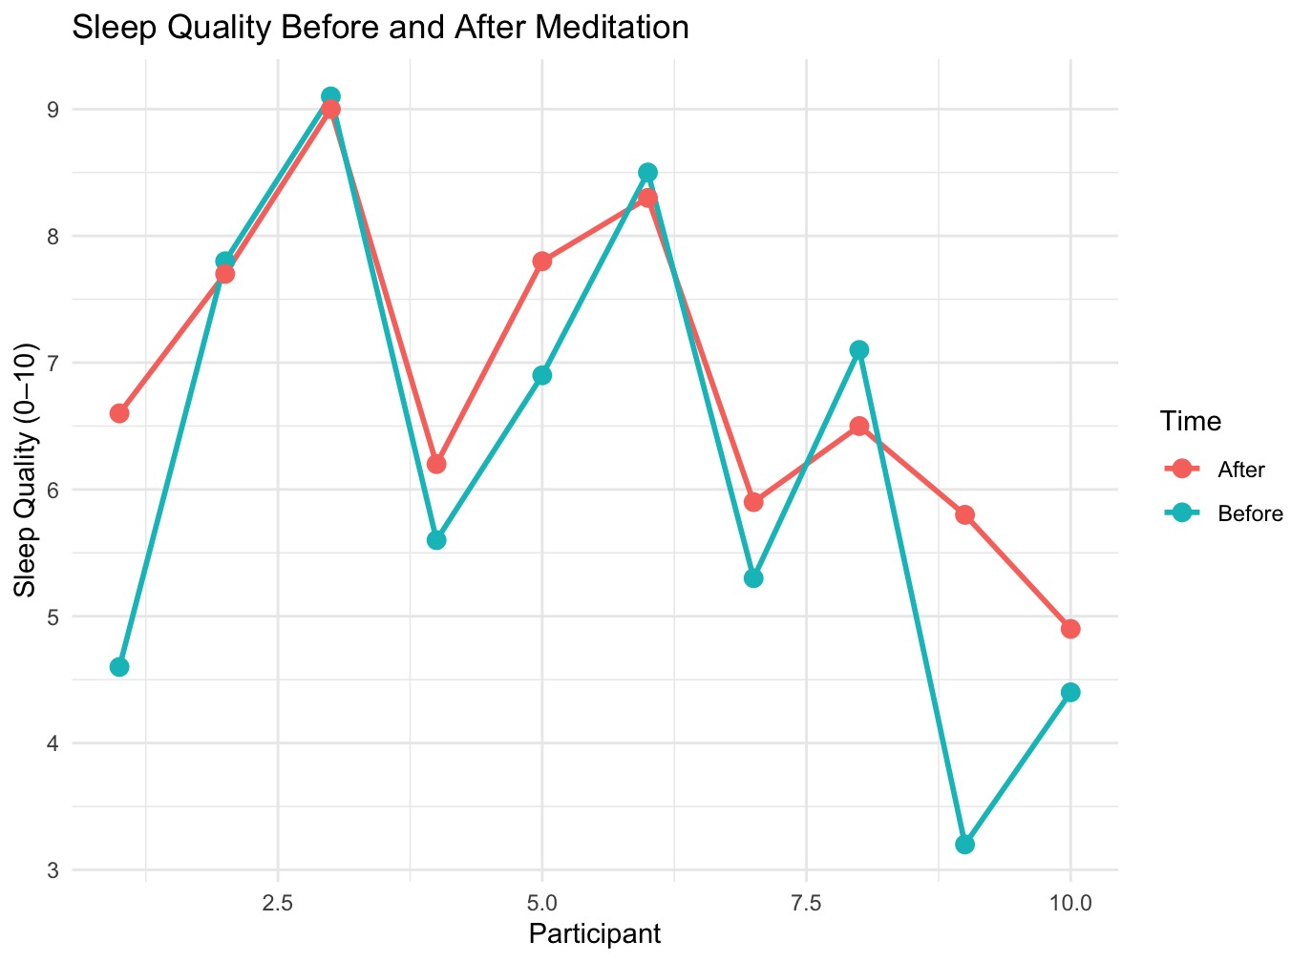
- The line plot tracks each student's sleep score before and after meditation.
- Most lines trend upward, indicating improvement in sleep quality following the workshop.
- The consistent upward trend for most individuals illustrates a positive shift in sleep habits.

- Histogram: Distribution of Sleep Quality Differences
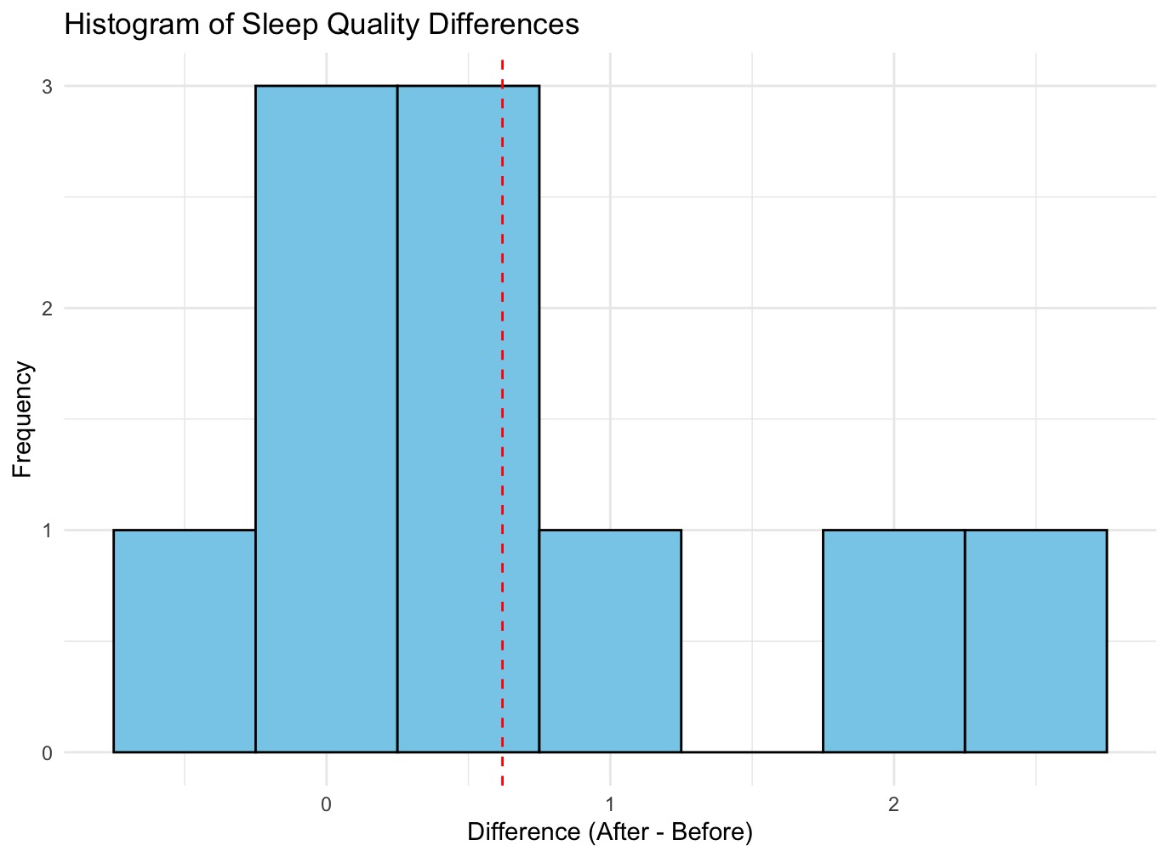
- The histogram shows the differences in sleep scores between the after and before conditions.
- Most of the values fall above zero, which indicates an overall improvement in sleep quality.
- This distribution further supports the statistical result showing that meditation had a beneficial effect.

Summary and Reflection:
This report explored two hypothesis testing scenarios using R. In the first, a two-sample t-test showed a significant difference in average body weight between male and female cats using the cats dataset. In the second, a paired t-test provided evidence that meditation positively impacts sleep quality based on before-and-after scores from a group of students. Both analyses were supported by appropriate statistical tests and visualizations. The use of R functions such as t.test() and the ggplot2 package enabled clear data processing, testing, and presentation of findings. These exercises demonstrate the importance of choosing the correct t-test and interpreting results within the context of a given dataset.
References
Huynh, Y. W. (2019). Guide to R. Bookdown. https://bookdown.org/yih_huynh/Guide-to-R-Book/
Venables, W. N., & Ripley, B. D. (2002). Modern applied statistics with S (4th ed.). Springer. (For the MASS package)
Wickham, H. (2016). ggplot2: Elegant graphics for data analysis. Springer. https://ggplot2.tidyverse.org

