Report | Module 5
Analyzing Crash Injuries in NYC

Probability Theory and Introductory Statistics

ALY6010



Submitted by: Vimlesh Vilas Sonawane
Instructor: Professor Tom Breur

College of Professional Studies
Northeastern University
June 2025

- Introduction
This report presents a statistical analysis of motor vehicle collisions in New York City using police-reported crash data. The dataset includes details such as the number of persons injured, the time of the crash, the number of vehicles involved, and location-related variables.
The purpose of the assignment was to apply regression and correlation techniques to explore relationships between injury counts and possible predictors. As instructed, the analysis includes data cleaning, the generation of correlation plots, the construction of a multiple linear regression model, and the creation of clear visualizations to support interpretation. Additional effort was made to present findings in a way that is accessible to both technical and non-technical readers.
The dataset used is based on the MV one zero four A N form, which records crash events involving injury, fatality, or significant property damage. This form is part of the broader data collection effort under the City’s traffic safety programs, including TrafficStat and Vision Zero. These initiatives aim to improve road safety by enabling data-driven strategies and reducing traffic-related injuries and fatalities.

Dataset Descriptions
The dataset utilized for this analysis was sourced from the official New York City Open Data platform. It contains detailed records of one hundred thousand police-reported motor vehicle collision incidents across various boroughs of New York City. Each record in the dataset corresponds to a single traffic collision, capturing various aspects of the event.
Key variables considered for analysis include:
- Number of persons injured – Represents how many individuals sustained injuries in each collision
- Hour – The time of the crash extracted in hourly format
- Vehicle count – Total number of vehicles involved in the collision
- Borough number – A numerical encoding of the borough where the incident occurred
- ZIP code – The postal code indicating the crash location
To ensure accuracy, the dataset underwent a cleaning process. This included filtering out records with missing or invalid values and transforming character fields into numerical formats where appropriate. Only essential variables relevant to the scope of the study were retained for further statistical analysis.
The structured and filtered data was then prepared for conducting both correlation and regression analyses to explore potential relationships between crash-related factors and the number of persons injured.

Part 1: Correlation Analysis with Visualization

Objective
To investigate the linear relationships between selected predictor variables and the number of persons injured in New York City motor vehicle collisions. The goal is to identify which variables tend to increase or decrease injury counts and to understand the strength of these relationships.
Why is it important to produce a correlation chart with no more than five variables?
- Limiting the correlation chart to five variables is important to keep the visualization clear and easy to interpret.
- Including too many variables can clutter the chart, making it difficult for readers to focus on key relationships.
- A smaller set of variables allows for a straightforward diagnostic tool that highlights the most relevant factors without overwhelming the audience.

Data and Variables Selected
A correlation matrix was computed from a cleaned dataset of one hundred thousand reported crashes. Five variables were chosen for analysis to ensure clarity and interpretability:
- Vehicle count: The number of vehicles involved in a collision.
- Hour of crash: The time of day the collision occurred, captured as an hourly value.
- Borough number: Numeric representation of the borough where the crash happened.
- ZIP code: Postal code of the crash location, representing fine-grained geographic information.
- Number of persons injured: The outcome variable indicating injury severity.

Key Findings from Correlation Analysis

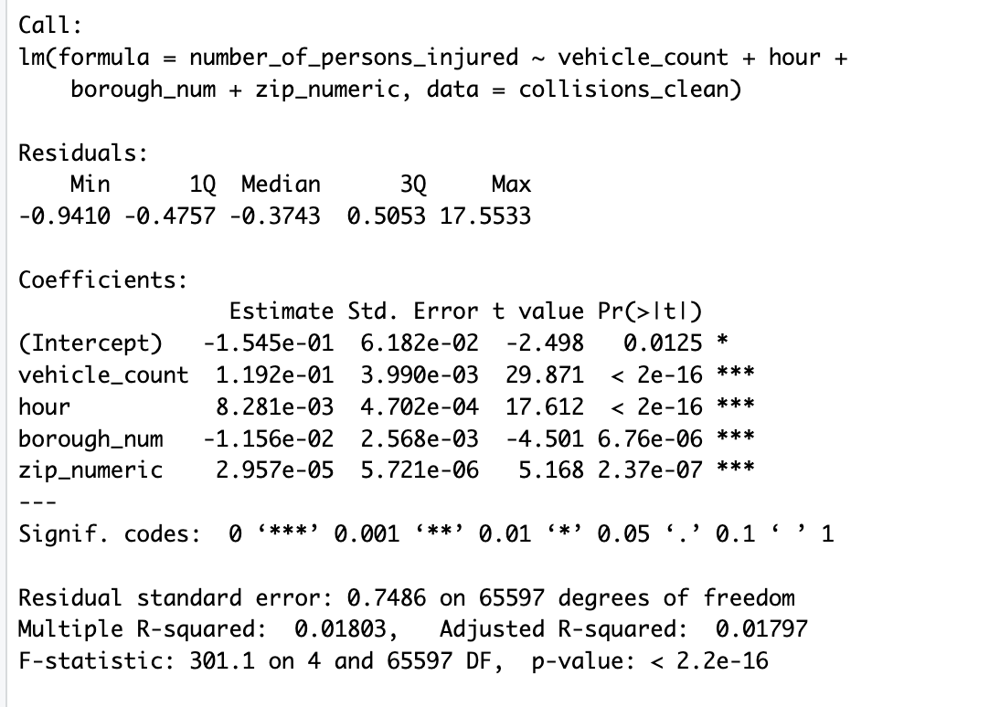
- Vehicle count showed the strongest positive correlation with the number of persons injured. This implies that collisions involving more vehicles tend to result in higher injury counts, highlighting the increased risk of multi-vehicle crashes.
- Hour of crash exhibited a moderate positive correlation, suggesting that injury rates fluctuate depending on the time of day, possibly influenced by factors such as traffic volume, lighting, and driver alertness.
- Borough number demonstrated a slight negative correlation with injury count. This may reflect differences in traffic patterns, road safety measures, or emergency response times across boroughs.
- ZIP code displayed a very weak correlation, indicating that while geographic location matters, ZIP code alone does not strongly predict injury severity and that other local factors may be at play.

Visualization Description
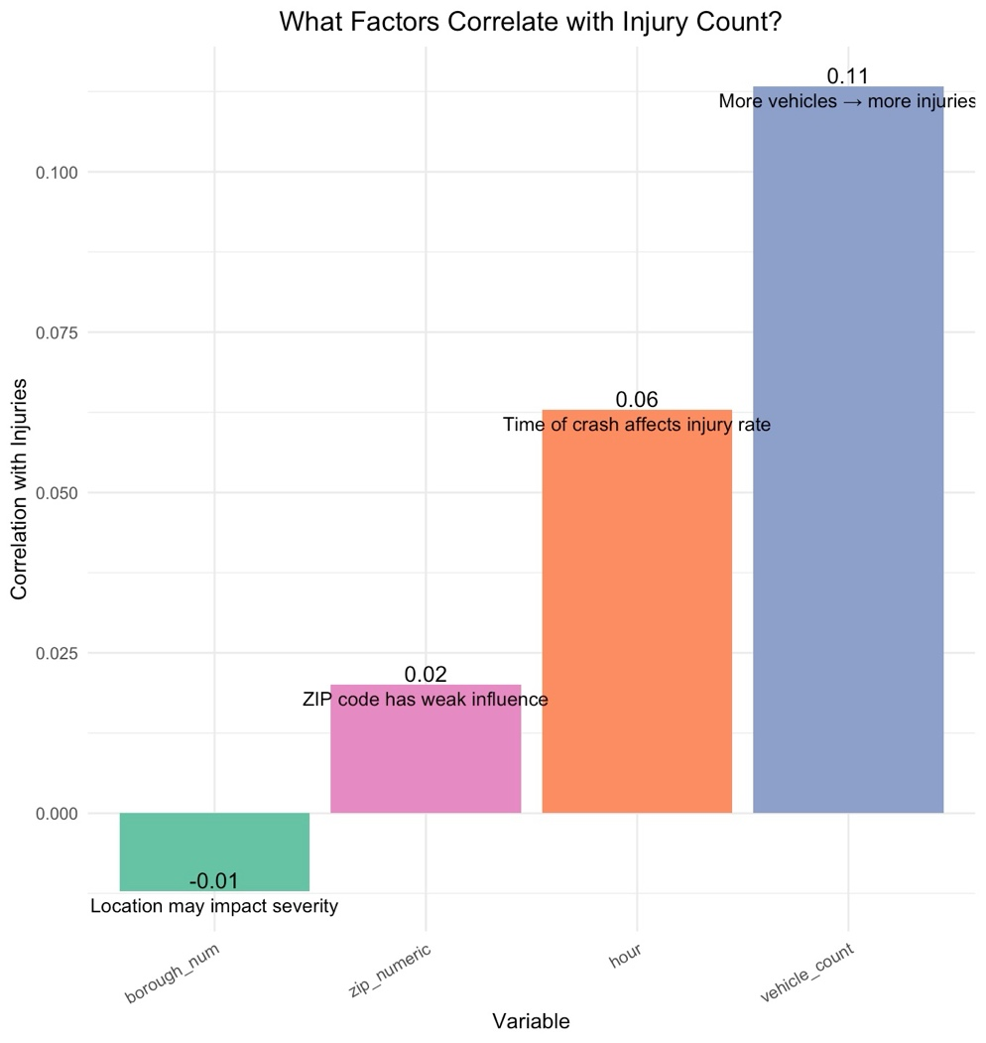

A vertical bar chart was created to illustrate the strength and direction of these correlations. Each bar represents a variable’s correlation coefficient with the number of persons injured and is color-coded to enhance visual differentiation. The chart is designed with no more than five variables to prevent information overload and to keep the diagnostic tool straightforward and effective. Labels on each bar provide the exact correlation value and a concise explanation, making the visualization accessible to both technical experts and non-specialists.

Insights and Interpretation of the Correlation Chart
- The visualization confirms that vehicle count is the most influential factor among those analyzed, strongly associated with injury severity.
- The positive relationship with crash hour points to specific times when injuries are more likely, potentially aligning with rush hour periods or low visibility conditions.
- The slight negative correlation with borough suggests that localized traffic policies or infrastructure differences may affect injury outcomes, warranting further investigation into borough-specific conditions.
- The minimal correlation of ZIP code suggests that simply knowing the postal area is insufficient to predict injuries, and that more detailed spatial or environmental data would be necessary to improve geographic insights.

Part 2: Regression Analysis with Visualization

Objective
To quantify the effect of multiple predictor variables on the number of persons injured in crashes simultaneously, while controlling for inter-variable influences, through a multiple linear regression model. This approach enables estimating the individual impact of each factor on injury severity, beyond mere associations.
How does regression analysis differ from correlation analysis, and what do the regression results reveal about factors influencing injury counts?
- Correlation analysis measures the strength and direction of a linear relationship between two variables without considering other factors. In contrast, regression analysis quantifies the influence of multiple predictor variables on an outcome variable simultaneously, adjusting for the effect of each other. This allows understanding of how each predictor uniquely contributes to injury counts, which correlation alone cannot provide.

Variables Included in the Regression Model
- Vehicle count: Number of vehicles involved in the collision.
- Hour of crash: Time of day of the collision.
- Borough number: Numeric code for the borough of occurrence.
- ZIP code: Geographic postal code.

Key Results and Interpretation
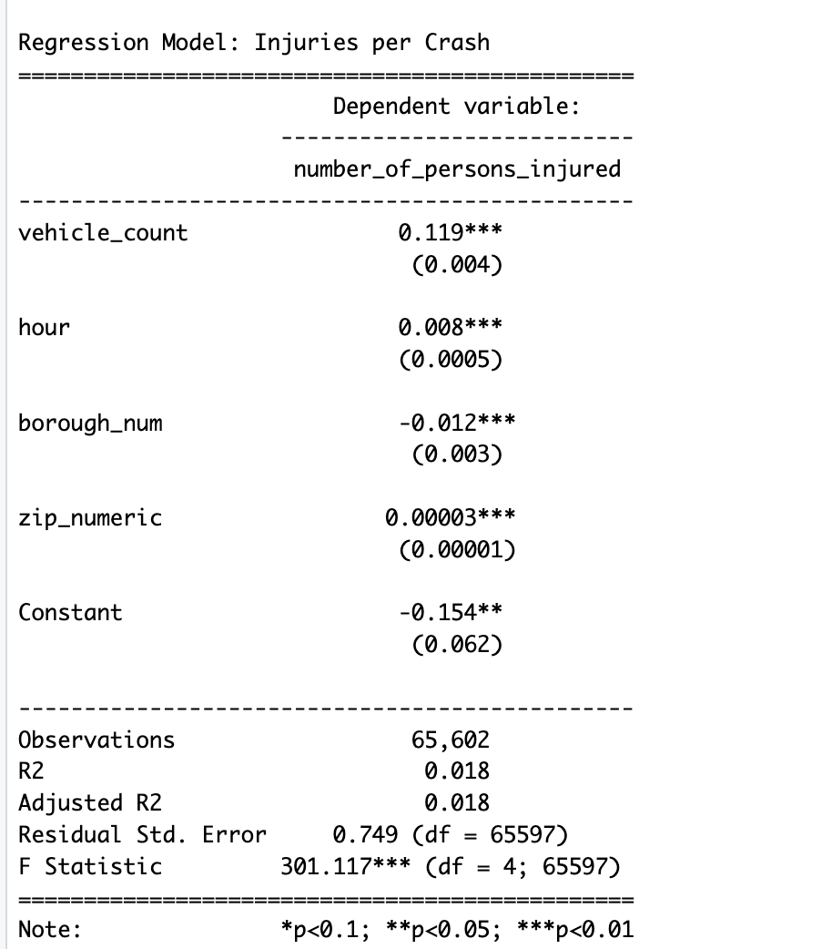
- Vehicle count was found to have a strong, positive, and highly significant effect on injury numbers. This confirms the intuitive understanding that more vehicles involved in a crash generally lead to more injuries.
- Hour of crash also showed a statistically significant positive association, reinforcing that crash timing influences injury severity. This may be due to traffic density, driver fatigue, or visibility factors varying throughout the day.
- Borough number exhibited a small but statistically significant negative effect, suggesting that some boroughs may experience fewer injuries per collision, potentially due to better road safety infrastructure or enforcement.
- ZIP code had a small positive effect on injury counts; however, its explanatory power was limited within this model framework.
- The model’s R-squared value of 0.018 indicates that the predictors explain about 1.8% of the variability in injury numbers, a relatively low value common in complex real-world urban data due to many unmeasured factors such as driver behavior, road conditions, and environmental influences.

Residual Plot Visualization
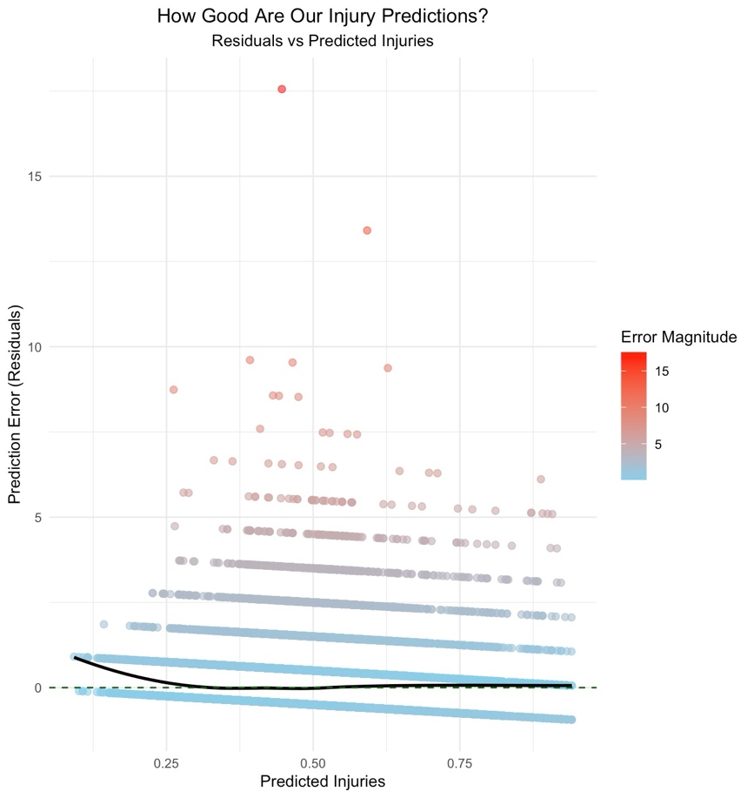
To evaluate the model’s predictive accuracy, a residual plot was generated displaying the differences between observed injury counts and the model’s predictions. The plot uses a color gradient to highlight larger residuals, which helps identify where the model tends to over- or under-predict injury severity. A smooth trend line overlays the plot to detect systematic biases in predictions, such as consistent overestimation or underestimation at specific injury levels. The residual plot is a critical diagnostic tool that informs the model’s strengths and limitations, suggesting areas where further refinement or additional variables may improve performance.

Insights and Interpretation of the Residual Plot
- The majority of points cluster near zero residual, indicating that for many cases, the model’s predictions closely match actual injury counts.
- However, the presence of points with large residuals shows that the model sometimes fails to capture extreme injury cases accurately, likely due to the complexity and variability of traffic collisions.
- The color gradient makes it easier to visually pinpoint these cases, guiding future model improvements or data collection efforts.
- Overall, the residual plot confirms the model captures general injury trends but highlights the need for more detailed or alternative predictors to enhance predictive accuracy.

Conclusion
This report investigated factors associated with injuries in New York City motor vehicle collisions using a sample of one hundred thousand crash records. The findings show that the number of vehicles and the time of day are consistent predictors of injury counts, while ZIP code and borough had minor effects. Despite the low R-squared value, the regression model provides a useful starting point for deeper investigation.
Improving urban traffic safety requires continued analysis of crash patterns. These results may guide future enhancements to road infrastructure, law enforcement strategies, and public awareness campaigns. Further studies can incorporate additional variables such as weather, driver behavior, or traffic density to improve predictive accuracy and support the city’s goal of eliminating traffic-related injuries and fatalities.

References

New York Police Department. (2025). Motor Vehicle Collisions – Crashes [Data set]. NYC Open Data. https://data.cityofnewyork.us/Public-Safety/Motor-Vehicle-Collisions-Crashes/h9gi-nx95/about_data

Wickham, H. (2016). ggplot2: Elegant graphics for data analysis. Springer-Verlag. https://ggplot2.tidyverse.org
Huynh, Y. W. (2019). Guide to R. Bookdown. https://bookdown.org/yih_huynh/Guide-to-R-Book/

