Report | Module 6
Understanding Factors Affecting Restaurant Inspection Scores in New York City
Probability Theory and Introductory Statistics

ALY6010



Submitted by: Vimlesh Vilas Sonawane
Instructor: Professor Tom Breur

College of Professional Studies
Northeastern University
June 2025

- Introduction
This report presents an analysis of restaurant inspection data collected by the New York City Department of Health and Mental Hygiene (DOHMH). The dataset includes detailed records from health inspections conducted at restaurants and college cafeterias across all five boroughs of New York City. Each inspection provides a numeric score, with higher values typically indicating a greater number of violations. The data also categorizes whether violations were flagged as critical, which may pose immediate risks to public health.
The objective of this analysis is to determine how inspection outcomes vary by borough and to assess the impact of critical violations on inspection scores. The analysis utilizes dummy variable regression and subset regression techniques to examine relationships in the data. Visualizations are included to support the interpretation of results and highlight key trends in a clear and accessible manner.
By examining these patterns, the report aims to provide insights into restaurant health and safety conditions across different boroughs and offer potential implications for improving inspection and compliance strategies.

Dataset Descriptions
The dataset used in this analysis comes from the New York City Department of Health and Mental Hygiene (DOHMH). It includes detailed inspection records for restaurants and college cafeterias located in the five boroughs of New York City: Manhattan, Brooklyn, Queens, The Bronx, and Staten Island.
Each entry in the dataset represents a single violation identified during a health inspection. A single restaurant may appear multiple times if several violations were recorded during one inspection. Records include restaurants that are active, those awaiting their first inspection (indicated by the inspection date 01/01/1900), and those with no violations, which are captured using the ACTION field.
Restaurants are uniquely identified by their CAMIS (Control and Management Information System) ID. To ensure accuracy, this analysis only used records with valid inspection scores, borough names, and meaningful dates. Inconsistent or missing data were removed.
The five boroughs included in the analysis are:
- Manhattan – a densely populated borough with a wide mix of high-end and fast-casual dining establishments.
- Brooklyn – known for its cultural diversity and a growing number of small, independent restaurants.
- Queens – one of the most ethnically diverse areas, offering a broad range of international cuisine.
- The Bronx – home to many neighborhood eateries and institutional dining facilities.
- Staten Island – a quieter residential borough with fewer, but notable, restaurant businesses.
The key variables used in this analysis are:
- SCORE: A number that reflects how many issues were found during an inspection. A higher score usually means more or worse violations.
- BORO: The borough (city area) where the restaurant is located. This includes Manhattan, Brooklyn, Queens, The Bronx, and Staten Island.
- CRITICAL.FLAG: Describes how serious a violation was. It tells whether the violation was labeled as "Critical", "Not Critical", or "Not Applicable".
- INSPECTION.DATE: The date the inspection happened.
- ACTION: What decision was made after the inspection (like no violations, closed, etc.).
- DBA: The name of the restaurant.
- CUISINE.DESCRIPTION: The kind of food served at the restaurant (e.g., Chinese, Pizza, Mexican).

- Data Analysis:
  - Part 1 – Dummy Variables and Borough-Level Regression
To examine if location affects inspection scores, dummy variables were created from the BORO column.
    - Why use dummy variables?
- Dummy variables allow R to treat borough names (like Manhattan or Brooklyn) as numeric predictors in a regression model.
- One borough (usually Bronx, because of alphabetical order) is chosen as the reference.
- The model then compares the inspection scores of other boroughs to the reference borough.
    - Model formula:
SCORE ~ BORO
- SCORE: The inspection score (numerical, more violations = higher score).
- BORO: The name of the borough (categorical, like Manhattan or Queens).
    - Steps performed:
- Unnecessary or missing data was cleaned.
- Dummy variables were created for the boroughs.
- A linear regression model was run to check the influence of borough on inspection scores.
    - Regression Summary for Overall Model
- The intercept shows the average score in the Bronx.
- Other boroughs have numbers showing how much higher or lower their average score is compared to the Bronx.
- Smaller standard errors and high t-values mean the estimates are reliable.
- p-values below 0.05 mean the differences are statistically significant.
- The R-squared shows borough explains a small part of score differences, meaning other factors matter too.

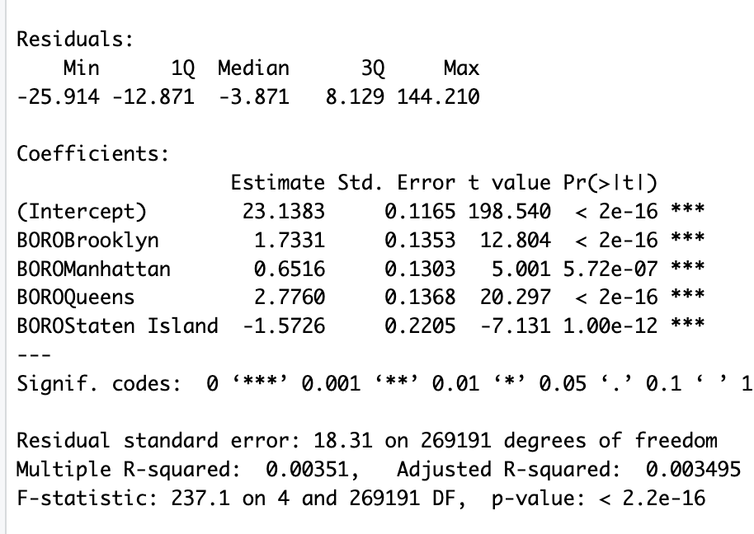
    - Key Points from the Output:
- Bronx average score is about 23.14.
- Brooklyn scores are about 1.73 points higher than Bronx.
- Manhattan scores are about 0.65 points higher.
- Queens scores are about 2.78 points higher.
- Staten Island scores are about 1.57 points lower.
- All except Staten Island show significant differences.
    - Summary:
- There are five boroughs (subsets).
- The model shows one combined regression with four dummy variables representing borough effects.
- This model highlights borough differences but doesn’t consider how violation severity affects scores.
    - Visualizations

      - Inspection Scores by Borough

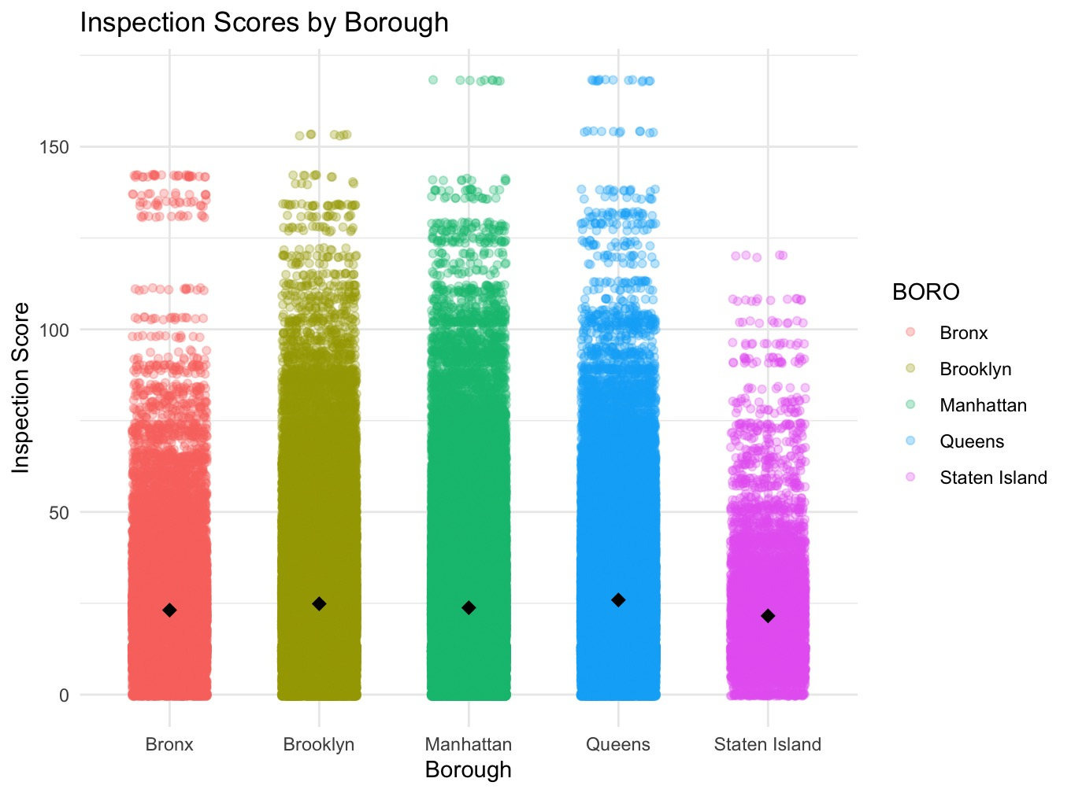
Description:
This scatterplot shows individual restaurant inspection scores across the five boroughs of New York City. Each dot is one restaurant’s score, with a little horizontal spread to avoid overlapping points. Black diamonds show the average score for each borough.
Insights:
- Inspection scores vary a lot within each borough, showing differences between restaurants.
- The average scores (black diamonds) differ clearly by borough, meaning location matters.
- Queens and Brooklyn usually have higher average scores, which means more or worse violations, while Staten Island has the lowest averages.
      - Average Inspection Score by Borough
Description:
This bar chart presents the average inspection scores for each of the five boroughs, with different colors for easy comparison.

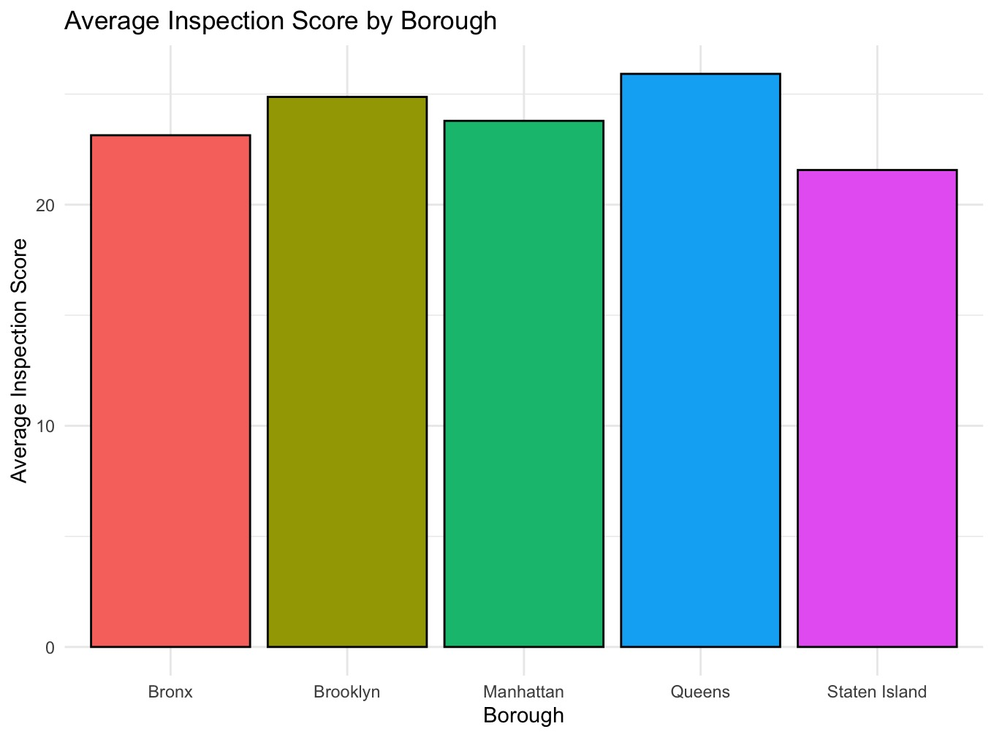
Insights:
- Queens has the highest average score, followed by Brooklyn and Manhattan.
- Staten Island has the lowest average score.
- The chart backs up the finding that borough location affects inspection scores.

Part 2 – Running Separate Regressions for Each Borough
After identifying borough differences, the data was split by borough to see how violation severity affects scores locally.
    - How many subsets?
- Five subsets, one per borough.
    - How many regression lines?
- Five separate lines, one for each borough.
    - Model formula in each borough:
nginx
Copy
SCORE ~ CRITICAL.FLAG
- CRITICAL.FLAG - shows if a violation is critical, not critical, or not applicable.
    - What was done:
- Split data into borough subsets.
- Ran regressions within each borough to examine how violation severity changes scores.
    - Regression Summary for Bronx:

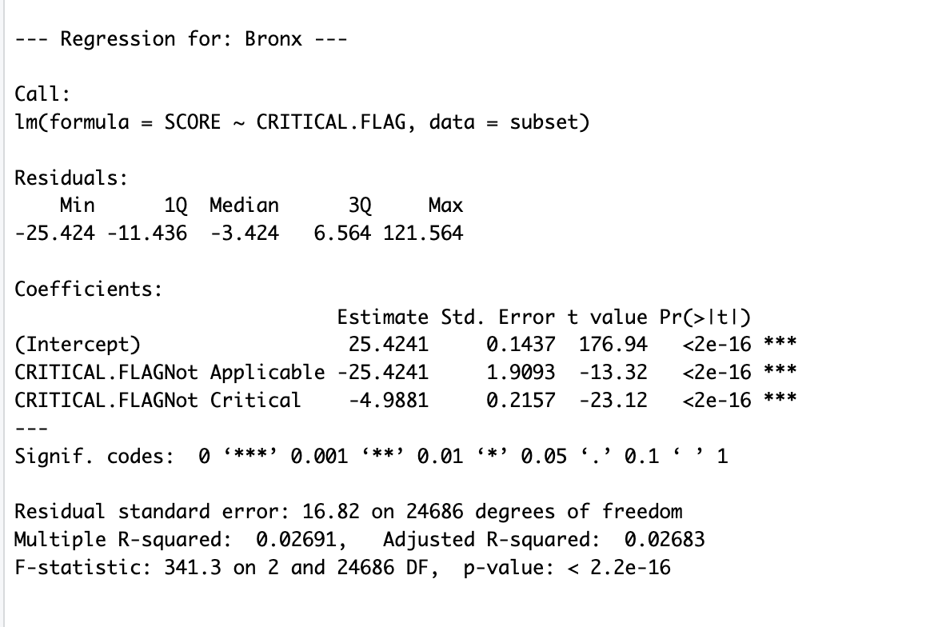
- Average score for critical violations is about 25.42.
- Non-critical violations lower scores by roughly 5 points.
- Not applicable violations lower scores by about 25 points.
- These differences are statistically significant.

Regression Summary for Brooklyn

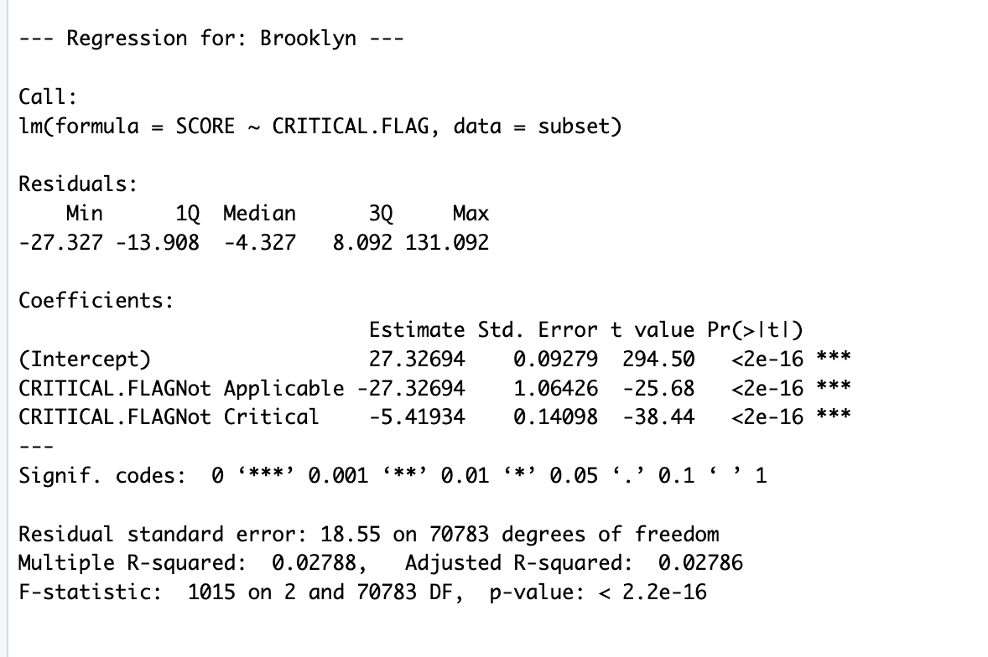
- Average score for critical violations is about 27.33.
- Non-critical violations reduce scores by around 5.4 points.
- Not applicable violations reduce scores by about 27 points.
- Effects are statistically significant.

Regression Summary for Manhattan

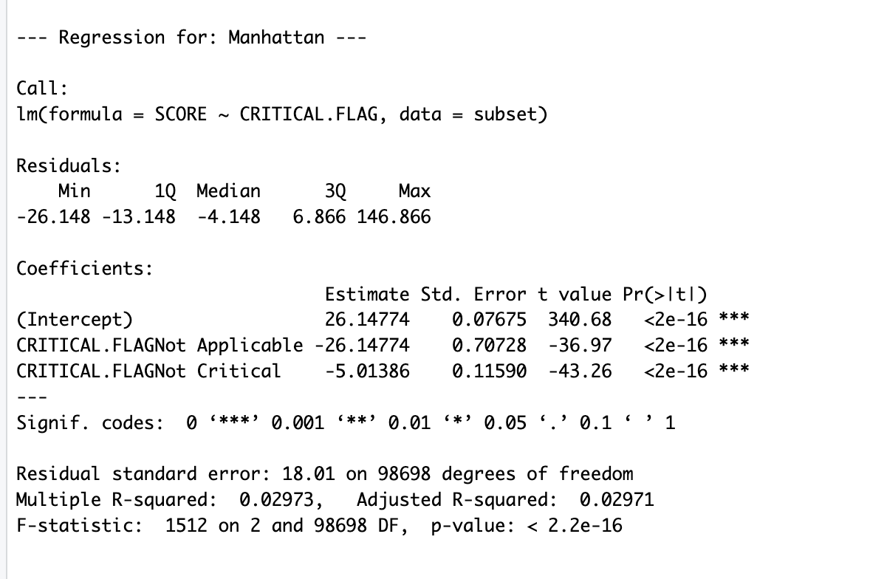
- Average score for critical violations is about 26.15.
- Non-critical violations lower scores by roughly 5 points.
- Not applicable violations lower scores by about 26 points.

Regression Summary for Queens

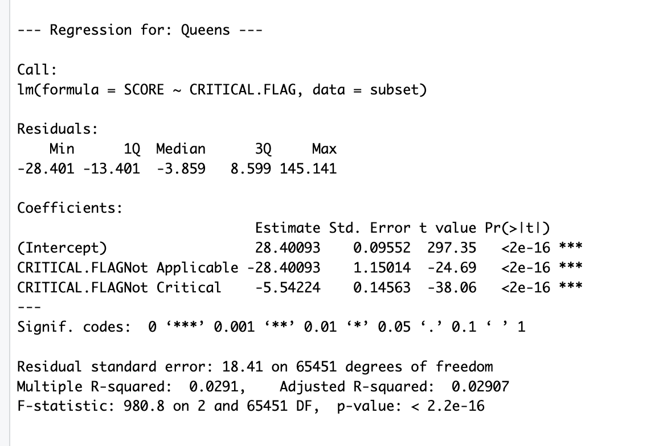
- Average score for critical violations is about 28.4 (highest among boroughs).
- Non-critical violations lower scores by about 5.5 points.
- Not applicable violations reduce scores by about 28 points.

Regression Summary for Staten Island

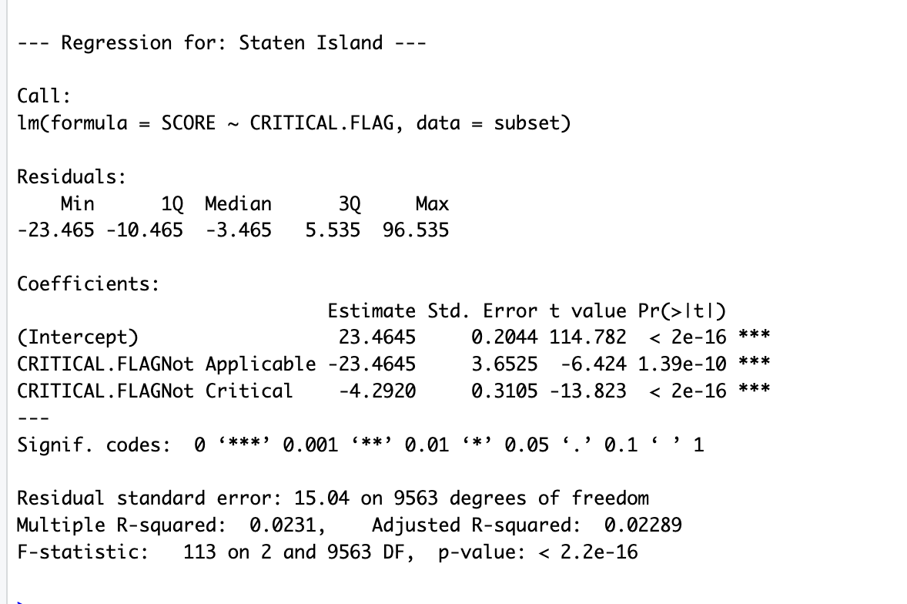
- Average score for critical violations is about 23.46 (lowest among boroughs).
- Non-critical violations lower scores by roughly 4.3 points.
- Not applicable violations reduce scores by about 23.5 points.
    - How Part 2 differs from Part 1:
- Part 1 regression lines differ only in height (intercept).
- Part 2 regression lines differ in height and slope, showing violation severity affects boroughs differently.
    - What this tells us:
- The impact of violation severity varies by borough.
- This gives a clearer, local picture of inspection scores and enforcement.

Visualization

Average Inspection Scores by Violation Severity and Borough
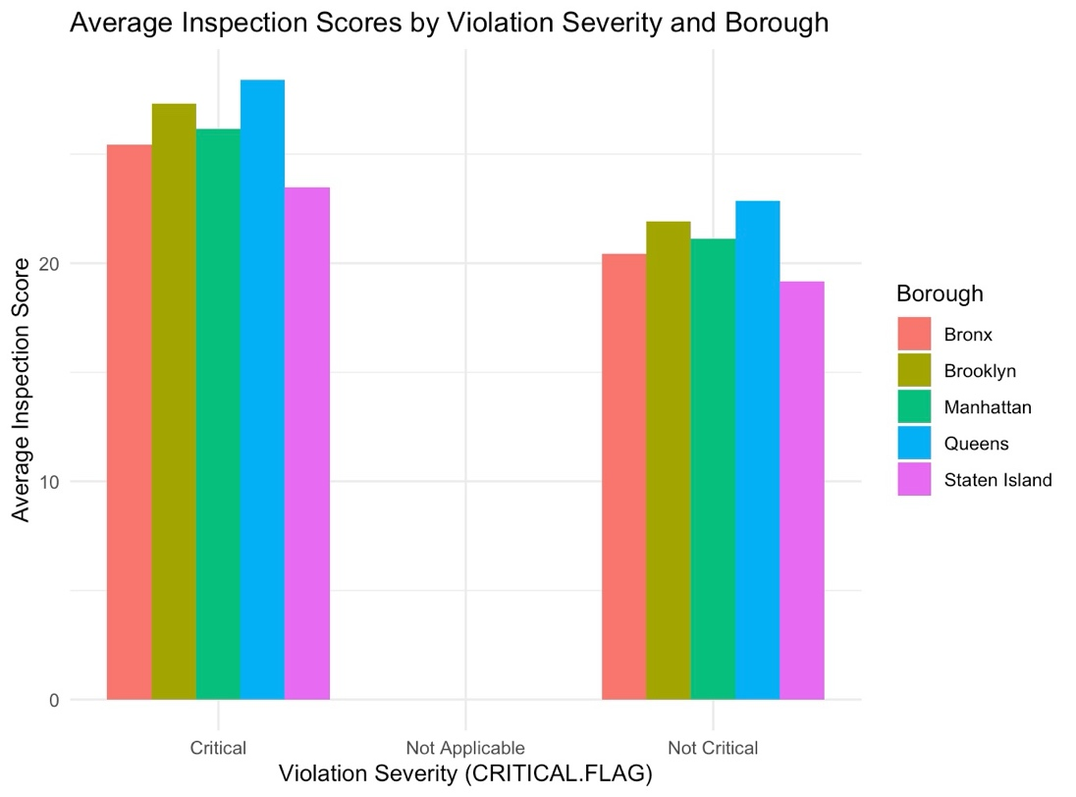
Description:
This grouped bar chart shows how average inspection scores change depending on the severity of violations (Critical, Not Critical, Not Applicable) in each borough. Bars are grouped by violation type and colored by borough.
Insights:
- Critical violations lead to higher scores in all boroughs.
- Non-critical and not applicable violations have lower scores, with “Not Applicable” usually the lowest.
- Differences between boroughs for the same violation severity show local differences in enforcement or compliance.
- This chart helps explain how violation severity affects scores differently in each borough, supporting the detailed regression results.

Conclusion
This study highlights that where a restaurant is located within New York City significantly influences its health inspection score. The initial analysis showed that inspection scores vary noticeably across the five boroughs, meaning the borough itself plays a key role in how restaurants are rated.
Digging deeper, the research looked at how the seriousness of violations—whether they are labeled as critical, not critical, or not applicable—affects inspection scores within each borough. It was found that critical violations consistently lead to higher inspection scores across all boroughs, indicating more serious health risks. However, the impact of these violations differs in size depending on the borough. This suggests that inspection procedures, enforcement strictness, or restaurant compliance may not be uniform citywide.
The use of both regression models and clear visual graphs helped to reveal these patterns effectively. The models showed broad location-based differences, while the visualizations made it easier to understand how violation severity plays out differently in each area. Together, these findings provide valuable insight that can assist health authorities in tailoring inspection strategies and focusing resources on areas that need it most.
By understanding these local variations, policymakers can improve public health outcomes by creating more targeted and effective inspection programs that consider the unique characteristics of each borough.

References
New York City Department of Health and Mental Hygiene. (2025). DOHMH New York City restaurant inspection results [Data set]. NYC Open Data. https://data.cityofnewyork.us/Health/DOHMH-New-York-City-Restaurant-Inspection-Results/43nn-pn8j
Wickham, H. (2016). ggplot2: Elegant graphics for data analysis. Springer-Verlag. https://ggplot2.tidyverse.org
Huynh, Y. W. (2019). Guide to R. Bookdown. https://bookdown.org/yih_huynh/Guide-to-R-Book/

