Report | Module 2
Crime Report

Probability Theory and Introductory Statistics

ALY6010



Submitted by: Vimlesh Vilas Sonawane
Instructor: Professor Tom Breur

College of Professional Studies
Northeastern University
May 2025

- Introduction
This report looks at crime incidents that happened in Washington, D.C. during the year 2024. The dataset includes over 29,000 reports, with details such as the type of crime, when it was reported, where it happened (based on coordinates), and which police district handled it.
The goal of this analysis is to better understand crime trends, like what types of crimes are most common, when they usually happen, and how they differ across areas. This can help police departments, city planners, and community members make more informed decisions about safety and prevention.
Before starting the analysis, the data was cleaned and prepared. This included fixing column names, converting the time into a format that’s easier to analyze, and creating a new column to show the hour each crime occurred. These steps made it easier to study the patterns in a clear and meaningful way.
By using basic statistics and simple charts, this report aims to give a clear picture of crime in D.C. during 2024 and highlight any useful patterns that stand out.

Description of the Data
The dataset used for this analysis contains records of crime incidents reported in Washington, D.C., during the year 2024. It was provided by the Metropolitan Police Department and includes over 29,000 entries with information about each crime, such as the type of offense, location, time, and the police district involved.
Each row in the dataset represents a single crime report, and there are 25 columns in total. These columns cover a variety of details, including:
- Crime Type: Such as theft, assault, or burglary.
- Date and Time: When the crime was reported.
- Hour of Day: Extracted from the report time to study crime patterns by time.
- Location: Includes latitude and longitude, along with street block identifiers.
- District and Neighborhood Info: Includes the assigned ward, PSA (Police Service Area), neighborhood cluster, and other administrative boundaries.
- Shift and Method: Indicates the police work shift and how the crime was committed.
While most records are complete, a few entries have missing or zero values, especially for location data. This is likely due to system errors during automatic location assignment, but these cases are limited and do not significantly affect the overall findings.
The dataset has a good balance of numerical and categorical variables, which makes it suitable for both statistical summaries and graphical exploration. It helps identify trends in when and where crimes occur and which types are most common.

Part 1: Descriptive Statistics

Full Dataset Summary
Using the psych::describe() function, descriptive statistics (mean, standard deviation, min, max, and count) were computed for all numeric variables in the dataset.
Output:
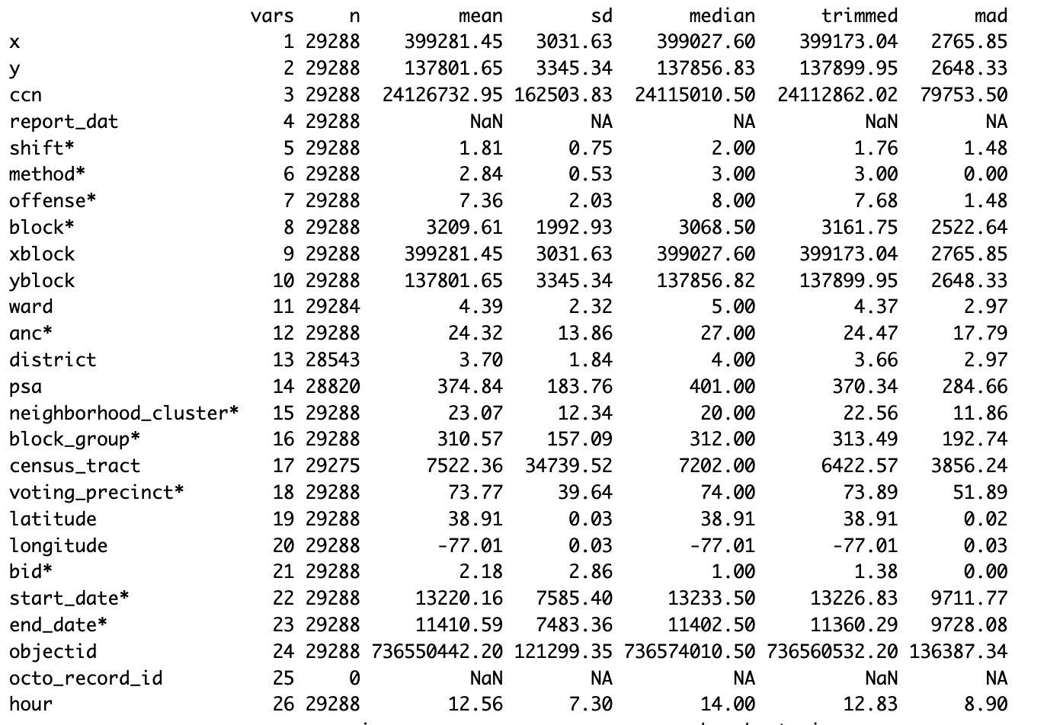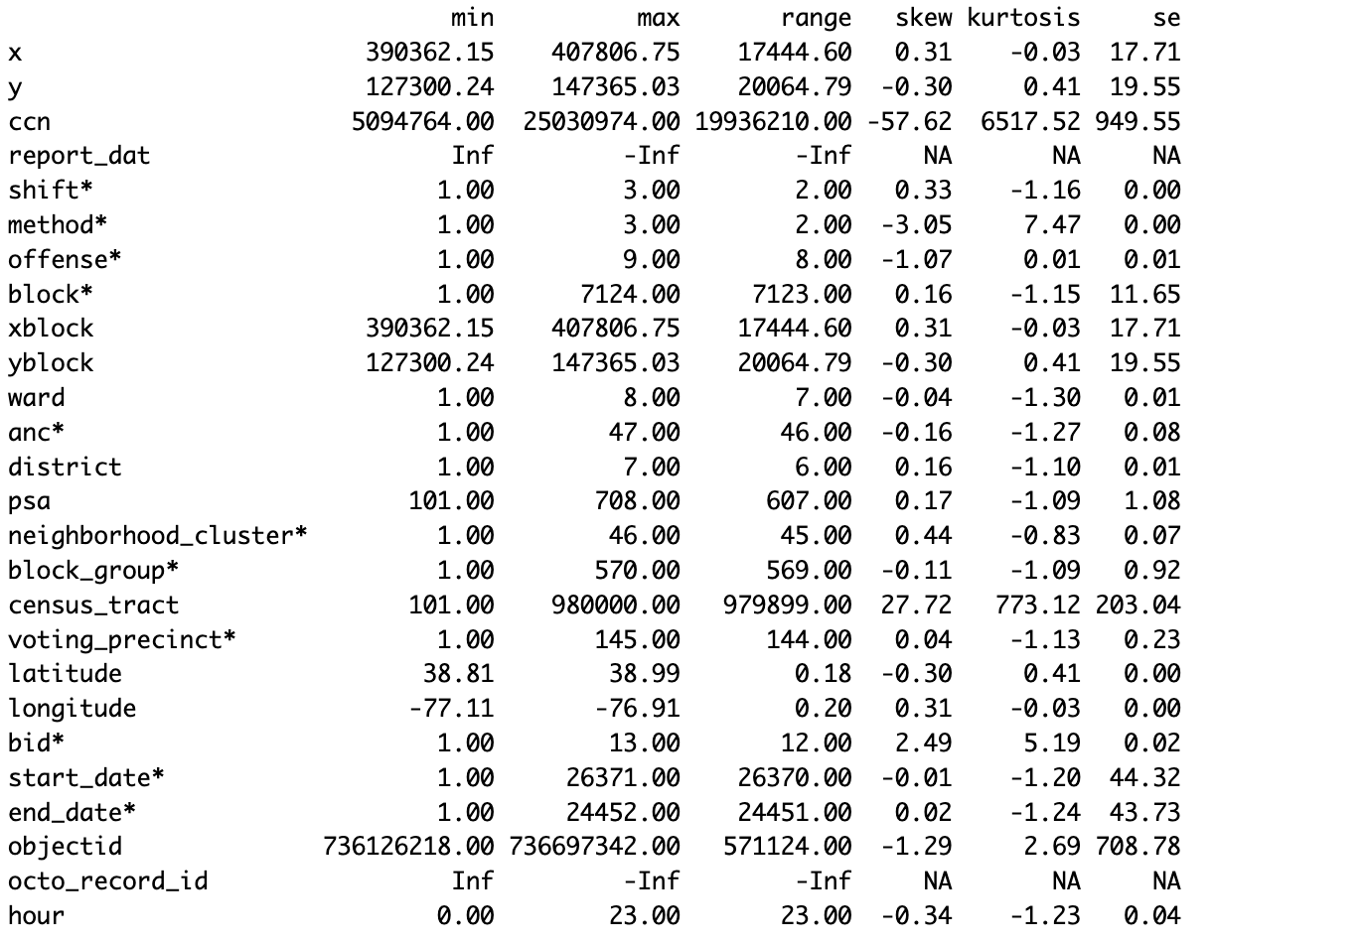
Interpretation:
- The average hour when crimes were reported was 12:34 PM, indicating most incidents tend to occur during the daytime.
- The standard deviation of 7.3 shows a wide variation, with crimes occurring throughout the day.
- The minimum value of 0 and maximum of 23 show crimes are reported across all 24 hours.
- The sample size (N) confirms this value is derived from 29,288 records, which supports the reliability of this average.

Grouped by Offense Type
We also grouped the descriptive statistics by offense type. This helps us see patterns based on the nature of the crime.
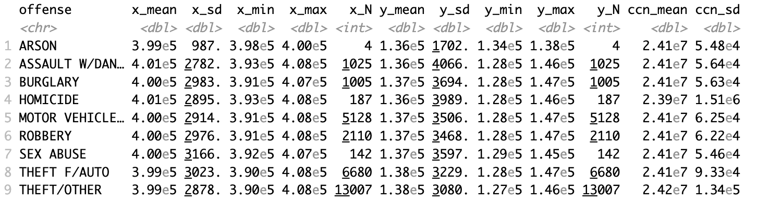
- Motor Vehicle Theft: Mean x-coordinate around 399,700 and y-coordinate near 137,000, showing wide distribution with over 5,100 cases.
- Robbery: More centralized, with moderate variation in locations.
Interpretation: Crimes like “Theft from Auto” and “Theft/Other” are more widespread, while offenses like “Homicide” or “Arson” tend to be limited in count and location.

Part 2: Visualizations

Scatter Plot of Crime Locations

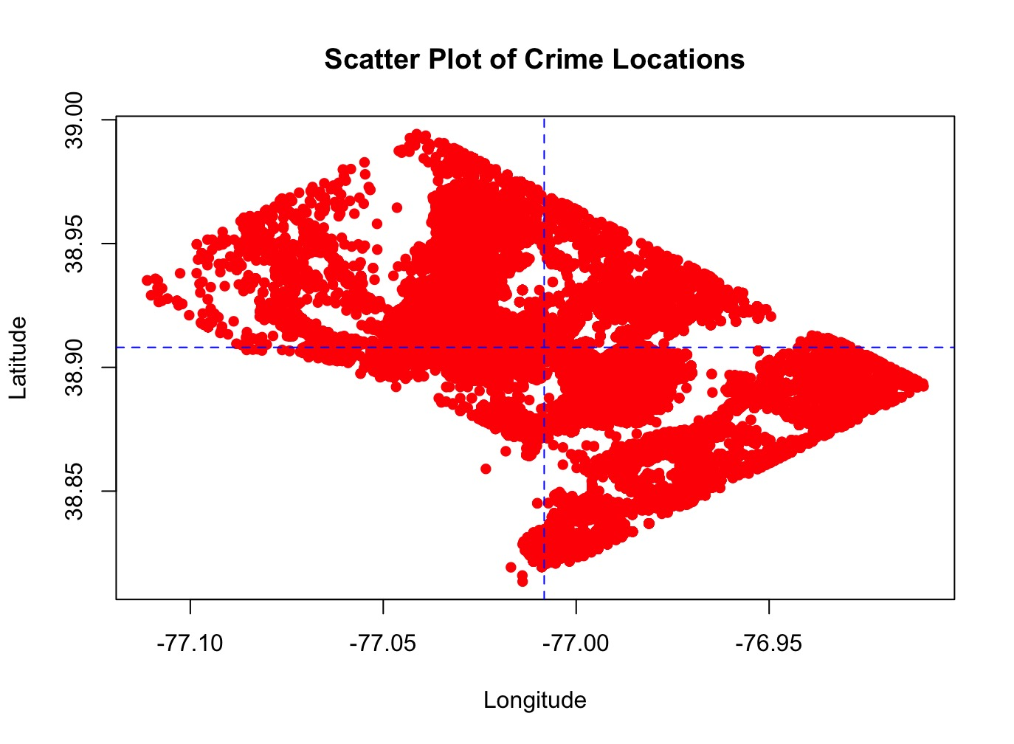
- X-Axis: Longitude
- Y-Axis: Latitude
- Purpose: To observe where crimes are happening across the city.
- Findings: Clear clusters of crime suggest hotspots, Averages were plotted as lines to show central tendencies.

2. Jitter Plot: Hour of Crime by Offense
- Functions Used: ggplot(), geom_jitter()
- Axes: Offense Type (x-axis), Hour of Day (y-axis)
- Purpose: To reduce overlapping and better visualize dense patterns in the dataset.

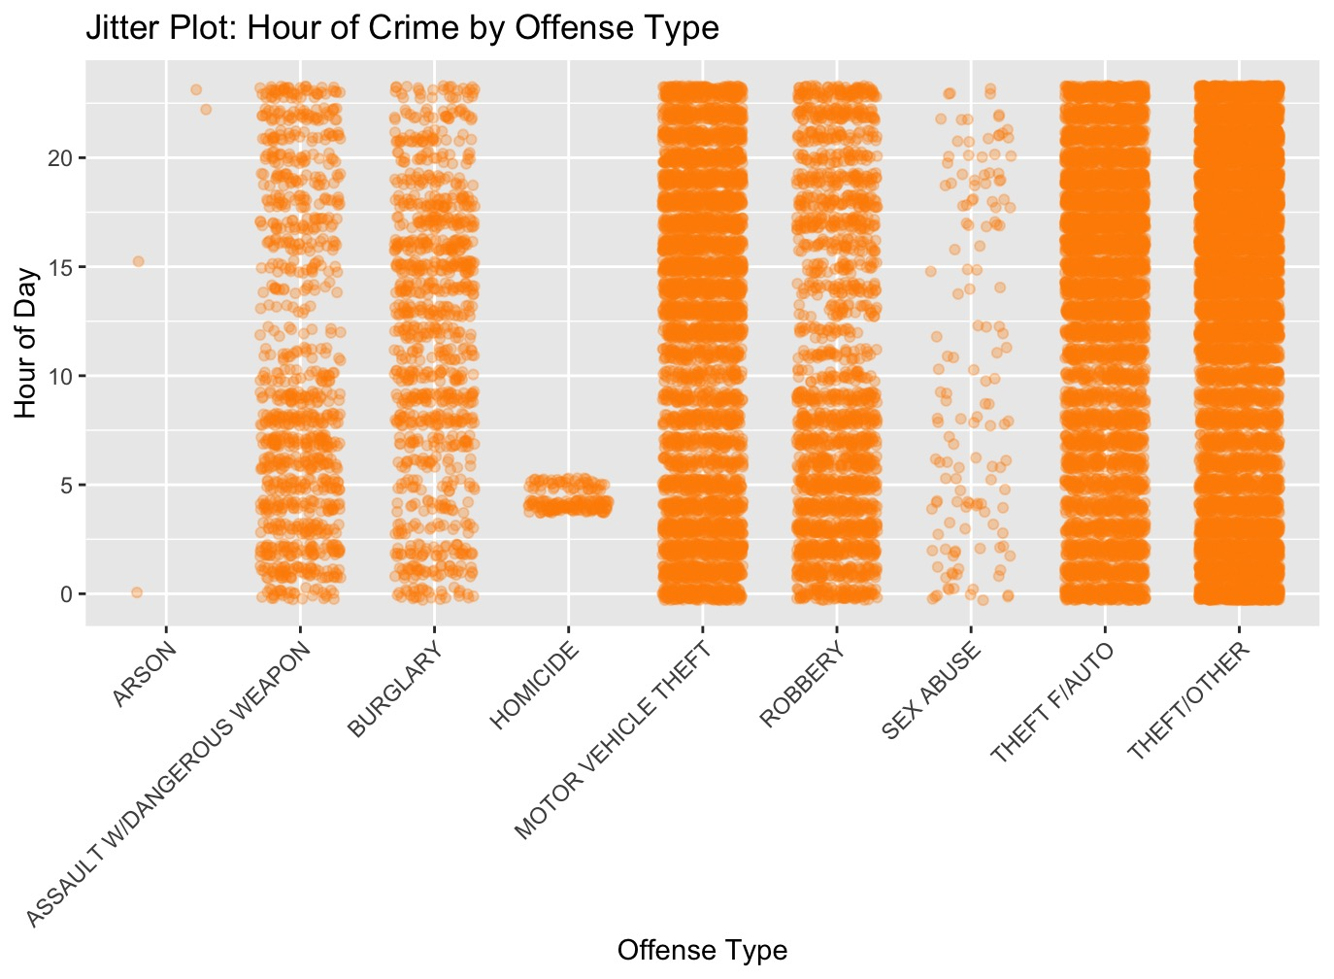
- Findings:
  - Crimes like robbery and assault tend to peak in evening hours.
  - Certain offenses like burglary or theft show spread throughout the day, while sexual abuse and homicides cluster around specific hours.
Why Use a Jitter Plot?
- Jitter plots help visualize dense data by slightly shifting overlapping points, revealing patterns that would otherwise be hidden.

3. Boxplot: Hour of Crime by Offense
- Functions Used: boxplot(), abline()
- Axes: Offense Type (x-axis), Hour (y-axis)
- Purpose: To explore the spread, central tendencies, and outliers in crime times for each offense.

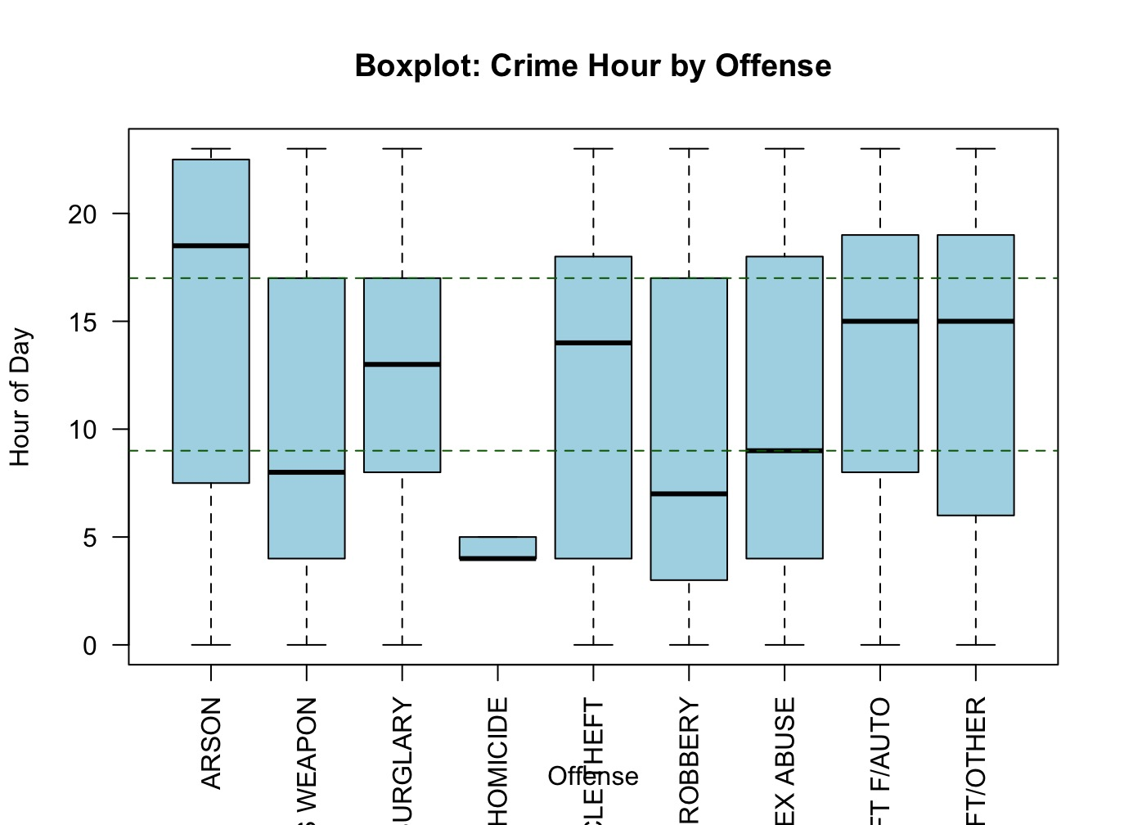

- Findings:
  - Theft and burglary typically occur during working hours.
  - Assault and robbery show a higher tendency in the evenings.
  - Some offenses display extreme values (outliers) indicating crimes at unusual hours, such as early morning or late night.
How Boxplots Detect Outliers?
- Outliers are values that lie beyond 1.5 times the interquartile range from the box, which helps identify unusual or rare incidents.

Summary and Key Takeaways
- Crimes vary by location and time of day: This analysis shows that certain neighborhoods consistently experience higher crime rates, and that the timing of offenses differs depending on the type of crime. For example, thefts often occur during the day, while assaults and robberies are more common in the evening.
- Statistical summaries help identify patterns: By grouping crime data based on offense type and examining summary statistics, we are able to pinpoint which crimes happen most frequently and where they occur. This helps simplify a complex dataset and highlights trends that might not be visible at first glance.
- Visualizations make patterns clearer: The charts and plots we used—such as scatter plots, jitter plots, and boxplots—provided a more intuitive understanding of how crimes are spread out over time and space. They helped bring attention to trends and outliers that warrant further investigation.
- Findings support better safety strategies: These insights can be useful for law enforcement and city planners. Understanding where and when crimes happen can lead to more targeted patrols, improved community safety efforts, and better use of resources. This analysis can also form the basis for more advanced forecasting models that aim to reduce crime rates in the future.** The analysis revealed that many crimes occur in specific neighborhoods and are more likely to happen during particular times of the day. This spatial-temporal relationship can help in mapping out areas of concern.
- Descriptive statistics spotlight crime concentrations: Grouping data by offense type and summarizing key statistics like mean, max, and frequency helped identify which types of crimes were most common and where they were occurring.
- Visualizations offer a practical lens for interpretation: Charts such as scatter plots and boxplots made it easier to grasp complex patterns in the data. They revealed crime hotspots and times when certain offenses were more likely to occur.
- Actionable insights for prevention strategies: By combining geographic data with time-based trends, law enforcement and policymakers can develop more targeted interventions. Predictive models built on such insights can support crime forecasting and enhance public safety resource allocation.

Future Exploration Questions
- Are specific neighborhoods more prone to crimes at certain times?
- What days of the week or months show crime spikes?
- Can this data predict crime hotspots in real time?
- Are there correlations between offense types and specific districts or wards?
References

Data.gov. (2024). Crime Incidents in 2024. https://catalog.data.gov/dataset/crime-incidents-in-2024
Huynh, Y. W. (2019). Guide to R. Bookdown. https://bookdown.org/yih_huynh/Guide-to-R-Book/
Wickham, H. (2016). ggplot2: Elegant Graphics for Data Analysis. Springer-Verlag New York.
https://ggplot2.tidyverse.org
Wickham, H., & Grolemund, G. (2017). R for Data Science. O'Reilly Media, Inc.

