Report | Module 6

Analysis of Social Media Addiction and Its Effects on Mental Health and Sleep among Students

Probability Theory and Introductory Statistics

ALY6010



Submitted by: Vimlesh Vilas Sonawane
Instructor: Professor Tom Breur
College of Professional Studies
Northeastern University
June 2025

1. Introduction
In recent years, social media platforms have become deeply integrated into the daily lives of students around the world. These platforms offer many benefits, including instant communication, entertainment, and access to information. However, increasing evidence suggests that excessive social media use can lead to addictive behaviors. Such addiction has the potential to negatively influence students’ mental health and interfere with their sleep patterns, which are crucial for cognitive functioning and overall well-being.
This study aims to investigate how social media usage relates to addiction severity among students and whether addiction impacts their mental health and sleep duration. By exploring these relationships, we hope to better understand the risks associated with heavy social media use and provide insights that may inform effective awareness campaigns and interventions to support healthier habits in the student population.

2. Dataset Description
The data for this analysis was collected via a survey of 705 students aged between 18 and 24 years from various countries. The dataset contains demographic variables such as age, gender, academic level, and country of residence, as well as detailed information about students’ social media habits and personal well-being measures.
Specifically, the variables examined include:
- Average Daily Usage Hours: The average number of hours per day a student spends on social media platforms. This provides a quantitative measure of social media engagement intensity.
- Addicted Score: A numeric score that represents the self-reported level of social media addiction on a scale ranging from 2 (lowest) to 9 (highest). This variable serves as an indicator of the severity of addictive behavior.
- Mental Health Score: A self-assessed score indicating the current mental health status of the student. Higher scores denote better mental health.
- Sleep Hours Per Night: The average number of hours a student sleeps each night, which is essential for physical and psychological health.
These variables are central to understanding the relationships between social media use and well-being in this student sample.

3. Summary of Initial Exploratory Data Analysis (EDA)

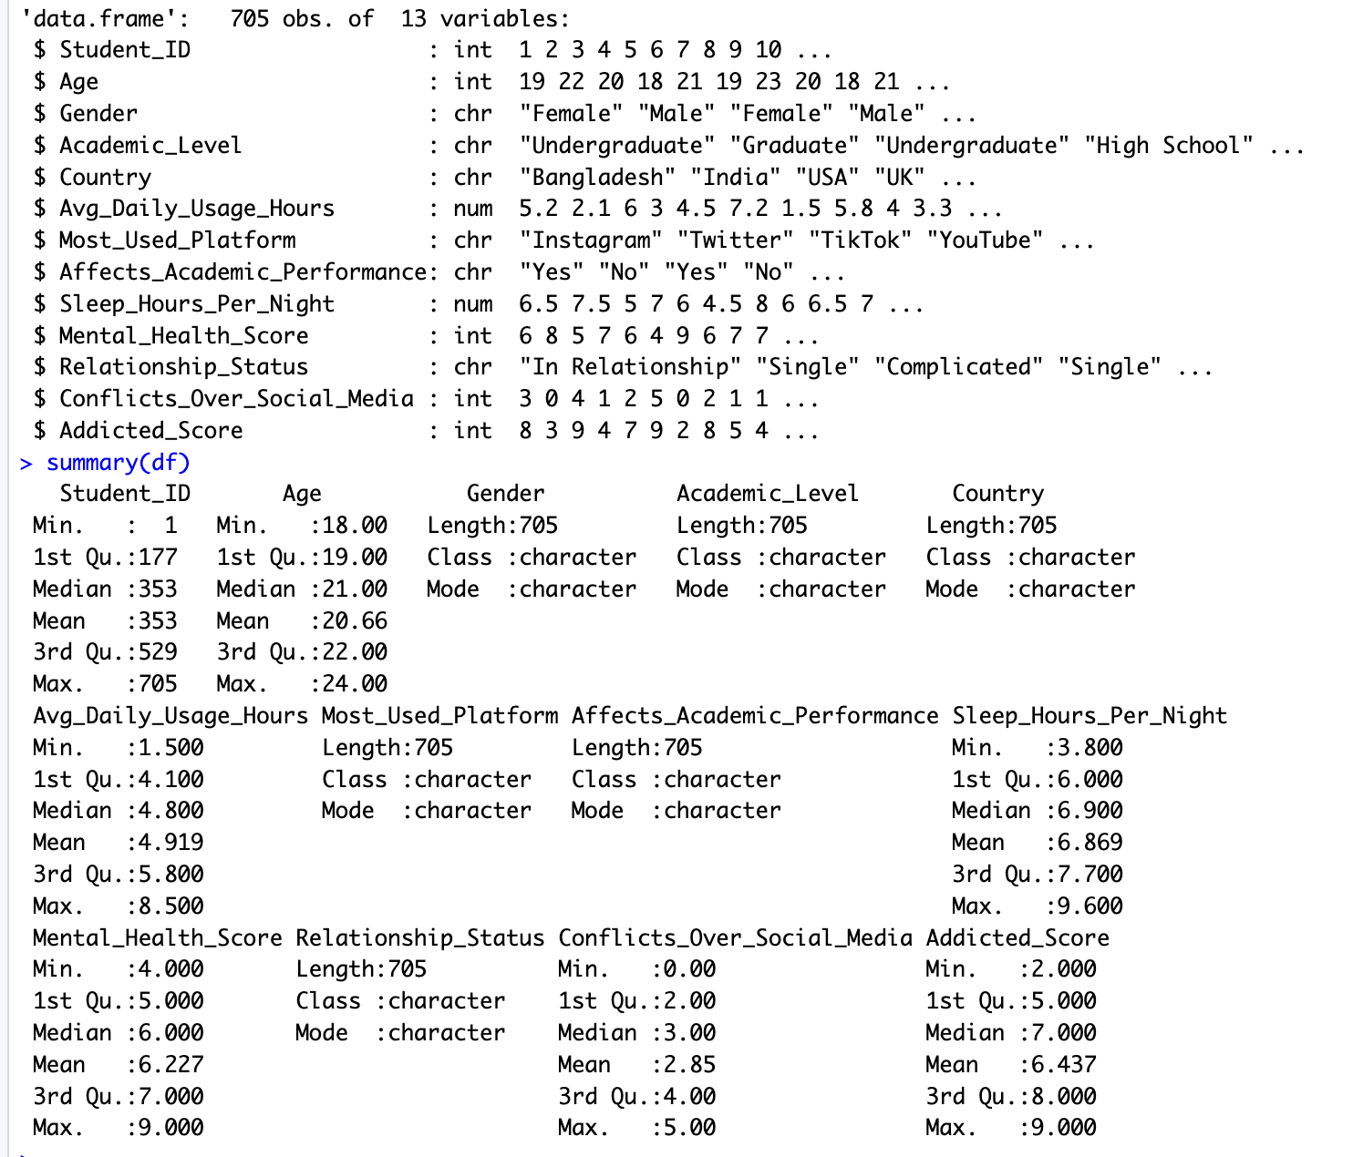

(A table summarizing minimum, first quartile, median, mean, third quartile, and maximum for Avg_Daily_Usage_Hours, Addicted_Score, Mental_Health_Score, Sleep_Hours_Per_Night)

Before conducting inferential analyses, the dataset was carefully examined to understand its basic structure and distribution of key variables. Descriptive statistics revealed the following:
- Students reported an average social media usage of approximately 4.9 hours per day, with some spending as little as 1.5 hours and others as many as 8.5 hours daily. This wide range indicates varied social media engagement levels among participants.
- Addiction scores ranged from 2 to 9, with a median score around 7, suggesting that a significant portion of students experience moderate to high levels of addictive tendencies.
- Mental health scores spanned from 4 to 9, reflecting a diverse spectrum of psychological well-being within the group.
- Sleep duration averaged close to 6.9 hours per night, though some students reported sleeping less than 4 hours and others up to nearly 10 hours.
Initial scatterplots showed promising patterns: a positive association between daily usage hours and addiction scores, and negative associations between addiction and both mental health and sleep hours. These preliminary insights laid the foundation for more detailed inferential testing.

4. Research Questions and Hypotheses
Building upon the patterns observed in the EDA, three specific research questions were formulated to explore the relationships between social media use and well-being indicators.

Question 1: Does the average daily time spent on social media predict the level of addiction?
- Null Hypothesis (H0): There is no association between the average number of daily social media usage hours and addiction score among students.
- Alternative Hypothesis (H1): Higher average daily social media usage hours are associated with higher addiction scores.

Question 2: Is there a relationship between addiction score and mental health?
- Null Hypothesis (H0): Addiction score and mental health score are independent and unrelated.
- Alternative Hypothesis (H1): Increased addiction scores are related to lower mental health scores, indicating poorer mental well-being.

Question 3: Does social media addiction affect sleep duration?
- Null Hypothesis (H0): Addiction score has no effect on the amount of sleep students get per night.
- Alternative Hypothesis (H1): Higher addiction scores predict fewer hours of sleep per night.
To test these hypotheses, Pearson correlation tests and simple linear regressions were performed for each question. Scatterplots with regression lines were created to visualize these relationships clearly.

5. Visualization and Statistical Outputs with Descriptions and Insights

Question 1: Average Daily Usage Hours and Addiction Score
The scatterplot below depicts the relationship between average daily social media usage hours and addiction score. Each point represents a student, with the blue line indicating the best-fit regression line that models addiction score as a function of daily usage hours.
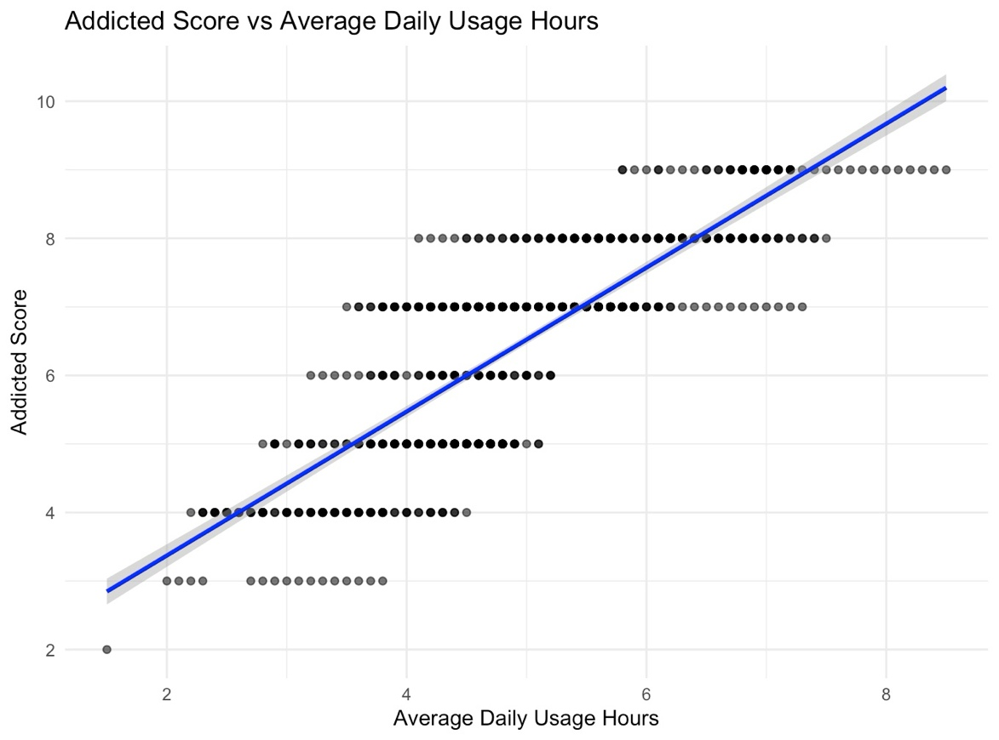
Figure 1: Addicted Score vs Average Daily Usage Hours
The Pearson correlation coefficient was found to be r = 0.83 with a p-value less than 0.001, indicating a very strong and statistically significant positive correlation. The linear regression model estimated a slope (β) of 1.05 (p < 0.001), and the model explained approximately 69% of the variance in addiction scores (R² = 0.69).
Interpretation:
This result demonstrates that students who spend more time on social media daily are significantly more likely to have higher addiction scores. Specifically, each additional hour of social media use corresponds to an increase of about 1.05 points in the addiction score. This strong relationship validates the hypothesis that increased social media engagement elevates addiction risk.

Question 2: Addiction Score and Mental Health Score
The following scatterplot illustrates the inverse relationship between addiction score and mental health score. The red regression line clearly slopes downward, highlighting the negative association.
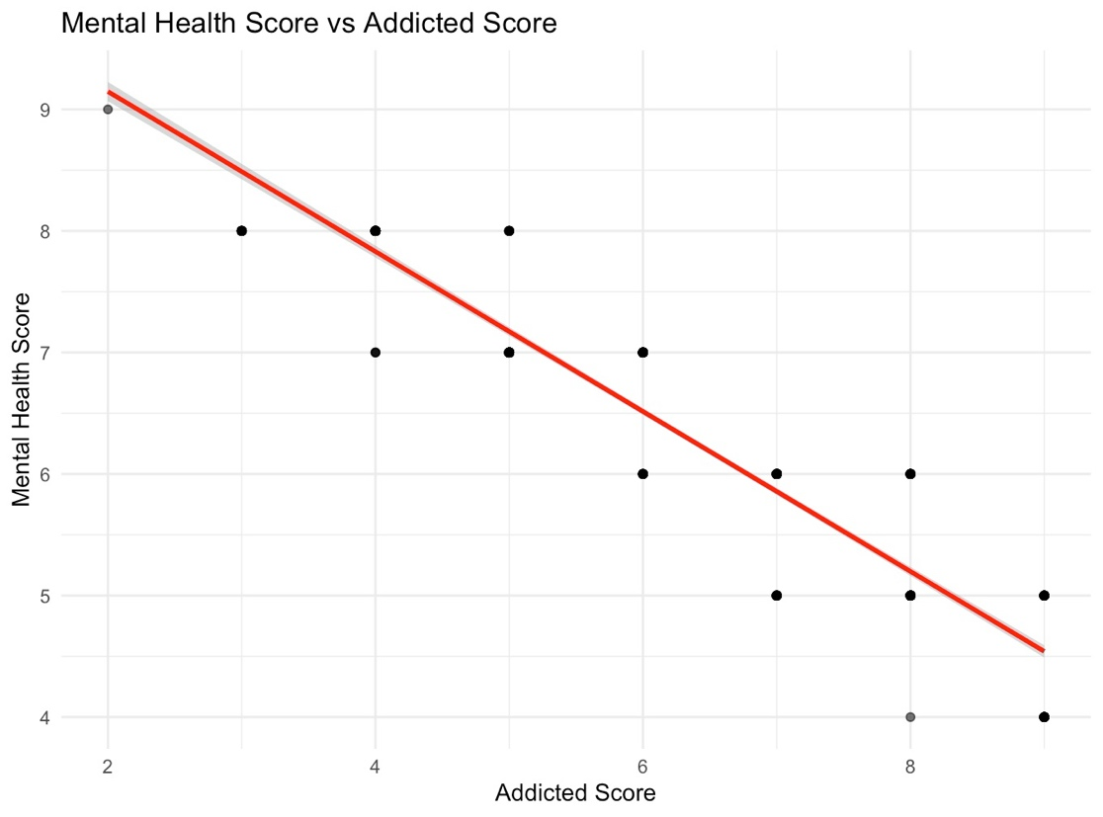
Figure 2: Mental Health Score vs Addicted Score
Statistical analysis revealed a Pearson correlation coefficient of r = -0.95 (p < 0.001), indicating a very strong negative correlation. The regression coefficient (β) was -0.66 (p < 0.001), and the model explained about 89% of the variability in mental health scores (R² = 0.89).
Interpretation:
This finding indicates that higher levels of social media addiction are strongly associated with poorer mental health. On average, a one-point increase in addiction score results in a 0.66 point decrease in mental health score, highlighting the significant psychological risks associated with excessive social media use.

Question 3: Addiction Score and Sleep Hours Per Night
The scatterplot below presents the relationship between addiction score and average sleep hours. The green regression line slopes downward, suggesting that higher addiction scores are linked to less sleep.
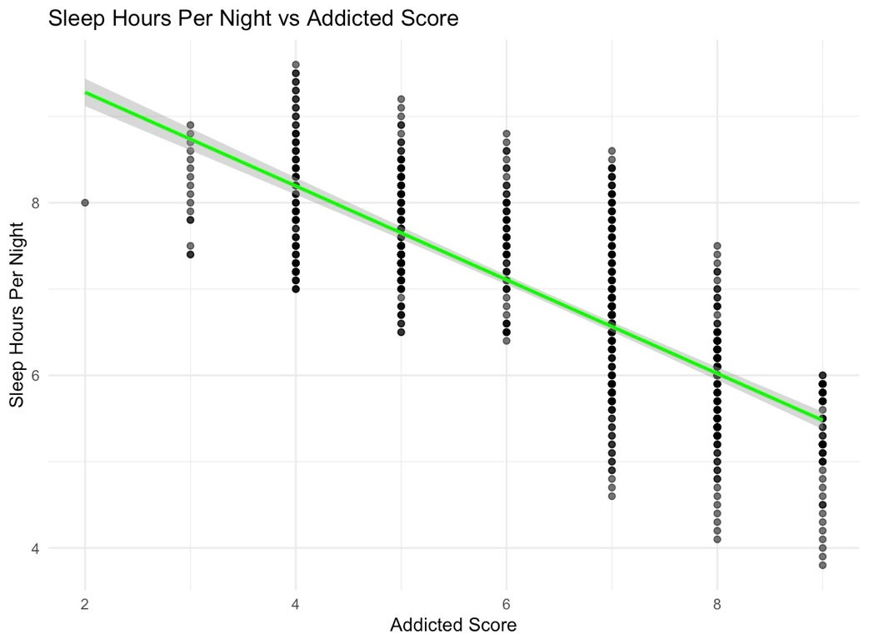
Figure 3: Sleep Hours Per Night vs Addicted Score
The Pearson correlation coefficient was r = -0.76 with a significant p-value (< 0.001), indicating a strong negative correlation. The regression coefficient (β) was -0.54 (p < 0.001), and the model explained approximately 58% of the variance in sleep duration (R² = 0.58).
Interpretation:
Students with higher social media addiction tend to get less sleep, with each increase in addiction score corresponding to roughly a half-hour reduction in nightly sleep. This suggests addiction’s detrimental effect on a vital aspect of physical health.

6. Conclusion
The analysis provides compelling evidence of significant relationships between students’ social media use, addiction, mental health, and sleep. Specifically, increased daily social media usage strongly predicts higher addiction scores. In turn, higher addiction scores are linked to lower mental health and reduced sleep duration.
These findings highlight the importance of promoting balanced social media usage among students to safeguard their psychological and physical well-being. Educational institutions and mental health professionals should consider integrating digital wellness initiatives to support students in developing healthier social media habits.
Future research could further explore causal pathways and investigate intervention strategies to mitigate the negative effects identified.

References
Shamim, A., Ghazali, E. M., Shabbir, M. S., & Pahi, M. H. (2024). The role of credibility signals in influencer marketing and impulse buying: An S–O–R perspective. Humanities and Social Sciences Communications, 11(1), 173. https://doi.org/10.1057/s41599-024-03796-7
Huynh, Y. W. (2019). Guide to R. Bookdown. https://bookdown.org/yih_huynh/Guide-to-R-Book/
R Core Team. (2024). R: A language and environment for statistical computing (Version 4.3.1) [Computer software]. R Foundation for Statistical Computing. https://www.R-project.org/

