Report

Final Project Milestone 2

Probability Theory and Introductory Statistics

ALY6010



Submitted by: Vimlesh Vilas Sonawane
Instructor: Professor Tom Breur

College of Professional Studies
Northeastern University
June 2025
- Introduction
Social media plays an important role in the daily lives of students. Whether it is staying connected with friends, watching videos, or sharing content, these platforms are used frequently. With so much time spent online, it is natural to question how social media might be affecting important areas such as sleep, academic performance, and mental health.
The dataset titled “Students Social Media Addiction” was used in Assignment 1 to explore how students use social media and how it relates to their academic and personal lives. Some noticeable patterns were observed. For example, students who believed that social media affected their studies often had higher addiction scores. Male students appeared more addicted than female students, and many students reported sleeping fewer than the recommended seven hours each night.
This report continues the analysis by using hypothesis testing to determine if those patterns are statistically meaningful. One sample and two sample t tests are applied to examine three key questions. This approach helps show whether the observed differences in the data are significant or simply due to random chance.

Description of the Data
The dataset used in this report is called “Students Social Media Addiction”, which was also explored in Assignment 1. It includes responses from students with different backgrounds, focusing on how they use social media and how it might affect their daily lives. The data provides useful information about each student's habits, such as how much time they spend on social media, how well they sleep, and how they feel mentally. It also includes details like their age, academic level, and relationship status.
To better understand the information in the dataset, the main variables are listed below:

Categorical Variables
- Gender – Whether the student is male or female
- Academic Level – The student’s level of study (undergraduate, postgraduate, etc.)
- Country – The country the student is from
- Most Used Platform – The social media platform used most often (like Instagram or Facebook)
- Relationship Status – Whether the student is single, in a relationship, or married
- Affects Academic Performance – Whether the student feels social media affects their academic work (Yes or No)

Numerical Variables
- Age – The student’s age in years
- Average Daily Usage Hours – How many hours they spend on social media each day
- Sleep Hours Per Night – How many hours they sleep on average each night
- Mental Health Score – A self-rated score showing how the student feels mentally
- Conflicts Over Social Media – The number of arguments or issues caused by social media use
- Addicted Score – A score that shows how addicted the student feels to social media
Data cleaning included renaming column headers, converting types (e.g., character to factor or numeric), and standardizing binary responses such as "Affects_Academic_Performance" to "Yes" and "No". Missing values were handled using as.numeric() and as.factor() conversions with proper coercion.

Hypothesis Testing
This part of the report looks at three questions based on patterns found in Assignment 1. These questions are tested using one-sample and two-sample t-tests to check if the differences seen in the data are real or just happened by chance.
The three questions are:
- Do students who believe that social media affects their academic performance have higher addiction scores than those who do not?
- Is the average number of sleep hours among students less than the recommended seven hours per night?
- Do male and female students have different levels of social media addiction?

Test 1: Addiction Score vs. Academic Impact
Test Type: Two-sample t-test (independent samples)
Null Hypothesis (H₀):
There is no difference in the average addiction scores between students who believe social media affects their academic performance and those who do not.
Alternative Hypothesis (H₁):
Students who believe that social media affects their academic performance have higher average addiction scores than students who believe it does not.
Explanation of the Test:
This test compares the average addiction scores of two independent groups of students. One group consists of students who answered “Yes” when asked if social media affects their academics, and the other group includes those who answered “No.” A two-sample t-test is appropriate here because it tests whether the means of two unrelated groups are significantly different. Since the research question focuses on whether one group (Yes) has a higher mean than the other (No), a one-sided (greater) test was used.
R Code Used:
group1 <- student_data$Addicted_Score[student_data$Affects_Academic_Performance == "Yes"]
group2 <- student_data$Addicted_Score[student_data$Affects_Academic_Performance == "No"]
t.test(group1, group2, alternative = "greater", var.equal = FALSE)

Output
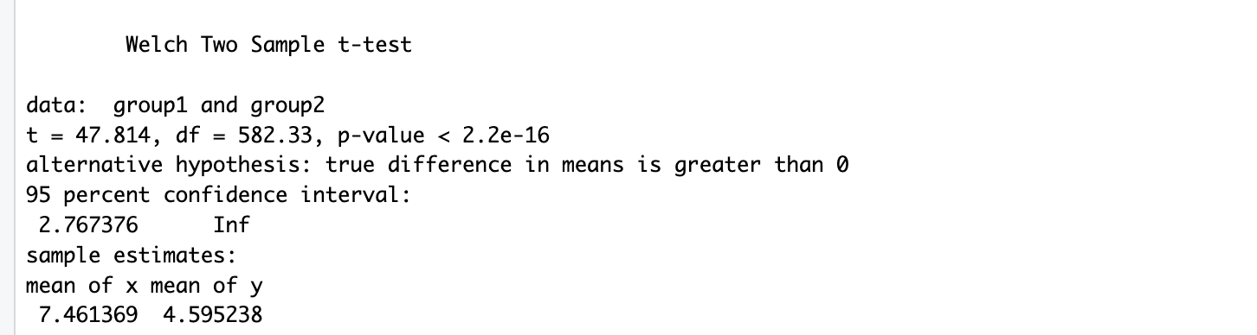

Results:
- Mean addiction score (Yes group): 7.46
- Mean addiction score (No group): 4.60
- t-value: 47.81
- p-value: < 2.2e-16
- 95% Confidence Interval: (2.77, ∞)
Interpretation:
The p-value is extremely small and well below the standard threshold of 0.05, which means the result is statistically significant. This indicates strong evidence that students who think social media affects their academics tend to have higher addiction scores compared to those who do not. The large t-value and the wide gap between the means support this conclusion. These results suggest a meaningful connection between perceived academic distraction and levels of social media addiction.

- Test 2: Average Sleep Hours Less Than 7
Test Type: One-sample t-test.

Null Hypothesis (H₀):
The average number of sleep hours among students is equal to 7 hours per night.

Alternative Hypothesis (H₁):
Students sleep less than 7 hours per night on average.

Explanation of the Test:
This one-sample t-test is used to compare the average sleep duration reported by students to a known benchmark: 7 hours, which is widely considered the recommended minimum sleep time for healthy adults. The test checks whether the students, on average, are sleeping significantly less than this recommended amount.

R Code Used:
t.test(student_data$Sleep_Hours_Per_Night, mu = 7, alternative = "less")

Output
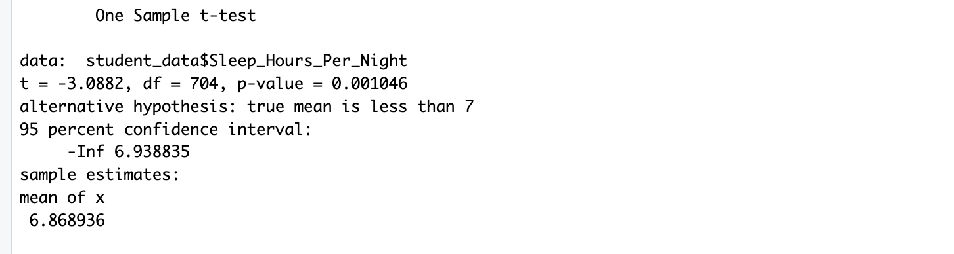
Results:
- Mean sleep hours: 6.87
- t-value: -3.09
- p-value: 0.0010
- 95% Confidence Interval: (-∞, 6.94)
Interpretation:
The p-value is less than 0.05, so this result is statistically significant. This means there is strong evidence that students are getting less than 7 hours of sleep per night on average. The negative t-value also confirms that the observed mean is lower than the reference value. Lack of sufficient sleep may be linked to increased social media usage or academic workload, and this result highlights the need to pay attention to student sleep habits.

Test 3: Gender Difference in Addiction Scores
Test Type: Two-sample t-test (independent samples)
Null Hypothesis (H₀):
There is no difference in the average addiction scores between male and female students.
Alternative Hypothesis (H₁):
There is a difference in the average addiction scores between male and female students.
Explanation of the Test:
This two-sample t-test is used to compare the mean addiction scores between two independent groups: male and female students. It checks whether gender plays a significant role in social media addiction levels. Since the test does not assume which gender has a higher or lower mean, a two-sided (two-tailed) test is used.
R Code Used:
t.test(Addicted_Score ~ Gender, data = student_data)

Output
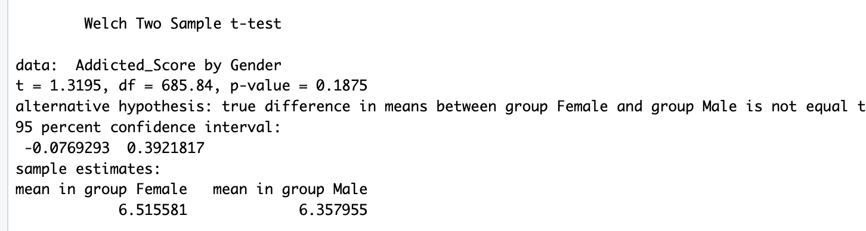
Results:
- t-value: 1.32
- p-value: 0.1875
- 95% Confidence Interval: (-0.077, 0.392)
Interpretation:
The p-value is greater than 0.05, so the result is not statistically significant. This means there is no strong evidence to suggest a meaningful difference in addiction scores between male and female students in this dataset. While male students may show slightly higher average scores, the difference is not large enough to be considered reliable. Therefore, gender alone may not be a strong factor influencing social media addiction levels in this group of students.

Insights
- Students who feel that social media affects their academics have noticeably higher addiction scores. This may reflect the way excessive social media use impacts study habits and focus.
- The average sleep among students is less than the recommended 7 hours, raising concerns about well-being and the possible influence of screen time on sleep quality.
- There is no meaningful difference in addiction scores between male and female students, suggesting that social media usage patterns affect all genders similarly.
- Conclusion
The results of the hypothesis testing provide a clearer picture of how social media habits relate to students’ academic and personal well-being. It is evident that students who believe social media is affecting their academic performance tend to be more addicted to it. This pattern suggests that overuse might be contributing to lower focus or productivity in studies.
Additionally, the analysis confirms that students are not getting the recommended amount of sleep. Lack of sleep can affect attention, memory, and academic performance, and may be linked to screen time habits.
Interestingly, although descriptive data hinted that males might have higher addiction scores, there was no significant statistical difference between genders. This shows that excessive use of social media is a common concern for students regardless of gender.
Overall, these insights call for greater awareness around balancing screen time with healthy sleep and study routines. Educators, institutions, and even students themselves can benefit from understanding these patterns to promote better academic outcomes and personal well-being.

References
Shamim, A. (2023). Social media addiction vs relationships [Dataset]. Kaggle. https://www.kaggle.com/datasets/adilshamim8/social-media-addiction-vs-relationships
Wickham, H. et al. (2024). ggplot2: Create elegant data visualisations using the grammar of graphics (v3.5.0) [R package]. https://ggplot2.tidyverse.org/
R Core Team. (2024). R: A language and environment for statistical computing (v4.3.1). https://www.R-project.org/

