HealthCare Project Implementation

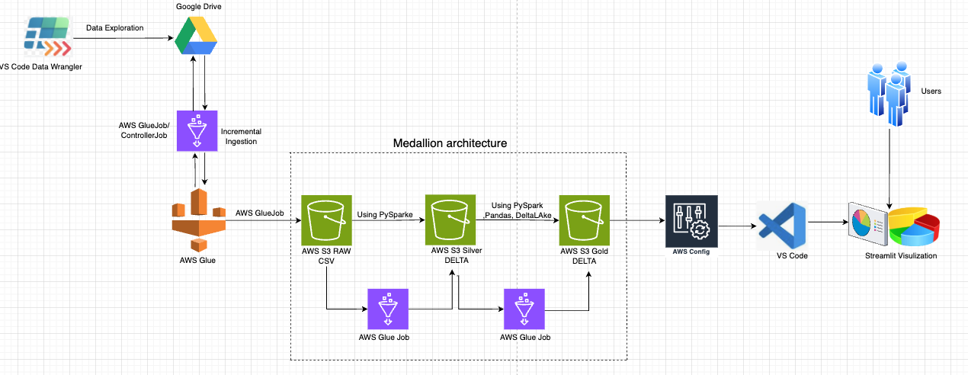

All the Glue jobs script files were upload to below GIT Repository
GitHub Link - https://github.com/Vimmani/HealthCare_End_To_End_Project

Data Ingestion From G-Drive to S3 RAW :

Enabling Google Drive API in Google Cloud for my project:-
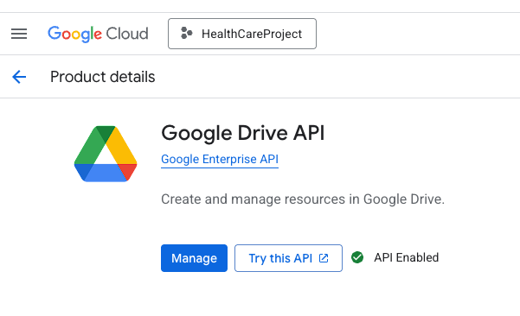

Create Google Cloud Service Account:-

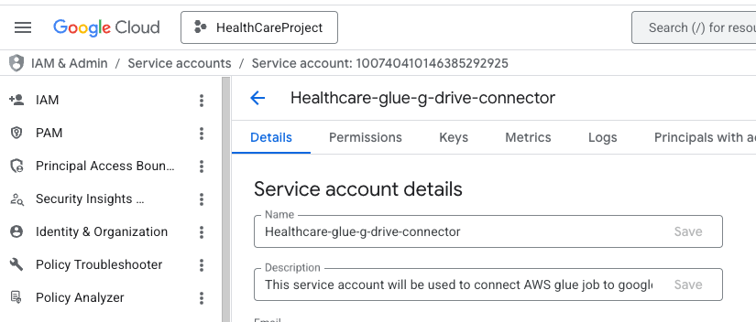

Generating JSON key for google drive service account and download it so that it can be up-loaded to AWS Secrets Manager. And can be pulled from AWS SSM to ingestion glue Job script.

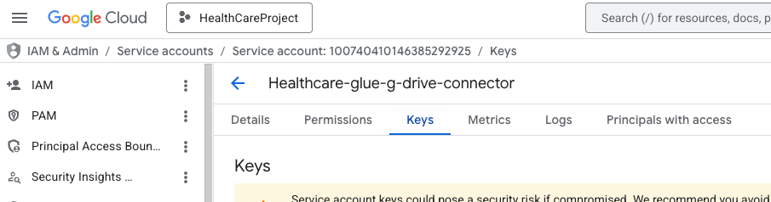

Create AWS System manager Parameter for bookmarking the files to implement incremental ingestion logic. For every run AWS will update the runtime in these parameters.

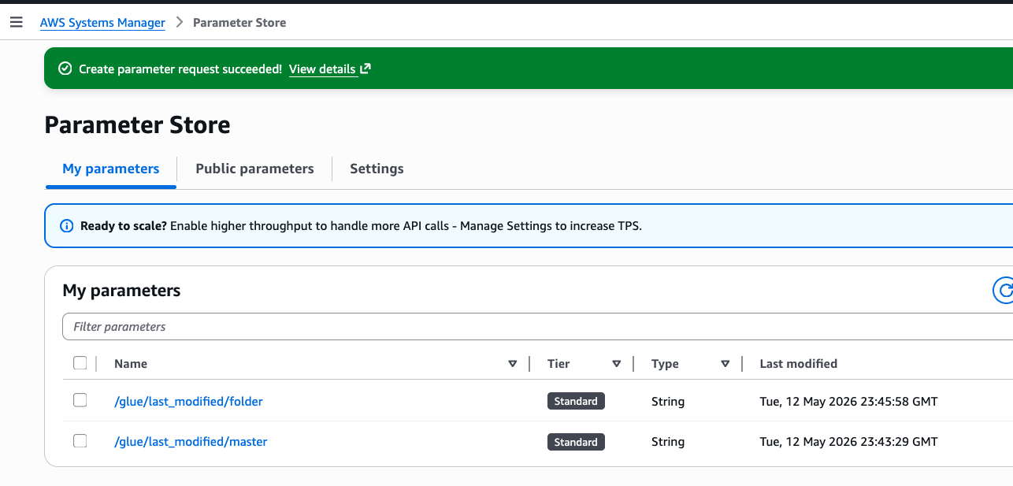

Create all required S3 buckets for RAW, SILVER and GOLD.

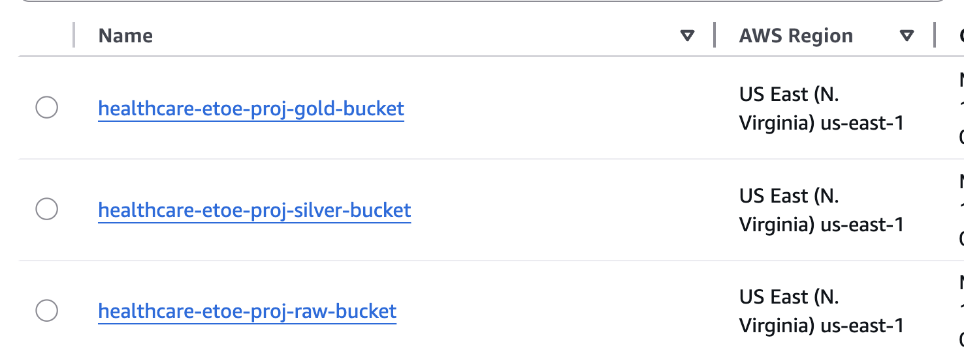

Create IAM user in AWS and provide necessary permissions(AWSS3FullAccess, AWSSSMFullAccess, SecretsManagerReadGoogleDriveCreds to access S3 and AWS Secrete manager and generate a key and secret and configure it in vs code by running AWS configure command.

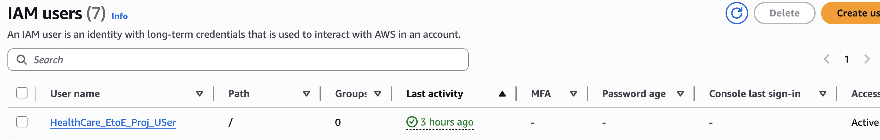

AWS Glue Jobs:

Ingestion Controller Job (Python):-
Create a glue job (controller job) which access the CSV data files form google drive using G drive service account by implementing the incremental ingestion logic
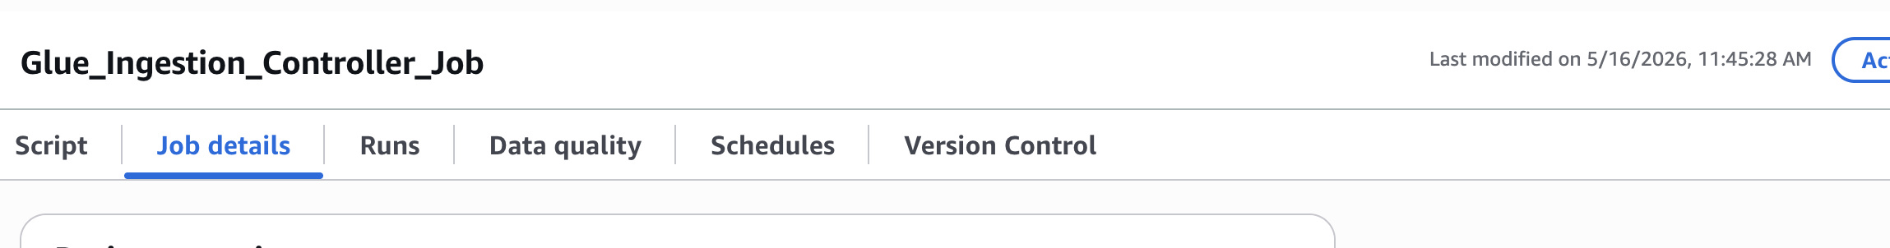
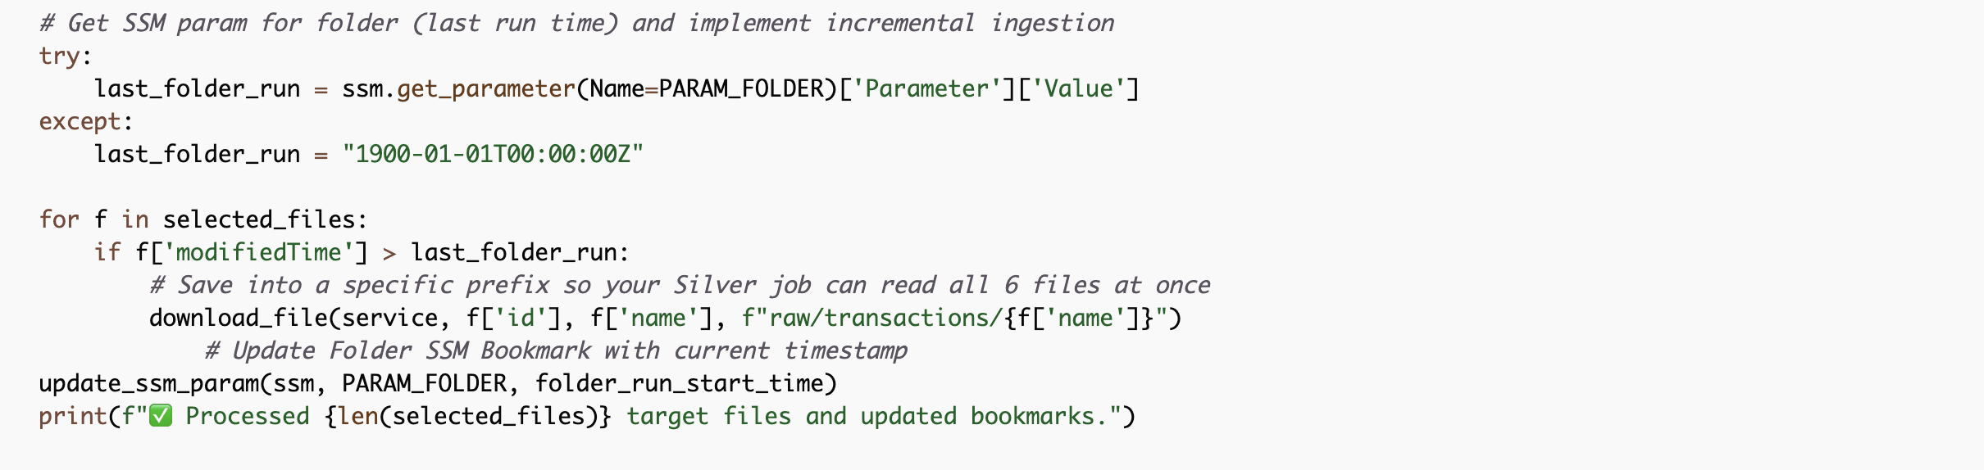

Silver Jobs (Spark):
Create all the remaining Silver Glue Jobs as per metrics requirement. Make sure to enable the bookmark for all the silver and gold jobs.
And When creating these Silver and Gold Spark jobs in the AWS Glue Console, you must provide it with explicit instructions to use Delta Lake natively instead of the default Parquet configurations: add these three exact key-value pairs to allow the open-source Delta libraries to load:

• Key: --conf
Value: spark.sql.extensions=io.delta.sql.DeltaSparkSessionExtension
• Key: --conf
Value: spark.sql.catalog.spark_catalog=org.apache.spark.sql.delta.catalog.DeltaCatalog
• Key: --datalake-formats
Value: delta
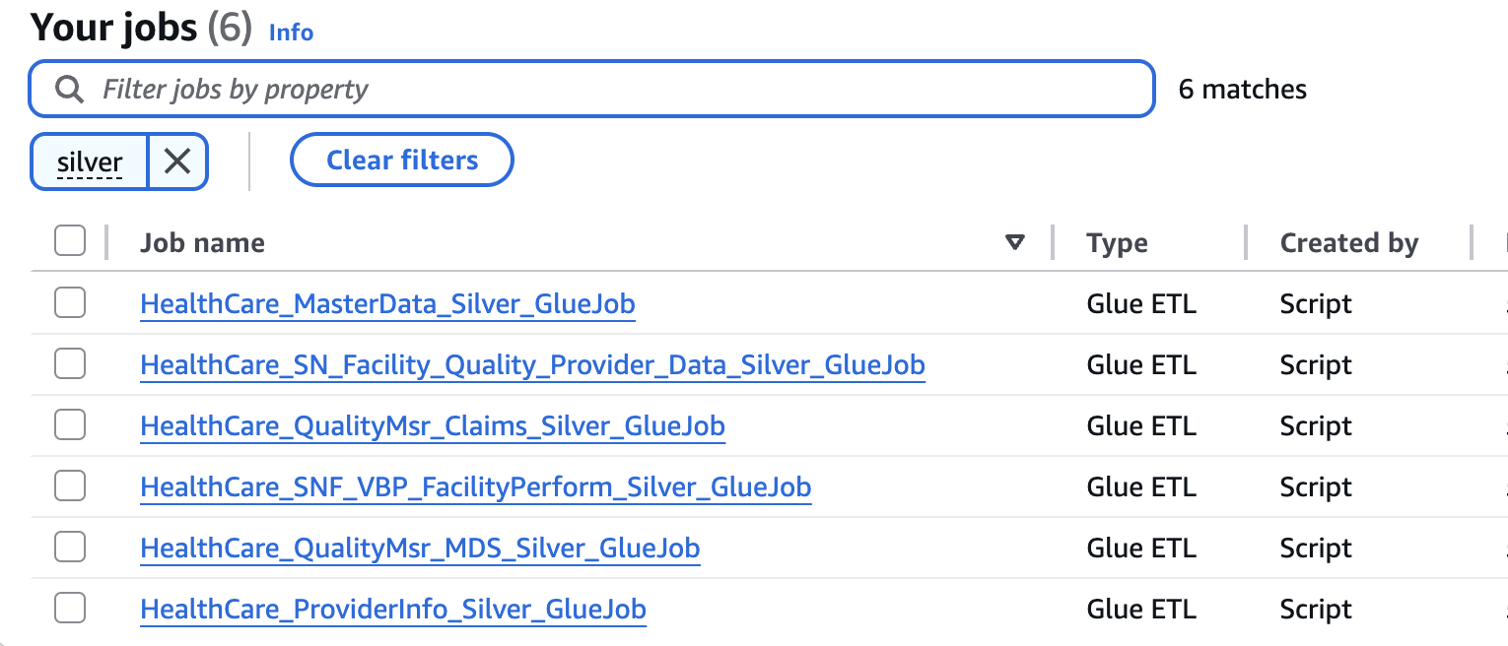

Gold Jobs (Spark):

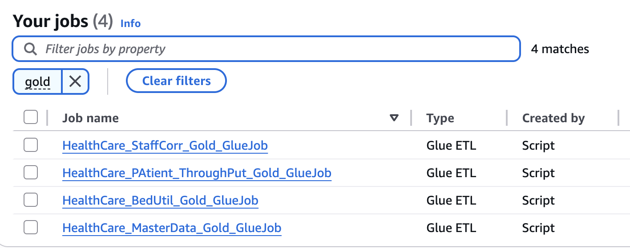

AWS Glue WorkFlow (Orchestration):

Create a new Glue workflow:

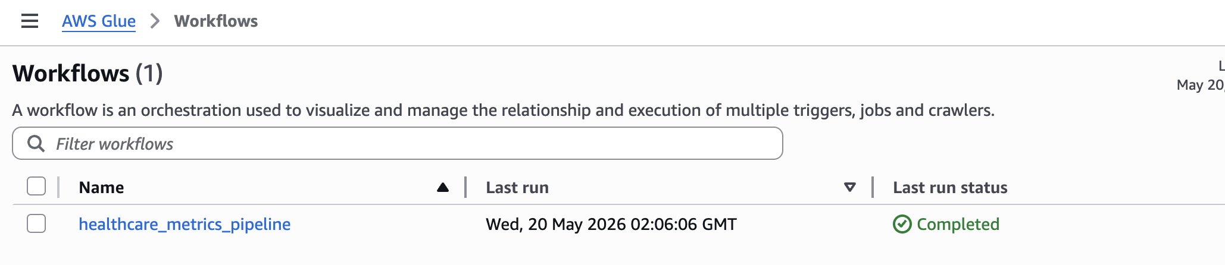

Trigger 1:- This trigger will initiate “Glue_Ingestion_Controller Job” at a scheduled time run daily(eg 2:00 AM everyday) which connects to Google Drive and perform the ingestion to S3 RAW incrementally.

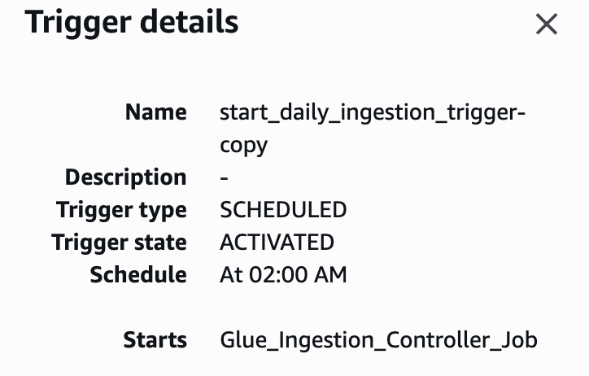

Glue_Ingestion_Controller_Job:

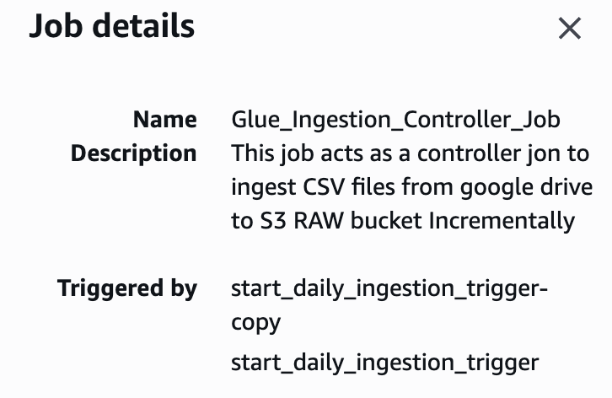

Trigger2 : This trigger Watches for the successful completion of Glue_Ingestion_controller_job . Once it ran as expected it will initiate all the Silver jobs parallelly without any delay.

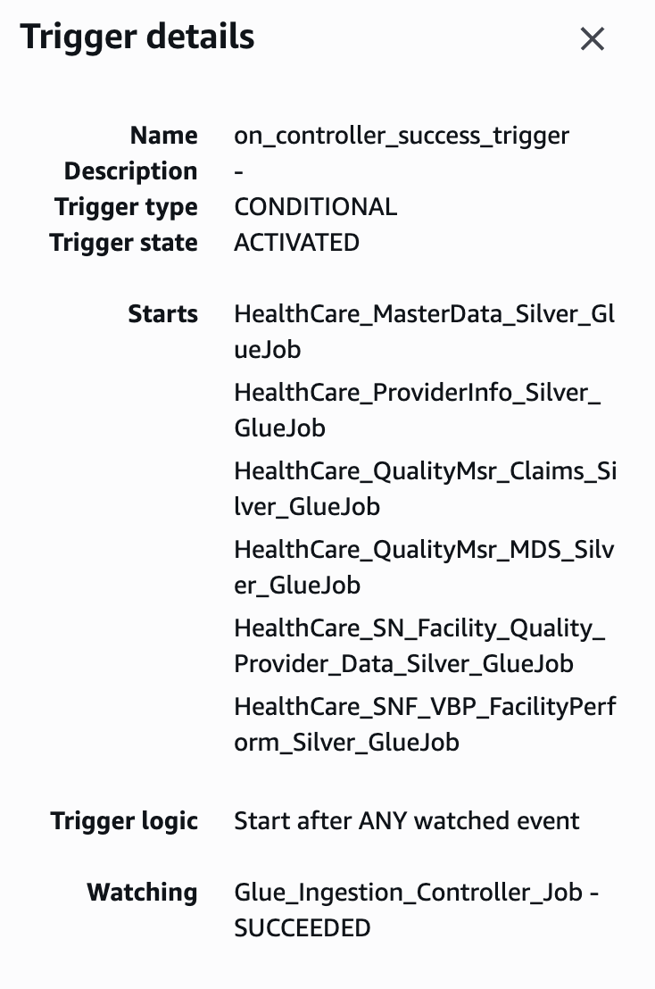 ----------------- > 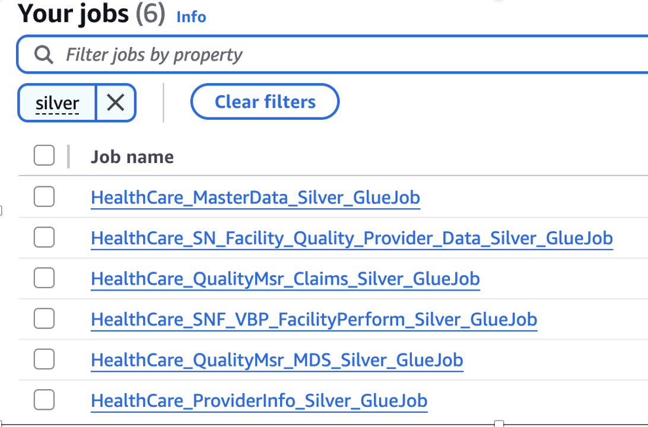

Trigger3 : This trigger Watches for the successful completion of all Silver jobs once they all ran as expected it will initiate all the Gold jobs parallelly without any delay.

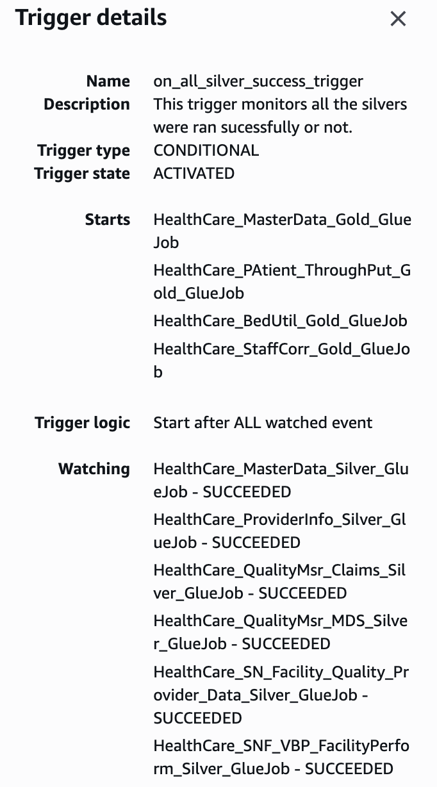 --------- > 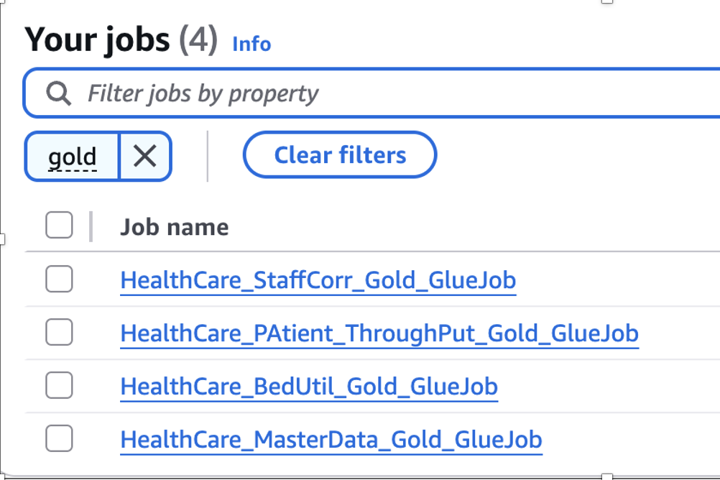

Overall Glue WorkFlow Graph:

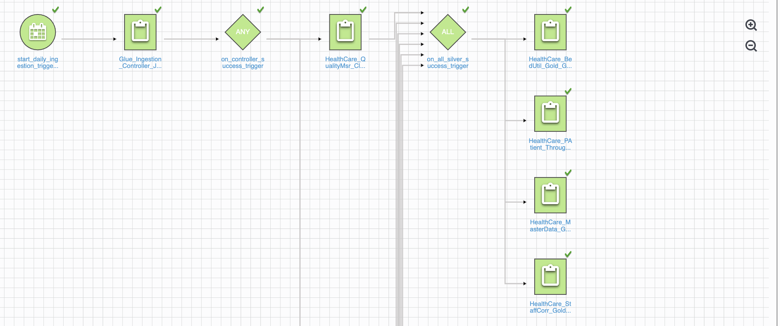
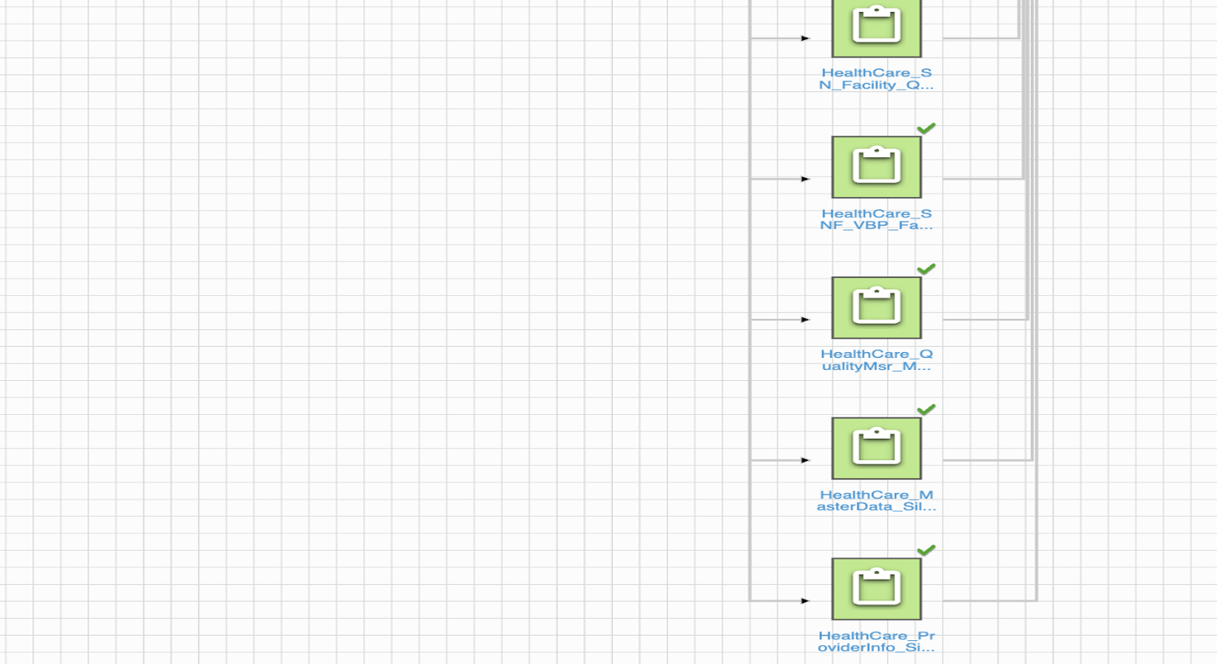

Streamlit Data Visualizations:

Total On-duty Nurse Hours:

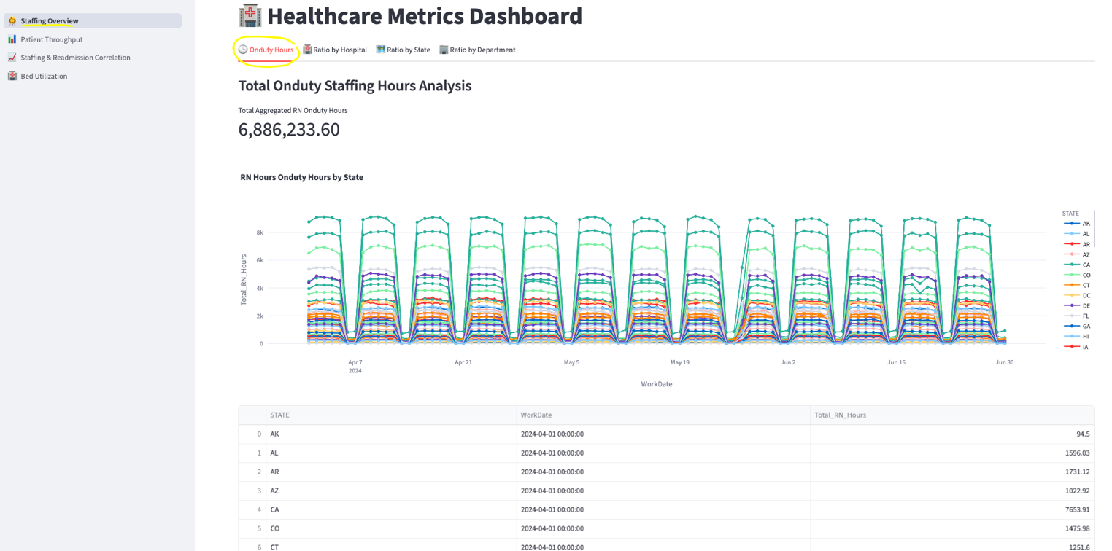

Average Nurse-to-Patient Ratio by Hospital

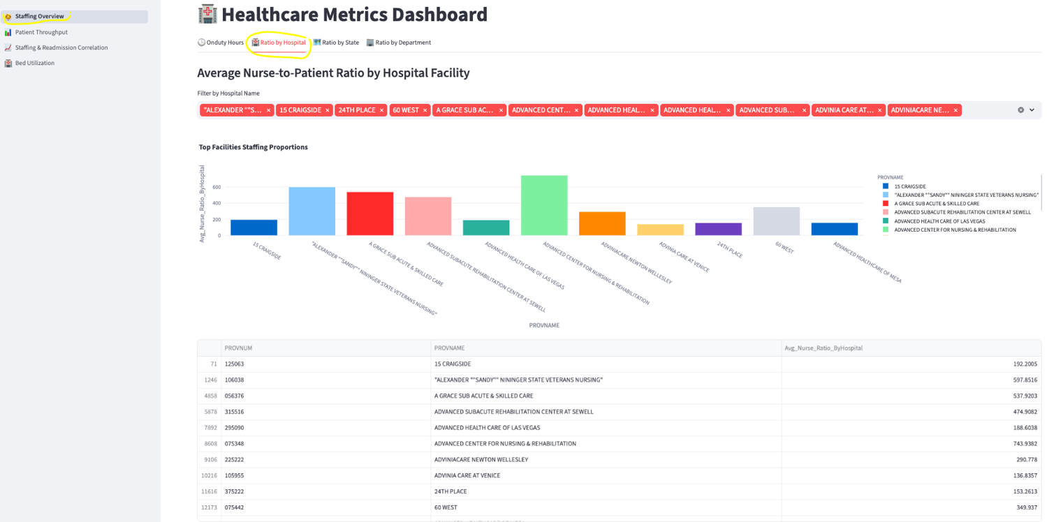

Average Nurse-to-Patient Ratio by State

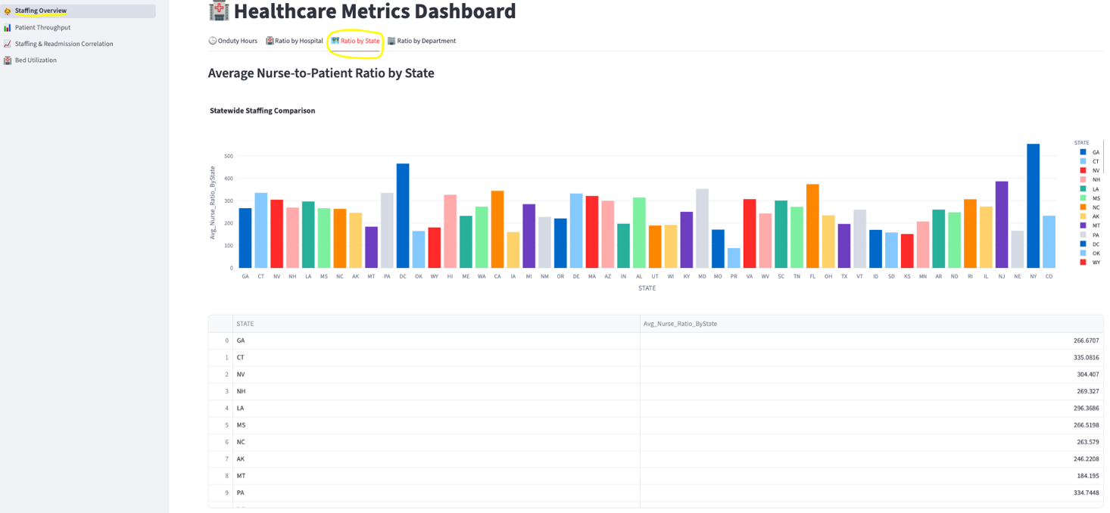

Average Nurse-to-Patient Ratio by Department

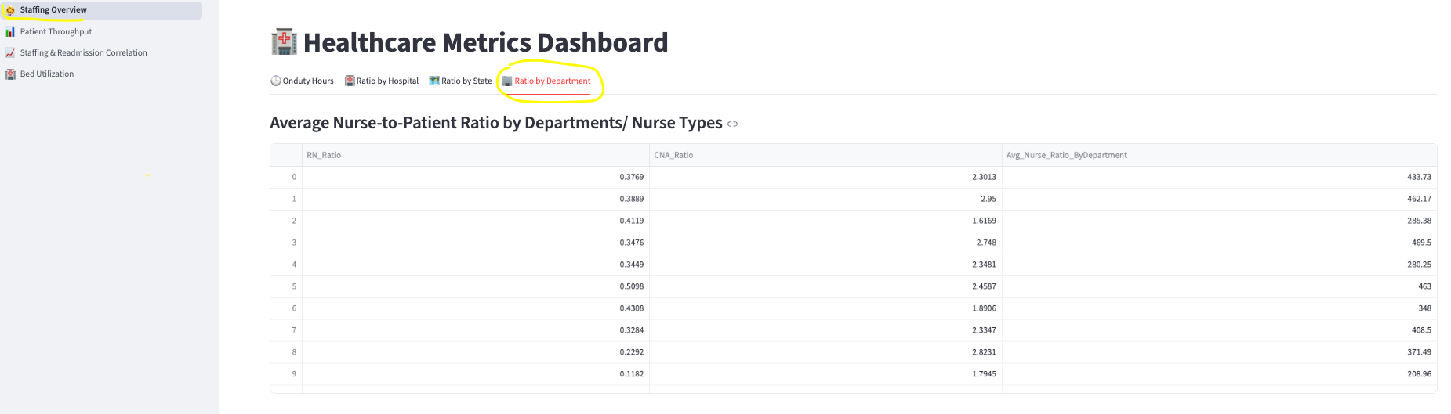

Top 10 Hospitals With Highest Patient ThroughPut

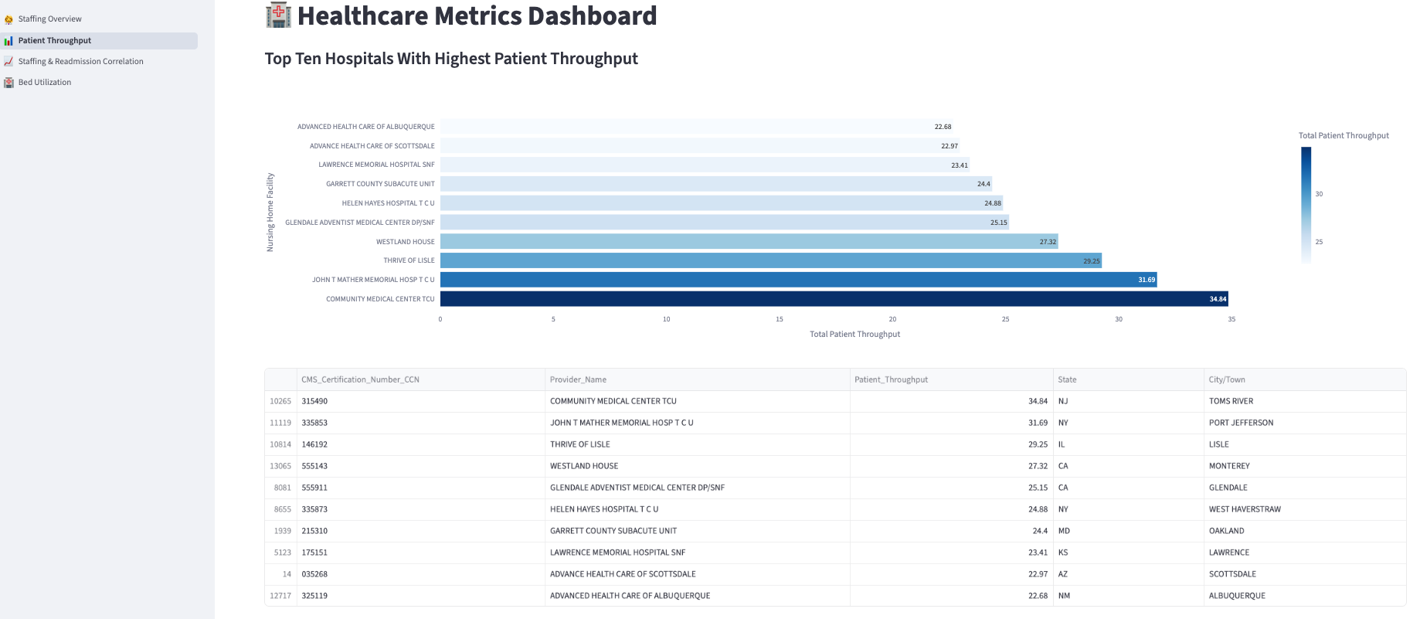

Nurse Staffing VS Readmission Correlation:

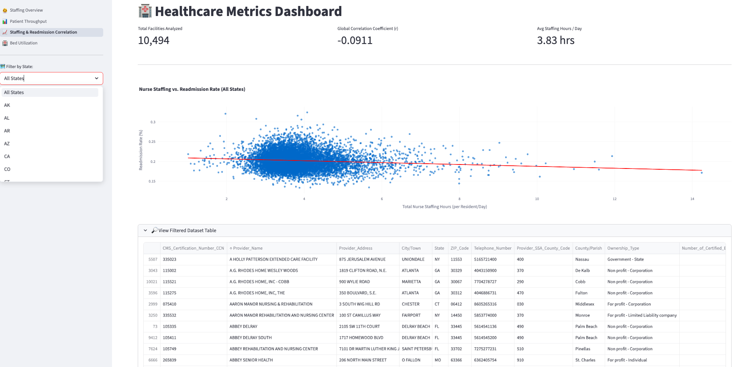

Filtered with specific State

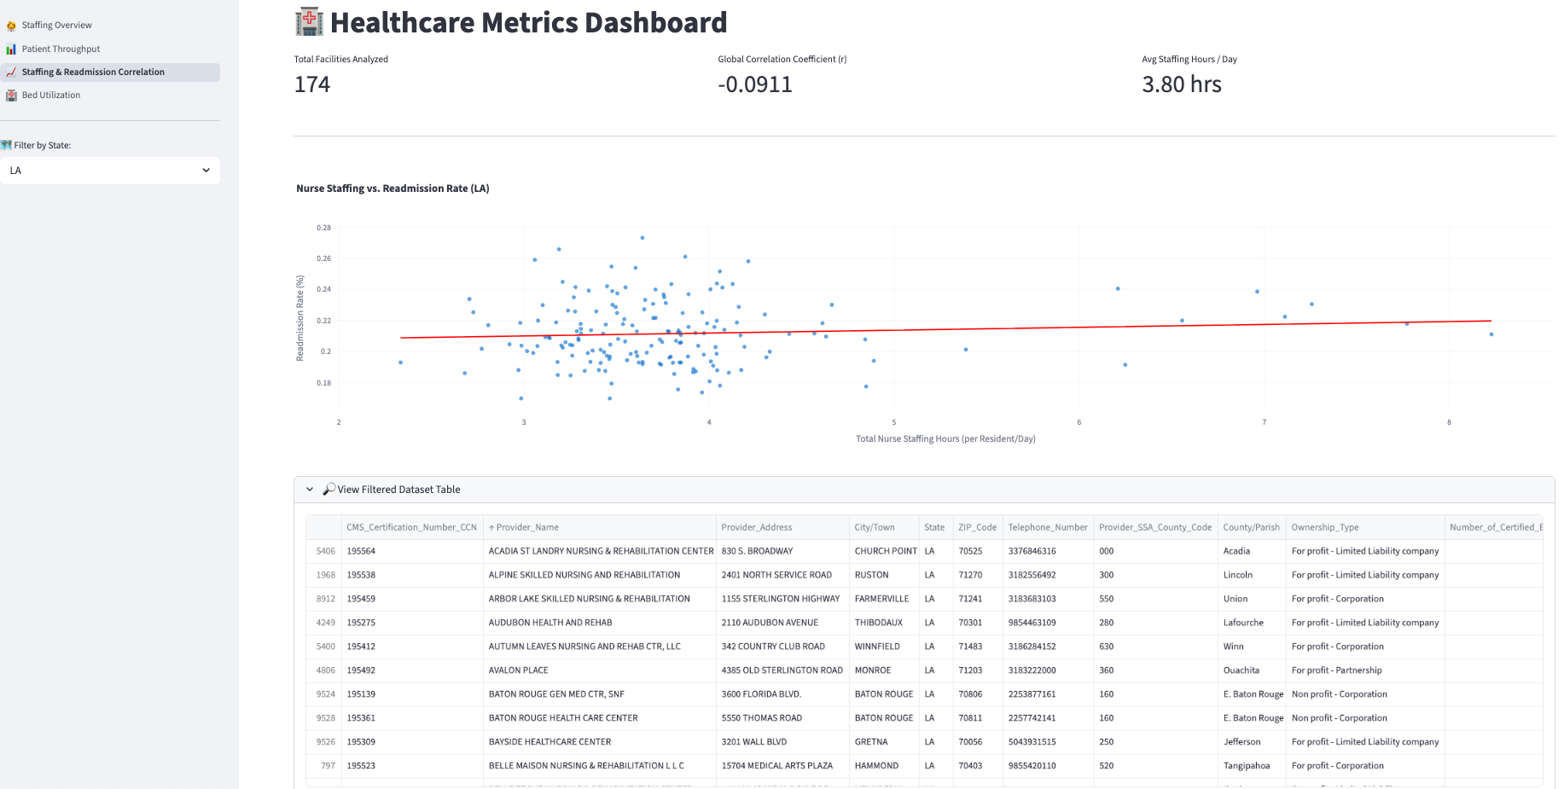

Bed Utilization Rate By Hospital (Filtered by State)

