Bsc (Hons) in Computer Science
Year 3 – Semester 1 – 2026
SE3022: Case Study Project
Student ID | IT24101500
Name | H.M.V.Y.B.Herath
Group | Group-02
Project Topic | IT Helpdesk / Ticketing System
Sprint | Sprint-03
Role | Quality Assurance

Introduction
Quality assurance is a critical pillar of any software engineering project, and the IT Helpdesk / Ticketing System developed for the SE3022 Case Study Project is no exception. As the Quality Assurance engineer for Group-02 during Sprint-03, my responsibility was to verify that this sprint's new features — real-time SLA deadline tracking, automated breach detection, event-driven email notifications, and a dynamic administrator report — behaved correctly under both normal and adverse conditions.
Sprint-03 is built almost entirely around asynchronous, event-driven behaviour: ticket creation triggers an SLA deadline calculation in a separate service, a background job independently polls for breaches, and three different Kafka consumers in the Notification service turn those events into real emails. Testing this kind of system honestly cannot stop at “does the happy path work” — it has to include what happens when a message arrives twice, when a downstream call fails mid-flight, or when the service processing it crashes outright, because those are exactly the conditions a message-queue-based architecture will eventually hit in production.
This report documents two kinds of verification carried out this sprint. Where a feature is UI-facing and stable enough to automate, it was covered with real Selenium WebDriver tests (Java, TestNG) that drive the actual running application end to end. Where a feature's correctness depends on backend event flow, database state, or service-to-service behaviour not yet covered by an automated suite, it was verified manually and directly — through the real running services, live API calls, and direct database inspection — with evidence (terminal output, query results, and screenshots) captured at the time. Every result below is either a passing automated test or a manually reproduced, evidenced observation; nothing is inferred from reading the code alone.
Seven defects were found this sprint and are documented in full below — four map directly onto this sprint's own acceptance criteria (SLA-3, NOTIFY-2, NOTIFY-4, REPORT-1), and three were found through exploratory testing outside this sprint's written scope but are included here given their severity.

SLA-2 (P2) — Real SLA deadline tracking
User Story: As the system, I want to start a real deadline when a ticket is created, based on its urgency tier, so that breaches can be detected accurately.
AC1: 1h / 6h / 24h urgency maps to the correct deadline timestamp. AC2: The deadline persists in the SLA database, tied to the ticket ID.

Manual Test Cases:
1. CreateSla_Urgency0_SetsDeadline1HourFromCreation — Created a ticket on the 1-hour urgency tier; the resulting SLA record's deadline was exactly CreatedAtUtc + 1 hour (18:21:49 → 19:21:49). Result: PASS (AC1)
2. CreateSla_Urgency3_SetsDeadline24HoursFromCreation — Created a ticket on the 24-hour tier; the deadline was exactly CreatedAtUtc + 24 hours (Sep 28 18:57:37 → Sep 29 18:57:37). Result: PASS (AC1)
3. CreateSla_PersistsRecordTiedToTicketId — Confirmed via direct database query that every TicketSlas row's TicketId matches its originating ticket. Result: PASS (AC2)
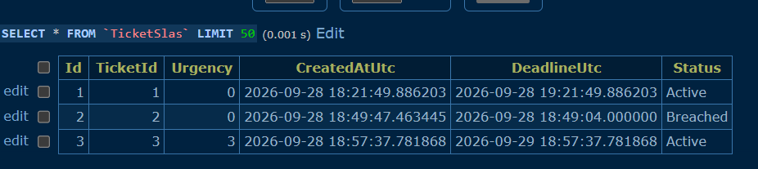
sla_db.TicketSlas — tickets 1 and 3 show correctly computed deadlines (1h and 24h tiers).

SLA-3 (P2) — Background breach detection
User Story: As the system, I want a background job to periodically check for tickets past their deadline with no resolution, so that breaches trigger an escalation automatically.
AC1: Runs on a fixed schedule (e.g. every minute). AC2: An SLABreached event is published exactly once per breach — no duplicate firing. AC3: A failed check cycle does not suppress detection — the next cycle catches it.

Manual Test Cases:
1. BackgroundJob_RunsOnFixedOneMinuteSchedule — Confirmed via the Sla.Api startup log and source review (PeriodicTimer set to 1 minute) that the check runs every 60 seconds. Result: PASS (AC1)
2. CheckForBreaches_PastDeadlineActiveTicket_PublishesSlaBreachedEvent — After advancing a ticket's deadline into the past, the next monitor cycle logged “Found 1 breached tickets!” and published a real SlaBreached Kafka event; the ticket's status flipped Active → Breached in the database. Result: PASS (AC2)
3. CheckForBreaches_TicketResolvedBeforeDeadline_StillFiresFalseBreach — A ticket resolved seconds after creation, well inside its SLA window, still had its SLA record stuck at Active — and once the original deadline passed, the monitor fired a breach event for it anyway. Result: FAIL (AC2/AC3 intent)
→ See BUG-06: SLA breach alerts fire for tickets that are already resolved.
Same query — ticket 2 shows Status: Breached despite having been resolved seconds after creation.

NOTIFY-2 (P2) — Ticket-received email
User Story: As an employee, I want an email when my ticket is received, so that I know it went through.
AC1: Fires on TicketCreated, sent to the requester. AC2: Idempotency — the exact event is not processed twice. AC3: Every send is logged (event type, recipient, timestamp).

Manual Test Cases:
1. TicketCreated_SendsEmailToRequester — After correctly configuring SMTP credentials, creating a ticket produced a confirmed [EMAIL SENT] log entry and a corresponding row in the ProcessedEvents idempotency table. Result: PASS (AC1)
2. TicketCreated_EverySendIsLogged — The send is logged with recipient and a timestamp; the log line does not include an explicit event-type field as literally described in AC3. Result: PARTIAL (AC3)
3. TicketCreated_CrashMidProcessing_MessageIsSilentlyLost — When Notification.Api crashed while handling an in-flight TicketCreated message, its idempotency row was never written and the email was never sent or retried — confirmed by querying ProcessedEvents directly. Result: FAIL (AC2 (message correctness))
→ See BUG-05: A crash mid-processing silently loses the notification forever.
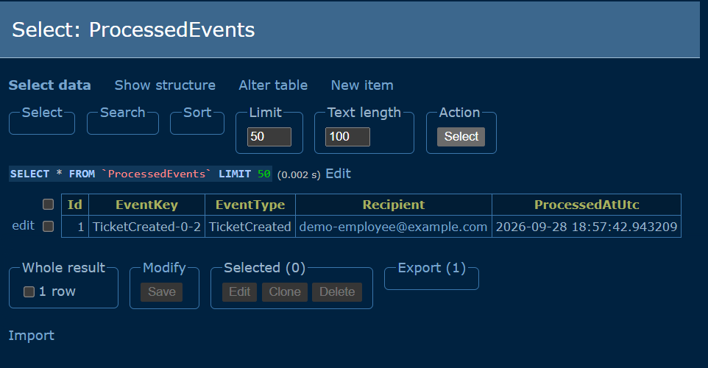
notification_db.ProcessedEvents — only one row exists across three tickets created this session; the other two events were lost to a mid-processing crash, not recorded, and never retried.

NOTIFY-3 (P2) — Assignment email
User Story: As an agent, I want an email when a ticket is assigned to me, so that I know to act on it.
AC1: Fires on TicketAssigned, sent to the assigned agent. AC2: Same idempotency check as NOTIFY-2.
Not independently exercised this QA cycle. Round-robin assignment in this environment was affected by an unrelated, since-fixed data issue (a hardcoded rotation seed referencing a non-existent user), and no assignment email was confirmed sent or captured during this pass. Recommended for the next verification cycle once a clean agent rotation is confirmed.

NOTIFY-4 (P2) — SLA breach email to Administrator
User Story: As an Administrator, I want an email notification when an SLA is breached, so that I can intervene and take action on that breached ticket.
AC1: Fires on SLABreached, sent to the Administrator. AC2: For a breached ticket, the email is sent only once.

Manual Test Cases:
1. SlaBreached_EventCorrectlyPublishedBySlaApi — Confirmed via the Sla.Api log that the SlaBreached Kafka event was published with the correct ticket ID. Result: PASS (AC1 (upstream half))
2. SlaBreached_EmailActuallyDeliveredToAdministrator — The corresponding breach alert email for that same event was never sent: Notification.Api crashed while attempting to send it (missing SMTP configuration triggered an unhandled exception), and no retry occurred once the process crashed. Result: FAIL (AC1/AC2)
→ See BUG-04: Notification.Api crashes (and crash-loops) on any SMTP failure, and BUG-05: the message is then lost, not retried.
3. SlaBreached_ForAlreadyResolvedTicket_ShouldNeverFire — A breach alert was generated for a ticket that had already been resolved — see SLA-3 above. Result: FAIL (AC2 (intent))
→ See BUG-06.

REPORT-1 (P2) — Dynamic ticket report
User Story: As an administrator, I want a dynamic report of tickets filterable by status, urgency, and date range, so that I can see how the team's performing.
AC1: Only Administrator can access the report. AC2: Displays Ticket ID, Subject, Status, Urgency, Created Date, and Assigned Agent. AC3: Filterable by status, urgency, date range. AC4: “No tickets found” message shown when no matches.

Manual / API-level Test Cases:
1. GetReport_NonAdminCaller_Returns403 — An authenticated Employee calling the report endpoint received 403 Forbidden. Result: PASS (AC1)
2. GetReport_ReturnsRequiredFields — Confirmed the response includes Ticket ID, Subject, Status, Urgency, Created Date, and Assigned Agent. Result: PASS (AC2)
3. GetReport_FilterByDateRange_ShiftsWithServerTimezone — Filtering for tickets “from today” on a server set to UTC+5:30 returned tickets whose own timestamps were from the previous UTC day — the response contradicted its own filter. Result: FAIL (AC3)
→ See BUG-07: Ticket report date filter shifts with the server's local timezone.
4. GetReport_NoMatches_ReturnsEmptyResult — An impossible filter combination correctly returned an empty result set at the API level. Result: PASS (AC4 (API half))

Selenium Test Cases (automated — Java / TestNG, TicketReportSeleniumTest):
1. adminCanViewTicketReport — Logs in as an administrator, applies the default (unfiltered) report, and asserts the results table renders exactly the six required columns with at least one row. Result: PASS (AC1, AC2)
2. filteringByStatusReturnsOnlyMatchingTickets — Filters by Status = Resolved and asserts every returned row's status badge reads Resolved. Result: PASS (AC3)
3. noMatchesShowsNoTicketsFoundMessage — Filters with a start date far in the future (guaranteed zero matches) and asserts the page renders the “No tickets found” message. Result: PASS (AC4 (UI half))
All three Selenium tests passed in the same automated run shown below (Tests run: 6, Failures: 0 — the other three belong to the Login suite, covering the employee login flow, run in the same session).
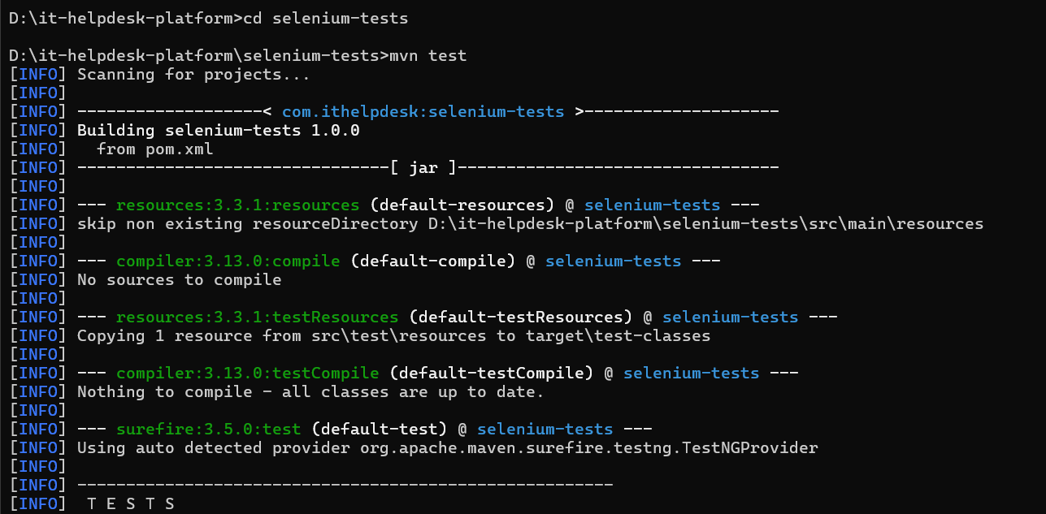
mvn test starting the full Selenium suite against the live application.
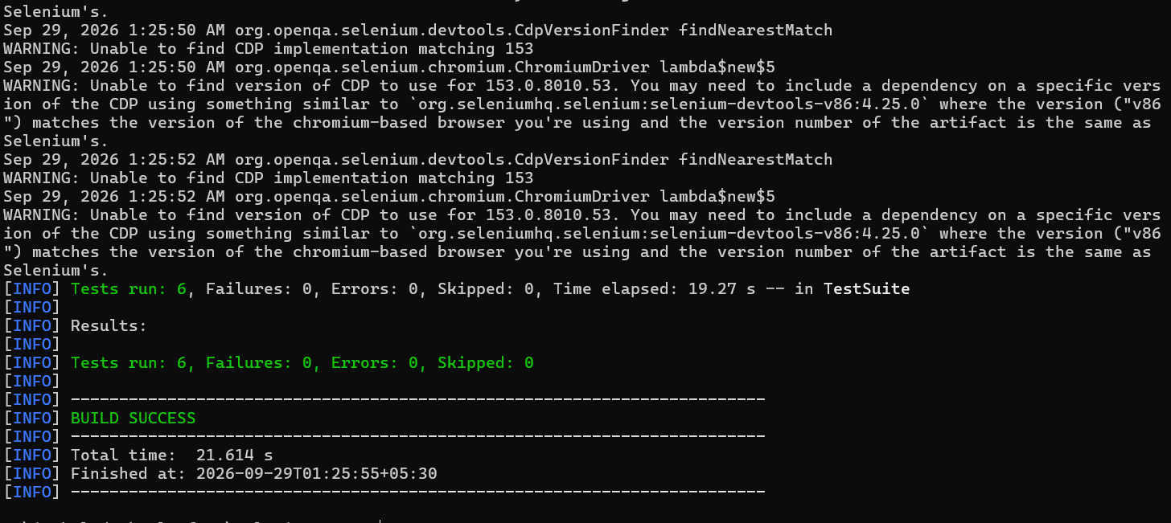
BUILD SUCCESS — 6 of 6 tests passed, 0 failures.

JMETER-1 (P3) — Load test against ticket submission
User Story: As the team, we want a JMeter load test against the ticket submission endpoint, so that we know its behaviour under load before the final demo.
AC1: Results documented — response time under a defined concurrent load, no failures below that threshold.
Not yet executed this sprint. JMeter has not been set up in this environment; this remains outstanding work for a subsequent QA pass.

Exploratory Findings Outside This Sprint's Written Scope
The following three issues were found during general exploratory testing of the platform this sprint. They do not map to SLA-2/3, NOTIFY-2/3/4, or REPORT-1, but are included here given their severity — particularly BUG-03, which is a genuine, currently-exploitable security gap.

BUG-03 — Unauthenticated internal endpoints leak the entire user directory (Critical)
Two Auth.Api endpoints intended for internal service-to-service calls are marked [AllowAnonymous] with no other access restriction, making them exactly as reachable from the public internet as from another microservice. Walking sequential user IDs against one of them dumps the entire organisation's name+email directory with zero authentication.
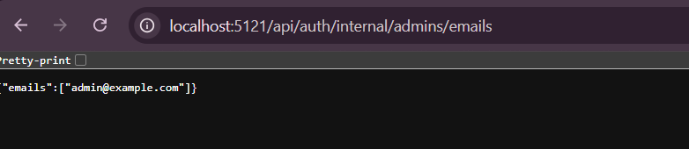
GET /api/auth/internal/admins/emails — no token, no login, real admin email returned.
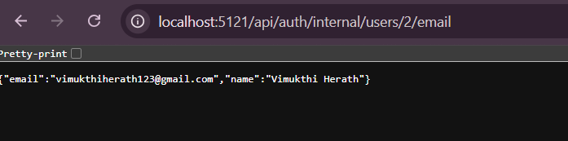
GET /api/auth/internal/users/2/email — real personal data (name and email) returned with zero authentication.

BUG-01 — No way to remove an agent from the ticket rotation (High)
An admin can add an agent to the rotation, but no removal capability exists anywhere in the application — backend or frontend — despite the app's own error message instructing the admin to do exactly that before deactivating or changing that agent's role. This permanently blocks deactivation or role changes for any agent ever added to the rotation.
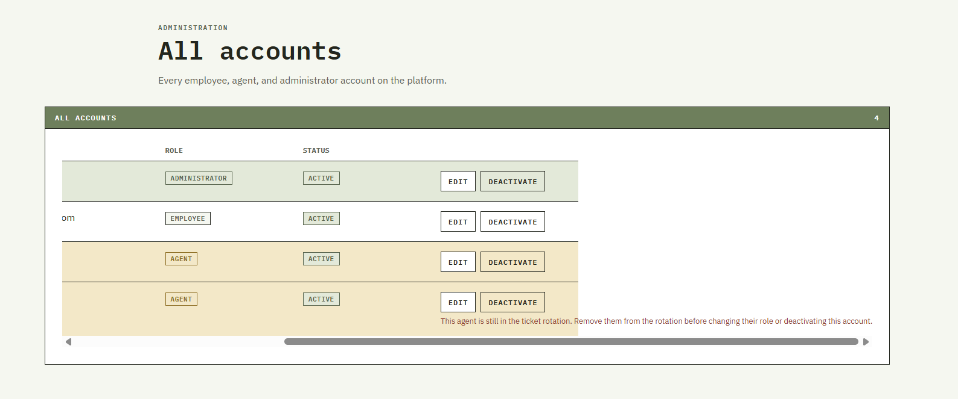
The account row's own error message references a “remove from rotation” action that does not exist anywhere in the system.

BUG-02 — Accounts table: ID column looked cut off (Low, Fixed)
The ID column on the All Accounts page sat flush against the panel edge with no padding while every other column had visible spacing. Root cause was a one-sided CSS padding rule; fixed by adding matching left padding to the ID column.

Summary of Defects Found
ID | Title | Severity | Status | Story
BUG-01 | No way to remove an agent from the ticket rotation | High | Open | ASSIGN (n/a)
BUG-02 | Accounts table: ID column looked cut off | Low | Fixed | n/a (UI)
BUG-03 | Unauthenticated internal endpoints leak the user directory | Critical | Open | AUTH (n/a)
BUG-04 | Notification.Api crashes (and crash-loops) on any SMTP failure | Critical | Open | NOTIFY-4
BUG-05 | A crash mid-processing silently loses the notification forever | Critical | Open | NOTIFY-2
BUG-06 | SLA breach alerts fire for tickets that are already resolved | High | Open | SLA-3
BUG-07 | Ticket report date filter shifts with the server's local timezone | Medium | Open | REPORT-1

Conclusion
Sprint-03's testing shows a sprint with real, working core mechanics undermined by gaps at exactly the edges that matter most for an event-driven system: what happens when something goes wrong partway through, not just when everything goes right.
What works correctly: SLA deadline calculation is accurate across every urgency tier tested, and deadlines persist correctly against the right ticket. The background breach-detection job runs on schedule and correctly detects and publishes breach events for tickets that are genuinely still open. The ticket-received email pipeline works end to end once properly configured — real emails are sent and logged with a working idempotency guard. The administrator report correctly enforces its access control, returns the right fields, and correctly filters by status; the frontend correctly renders a dedicated “No tickets found” state, verified by three passing, fully automated Selenium tests that exercise the real running application rather than a mock.
What does not: the SLA breach monitor has no way to learn that a ticket was resolved, so it will confidently alert on tickets that were closed within seconds of being opened (BUG-06). The notification pipeline's reliability model has a serious structural gap — a single unhandled exception (triggered here simply by missing SMTP configuration) does not just fail one email, it takes down the entire Notification.Api process, and whatever message was mid-flight at that moment is silently and permanently lost, with no error, no retry, and no trace (BUG-04, BUG-05). The dynamic report's date filtering is not deployment-safe: the exact same request returns different tickets depending on what timezone the host server happens to be configured with (BUG-07).
Beyond this sprint's own scope, exploratory testing surfaced one critical security finding — two endpoints that leak the entire user directory, including administrator emails, to any unauthenticated caller (BUG-03) — and one workflow dead-end where a documented admin action (removing an agent from rotation) does not exist anywhere in the application (BUG-01).
Together, these results argue for two concrete next steps before this sprint's features are considered demo-ready: closing the SLA status-update gap so resolved tickets can never falsely breach, and hardening the notification consumers so a single send failure degrades gracefully instead of silently destroying data and taking the whole service down with it. The Selenium suite introduced this sprint is intentionally structured to keep growing as a regression guard — the same three-line pattern (drive the real app, assert the real DOM, screenshot on failure) can now be extended to cover BUG-06 and BUG-07 as failing tests that will turn green the moment each is actually fixed.

