Attendance Management Tracker

**Functional Requirement: -**

A web application that tracks employees' attendance statuses such as present, absent, active, inactive, and deployed.

Develop this project using UI (i.e. Angular) and Spring Boot, Hibernate and Rest Services.

**Requirement - I:**

1. Defining EmployeeMaster: Master screen is a service and it should take parameter is album type.
2. Name of the table **EmployeeTypeMaster**.
3. The table should have the following columns with proper datatypes and constraints
4. Implements all CRUD Operations using Rest Controller - >Model - > DAO – >Service Layer – > Database

1)Employeelist

empId

name

emailid

batchNum

DOJ

|  |  |  |  |
| --- | --- | --- | --- |
| Empid | int(11) | PRI | auto_increment |
| emp_name | varchar(20) |  |  |
| Emailed | int(4) |  |  |
| Batchnum | Int(6) |  |  |
| DOJ | Date |  |  |
| Date |  |  |  |

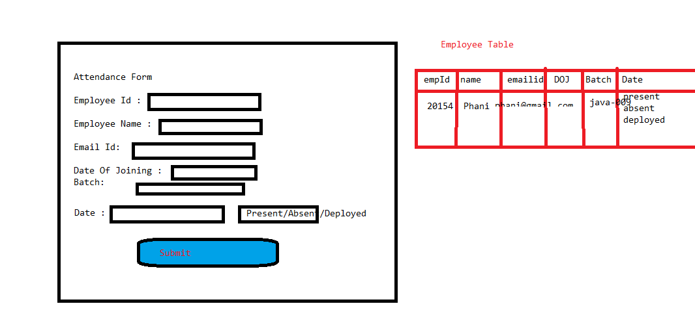

1. A calendar should appear when we select month name.
2. When we select batchnumber, it should display available employees as well as values such as Absent, Present, Halfday Present, Halfday Absent, Deployed, and Inactive in each employee's dropdown list.
3. Every employee's present days should be calculated based on the month chosen, excluding Sunday and other holidays.

4. Admin can add holiday to any day in the month.

5. Absenteeism, deployed days

6. Download, upload, export.