

Pattern Programming

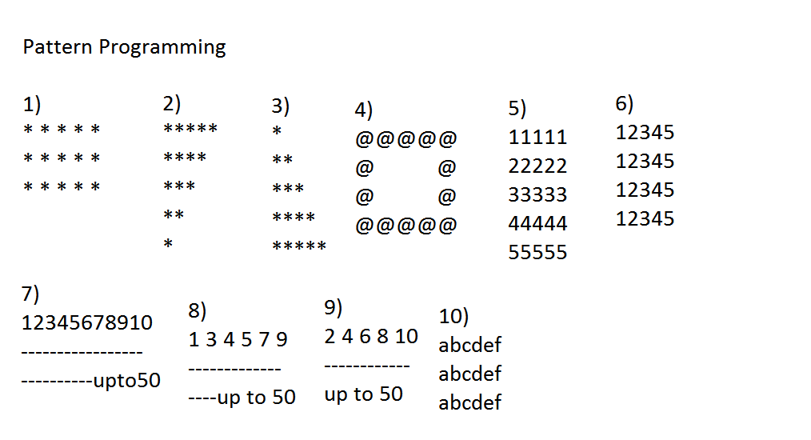

### Floyd's Triangle Pattern

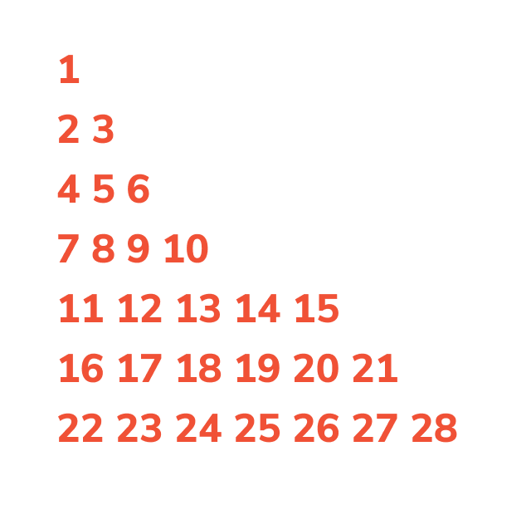

### Pascal's Triangle Pattern

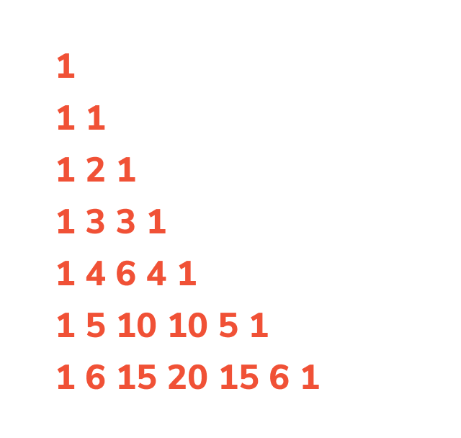

### Pyramid Program

*

* *

* * *

* * * *

* * * * *

Q) W.a.p Swap two numbers with temp varible?

Q) W.a.p Swap two numbers with out temp variable?

Q)W.a.p swap three numbers with temp variable?

Q)w.a.p swap three numbers with out temp variable?

Q)wa.sp swap four numbers with temp variable?

Q)w.a.p swap four numbers with out temp variable?

Q)w.a.p factorial?