## Report on Seabirds at-sea data collection

**Susan Abbott**

**On the**

**From 07 March to 22 March 2014**

Prepared by: Author

Environment Canada, Canadian Wildlife Service

2017-01-27 _______________________________________________________________________________________________

## Background

The east coast of Canada supports millions of breeding marine birds as well as migrants from the southern hemisphere and northeastern Atlantic. In 2005, the Canadian Wildlife Service (CWS) of Environment Canada initiated the Eastern Canada Seabirds at Sea (ECSAS) program with the goal of identifying and minimizing the impacts of human activities on birds in the marine environment. Since that time, a scientifically rigorous protocol for collecting data at sea and a sophisticated geodatabase have been developed, relationships with industry and DFO to support offshore seabird observers have been established, and over 100,000 km of ocean track have been surveyed by CWS-trained observers. These data are now being used to identify and address threats to birds in their marine environment. In addition, data are collected on marine mammals, sea turtles, sharks, and other marine organisms when they are encountered.

## Methods

Seabird and marine mammal surveys were conducted from the port side of the bridge of the from 07 March to 22 March 2014 by Susan Abbott. Surveys were conducted while the ship was moving at speeds greater than 4 knots, looking forward and scanning a 90 degree arc to one side of the ship. All birds observed on the water within a 300 m-wide transect were recorded, and we used the snapshot approach for flying birds (intermittent sampling based on the speed of the ship) to avoid overestimating abundance of birds flying in and out of transect. Distance sampling methods were incorporated to address the variation in bird detectability. Details of the methods used can be found in the CWS standardized protocol for pelagic seabird surveys from moving platforms.

## Results

### Seabird Sightings

We surveyed 1000 km of ocean from 07 March to 22 March 2014. During the survey, a total of 1047 birds were observed in 532 (53%) of the 1008 surveyed 5-min periods. The observations were distributed across 19 species/genus (Table 1) and flock size ranged from 1 to 75 birds.

Table 1: Numbers of flocks, total number of birds, and mean flock size by species

|  |  |  |  |
| --- | --- | --- | --- |
| English | Flocks | Birds | Mean flock size |
| Dovekie | 137 | 293 | 2.1 |
| Thick-billed Murre | 60 | 156 | 2.6 |
| Herring Gull | 76 | 112 | 1.5 |
| Common Murre | 69 | 109 | 1.6 |
| Long-tailed Duck | 6 | 95 | 15.8 |
| Great Black-backed Gull | 66 | 79 | 1.2 |
| Northern Fulmar | 39 | 72 | 1.8 |
| White-winged Scoter | 8 | 37 | 4.6 |
|  | 496 | 21 | 0.0 |
| Common Eider | 5 | 20 | 4.0 |
| Iceland Gull | 14 | 15 | 1.1 |
| Northern Gannet | 8 | 10 | 1.2 |
| Black-legged Kittiwake | 7 | 7 | 1.0 |
| Black Guillemot | 4 | 6 | 1.5 |
| Common Loon | 5 | 6 | 1.2 |
| Atlantic Puffin | 3 | 4 | 1.3 |
| Glaucous Gull | 3 | 3 | 1.0 |
| American Black Duck | 1 | 1 | 1.0 |
| Great Skua | 1 | 1 | 1.0 |

The was most common species, accouting for 49.21% of the observed flocks (Table 1), followed by the Dovekie (13.59%), and the Herring Gull (7.54%).

The largest flock observed was one of Long-tailed Duck, numbering 75 individiuals. Overall, Long-tailed Duck showed the highest average flock size ( $\overline{x}$ = 15.83; sd=29.02; Table 1), followed by the White-winged Scoter( $\overline{x}$ = 4.62; sd=3.11), and Common Eider( $\overline{x}$ = 4; sd=3.94).

TheDovekie was the most abundant species (Table 1), accounting for 27.98% of the birds observed (Table 1), followed by the Thick-billed Murre (14.9%) and the Herring Gull (10.7%).

### Seabird detection

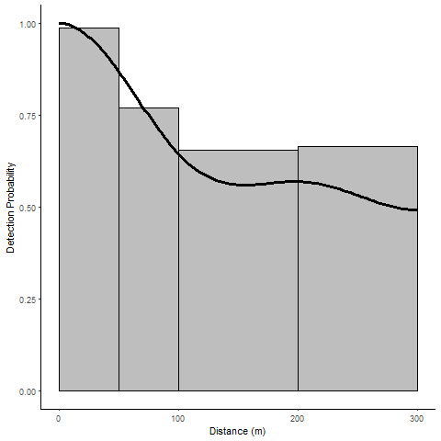

Figure 1: Detection function of all species combined in function of the distance bins (line) with observations by distance bins

The distance sampling model best describing how the number of seabird observations varied with the perpendicular distance from the ship was a uniform with a cosinus adjustement. The estimated probability of detection was 0.65 (95%CI:0.54 - 0.79; Figure 1) within the 300 meter width of the transect. The model predicted a density of 4.57 (95%CI:3.62 - 5.76) seabirds/ $km^{2}$ along the ship path. Note that this model doesn't account for potential different detection probabilities among species or effects of daily conditions.

### Seabird distribution

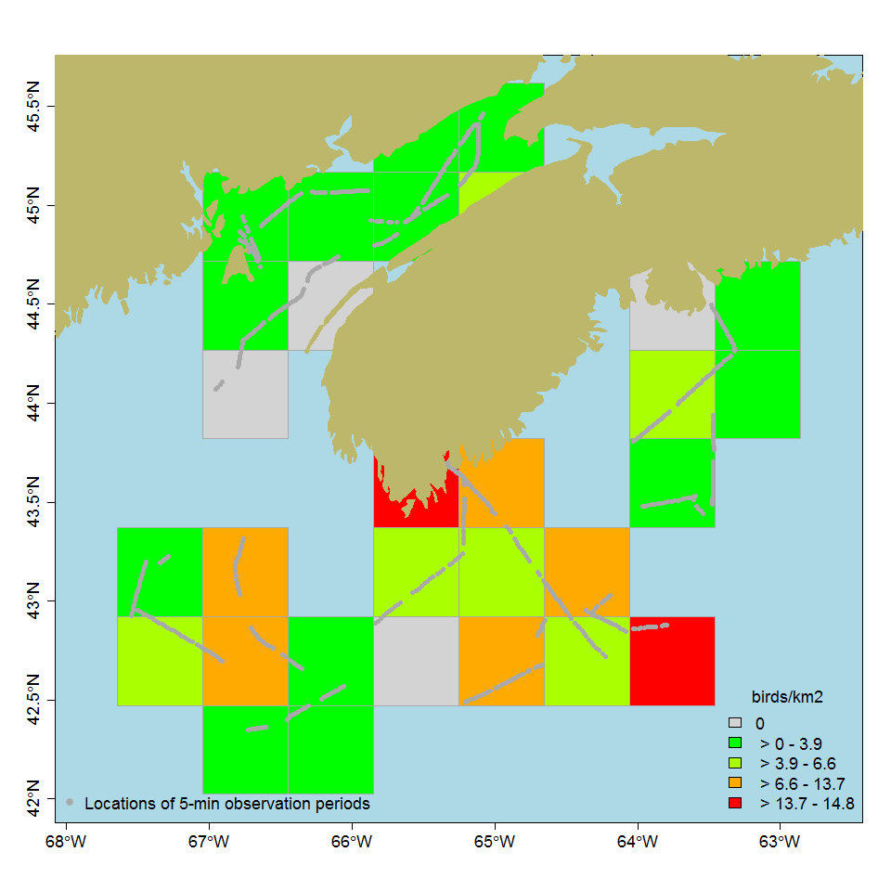

Figure 2: Seabird density by 50x50 km cell where observations were conducted, given the selected detection model

Following the spatial post-stratification of the selected distance model, there were 13 grid cells with densities below the 50% quantile, 6 cell(s) between the latter and the 75% quantile, 5 cell(s) between the latter and the 95% quantile, and 2 cell(s) in the top 5% quantile (Fig. 4). Given the visited cells corresponded to the study area, we estimated the total seabird population at 3.164398410^{5} during the cruise.