Machine Learning

Vinsent

Monday, April 4, 2016

### Prediction Assignment1

### Overview:

### The goal of your project is to predict the manner in which they did the exercise by using any of the machine learning model. Then evaluate the results obtained by cross validating the prediction and actual results. The model also needs to validate the given 20 test cases and the error in predicting them.

### 

## Read the training data

# load the libraries  
library(class)  
library(gmodels)  
library(corrgram)

## Warning: package 'corrgram' was built under R version 3.2.4

library(ellipse)  
  
  
as1_train <- read.csv("G:/coursera/DataScience_specialization/practical machine learning/assignment1/pml-training_01.csv", header = TRUE, sep = ",")  
  
# summary(as1_train)   
  
# summary(as1_train$classe)

## Read the test data and its summary

as1_test <- read.csv("G:/coursera/DataScience_specialization/practical machine learning/assignment1/pml-training_01.csv", header = TRUE, sep = ",")  
# summary(as1_test)

# PreProcessing

## Check the number of target classes. Plot these values

## PCA principle component analysis to reduce the inputs to the model.

#### removing the time stamp columns to get rid of the dates column for PCA...

#### removed the NA, completely missing value columns for PCA input.

#### selecting only a subset of columns from the original data set as1_train

#### the below subset command did not work.

#### as1_test.sub2 <- as1_test[, c(user_name, num_window,roll_belt,pitch_belt,yaw_belt,total_accel_belt,kurtosis_roll######_beearm_y,magnet_forearm_z,problem_id)]

##### as1.test.sub2 <- as1_test[, c(1,2)]

##### x.sub2 <- subset(as1_test, select = c(1,3,4))

as1_train <- read.csv("G:/coursera/DataScience_specialization/practical machine learning/assignment1/pml-training_01.csv", header = TRUE, sep = ",")  
  
#### after cleaning the dataset we have around 54 columns from 159 columns..   
#### the last variable is the target class  
ncol(as1_train)

## [1] 55

pca_analysis <- prcomp(as1_train[1:54], scale.=TRUE)  
  
#!summary(pca_analysis)  
  
sum((pca_analysis$sdev)^2)

## [1] 54

screeplot(pca_analysis, type="lines")

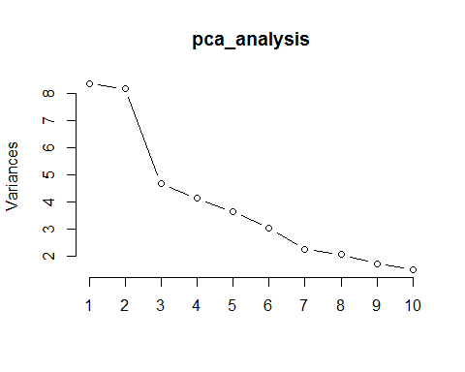

(pca_analysis$sdev)^2

## [1] 8.356570172 8.157815849 4.680516775 4.129791796 3.653030206  
## [6] 3.032841966 2.251446042 2.074181484 1.725702211 1.509380865  
## [11] 1.396554772 1.152153183 1.045158291 0.998367113 0.944813173  
## [16] 0.885620566 0.805433462 0.727531035 0.677386427 0.600709013  
## [21] 0.528925794 0.481039208 0.417822070 0.389818048 0.382460056  
## [26] 0.334236645 0.305830962 0.290899406 0.255355082 0.233671195  
## [31] 0.203412168 0.179755274 0.169989400 0.131132895 0.121759668  
## [36] 0.112181282 0.091890739 0.079717372 0.063952948 0.056406421  
## [41] 0.055131359 0.040797172 0.037730038 0.035291857 0.033662078  
## [46] 0.031450611 0.028617467 0.026551884 0.021661870 0.020426383  
## [51] 0.013439953 0.011874638 0.005954931 0.002148724

# PCA 1 to 14 can be combined to have 0.81 % of variation in the dataset. but for this study I am taking only PCA1 and PCA 2. Also this is able to capure the five groups A,B,C,D,E  
plot(pca_analysis$x[,1],pca_analysis$x[,2])  
text(pca_analysis$x[,1],pca_analysis$x[,2], pca_analysis$V1, cex=0.7, pos=4, col="red")

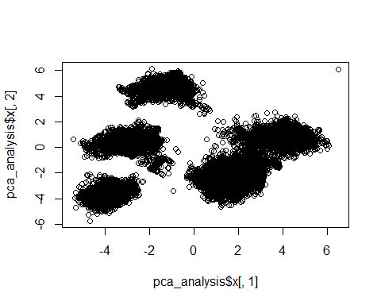

pca_analysis$rotation[,1]

## new_window num_window roll_belt   
## -2.349418e-03 2.892623e-03 -3.067589e-01   
## pitch_belt yaw_belt total_accel_belt   
## -2.595569e-02 -1.993288e-01 -3.034154e-01   
## gyros_belt_x gyros_belt_y gyros_belt_z   
## 9.571321e-02 -1.018383e-01 1.799252e-01   
## accel_belt_x accel_belt_y accel_belt_z   
## 1.089242e-02 -3.165177e-01 3.158463e-01   
## magnet_belt_x magnet_belt_y magnet_belt_z   
## -1.424278e-02 1.170732e-01 6.049548e-02   
## roll_arm pitch_arm yaw_arm   
## 6.152848e-02 3.703377e-02 5.008837e-02   
## total_accel_arm gyros_arm_x gyros_arm_y   
## 1.109588e-01 -1.094312e-02 7.511105e-02   
## gyros_arm_z accel_arm_x accel_arm_y   
## -1.559444e-01 -1.620109e-01 2.680228e-01   
## accel_arm_z magnet_arm_x magnet_arm_y   
## -1.265057e-01 -9.080482e-02 6.600444e-02   
## magnet_arm_z roll_dumbbell pitch_dumbbell   
## 3.272818e-02 8.779864e-02 -1.103710e-01   
## yaw_dumbbell total_accel_dumbbell gyros_dumbbell_x   
## -1.263303e-01 1.694594e-01 -3.457356e-03   
## gyros_dumbbell_y gyros_dumbbell_z accel_dumbbell_x   
## -8.234470e-04 -1.978944e-04 -1.711847e-01   
## accel_dumbbell_y accel_dumbbell_z magnet_dumbbell_x   
## 1.827605e-01 -1.552965e-01 -1.701897e-01   
## magnet_dumbbell_y magnet_dumbbell_z roll_forearm   
## 1.470041e-01 1.704761e-01 6.443666e-02   
## pitch_forearm yaw_forearm total_accel_forearm   
## -1.460158e-01 1.136102e-01 -6.290671e-05   
## gyros_forearm_x gyros_forearm_y gyros_forearm_z   
## -6.850299e-02 -3.349934e-03 2.312228e-03   
## accel_forearm_x accel_forearm_y accel_forearm_z   
## 1.913320e-01 3.553536e-02 -3.103106e-02   
## magnet_forearm_x magnet_forearm_y magnet_forearm_z   
## 1.051439e-01 2.502355e-02 -3.771553e-02

# Exploratory Analysis To see how the variables are correlated.

### The below exploration also explains what the variable highly correlated, This indicates like what variables are good for the prediction. A good feature selection should include uncorrelated variables to have less bias in your prediction.

# corrgram(as1_train, order= NULL, lower.panel=panel.shade,  
# upper.panel = NULL, text.panel=panel.txt,  
# main="Groupware Human Activity Recognition Data in PC2/PC1 Order")  
# another colored corrgram  
  
R = cor(as1_train[, 1:10])  
round(R, 3)

## new_window num_window roll_belt pitch_belt yaw_belt  
## new_window 1.000 0.009 0.009 0.001 0.004  
## num_window 0.009 1.000 0.072 -0.102 0.086  
## roll_belt 0.009 0.072 1.000 -0.216 0.815  
## pitch_belt 0.001 -0.102 -0.216 1.000 -0.700  
## yaw_belt 0.004 0.086 0.815 -0.700 1.000  
## total_accel_belt 0.009 0.066 0.981 -0.139 0.762  
## gyros_belt_x 0.000 0.210 -0.117 -0.436 0.145  
## gyros_belt_y 0.009 0.224 0.464 -0.397 0.530  
## gyros_belt_z 0.002 0.067 -0.459 -0.107 -0.275  
## accel_belt_x 0.000 0.133 0.257 -0.966 0.708  
## total_accel_belt gyros_belt_x gyros_belt_y gyros_belt_z  
## new_window 0.009 0.000 0.009 0.002  
## num_window 0.066 0.210 0.224 0.067  
## roll_belt 0.981 -0.117 0.464 -0.459  
## pitch_belt -0.139 -0.436 -0.397 -0.107  
## yaw_belt 0.762 0.145 0.530 -0.275  
## total_accel_belt 1.000 -0.165 0.409 -0.475  
## gyros_belt_x -0.165 1.000 0.333 0.340  
## gyros_belt_y 0.409 0.333 1.000 0.342  
## gyros_belt_z -0.475 0.340 0.342 1.000  
## accel_belt_x 0.172 0.474 0.447 0.117  
## accel_belt_x  
## new_window 0.000  
## num_window 0.133  
## roll_belt 0.257  
## pitch_belt -0.966  
## yaw_belt 0.708  
## total_accel_belt 0.172  
## gyros_belt_x 0.474  
## gyros_belt_y 0.447  
## gyros_belt_z 0.117  
## accel_belt_x 1.000

plotcorr(R, col = colorRampPalette(c("#E08214", "white", "#8073AC"))(10), type = "lower")

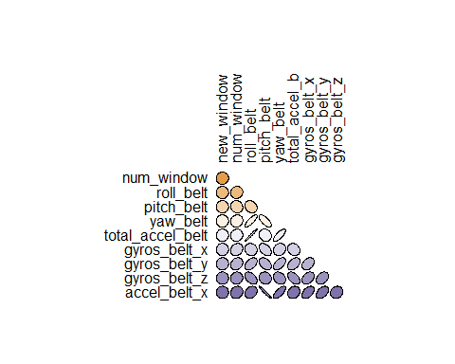

# reference http://little-book-of-r-for-multivariate-analysis.readthedocs.org/en/latest/src/multivariateanalysis.html  
  
  
  
# Loading the data to check the proportion in each case A to E. in percentage  
  
round(prop.table(table(as1_train$classe)) * 100, digits = 1)

##   
## A B C D E   
## 28.4 19.4 17.4 16.4 18.4

round(prop.table(table(as1_test$classe)) * 100, digits = 1)

##   
## A B C D E   
## 28.4 19.4 17.4 16.4 18.4

# Normalizing the data   
  
normalize <- function(x) {  
return ((x - min(x)) / (max(x) - min(x)))  
}  
  
as1_train_n <- as.data.frame(lapply(as1_train[1:54], normalize))  
as1_test_n <- as.data.frame(lapply(as1_test[1:54], normalize))

## KNN Classifier

# Extracting the labels  
as1_train_labels <- as1_train$classe  
as1_test_labels <- as1_test$classe  
  
# Need to remove the missing values in the training and test dataframes  
  
as1_train_n1 <- na.omit(as1_train_n)  
# as1_test_n1 <- na.omit(as1_test_n)  
  
# Prediction  
  
as1_pred <- knn(train = as1_train_n1, test = as1_test_n, cl = as1_train_labels, k=5)  
  
# test set classification  
  
as1_test_pred <- knn(train = as1_train_n1, test = as1_test_n,  
cl = as1_train_labels, k=5)  
  
# The below are the predicted lables.  
head(as1_test_pred, 10)

## [1] A A A A A A A A A A  
## Levels: A B C D E

## Evaluating the model

library(gmodels)  
  
# I have assigned some fictitious data for the label as there were no lables given for the test set.  
  
  
CrossTable(x = as1_test_labels, y = as1_test_pred,  
prop.chisq=FALSE)

##   
##   
## Cell Contents  
## |-------------------------|  
## | N |  
## | N / Row Total |  
## | N / Col Total |  
## | N / Table Total |  
## |-------------------------|  
##   
##   
## Total Observations in Table: 19622   
##   
##   
## | as1_test_pred   
## as1_test_labels | A | B | C | D | E | Row Total |   
## ----------------|-----------|-----------|-----------|-----------|-----------|-----------|  
## A | 5536 | 20 | 8 | 11 | 5 | 5580 |   
## | 0.992 | 0.004 | 0.001 | 0.002 | 0.001 | 0.284 |   
## | 0.992 | 0.005 | 0.002 | 0.003 | 0.001 | |   
## | 0.282 | 0.001 | 0.000 | 0.001 | 0.000 | |   
## ----------------|-----------|-----------|-----------|-----------|-----------|-----------|  
## B | 29 | 3695 | 49 | 15 | 9 | 3797 |   
## | 0.008 | 0.973 | 0.013 | 0.004 | 0.002 | 0.194 |   
## | 0.005 | 0.983 | 0.014 | 0.005 | 0.003 | |   
## | 0.001 | 0.188 | 0.002 | 0.001 | 0.000 | |   
## ----------------|-----------|-----------|-----------|-----------|-----------|-----------|  
## C | 5 | 22 | 3364 | 27 | 4 | 3422 |   
## | 0.001 | 0.006 | 0.983 | 0.008 | 0.001 | 0.174 |   
## | 0.001 | 0.006 | 0.961 | 0.008 | 0.001 | |   
## | 0.000 | 0.001 | 0.171 | 0.001 | 0.000 | |   
## ----------------|-----------|-----------|-----------|-----------|-----------|-----------|  
## D | 9 | 8 | 63 | 3127 | 9 | 3216 |   
## | 0.003 | 0.002 | 0.020 | 0.972 | 0.003 | 0.164 |   
## | 0.002 | 0.002 | 0.018 | 0.979 | 0.003 | |   
## | 0.000 | 0.000 | 0.003 | 0.159 | 0.000 | |   
## ----------------|-----------|-----------|-----------|-----------|-----------|-----------|  
## E | 4 | 13 | 15 | 14 | 3561 | 3607 |   
## | 0.001 | 0.004 | 0.004 | 0.004 | 0.987 | 0.184 |   
## | 0.001 | 0.003 | 0.004 | 0.004 | 0.992 | |   
## | 0.000 | 0.001 | 0.001 | 0.001 | 0.181 | |   
## ----------------|-----------|-----------|-----------|-----------|-----------|-----------|  
## Column Total | 5583 | 3758 | 3499 | 3194 | 3588 | 19622 |   
## | 0.285 | 0.192 | 0.178 | 0.163 | 0.183 | |   
## ----------------|-----------|-----------|-----------|-----------|-----------|-----------|  
##   
##

### The below are the predicted lables.

as1_test_pred

#### [1] B A A A A E D B A A B A B A E E E B B B

#### Levels: A B C D E

## Inference from the prediction

### there were no labels for 'C' Category, A was predicted as A 100% classified correctly, There were 10% miss classification ####for 'B', C were all miss classified. D was also calssified correctly 100%. E was also calssified correctly 100%.

Note that the echo = FALSE parameter was added to the code chunk to prevent printing of the R code that generated the plot.