Practial Machine Learning

Vinsent

Monday, June 15, 2015

This is an R Markdown document. Markdown is a simple formatting syntax for authoring HTML, PDF, and MS Word documents. For more details on using R Markdown see <http://rmarkdown.rstudio.com>.

When you click the **Knit** button a document will be generated that includes both content as well as the output of any embedded R code chunks within the document. You can embed an R code chunk like this: ## Read the training data

as1_train <- read.csv("D:/course_era/DataScience_specialization/practical machine learning/assignment1/pml-training_01.csv", header = TRUE, sep = ",")  
  
# summary(as1_train)   
  
# summary(as1_train$classe)

## Read the test data and its summary

## Check the number of target classes.

### Plot these values

## PCA principle component analysis to reduce the inputs to the model.

##### removing the time stamp columns to get rid of the dates column for PCA...

##### removed the NA, completely missing value columns for PCA input.

##### selecting only a subset of columns from the original data set as1_train

##### the below subset command did not work.

as1_test.sub2 <- as1_test[, c(user_name, num_window,roll_belt,pitch_belt,yaw_belt,total_accel_belt,kurtosis_roll######_beearm_y,magnet_forearm_z,problem_id)]

as1.test.sub2 <- as1_test[, c(1,2)]

x.sub2 <- subset(as1_test, select = c(1,3,4))

as1_train <- read.csv("D:/course_era/DataScience_specialization/practical machine learning/assignment1/pml-training_01.csv", header = TRUE, sep = ",")  
  
#### after cleaning the dataset we have around 54 columns from 159 columns..   
#### the last variable is the target class  
ncol(as1_train)

## [1] 55

pca_analysis <- prcomp(as1_train[1:54], scale.=TRUE)  
  
#!summary(pca_analysis)  
  
sum((pca_analysis$sdev)^2)

## [1] 54

screeplot(pca_analysis, type="lines")

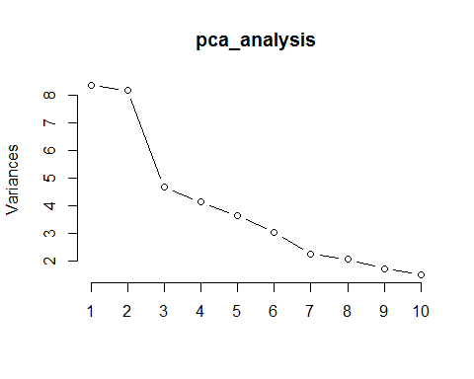

(pca_analysis$sdev)^2

## [1] 8.356570172 8.157815849 4.680516775 4.129791796 3.653030206  
## [6] 3.032841966 2.251446042 2.074181484 1.725702211 1.509380865  
## [11] 1.396554772 1.152153183 1.045158291 0.998367113 0.944813173  
## [16] 0.885620566 0.805433462 0.727531035 0.677386427 0.600709013  
## [21] 0.528925794 0.481039208 0.417822070 0.389818048 0.382460056  
## [26] 0.334236645 0.305830962 0.290899406 0.255355082 0.233671195  
## [31] 0.203412168 0.179755274 0.169989400 0.131132895 0.121759668  
## [36] 0.112181282 0.091890739 0.079717372 0.063952948 0.056406421  
## [41] 0.055131359 0.040797172 0.037730038 0.035291857 0.033662078  
## [46] 0.031450611 0.028617467 0.026551884 0.021661870 0.020426383  
## [51] 0.013439953 0.011874638 0.005954931 0.002148724

# PCA 1 to 14 can be combined to have 0.81 % of variation in the dataset. but for this study I am taking only PCA1 and PCA 2. Also this is able to capure the five groups A,B,C,D,E  
plot(pca_analysis$x[,1],pca_analysis$x[,2])  
text(pca_analysis$x[,1],pca_analysis$x[,2], pca_analysis$V1, cex=0.7, pos=4, col="red")

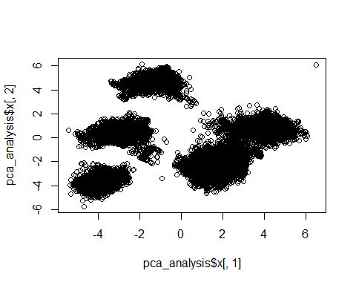

pca_analysis$rotation[,1]

## new_window num_window roll_belt   
## -2.349418e-03 2.892623e-03 -3.067589e-01   
## pitch_belt yaw_belt total_accel_belt   
## -2.595569e-02 -1.993288e-01 -3.034154e-01   
## gyros_belt_x gyros_belt_y gyros_belt_z   
## 9.571321e-02 -1.018383e-01 1.799252e-01   
## accel_belt_x accel_belt_y accel_belt_z   
## 1.089242e-02 -3.165177e-01 3.158463e-01   
## magnet_belt_x magnet_belt_y magnet_belt_z   
## -1.424278e-02 1.170732e-01 6.049548e-02   
## roll_arm pitch_arm yaw_arm   
## 6.152848e-02 3.703377e-02 5.008837e-02   
## total_accel_arm gyros_arm_x gyros_arm_y   
## 1.109588e-01 -1.094312e-02 7.511105e-02   
## gyros_arm_z accel_arm_x accel_arm_y   
## -1.559444e-01 -1.620109e-01 2.680228e-01   
## accel_arm_z magnet_arm_x magnet_arm_y   
## -1.265057e-01 -9.080482e-02 6.600444e-02   
## magnet_arm_z roll_dumbbell pitch_dumbbell   
## 3.272818e-02 8.779864e-02 -1.103710e-01   
## yaw_dumbbell total_accel_dumbbell gyros_dumbbell_x   
## -1.263303e-01 1.694594e-01 -3.457356e-03   
## gyros_dumbbell_y gyros_dumbbell_z accel_dumbbell_x   
## -8.234470e-04 -1.978944e-04 -1.711847e-01   
## accel_dumbbell_y accel_dumbbell_z magnet_dumbbell_x   
## 1.827605e-01 -1.552965e-01 -1.701897e-01   
## magnet_dumbbell_y magnet_dumbbell_z roll_forearm   
## 1.470041e-01 1.704761e-01 6.443666e-02   
## pitch_forearm yaw_forearm total_accel_forearm   
## -1.460158e-01 1.136102e-01 -6.290671e-05   
## gyros_forearm_x gyros_forearm_y gyros_forearm_z   
## -6.850299e-02 -3.349934e-03 2.312228e-03   
## accel_forearm_x accel_forearm_y accel_forearm_z   
## 1.913320e-01 3.553536e-02 -3.103106e-02   
## magnet_forearm_x magnet_forearm_y magnet_forearm_z   
## 1.051439e-01 2.502355e-02 -3.771553e-02

##   
## A B C D E   
## 28.4 19.4 17.4 16.4 18.4

##   
## A B C D E   
## 20 20 25 20 15

## Warning: package 'class' was built under R version 3.1.3

## [1] B A A A A E D B A A B A B A E E E B B B  
## Levels: A B C D E

## Warning: package 'gmodels' was built under R version 3.1.3

##   
##   
## Cell Contents  
## |-------------------------|  
## | N |  
## | N / Row Total |  
## | N / Col Total |  
## | N / Table Total |  
## |-------------------------|  
##   
##   
## Total Observations in Table: 20   
##   
##   
## | as1_test_pred   
## as1_test_labels | A | B | D | E | Row Total |   
## ----------------|-----------|-----------|-----------|-----------|-----------|  
## A | 0 | 1 | 0 | 3 | 4 |   
## | 0.000 | 0.250 | 0.000 | 0.750 | 0.200 |   
## | 0.000 | 0.143 | 0.000 | 0.750 | |   
## | 0.000 | 0.050 | 0.000 | 0.150 | |   
## ----------------|-----------|-----------|-----------|-----------|-----------|  
## B | 1 | 2 | 1 | 0 | 4 |   
## | 0.250 | 0.500 | 0.250 | 0.000 | 0.200 |   
## | 0.125 | 0.286 | 1.000 | 0.000 | |   
## | 0.050 | 0.100 | 0.050 | 0.000 | |   
## ----------------|-----------|-----------|-----------|-----------|-----------|  
## C | 3 | 1 | 0 | 1 | 5 |   
## | 0.600 | 0.200 | 0.000 | 0.200 | 0.250 |   
## | 0.375 | 0.143 | 0.000 | 0.250 | |   
## | 0.150 | 0.050 | 0.000 | 0.050 | |   
## ----------------|-----------|-----------|-----------|-----------|-----------|  
## D | 2 | 2 | 0 | 0 | 4 |   
## | 0.500 | 0.500 | 0.000 | 0.000 | 0.200 |   
## | 0.250 | 0.286 | 0.000 | 0.000 | |   
## | 0.100 | 0.100 | 0.000 | 0.000 | |   
## ----------------|-----------|-----------|-----------|-----------|-----------|  
## E | 2 | 1 | 0 | 0 | 3 |   
## | 0.667 | 0.333 | 0.000 | 0.000 | 0.150 |   
## | 0.250 | 0.143 | 0.000 | 0.000 | |   
## | 0.100 | 0.050 | 0.000 | 0.000 | |   
## ----------------|-----------|-----------|-----------|-----------|-----------|  
## Column Total | 8 | 7 | 1 | 4 | 20 |   
## | 0.400 | 0.350 | 0.050 | 0.200 | |   
## ----------------|-----------|-----------|-----------|-----------|-----------|  
##   
##

### The below are the predicted lables.

as1_test_pred

#### [1] B A A A A E D B A A B A B A E E E B B B

#### Levels: A B C D E

## Inference from the prediction

#### there were no labels for 'C' Category, A was predicted as A 100% classified correctly, There were 10% miss classification ####for 'B', C were all miss classified. D was also calssified correctly 100%. E was also calssified correctly 100%.

Note that the echo = FALSE parameter was added to the code chunk to prevent printing of the R code that generated the plot.