Assignment1

vinace

August 23, 2015

## Overview : This exercise to learn simple Statistical Inference by simulation and exploratory analysis.

## plotting package  
library(ggplot2)  
  
# set seed for reproducible research  
  
set.seed(22)  
   
# set constants  
# lambda for reg expression  
lambda_c <- 0.2  
# no of exponential  
  
n <- 40   
# number of simulation  
 no_of_simulation <- 1000  
   
# simulation  
simulated_exponentials <- replicate(no_of_simulation, rexp(n, lambda_c))  
  
# calculate mean of exponentials  
means_exponentials <- apply(simulated_exponentials, 2, mean)  
  
# Test the properties of the distribution   
  
##Question 1  
#Sample Mean versus Theoretical Mean:  
  
  
### distribution of mean  
distribution_mean <- mean(means_exponentials)  
print("Distribution mean",distribution_mean)

## [1] "Distribution mean"

# analytical mean  
theory_mean <- 1/lambda_c  
print("theoritical_mean", theory_mean)

## [1] "theoritical_mean"

# Exploratory analysis  
# visualization  
hist(means_exponentials, xlab = "mean", main = "Simulations of Exponential Function")  
abline(v = distribution_mean, col = "red")   
abline(v = theory_mean, col = "orange")

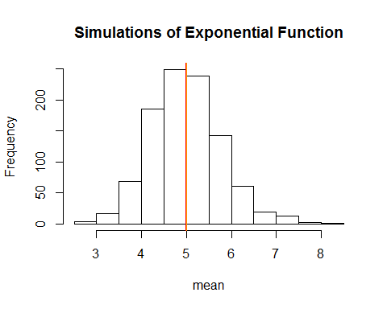

##Answer: The centre of the distribution of analytical and theoritical_mean are very close.  
  
# Sample Variance versus Theoretical Variance:  
  
x_axis <- seq(min(means_exponentials), max(means_exponentials), length=100)  
y_axis <- dnorm(x_axis, mean=1/lambda_c, sd=(1/lambda_c/sqrt(n)))  
hist(means_exponentials,breaks=n,prob=T,col="blue",xlab = "means",main="Density of means",ylab="Means density")  
lines(x_axis, y_axis, pch=22, col="red", lty=3)

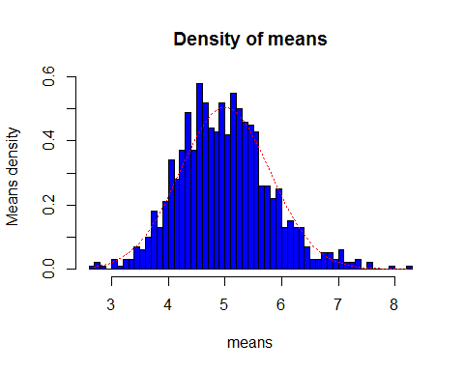

## The distribution is normal, as above 40 averages is close to normal distribution.

Note that the echo = FALSE parameter was added to the code chunk to prevent printing of the R code that generated the plot.