Statistical Inference project part 2

vinace

August 23, 2015

This is an R Markdown document. Markdown is a simple formatting syntax for authoring HTML, PDF, and MS Word documents. For more details on using R Markdown see <http://rmarkdown.rstudio.com>.

When you click the **Knit** button a document will be generated that includes both content as well as the output of any embedded R code chunks within the document. You can embed an R code chunk like this:

## 1. Load the ToothGrowth data and perform some basic exploratory data analyses   
library(ggplot2)  
data(ToothGrowth)  
  
## 2. Provide a basic summary of the data.  
names(ToothGrowth)

## [1] "len" "supp" "dose"

summary(ToothGrowth)

## len supp dose   
## Min. : 4.20 OJ:30 Min. :0.500   
## 1st Qu.:13.07 VC:30 1st Qu.:0.500   
## Median :19.25 Median :1.000   
## Mean :18.81 Mean :1.167   
## 3rd Qu.:25.27 3rd Qu.:2.000   
## Max. :33.90 Max. :2.000

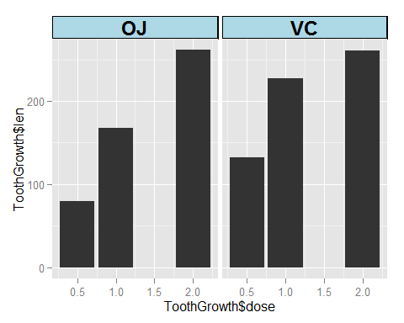 ### 3. Use confidence intervals and/or hypothesis tests to compare tooth growth by supp and dose. (Only use the techniques from class, even if there's other approaches worth considering)

### Doing a T- test to undestand the significance of the dose.

### H0: there is no significance of doses OJ and VC..

### H1: there is a significant difference in the treatment OJ and VC

### Testing the significance with T test.

##   
## Welch Two Sample t-test  
##   
## data: len by supp  
## t = 1.9153, df = 55.309, p-value = 0.06063  
## alternative hypothesis: true difference in means is not equal to 0  
## 95 percent confidence interval:  
## -0.1710156 7.5710156  
## sample estimates:  
## mean in group OJ mean in group VC   
## 20.66333 16.96333

### State your conclusions and the assumptions needed for your conclusions.

### Summary : Accepting the alernate hyposthesis as there is a significance difference in the support of the doses OJ and VC.

Note that the echo = FALSE parameter was added to the code chunk to prevent printing of the R code that generated the plot.