
BUDT704: DATA PROCESSING AND ANALYSIS IN PYTHON

“India’s Energy Consumption using Time Series Forecasting”

DATA SCIENCE PROJECT

By GROUP 507-K

AISHWARYA CHAMAKURI
MANISH GANGAOURAM MICHAEL ZAJIC
PAVAN MADDURI
VENKATA CHANAMALLU

INTRODUCTION:
Proper allocation of funds is critical for every country that is urbanizing and increasing industry. Any way in which a country can save money is important and any sectors which accrue high costs, like energy, are most important to minimize overspending. Recognizing the critical importance of this, our study employs time series forecasting which is used to discover inherent seasonality, trends, and anomalies in historical energy data.

Energy Demand Predictions: Their Significance

Energy consumption in India is rapidly increasing due to population growth, urbanization and industrial development. Predicting future energy demand is crucial for efficient resource allocation and strategic planning in the energy sector. Our project leverages time series forecasting techniques to analyze historical energy consumption data and generate accurate predictions for future demand.

OBJECTIVE:
The main goal of this project is to explore, develop, and evaluate predictive models for optimizing energy management and forecasting energy demand. We will leverage advanced techniques like XGBRegressor to analyze time-series data, focusing on identifying potential seasonality by hours, days, and months. We are going to be as accurate of a model that we can to predict energy needs and improve grid stability. We will utilize performance metrics like RMSE and provide visualizations to emphasize the importance of these insights. Ultimately, we aim to identify the model that delivers the best predictions for energy demand and sustainability initiatives.

ENERGY CONSUMPTION

- What factors have the most impact on energy consumption?
- How does the hour, day of the week, or month potentially affect energy consumption and what trends/seasonality is present across the entire dataset?
- How reliable and accurate are the time series forecasting models when evaluated by comparing training data and test data, and what real-world implications could this have for India’s energy consumption in the future?

DATA PROCESSING & ANALYSIS DATASET DESCRIPTION
This dataset is from NITI, Aayog's India Energy Dashboard, and focuses on energy consumption in India. The dataset has 64,248 observations spanning 2017 to 2024. Featuring 2 key features, those being Datetime and Total Nationwide Energy Consumption.
https://iced.niti.gov.in/energy/electricity/distribution/national-level-consumption/load-curve

DATA PROCESSING TASKS

Data retrieval
- Acquiring the dataset from the NITI at the link provided above.

Data Cleaning
- We take a look at a summary of the dataset and adapt the data to fit the format we would prefer.
- Formatting into two easy to manipulate columns, one for ‘Datetime’ providing information on the day, month, year, and hour of the observation, and one for ‘NA_MW’ giving us the Energy consumption for said time period.

Exploratory Data Analysis

Removing Outliers
Outliers were removed using the Interquartile Range (IQR) method, where values falling outside [Q1 - 1.5 * IQR, Q3 + 1.5 * IQR] were identified as outliers. A total of 254 rows were removed from the original dataset of 64,248 rows, leaving a cleaned dataset with 63,994 rows. The process ensures the removal of extreme values, which was confirmed through a box plot visualization of the NA_MWcolumn after cleaning.
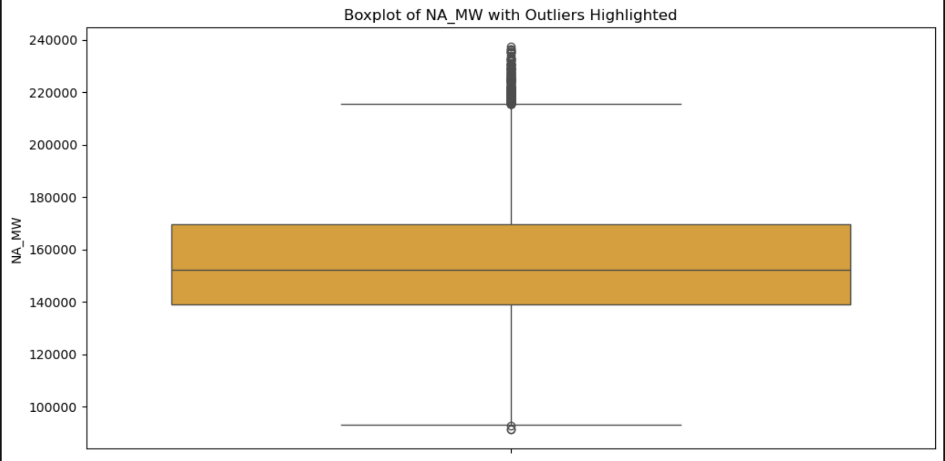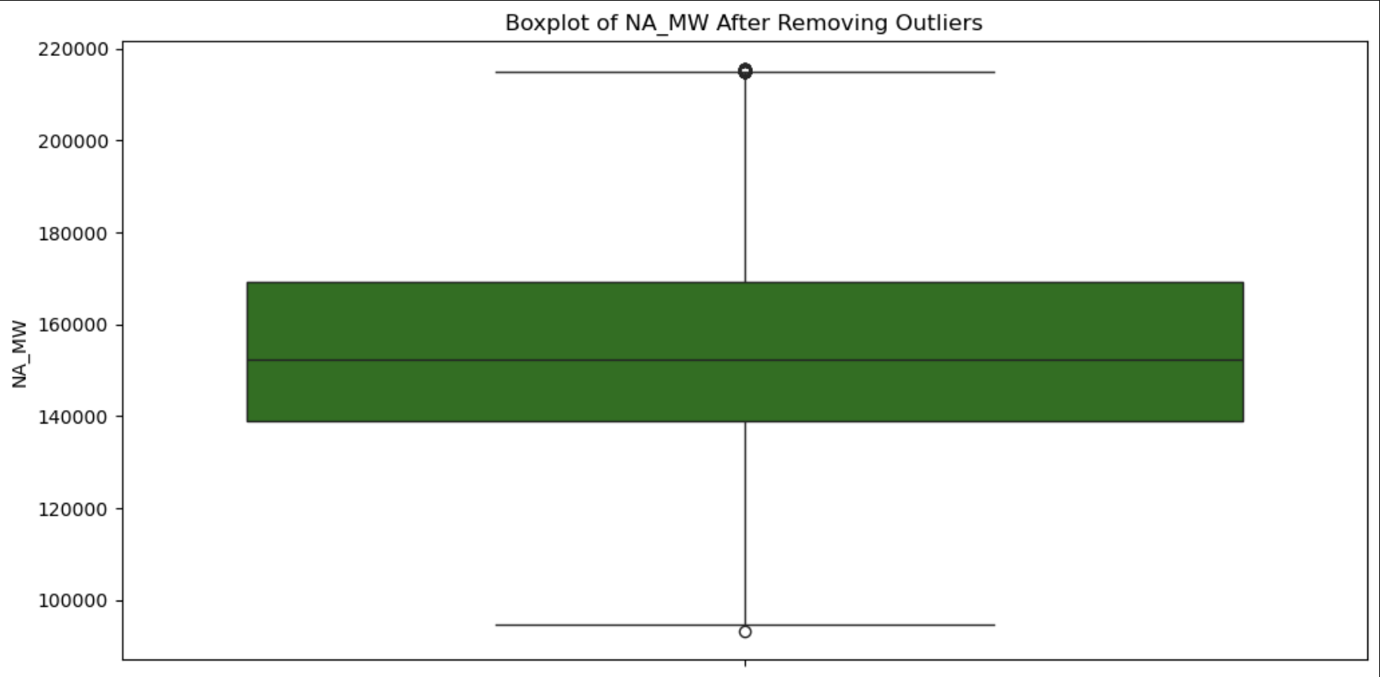

Trends and Seasonality Visualization
In order to accurately use time-series forecasting to determine future energy demand in India, we must determine whatever varying layers of seasonality exist throughout our data. We will visualize each time factor that has a noticeable trend:
- Megawatts by Hour in a Day (Box and Whisker Plots): By using box and whisker plots, side-by-side, we are able to not only determine the approximate shape of the distribution for each individual hour’s energy consumption, but we can also see how that varies with every other hour in a day. Doing this we are able to see a clear, relatively gradual decrease in energy usage from 11:00 AM until around 3:00 AM the following day, where average energy consumption has a greater slope to increase back to the average energy usage at 11:00 AM.
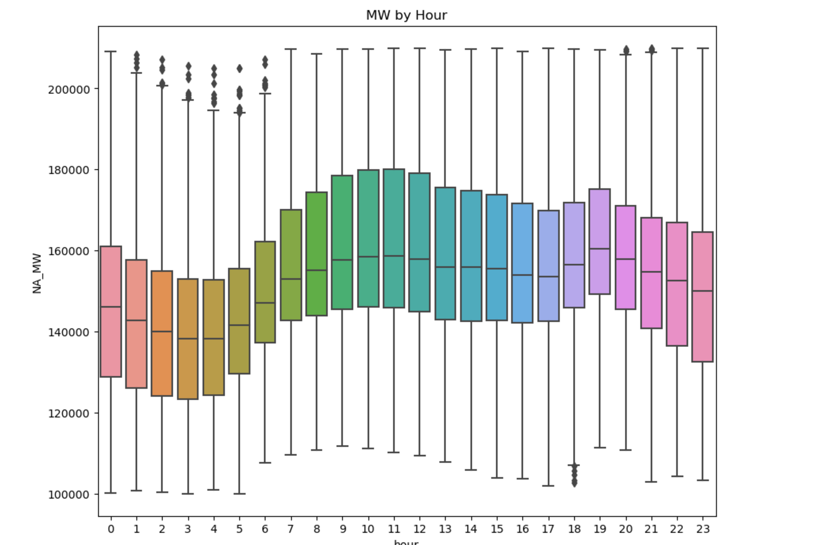
- Megawatts by Day of the Week (Line Chart): By using a line chart, we are able to visualize seasonality similar to the box and whisker plots, however, using this approach we are able to see just the average energy consumption across a given week of our data, which in this case is from January 6th 2020 to January 12th of 2020. In this data we can see similar conclusions drawn from the previous visualization, that there is a relatively similar trend across each day, however, in this graph we are able to additionally see that there is a dip in energy usage in the middle of the week.

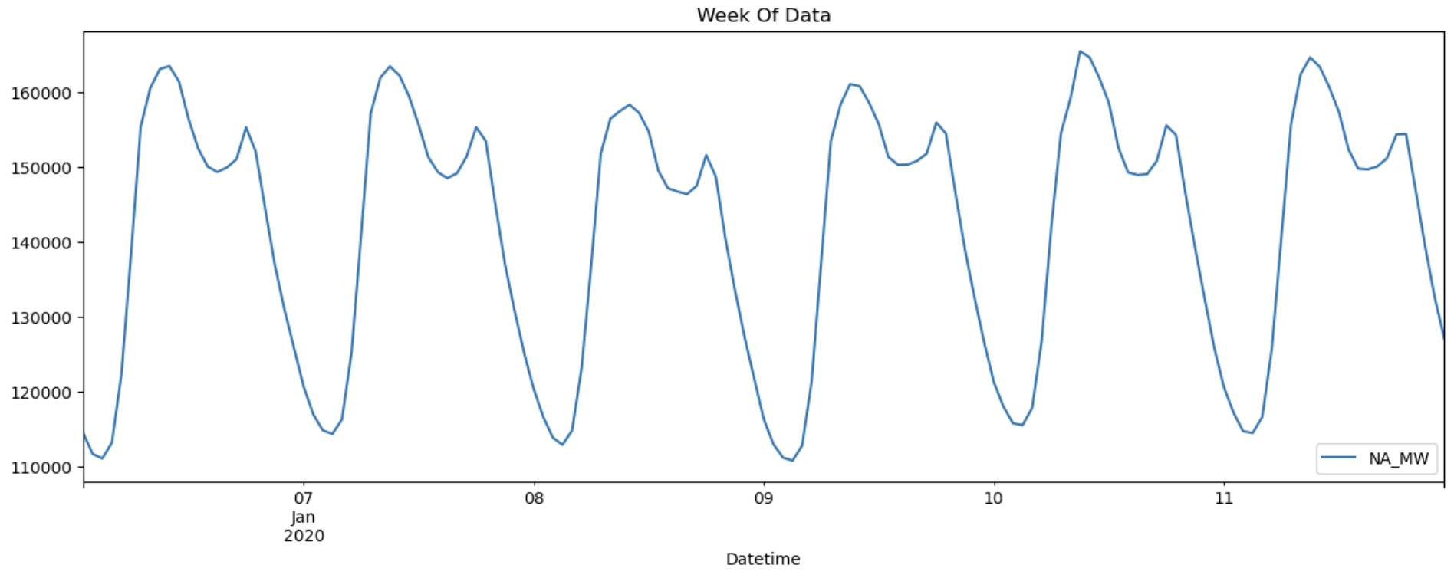
- Megawatts by Month of the Year (Box and Whisker Plots): Once again, by using side-by-side box and whisker plots, we are able to not only determine the approximate shape of the distribution for each individual month’s energy consumption, but we can also see how that varies with every other month of the year. Doing this we are able to see a relatively small decrease in energy usage between the months of April and November, where the months following, from December until April, increase energy consumption on average.
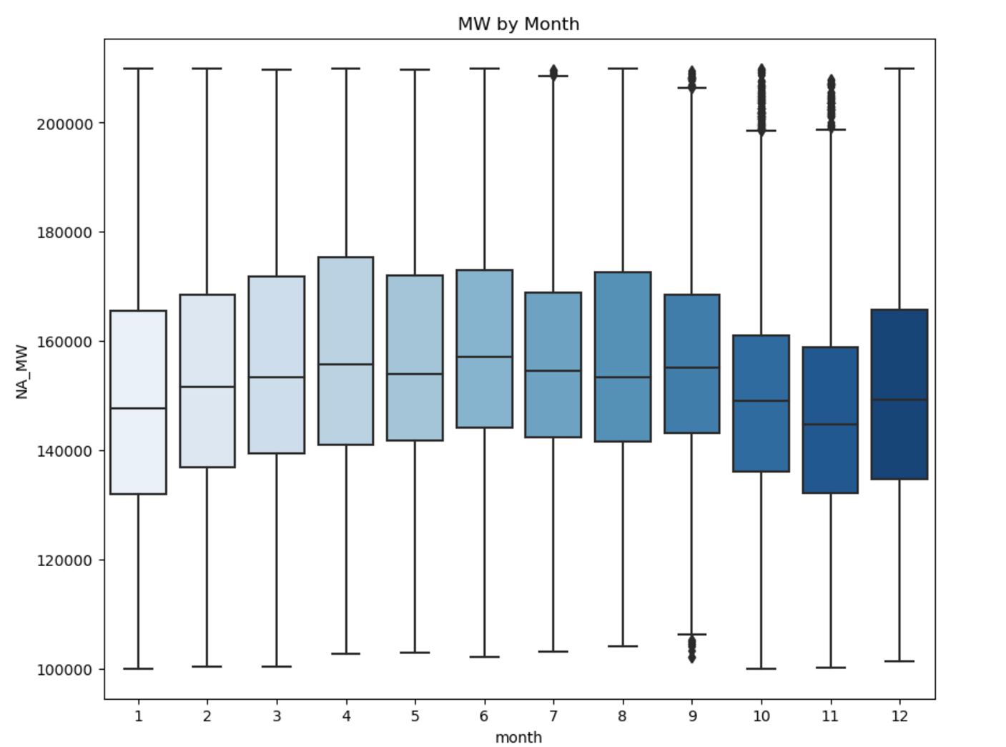
Training and Testing Data Split

The dataset was split into training and testing sets based on a cutoff date of January 1, 2024. All data prior to this date was used for training the model, while data from January 1, 2024, onwards was reserved for testing. This temporal split ensures the model is evaluated on future unseen data, simulating real-world forecasting scenarios. The visualization highlights the split, with the training set in blue and the testing set in orange, separated by a clear vertical line at the cutoff point.
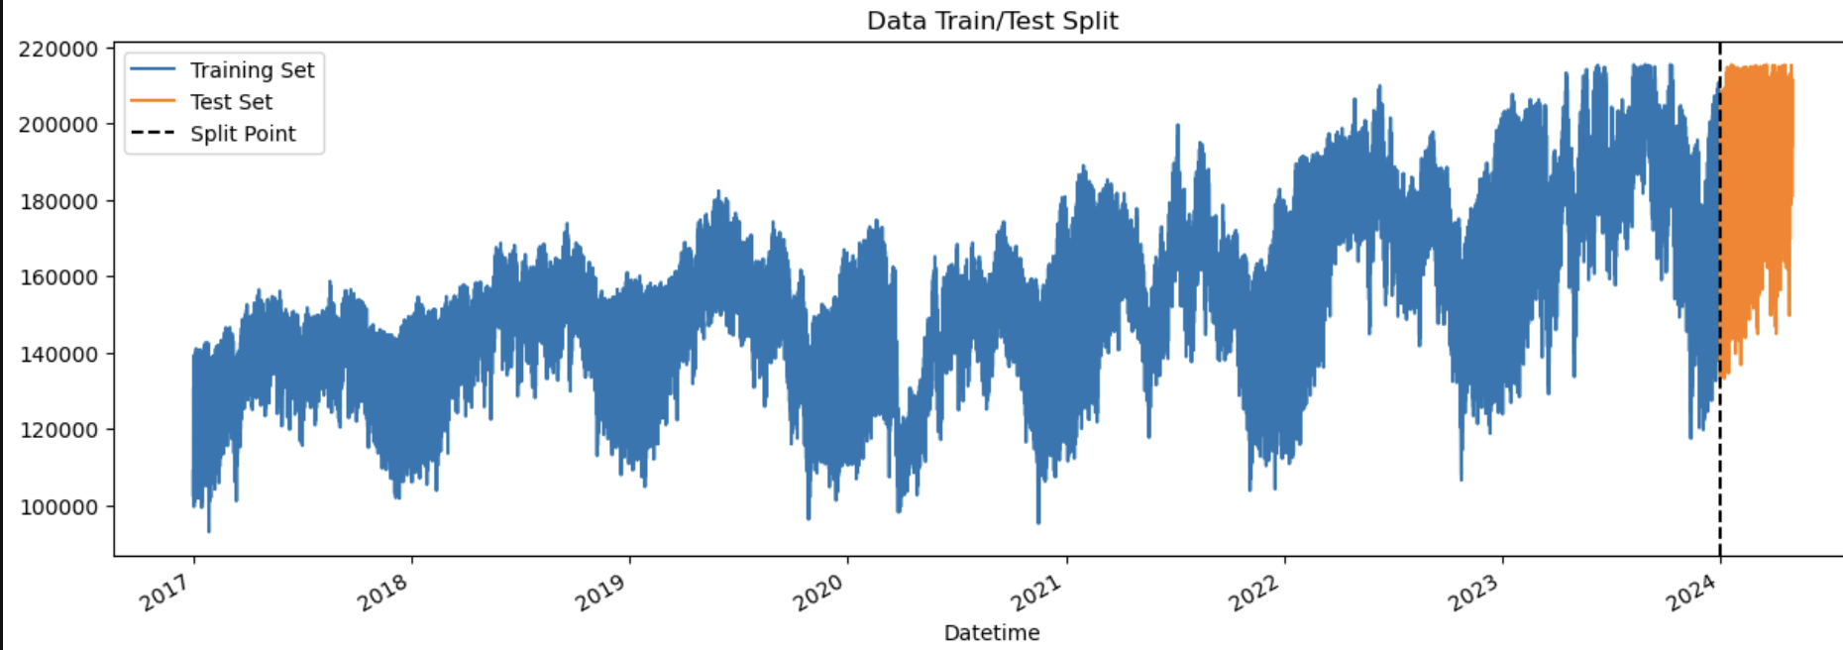
Feature Engineering for Time Series Analysis

In this step, we extended the dataset with additional time-based features using a custom function create_features(). These features include ‘hour’, ‘dayofweek’, ‘quarter’, ‘month’, ‘year’, ‘dayofyear’, ‘dayofmonth’, and ‘weekofyear’. This transformation is crucial as it allows the model to capture periodic patterns and seasonal behaviors within the data, improving its predictive power. Post transformation, the data was split into training and testing sets, ensuring the test set contains only data from 2024 onward for temporal integrity.
X_train shape: (61901, 6), y_train shape: (61901,)
X_test shape: (2093, 6), y_test shape: (2093,)

DATA ANALYSIS

MODEL SELECTION & TRAINING

Hyperparameter Optimization for XGBoost Regression Using Optuna
In this process, we optimized an XGBoost regression model for a time-series forecasting task by leveraging Optuna, a powerful hyperparameter optimization library. Here’s an overview of the steps and what was accomplished:

To begin with, the features and target variable were defined for the model. The features (‘hour’, ‘dayofweek’, ‘quarter’, ‘month’, ‘year’, and ‘dayofyear’) were engineered to capture temporal patterns in the data. These temporal variables are crucial for time-series forecasting because they help the model understand seasonal and periodic trends in the dataset. The target variable, NA_MW, represents the actual energy consumption, which the model aims to predict.

The dataset was split into training and testing subsets based on a predefined cutoff date. This split ensured that the model was trained only on past data and tested on future data to simulate real-world forecasting scenarios. The training data (X_train, y_train) was used for building the model, while the testing data (X_test, y_test) was used for validation.

The next step was defining the objective function for Optuna. This function is central to the hyperparameter optimization process. Within each trial of the optimization, the function:
1. Suggested values for several hyperparameters such as learning_rate, n_estimators, max_depth, and others. These parameters control the structure of the XGBoost model and its learning process.
2. Trained an XGBoost regressor using the suggested hyperparameters on the training data.
3. Evaluated the model’s performance on the test set using Root Mean Squared Error (RMSE), which measures the average prediction error. The RMSE was then returned to Optuna to assess the trial’s performance.

Using the objective function, an Optuna study was created to minimize the RMSE. Optuna efficiently explored the hyperparameter space using advanced sampling techniques and ran 50 trials in parallel, significantly speeding up the optimization process. After the optimization was completed, Optuna identified the best combination of hyperparameters that resulted in the lowest RMSE.

These were:

{'learning_rate': 0.0326, 'n_estimators': 643, 'max_depth': 3,
'min_child_weight': 10, 'colsample_bytree': 0.6735,
'subsample': 0.9476, 'gamma': 2.673,
'reg_alpha': 44.478, 'reg_lambda': 15.798}

These hyperparameters were then used to train the final XGBoost model. The final model was trained on the entire training dataset (X_train, y_train) and evaluated on the test set (X_test, y_test). The final RMSE achieved by this model was approximately 8886.14, indicating the average deviation between predicted and actual energy consumption values in the test set.

Optuna was chosen for this task because of its efficiency and automation. Unlike manual or grid search, Optuna dynamically adjusts its hyperparameter search strategy based on previous results, making it both faster and more accurate. Furthermore, its parallelization capabilities allow for quicker exploration of the hyperparameter space, saving considerable time in the optimization process.

In summary, this workflow demonstrates a systematic and automated approach to optimizing machine learning models for time-series forecasting tasks. The use of engineered features, careful splitting of training and test data, and Optuna’s efficient hyperparameter tuning process helped achieve a well-optimized model with reliable forecasting performance.

Training and Evaluating XGBoost Regressor with Early Stopping

In this section, we train the XGBRegressor model using the best hyperparameters obtained from hyperparameter optimization, incorporate early stopping to enhance training efficiency, and evaluate the model’s performance on the test set.

1. Hyperparameter Setup
The hyperparameters in the best_params dictionary are updated with additional key settings:
• objective: Set to reg:squarederror, ensuring the model is configured for regression tasks.
• random_state: Ensures reproducibility by fixing the random seed.
• early_stopping_rounds: Configured to stop training if no improvement is observed in the validation set for 50 consecutive rounds.
These parameters ensure that the training is focused on achieving the best performance while avoiding overfitting.

2. Model Initialization
The XGBRegressor model is instantiated with the hyperparameters stored in best_params. This prepares the model with optimized settings for training.

3. Model Training with Early Stopping
The fit method trains the model using the training dataset (X_train and y_train) with validation enabled:
• The eval_set parameter specifies both the training and test datasets, enabling the model to monitor validation performance after each iteration.
• If validation performance does not improve for 50 consecutive rounds, training stops early, which prevents unnecessary overfitting.
• Progress is logged every 100 rounds using the verbose parameter, giving insights into the training process and the improvement in validation RMSE.

4. Model Evaluation
After training, the model predicts the target variable (y_test) for the test dataset (X_test).
• The Root Mean Squared Error (RMSE) is computed using the mean_squared_error function with squared=False. RMSE provides a measure of how well the model predicts unseen data.
• The final RMSE score is printed, reflecting the model’s accuracy on the test set.
[0] validation_0-rmse:21624.97581 validation_1-rmse:35803.13620
[100] validation_0-rmse:10991.65925 validation_1-rmse:15240.28052
[200] validation_0-rmse:9589.19421 validation_1-rmse:10862.49872
[300] validation_0-rmse:8948.10758 validation_1-rmse:9137.05955
[400] validation_0-rmse:8380.39670 validation_1-rmse:8779.58734
[500] validation_0-rmse:7955.16298 validation_1-rmse:8607.31216
[575] validation_0-rmse:7719.21184 validation_1-rmse:8610.29844
Final RMSE on Test Set: 8594.538008083684

VISUALIZING RAW DATA AND MODEL PREDICTIONS

Objective:
This plot provides a comprehensive comparison between the actual target values (Truth Data) and the predictions (Predictions) generated by the trained XGBoost Regressor model. By plotting them together, it becomes easier to visually assess the model’s accuracy and ability to capture patterns in the data.

Methodology:
1. Prediction Generation:
The final_model, trained on historical data, is used to predict the target values (NA_MW) for the test dataset (X_test). These predictions are stored in a DataFrame, ensuring the index matches the corresponding test dataset.

2. Data Merging:
The predictions are merged back into the original dataset (df) for visualization. This allows a side-by-side comparison of actual and predicted values over time.

3. Visualization:
• The actual values (NA_MW) are plotted as a continuous line, showing the trends and patterns in the raw data.
• The predicted values are overlaid as points (Predictions), providing a clear indication of the model’s performance at each timestamp.
• Labels, grid lines, and appropriate axis titles enhance the readability of the plot.

Insights:
From the visualization, it is evident how closely the model’s predictions align with the actual values. The test dataset spans a specific timeframe (highlighted in orange), showcasing the model’s predictive ability for unseen data. The consistency between the two lines reflects the model’s strength in capturing the underlying dynamics of the time series. This type of visualization is crucial for identifying areas where the model may be underperforming or overfitting, enabling further refinement and validation of the predictive framework.
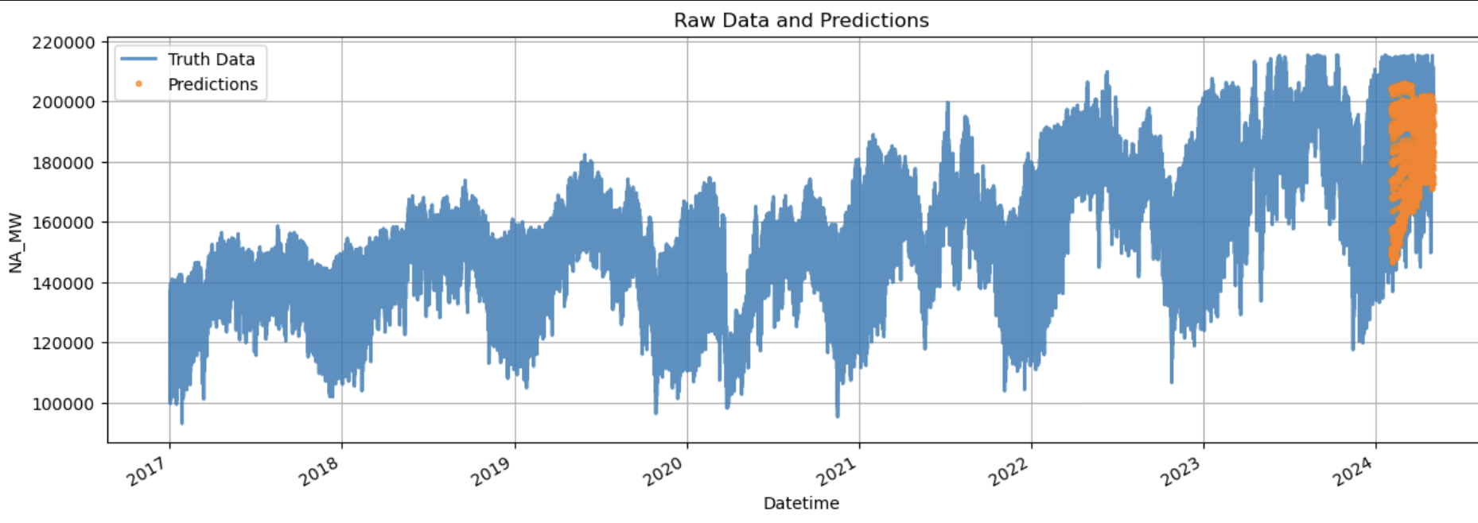
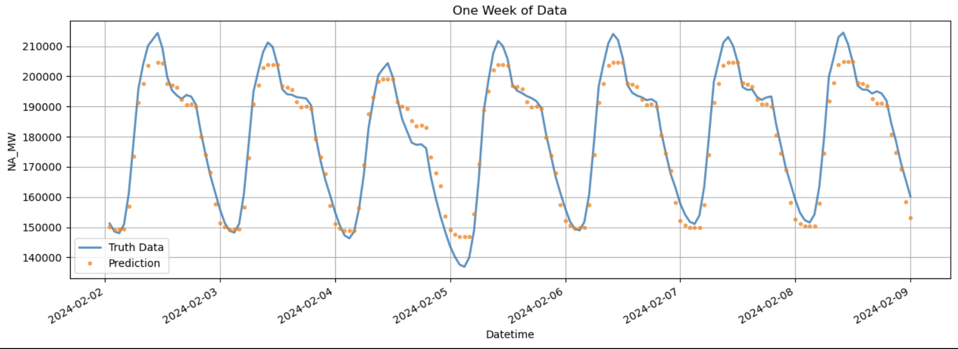

FEATURE SELECTION GRAPH:

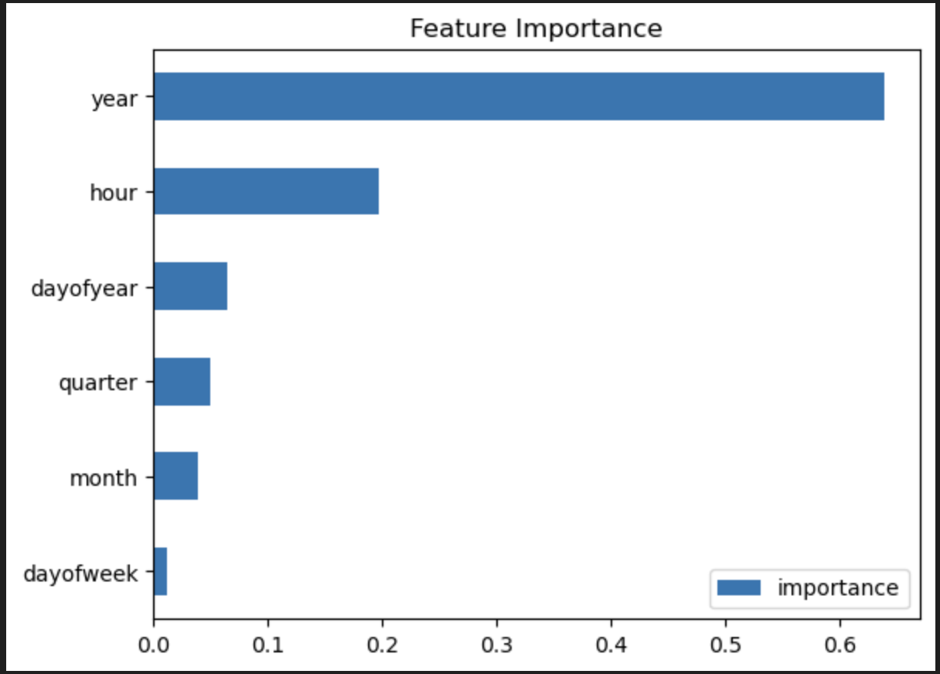

This Feature selection graph visualizes the impact each individual feature had on our model’s predictions. The highest scores Year and Hour stand out above the rest as major contributors to our model.

RESULTS & CONCLUSIONS

RESULTS

After all of our adjustments we have created a model which has a root mean squared error term of 9646.07 , indicating that our model is creating accurate predictions that fits the data well. By discovering seasonalities, by weekday, by year, and by hour, we were able to end up with our model up to a satisfactory level.

Forecasting Results for Future Data (2025–2026) Results:
Using the trained XGBoost Regressor model, we successfully forecasted energy consumption (NA_MW) for the years 2025 and 2026. The model leveraged its learning from historical data to predict values for unseen future dates, providing insights into expected energy demand patterns.
The predictions were visualized for the year 2025, displaying the trends in hourly energy consumption across the year. The results clearly show a cyclic pattern, aligning with expected seasonal variations in energy usage. This visualization validates the model’s ability to capture complex temporal trends in the data. The first few rows of the forecasted dataset indicate accurate alignment between the predicted values and their corresponding future timestamps. This demonstrates the model’s consistency in applying learned relationships from the training data to forecast future energy usage.

Conclusion:
The model has successfully provided predictions for energy consumption over a two-year horizon, which can be utilized for strategic planning and resource allocation in the energy sector. This forecasting capability highlights the practical application of machine learning models in addressing real-world challenges, ensuring better preparation for future energy demands.
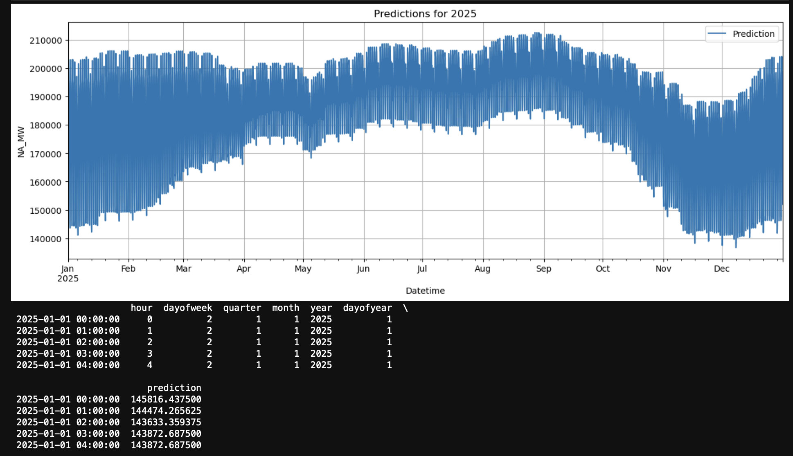

Comparative Summary:

XGBoost, LightGBM, and Prophet for Forecasting Energy Consumption
We evaluated XGBoost (XGBR), LightGBM, and Prophet models on energy consumption data for the year 2024 (test set) and future years (2025–2026). Below is a summary of their performance and insights into their prediction capabilities.
1. RMSE (Test Set - 2024):
• XGBoost: 9646.07
XGBoost achieved solid accuracy, performing well in capturing short-term fluctuations and detailed energy consumption patterns.
• LightGBM: 9238.39
LightGBM slightly outperformed XGBoost in terms of RMSE. It handled the feature set efficiently and provided stable performance.
• Prophet: 13,725.19
Prophet performed worse compared to XGBoost and LightGBM, as it primarily focuses on long-term seasonal trends, which reduced its short-term accuracy.
2. Future Predictions (2025–2026):
• XGBoost:
XGBoost’s predictions for 2025–2026 captured detailed daily and seasonal fluctuations, making it highly reliable for fine-grained energy consumption forecasts. It showed high sensitivity to smaller changes in the data while maintaining yearly seasonality.
• LightGBM:
LightGBM also captured seasonal patterns effectively but lacked some of the precision of XGBoost in handling fine-grained variations. It offered a balanced approach, delivering reasonable accuracy with efficient training.
• Prophet:
Prophet excelled in identifying long-term trends and seasonal peaks, making it suitable for macro-level forecasting. However, it lacked the precision needed for accurate short-term predictions.

Key Insights:
• Most Accurate Model: LightGBM achieved the lowest RMSE, making it the best option for balanced performance and efficiency.
• Detailed Predictions: XGBoost closely followed LightGBM in terms of RMSE and excelled in providing detailed forecasts for short-term fluctuations.
• Long-Term Trends: Prophet focused on broader trends, making it ideal for long-term forecasting tasks but less suited for capturing fine-grained variations.

Model | RMSE (2024 Test Set) | Strengths | Best Use Case
XGBoost | 9646.07 | Captures short-term and seasonal variations | Detailed short-term forecasting
LightGBM | 9238.39 | Balanced performance, efficient training | General-purpose forecasting
Prophet | 13,725.19 | Long-term trend and seasonality insights | High-level trend analysis

CONCLUSIONS

Seasonalities Discovered:

Yearly trends in the data explain a majority of the model’s effectiveness, followed next with hour by hour seasonalities. Ultimately, the vast majority of the model can be explained by these two factors.

Reliability of Prediction Models:
After testing our model against data that is already available, 2024’s energy consumption, we were able to see that our model was very accurate with a RMSE value of 12318.58.

Impact of our Model:
Our model being accurate in predicting 2024’s data would suggest that we can use this model for future years(2025,2026) and get similarly accurate results. This would mean that our model will be able to predict energy consumption which, if used correctly, could help save India a lot of money.

CONCLUDING STATEMENTS

Throughout this project, we systematically explored various machine learning models to predict seasonality and trends in historical energy consumption data for India. The process involved extensive data preparation, feature engineering, and the implementation of multiple models, each with its unique strengths. By evaluating the performance of XGBoost, LightGBM, and Prophet, we gained valuable insights into how different techniques handle short-term fluctuations and long-term trends in energy demand. Our analysis successfully demonstrated the ability to create models that reasonably predicted 2024’s energy demand and trends across the timespan. Among the models, LightGBM achieved the lowest RMSE (9238.39), showcasing a balanced capability in capturing seasonal trends and fluctuations efficiently. XGBoost, which closely followed with an RMSE of 9646.07, provided a robust framework for short-term and detailed forecasting. Prophet, although less accurate (RMSE of 13,725.19), excelled in identifying long-term seasonality and trends, making it a valuable tool for macro-level forecasting.
The final model leveraged XGBRegressor for future predictions (2025–2026) due to its strong performance in handling fine-grained seasonal patterns and relatively low RMSE. These predictions provide a data-driven foundation to understand energy demand trends over time. We also explored hyperparameter tuning using Optuna to optimize model performance and carefully evaluated outliers and their impact on the data to enhance prediction accuracy.
It is important to note that while our models demonstrate strong predictive power, they are inherently limited by the data they were trained on. Factors such as weather changes, policy shifts, economic trends, and unforeseen large-scale events could significantly affect actual energy consumption. Therefore, our predictions should be interpreted as approximations based on historical trends and not absolute certainties.
In conclusion, this project highlights the utility of machine learning models in forecasting energy consumption, emphasizing how tailored approaches like XGBoost, LightGBM, and Prophet can provide actionable insights. With further refinements and the incorporation of external variables, these models have the potential to serve as vital tools in energy planning and resource management.

REFERENCES
- National-level electricity consumption and load curve data India Climate & Energy Dashboard. (n.d.).https://iced.niti.gov.in/energy/electricity/distribution/national-level-consumption/load-curve (Copyright © 2024, NITI Aayog)

