Advanced Java: Lab 5  
  
Multithreading

**Members:** Alexandre CASARA | Benoit Chaurand |Vincent JACOB

**Group:** Maths & Java

**Date:** 11 February 2018

This document aims to bring additional comments concerning some of the lab’s questions. However, the majority of the questions were answered as usual by commenting the source code.

Exercise 1

**Question 2**

By executing the following code:

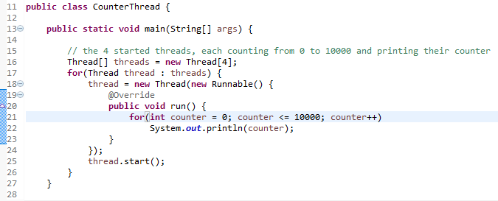

We could see in the console:

*Beginning:*



*A little after…:*



This behavior seems normal: all 4 threads are executing simultaneously, some might execute more than others (and thus count more) during some time lapses, that is why we can observe offsets between the several counters.

**Question 3**

We could verify this by printing the thread numbers:

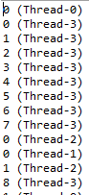

Here Thread-3 is executing more often than other threads, at least at the beginning.

**Question 4**

The call to the *join()* method in the main thread actually caused null pointer exceptions. Therefore we had to switch the data structure from a traditional array to an *ArrayList* for this question:

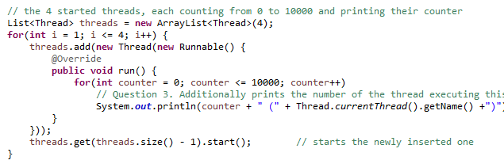

**Question 5**

When running this code:

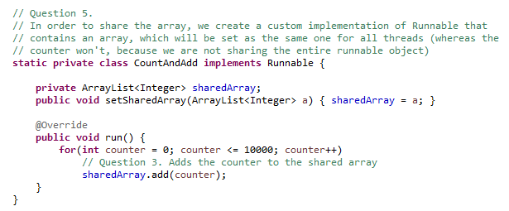

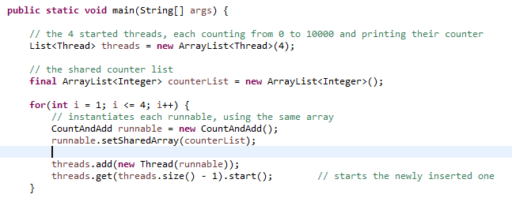

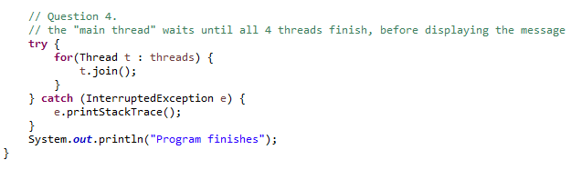

We actually get a different behavior each time. But most of the time we get the following Exception:

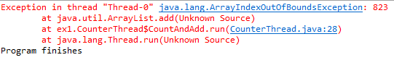

This could be explained by looking at the *ArrayList* class in the API Documentation:



Which states that *ArrayList* operations are **not *thread-safe***, therefore using them with multiple threads at the same time without synchronization causes undefined behavior.

Exercise 5

**Question 2**

Executing the following code:

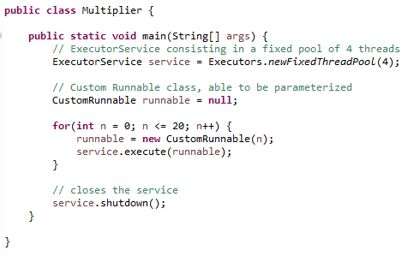

Gives the following result:

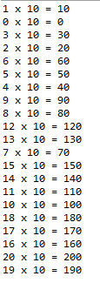

Which shows that the operations have effectively been distributed among the service’s threads (because not always executed in the order that they have been submitted).

Exercise 3

**Question 1**

The provided program will always display *ping* and then *pong*. Indeed, the main thread first starts a new thread, which waits for 2 seconds and then calls *ping()*:

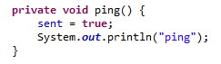

After having launched this thread, the main thread calls *pong()*:

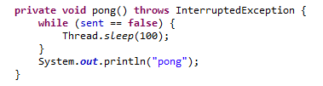

It is practically sure that *pong()* is called before *ping()*, since the thread calling *ping()* previously has to wait for 2 seconds, whereas the main thread does not wait at all.

However, *pong()* waits for *sent* to be *true* before printing *pong*. *sent* being shared between the two methods and only set to true in the *ping()* method, **pong() consequently waits for *ping()* to execute before continuing to process**. That is why *ping* will always be printed before *pong*.

**Remark**: This is not totally true, since *sent* is set to *true* before printing *ping* in the *ping()* method. Therefore it might happen that the *pong()* thread could actually print *pong* before the *ping()* thread prints *ping*. This will also be corrected in Question 3.

**Question 2**

Without the *Thread.sleep()* call in the *pong()* method, the thread would go through the loop **very fast without any interruption**. **This would cause the CPU to highly focus the *pong()* thread, and therefore not executing the others**, including the *ping()* method. **Our program would then be stuck in an infinite loop, because never seeing the *sent* attribute being set to *true***.