Advanced Java  
  
JEE Project – Nursery Web Application

**Members:** Alexandre CASARA |Benoit CHAURAND | Vincent JACOB

**Group:** Mathematics & Java

**Date:** 8th April 2018

Project Mock-up

According to the provided specifications, the aim of this section will be to present what the final web application is expected to look like by the end of the project (provided minor adjustments).

It is specified that the platform should be used by many nurseries, therefore we expect our first page to be a login screen:

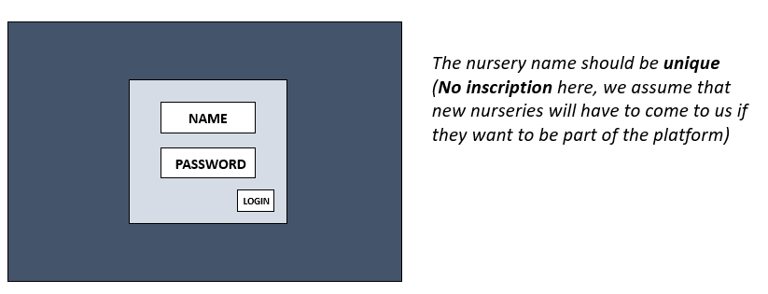

We will expect the login to be the *name* of the nursery. Once being logged in, we could be redirected to an **Attendance** tab:

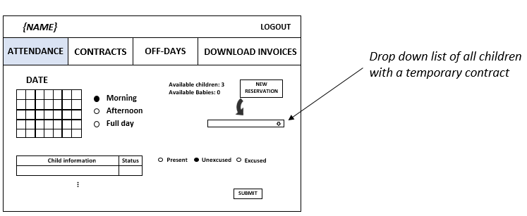

Which would gather all the expected attendances of children and babies for a selected day and half-day (which could at first be the current period).

From this page the nursery’s employees could check children as present, excused or unexcused, as well as try to add a reservation for the selected period, if a relevant place is available for a child/baby.

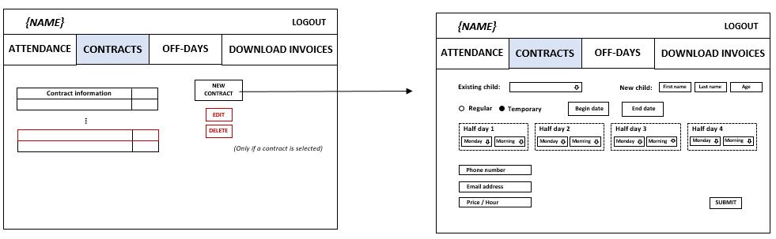Handling of contracts would be done by going to the **Contracts** tab:

Where the employee could see the current contracts, edit or delete ones he selected, or create a new contract by clicking on the corresponding button, which would send him to the page on the right.

From here, the employee will be invited to provide all the relevant information for the contract’s creation, with the possibility to either associate it to an existing child/baby in the database, or to a new one, who will therefore be added to the platform.

To add/delete a new off-day for the nursery, the employee would have to go to the **Off-days** tab:

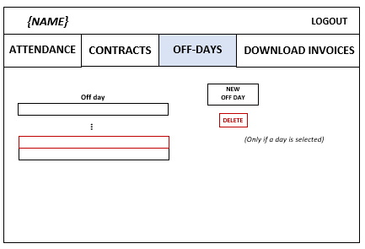

Finally, the employee should be able to download the zip file containing all invoices for a specified month, each one being in PDF format, and associated to a single contract. This could be done through the **Download invoice** tab:

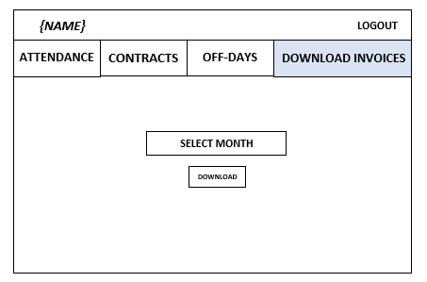

Database design

The entire web application will strongly rely on a relational database, of which we present the MCD diagram as follows:

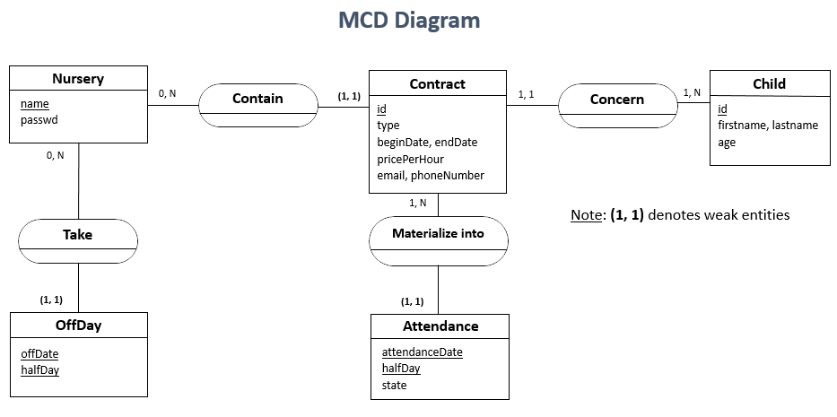

For simplicity, we will here store passwords in plain text, identify each nursery with its name, and consider that every employees of the same nursery have the same rights on the web platform.

The state of an attendance will be limited to the following values:

* “**HERE_REGULAR**”: the child/baby should be here according to its regular contract
* “**ABSCENT_REGULAR**”: the child/baby won’t be here according to its regular contract
* “**BOOKED_TEMPORARY**”: the child/baby has booked, thanks to his temporary contract
* “**CANCELED**”: the booking was cancelled
* “**PRESENT**”: the child/baby was actually here at the corresponding period
* “**EXCUSED**”: the child/baby wasn’t here in the corresponding period, but was excused
* “**UNEXCUSED**”: the child/baby wasn’t here in the corresponding period, without justification

The half-day can also, as expected, have only two values:

* **MORNING**
* **AFTERNOON**

This gives the corresponding MLD diagram, which will allow us to construct the tables:

