# Overview

[DHT temperature & humidity sensors](http://www.adafruit.com/category/35_66), these sensors are very basic and slow, but are great for hobbyists who want to do some basic data logging. The DHT sensors are made of two parts, a capacitive humidity sensor and a [thermistor](http://learn.adafruit.com/thermistor). There is also a very basic chip inside that does some analog to digital conversion and spits out a digital signal with the temperature and humidity. The digital signal is fairly easy to read using any microcontroller.

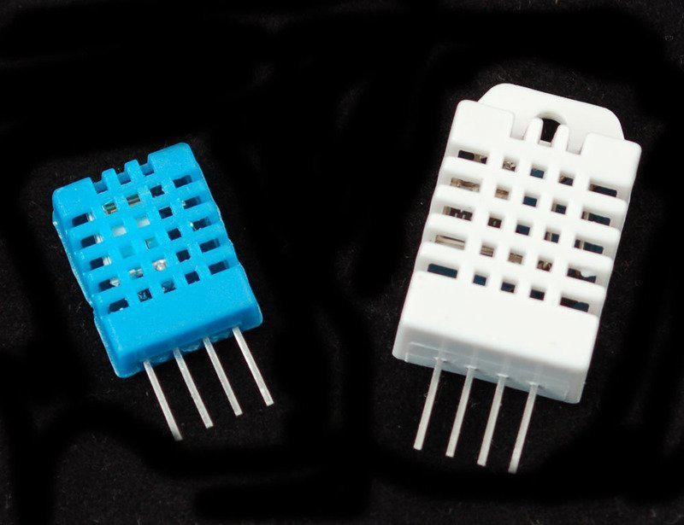

## DHT11 vs DHT22

We have two versions of the DHT sensor, they look a bit similar and have the same pinout, but have different characteristics. Here are the specs:

* Ultra low cost
* 3 to 5V power and I/O
* 2.5mA max current use during conversion (while requesting data)
* Good for 20-80% humidity readings with 5% accuracy
* Good for 0-50°C temperature readings ±2°C accuracy
* No more than 1 Hz sampling rate (once every second)
* Body size 15.5mm x 12mm x 5.5mm
* 4 pins with 0.1" spacing

[DHT22](http://www.adafruit.com/products/385)

* Low cost
* 3 to 5V power and I/O
* 2.5mA max current use during conversion (while requesting data)
* Good for 0-100% humidity readings with 2-5% accuracy
* Good for -40 to 80°C temperature readings ±0.5°C accuracy
* No more than 0.5 Hz sampling rate (once every 2 seconds)
* Body size 15.1mm x 25mm x 7.7mm
* 4 pins with 0.1" spacing

They have four pins

1. VCC - red wire Connect to 3.3 - 5V power. Sometime 3.3V power isn't enough in which case try 5V power.
2. Data out - white or yellow wire
3. Not connected
4. Ground - black wire

**Practical**

Diagram

Sketch→Include Library→Manage Libraries…

Enter “dht” in the search field and look through the list for “DHT sensor library by Ad afruit.” Click the “Install” button, or “Update” from an earlier version.

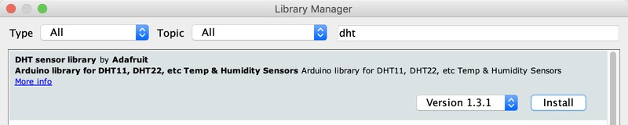

Now load up the Examples→DHT→DHTtester sketch

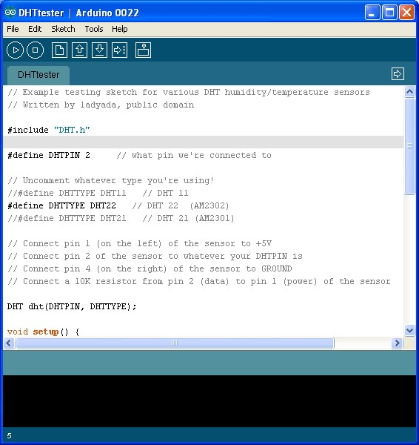

This will make the data appear correctly for the correct sensor. Upload the sketch!

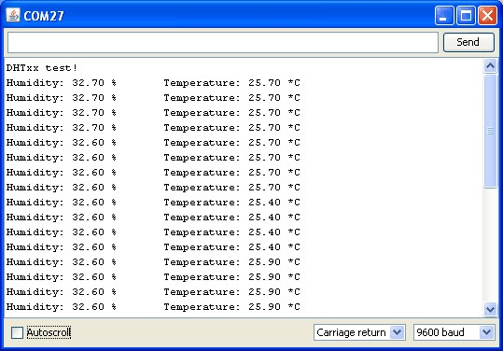

You should see the temperature and humidity. You can see changes by breathing onto the sensor

# Downloads

* [Arduino library and example code for DHT sensors](https://github.com/adafruit/DHT-sensor-library) (https://adafru.it/aJX)
* [Adafruit_Sensor library](https://github.com/adafruit/Adafruit_Sensor) (https://adafru.it/aZm) (required by the DHT library above)
* [DHT11 datasheet](http://www.adafruit.com/datasheets/DHT11-chinese.pdf)  (https://adafru.it/aJY)(in chinese, so see the DHT22 datasheet

too!)

* [DHT22 datasheet](http://www.adafruit.com/datasheets/DHT22.pdf) (https://adafru.it/aJZ)
* [K&R Smith calibration notes](http://www.kandrsmith.org/RJS/Misc/Hygrometers/calib_many.html) (https://adafru.it/BfU)

# Simulator

You can try out a [DHT simulator by Wowki](https://wokwi.com/) (https://adafru.it/N8B) here: [https:// wokwi.com/arduino/libraries/DHT-sensor-librar](https://wokwi.com/arduino/libraries/DHT-sensor-library)