Overview

PIR sensors allow you to sense motion, almost always used to detect whether a human has moved in or out of the sensors range. They are small, inexpensive, lowpower, easy to use and don't wear out. For that reason they are commonly found in appliances and gadgets used in homes or businesses. They are often referred to as PIR, "Passive Infrared", "Pyroelectric", or "IR motion" sensors.

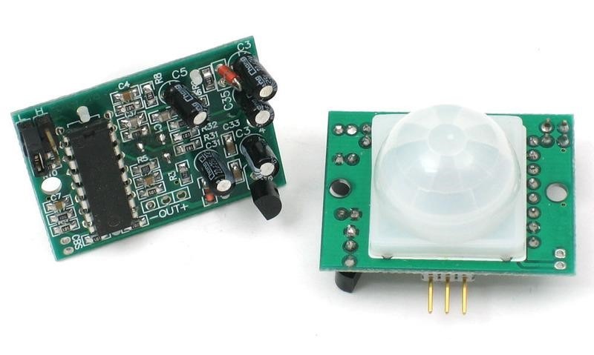

PIRs are basically made of a [pyroelectric sensor](http://en.wikipedia.org/wiki/Pyroelectric) which can detect levels of infrared radiation. Everything emits some low level radiation, and the hotter something is, the more radiation is emitted. The sensor in a motion detector is actually split in two halves. The reason for that is that we are looking to detect motion (change) not average IR levels. The two halves are wired up so that they cancel each other out. If one half sees more or less IR radiation than the other, the output will swing high or low.

Along with the pyroelectic sensor is a bunch of supporting circuitry, resistors and capacitors. It seems that most small hobbyist sensors use the [BISS0001 ("Micro Power](http://learn.adafruit.com/system/assets/assets/000/010/133/original/BISS0001.pdf) [PIR Motion Detector IC")](http://learn.adafruit.com/system/assets/assets/000/010/133/original/BISS0001.pdf) , undoubtedly a very inexpensive chip. This chip takes the output of the sensor and does some minor processing on it to emit a digital output pulse from the analog sensor.

Our older PIRs looked like this:

# **How PIRs Work**

PIR sensors are more complicated than many of the other sensors explained in these tutorials (like photocells, FSRs and tilt switches) because there are multiple variables that affect the sensors input and output. To begin explaining how a basic sensor works, we'll use this rather nice diagram

The PIR sensor itself has two slots in it, each slot is made of a special material that is sensitive to IR. The lens used here is not really doing much and so we see that the two slots can 'see' out past some distance (basically the sensitivity of the sensor).

When the sensor is idle, both slots detect the same amount of IR, the ambient amount radiated from the room or walls or outdoors. When a warm body like a human or animal passes by, it first intercepts one half of the PIR sensor, which causes a positive differential change between the two halves. When the warm body leaves the sensing area, the reverse happens, whereby the sensor generates a negative differential change. These change pulses are what is detected.

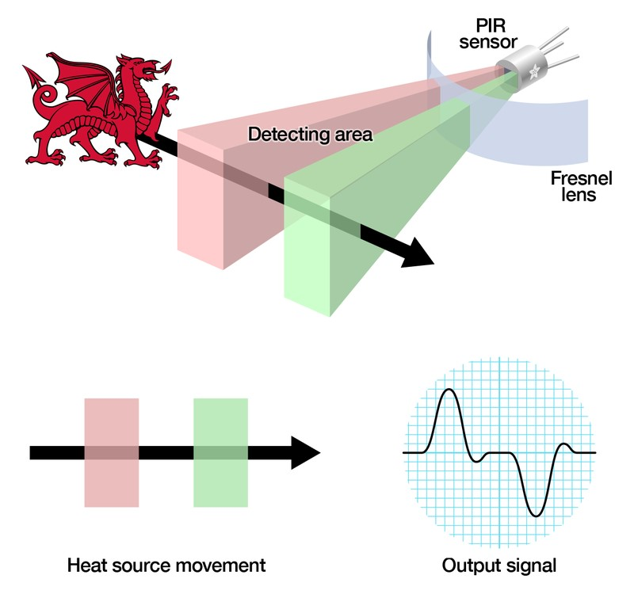

## The PIR Sensor

The IR sensor itself is housed in a hermetically sealed metal can to improve noise/ temperature/humidity immunity. There is a window made of IR-transmissive material (typically coated silicon since that is very easy to come by) that protects the sensing element. Behind the window are the two balanced sensors.

