# Introduction to Ultrasonic Sensor

Ultrasonic sensors work by emitting sound waves at a frequency which is too high for humans to hear.

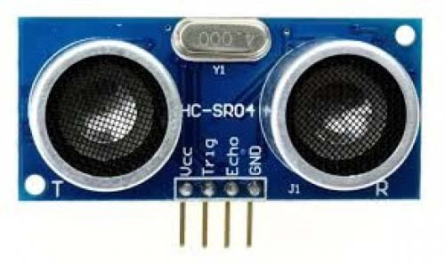

An above image shows the [**HC-SR-04 ultrasonic sensor**](https://robu.in/product/hc-sr04-ultrasonic-range-finder/) which has transmitter, receiver. The pin configuration is,

* **VCC** – +5 V supply
* **TRIG** – Trigger input of sensor. Microcontroller applies 10 us trigger pulse to the HC-SR04 ultrasonic module.
* **ECHO**–Echo output of sensor. Microcontroller reads/monitors this pin to detect the obstacle or to find the distance.
* **GND** – Ground

Sound is a mechanical wave traveling through the mediums, which may be a solid, or liquid or gas. Sound waves can travel through the mediums with specific velocity depends on the medium of propagation. The sound waves which are having high frequency reflect from boundaries and produce distinctive echo patterns.

## Features of an Ultrasonic Sensor

1. Supply voltage: 5V (DC).
2. Supply current: 15mA.
3. Modulation frequency: 40Hz.
4. Output: 0 – 5V (Output high when obstacle detected in range).
5. Beam Angle: Max 15 degrees.
6. Distance: 2 cm – 400 cm.
7. Accuracy: 0.3cm.
8. Communication: Positive TTL pulse.

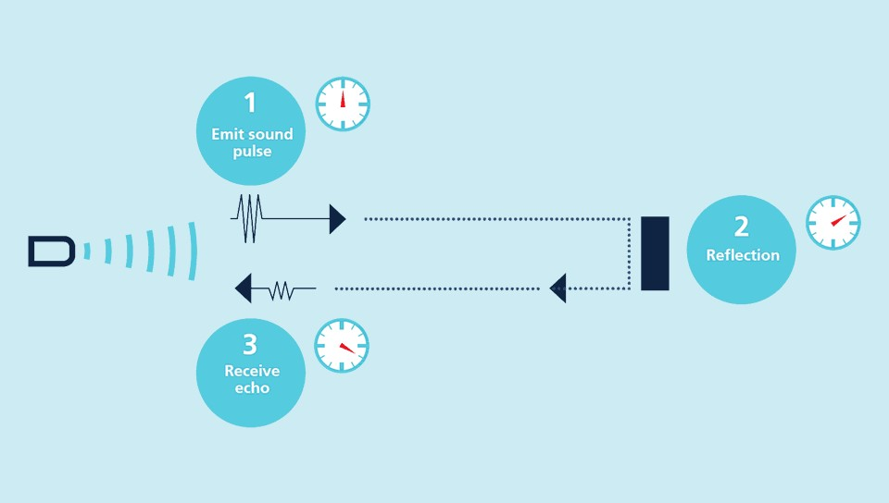

# Ultrasonic Sensor Working Principle

Ultrasonic sensors emit short, high-frequency sound pulses at regular intervals. These propagate in the air at the velocity of sound. If they strike an object, then they reflected back as an echo signals to the sensor, which itself computes the distance to the target based on the time-span between emitting the signal and receiving the echo.

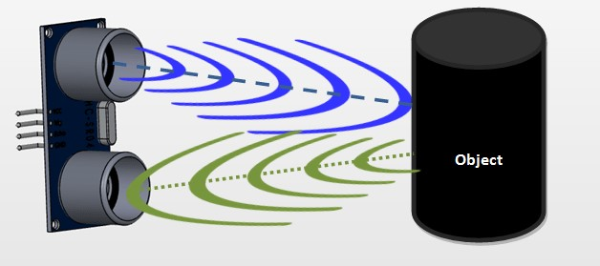

An [**ultrasonic sensors**](https://robu.in/product-category/sensor/ultrasonic-sensor/) are excellent at suppressing background interference. Virtually all materials which reflect sound can be detected, regardless of their colour. Even transparent materials or thin foils represent no problem for an ultrasonic sensor.

microsonic ultrasonic sensors are suitable for target distances from 20 mm to 10 m and as they measure the time of flight they can ascertain a measurement with pinpoint accuracy. Some of our sensors can even resolve the signal to an accuracy of 0.025 mm. Ultrasonic sensors can see through dust-laden air and ink mists. Even thin deposits on the sensor membrane do not impair

How to calculate Distance?

If you need to measure the specific distance from your sensor, this can be calculated based on this formula:

We know that, **Distance= Speed* Time.** The speed of [sound waves](https://en.wikipedia.org/wiki/Sound) is 343 m/s. So,

**Total Distance= (343 * Time of hight(Echo) pulse)/2**

Total distance is divided by 2 because signal travels from HC-SR04 to object and returns to the module HC-SR-04.

# Applications of an Ultrasonic Sensor

* It Uses to avoid and detect obstacles with robots like biped robot, obstacle avoider robot, [path finding robot](https://robu.in/non-looped-maze-solving-robot-with-mc40a/) etc.
* It Used to measure the distance within a wide range of 2cm to 400cm.
* Used to map the objects surrounding the sensor by rotating it.
* Depth of certain places like wells, pits etc can be measured since the waves can penetrate through water.