**CHAROTAR UNIVERSITY OF SCIENCE & TECHNOLOGY**

**DEVANG PATEL INSTITUTTE OF ADVANCE TECHNOLOGY AND RESEARCH**

**IT250 / CE252 DIGITAL ELECTRONICS**

**ASSIGNMENT OF CHAPTER 6**

**1.** A sequential circuit with Two D flip-flops, A and B; Two Inputs X & Y; and One Output Z, specified by the following Next State & Output Equations:

A ( t + 1 ) = X' Y + X A

B ( t + 1 ) = X' B + X A

Z = B

(a) Draw the logic diagram of the circuit

(b) Derive the State Table

(c) Derive the State Diagram

**2.** A sequential circuit has Three D flip-flops A, B & C. and One Input X. It is described by the following flip-flop input functions:

DA = ( B C' + B' C ) X + ( B C + B' C' ) X'

DB = A

DC = B

(a) Derive the State Table for the circuit

(b) Derive the State Diagram

**3.** A sequential circuit has One flip-flop, Q; Two Inputs X & Y; and One Output S. It consists of a Full Adder circuit connected to a D flip-flop as shown in below figure. Derive the State Table & State Diagram of the Sequential Circuit.

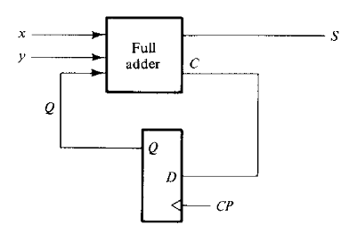

**4.** Derive the State Table & State Diagram of the sequential circuit shown in below figure.

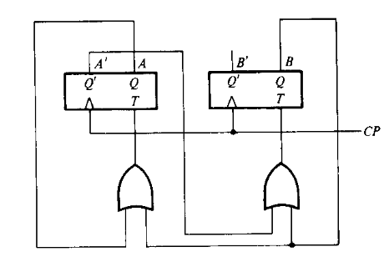

**5.** A sequential circuit has Two JK flip-flops; One Input X ; and One Output Y. Derive the State Table & State Diagram of the sequential circuit shown in below figure.

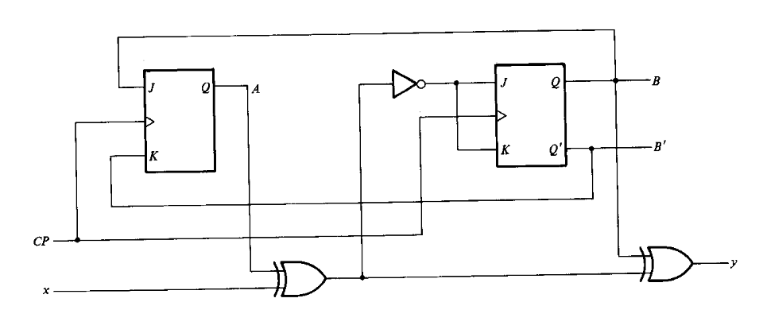

**6.** A sequential circuit has Two JK flip-flops A & B; Two Inputs X & Y; and One Output Z. It is described by the following flip-flop input functions:

JA = ( B X + B' Y' ) KA = ( B' X Y' )

JB = ( A' X ) KB = A + ( X Y' )

Z = ( A X Y + B X' Y' )

(a) Derive the State Table for the circuit

(b) Derive the State Diagram

**7.** Draw the State Diagram for the following State Table. Also reduce the numbers of the states of the State Table. TABULATE REDUCED STATE TABLE & DRAW THE REDUCED STATE DIAGRAM OF IT.

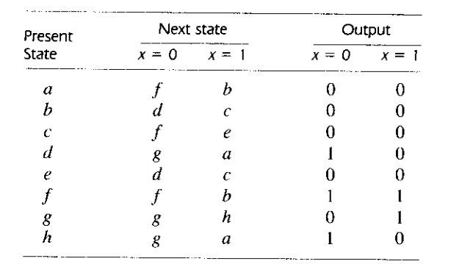

**8.** Analyze the circuit shown below & prove that it is equivalent to a T Flip-Flop.

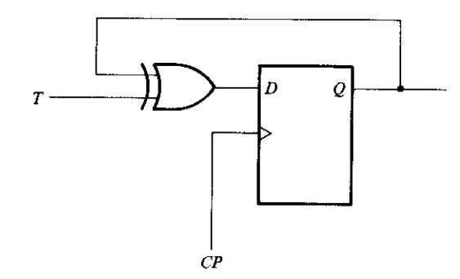

**9.** Design a sequential circuit with Two JK Flip-Flops A & B; and Two Inputs E & X; and One Output Y. If E = 0, The circuits remain in the same state regardless of Input X. When E = 1 & X = 1, the circuit goes through the state transitions from 00 to 01 to 10 to 11 back to 00 and repeats. When E = 1 & X = 0, the circuit goes through the state transitions from 00 to 11 to 10 to 01 back to 00 and repeats.

**10.** A sequential circuit has Three flip-flops A, B & C; One Input X; and One Output Y. The state diagram is as shown below.

(a) Design the Sequential Circuit using D Flip-Flops

(b) Design the Sequential Circuit using JK Flip-Flops

CONSIDER UNUSED STATES AS DON'T C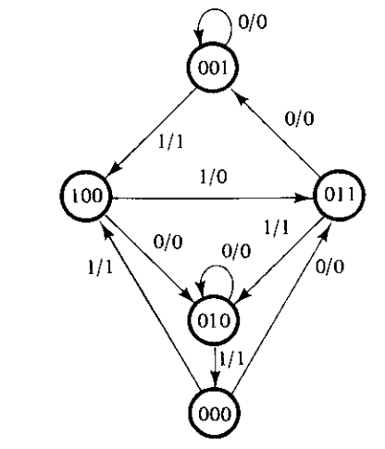

**11**. Design 4-bit Binary counter using JK Flip-flop

**12.** Design BCD counter using D Flip-flop

**13.** Design mod-4 counter using T Flip-flop

**14.** Design Decimal counter using SR Flip-flop