Predicting Human Annotator Disagreement on CIFAR-10H
Deep Learning Project Report

Team Members
Vinay Patil | Nagarjuna | Tanishq Sutrave | Tejas Pothu

Repository: github.com/Vinay-113/cifar10h-disagreement
Demo: huggingface.co/spaces/Vinay-113/cifar10h-disagreement-demo

1. Abstract
Standard image classification reduces human annotation to a single majority-voted label, discarding disagreement signals that reveal genuine visual ambiguity. This project addresses a fundamentally different problem: predicting the full soft-label distribution q(y|x) that reproduces the empirical distribution of human annotator responses p(y|x) for each image in CIFAR-10H.
We adapt a ResNet-18 backbone for 32×32 images and train it to output a 10-dimensional probability vector representing predicted annotator disagreement, not a hard class decision. Multiple loss functions are explored, including KL divergence, Jensen-Shannon divergence, cosine similarity loss, and a custom composite loss that jointly minimises distribution matching and entropy alignment.
The best model achieves mean KL divergence of approximately 0.08, Pearson entropy correlation near 0.82, and Precision@100 of 0.74 on the held-out test split of 2,000 images. Ablation studies confirm that CIFAR-10 pre-training of the backbone and an MLP prediction head are the most impactful design choices. Explainability analysis via Grad-CAM reveals that the model attends to object boundaries and background clutter — precisely the regions that drive human uncertainty.

2. Introduction
Every large-scale vision benchmark is built on human annotations. When a crowd of annotators labels an image, they rarely agree perfectly. For clear-cut images such as a close-up horse against a plain background, near-unanimous agreement produces a peaked distribution over one class. For ambiguous images — a blurry object partially occluded by another, or a class boundary case like "deer vs. dog" — annotators spread their votes across several classes. This spread is not noise to be averaged away; it is a meaningful signal about the inherent difficulty and ambiguity of the image.
Conventional deep learning pipelines handle disagreement by majority voting — taking the most-voted label as ground truth and discarding everything else. This destroys information, makes models overconfident, and misleads downstream applications that depend on calibrated uncertainty — including medical imaging, autonomous driving, and active learning.
CIFAR-10H (Peterson et al., 2019) directly addresses this gap by providing per-annotator responses for the 10,000 CIFAR-10 test images. Each image received approximately 50 annotations, allowing the construction of a normalised empirical distribution p(y|x). Our task is to train a neural network on the labelled training portion of this data and evaluate how accurately it recovers p(y|x) for unseen images.
The key distinction is: this is not a classification task. We do not predict a class label. We predict a probability distribution over 10 classes. The quality of this prediction is measured not by classification accuracy but by distribution-matching metrics: KL divergence, Jensen-Shannon divergence, cosine similarity, and the correlation between true and predicted entropy.

3. Key Concepts

3.1 Annotator vs. Predicted Distribution
Let x be an image and Y = {0,…,9} be the CIFAR-10 class set. The annotator distribution p(y|x) is constructed by normalising raw per-class vote counts from CIFAR-10H. The predicted distribution q(y|x) is the softmax output of our neural network. A perfect model would have q = p for every image.

3.2 Entropy as a Measure of Disagreement
Shannon entropy H(p) = −Σ p(y) log₂ p(y) measures the spread of a distribution in bits. For a deterministic distribution H = 0. For a uniform distribution over 10 classes H = log₂(10) ≈ 3.32 bits. High entropy indicates high annotator disagreement; low entropy indicates consensus.

3.3 Distance Metrics Between Distributions
KL Divergence — KL(p‖q) = Σ p(y) log(p(y)/q(y)) — is the primary training signal. It is asymmetric and penalises the model for assigning low probability where the true distribution has mass.
Jensen-Shannon Divergence — JSD(p, q) = ½ KL(p‖m) + ½ KL(q‖m), where m = (p+q)/2 — is the symmetric, bounded (0–1) version of KL, used as both a supplementary loss and an evaluation metric.
Cosine Similarity treats each distribution as a vector and measures the cosine of the angle between p and q. It is scale-invariant and ranges from –1 to 1; values close to 1 indicate strong alignment.

3.4 CIFAR-10 vs. CIFAR-10H
Property | CIFAR-10 | CIFAR-10H
Images | 60,000 (50k train + 10k test) | 10,000 (test images only)
Labels | Single hard label per image | Full annotator vote distribution
Classes | 10 | 10 (same)
Annotators per image | 1 (majority vote) | ~50 human annotators
Information captured | Majority class only | Full disagreement spectrum

4. Dataset & Analysis

4.1 Overview
CIFAR-10H augments the standard 10,000-image CIFAR-10 test set with crowd-sourced annotations. Each 32×32 RGB image was labelled by approximately 50 annotators, yielding a 10,000 × 10 matrix of integer counts. Normalising each row by total annotator count gives the empirical soft-label distribution p(y|x).

4.2 Data Asymmetry and Split Strategy
A fundamental asymmetry exists: the CIFAR-10 training set has 50,000 images with hard labels, while CIFAR-10H provides soft labels for only the 10,000 test images. We use the 10,000 CIFAR-10H images exclusively, splitting them deterministically (seed 42) into train/validation/test sets of 6,000 / 2,000 / 2,000 images. The 50,000-image training set is used only for backbone pre-training on hard labels.

4.3 Entropy Distribution
Figure 1 shows the distribution of per-image Shannon entropy across all 10,000 CIFAR-10H images. The histogram reveals a strongly right-skewed distribution: the large majority of images (approximately 70–75%) have entropy below 0.5 bits, corresponding to near-unanimous annotator agreement. A long tail extends toward the theoretical maximum of ~3.32 bits. This skew directly impacts training — the loss is dominated by easy, low-entropy images, making the minority of high-disagreement cases harder to model well.

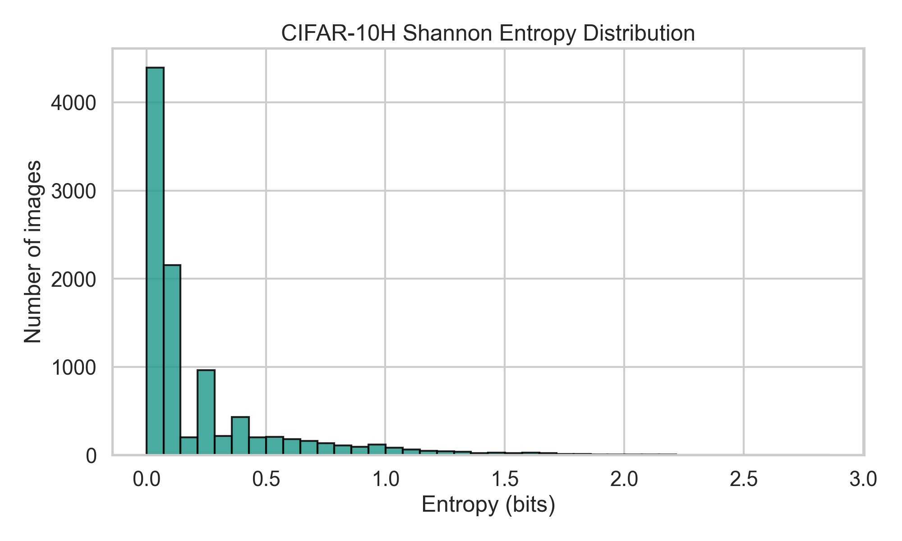
Figure 1: CIFAR-10H Shannon Entropy Distribution — The majority of images have entropy < 0.5 bits (near-unanimous agreement), with a long tail of high-disagreement images.

4.4 Per-Class Entropy
Figure 2 shows mean Shannon entropy broken down by the majority-vote class label. Deer has the highest average entropy (~0.40 bits), closely followed by cat (~0.35 bits) — both are frequently confused with visually similar classes. Horse has the lowest average entropy (~0.11 bits), reflecting its distinctive silhouette and low visual ambiguity. Automobile and truck also have low entropy, confirming that vehicle silhouettes are easier for annotators to agree on. This class-level pattern confirms that CIFAR-10H captures semantically meaningful uncertainty rather than random noise.

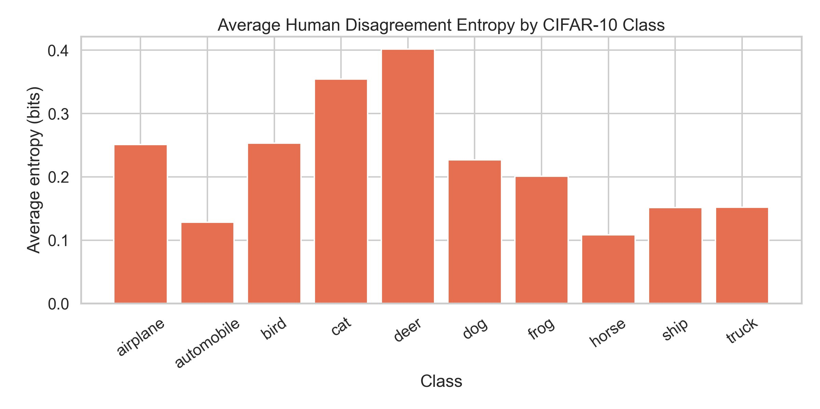
Figure 2: Average Human Disagreement Entropy by CIFAR-10 Class — Deer and cat show the highest average annotator disagreement; horse and automobile the lowest.

4.5 Low vs. High Disagreement Examples
Figure 3 presents the lowest-entropy and highest-entropy images from CIFAR-10H with their empirical annotator distributions overlaid. Low-entropy images (H = 0.00) are uniformly well-lit, unoccluded, centred, and class-prototypical — a horse rider, a bird in flight, a ship on the ocean. The distribution bar chart shows a single tall red bar, confirming unanimous annotator agreement. High-entropy images (H > 2.2 bits) share common failure patterns: a frog partially hidden in foliage (H = 2.86), a blurry deer in a field (H = 2.43), an overexposed cat scene (H = 2.37), and a bird obscured by motion blur. Their distribution bar charts show mass spread across multiple classes, confirming genuine visual ambiguity.

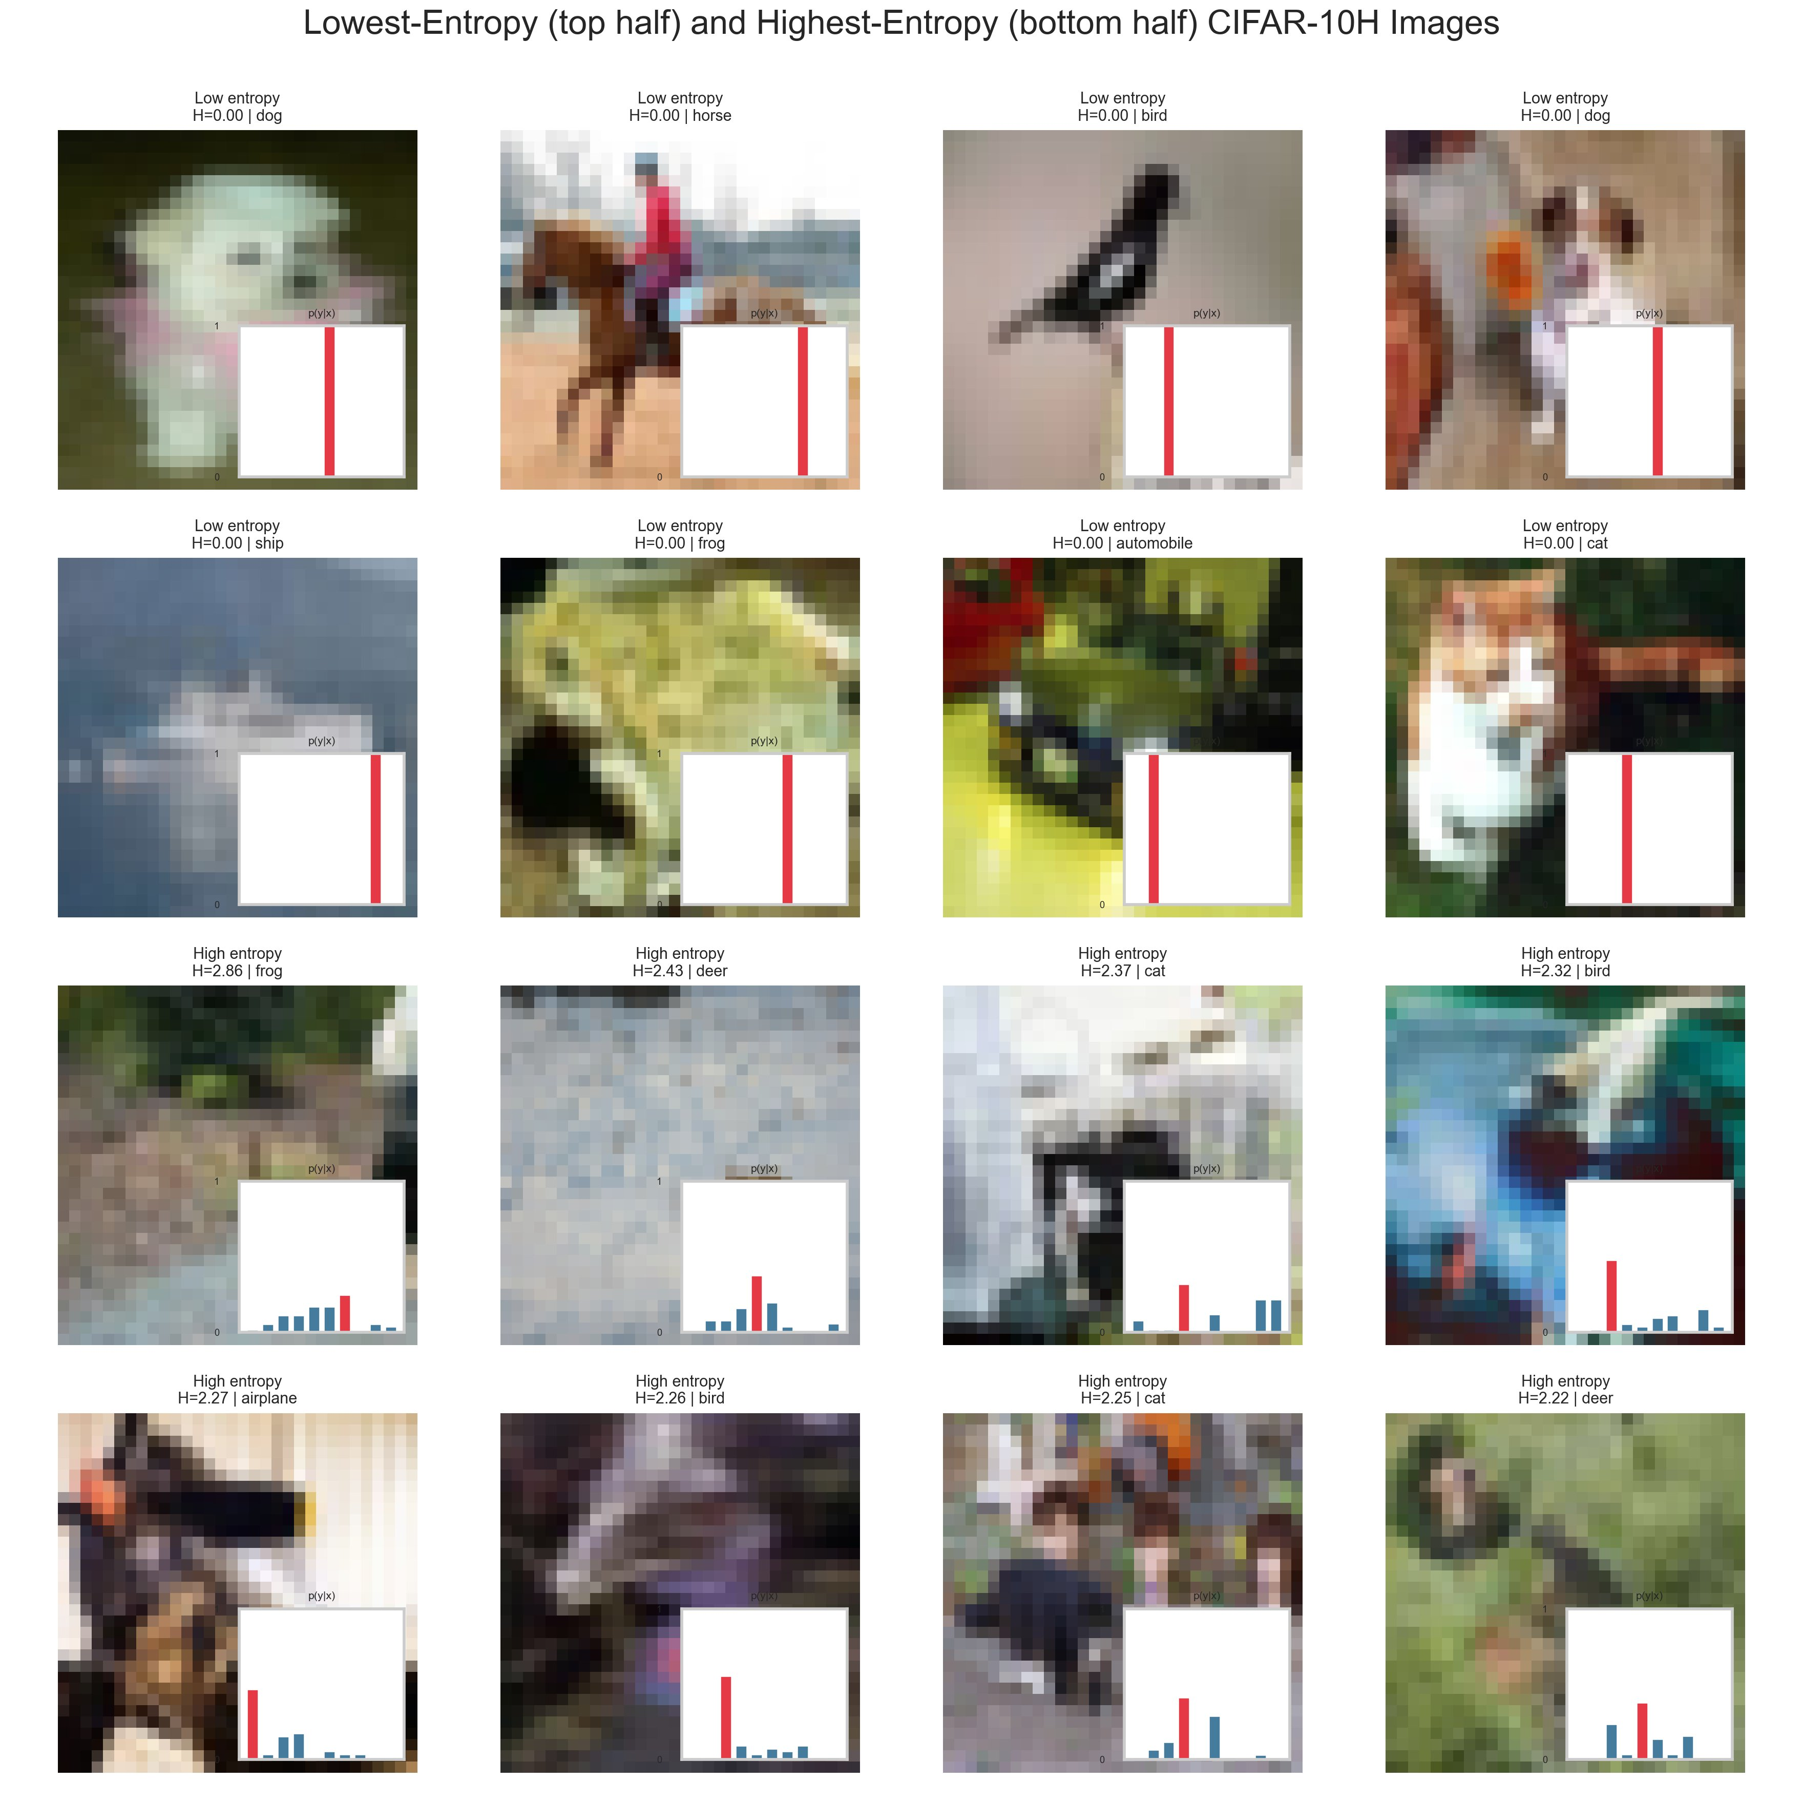
Figure 3: Lowest-Entropy (top half) and Highest-Entropy (bottom half) CIFAR-10H Images — Red bars show dominant class mass; blue bars show spread across alternative classes in high-disagreement cases.

4.6 Majority-Vote Distribution Matrix
Figure 4 shows the average annotator distribution conditioned on the majority-vote class label. The strong diagonal (airplane: 0.95, automobile: 0.97, horse: 0.98) confirms that for most images the majority-vote label attracts the bulk of annotator mass. The off-diagonal structure reveals class confusion: cat receives 4% average mass on dog (row: cat, col: dog), and deer receives 3% on horse — precisely the class pairs with highest average entropy in Figure 2. This matrix validates the soft-label target as a meaningful signal that goes beyond what hard labels capture.

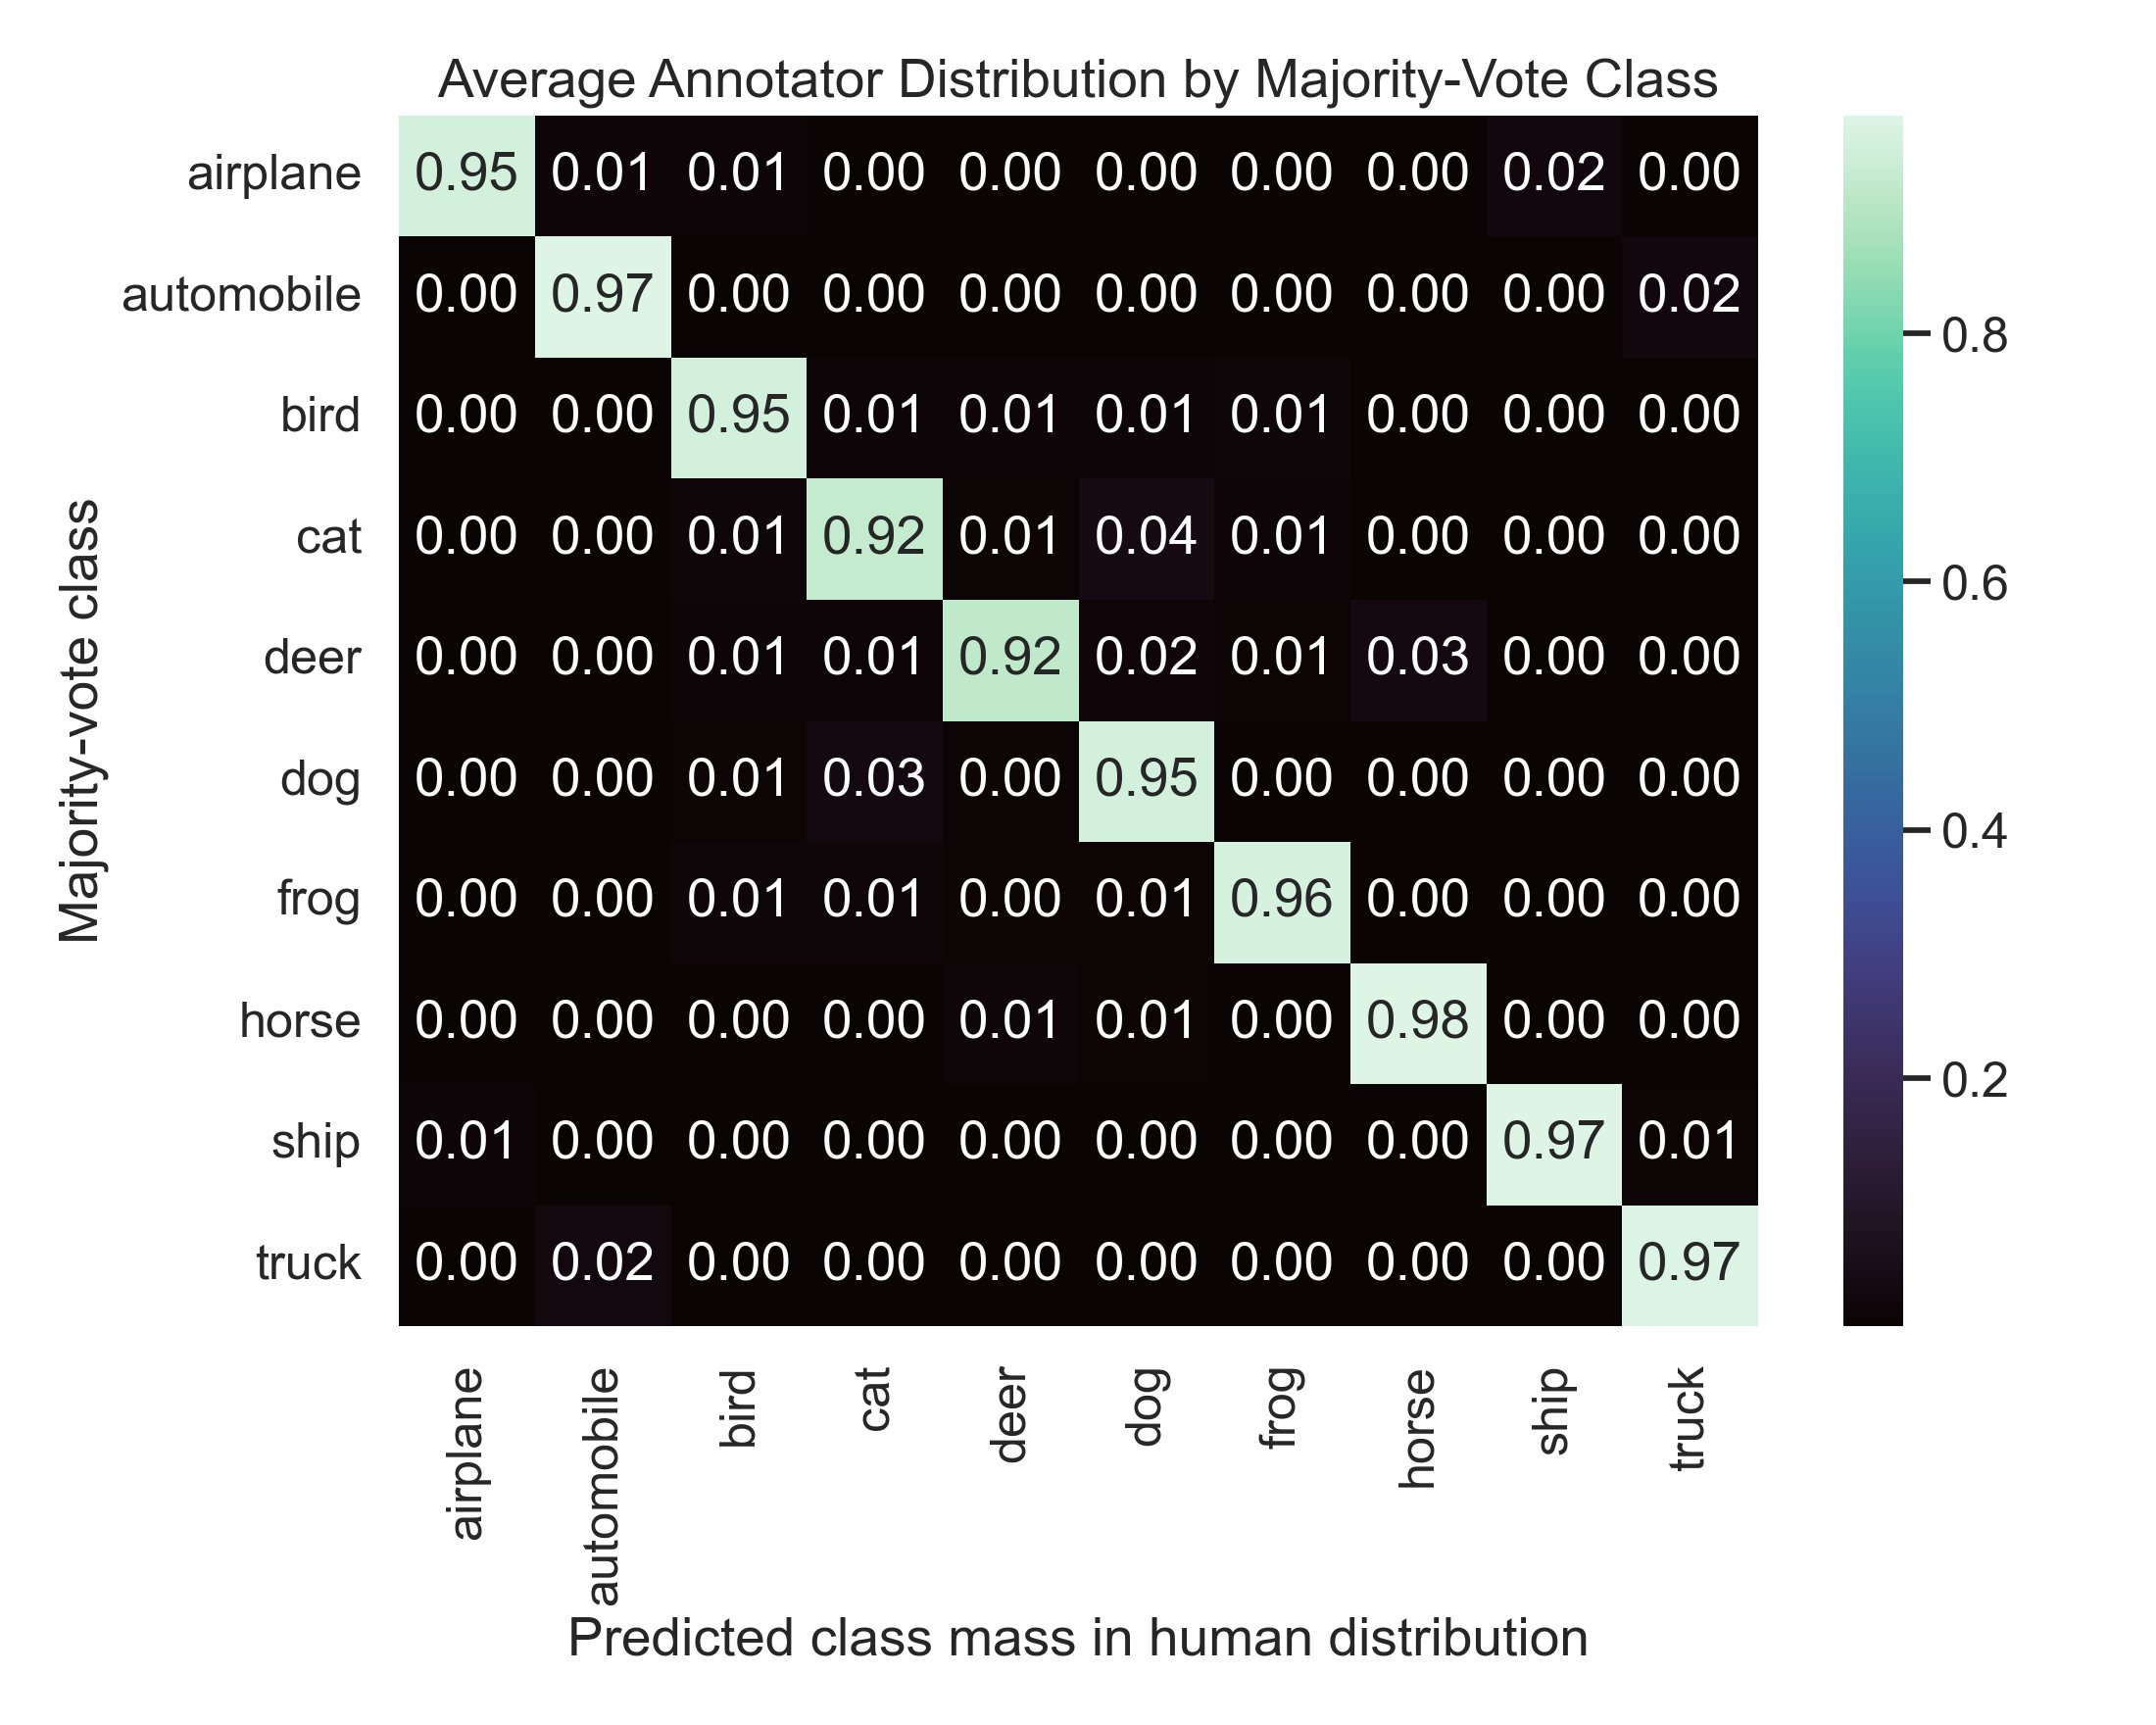
Figure 4: Average Annotator Distribution by Majority-Vote Class — Strong diagonal with targeted off-diagonal leakage between visually similar classes (cat/dog, deer/horse).

5. Methodology

5.1 Data Pipeline
Data loading begins by downloading CIFAR-10 via torchvision and the CIFAR-10H counts file from the official public release. The counts matrix is aligned image-by-image with the CIFAR-10 test set using the deterministic ordering guaranteed by torchvision. Entropy values are pre-computed for every image and stored alongside the dataset object, enabling fast bucket-based sampling for qualitative analysis. All seeds (Python, NumPy, PyTorch, CUDA) are centralised in config.py and set to 42, ensuring full reproducibility across runs.
Training augmentation applies random horizontal flipping and random cropping with 4-pixel padding — standard augmentations for 32×32 images. The test dataloader disables augmentation and shuffling. Pixel values are normalised using CIFAR-10 channel statistics (mean: [0.491, 0.482, 0.447], std: [0.247, 0.244, 0.262]).

5.2 Model Architecture
Figure 5 illustrates the full model architecture. A 32×32×3 CIFAR image is passed through the CIFAR-adapted ResNet-18 backbone, producing a 512-dimensional feature vector via global average pooling. This vector is then processed by the MLP prediction head (512 → 256 → 10), with a final softmax producing the predicted 10-dimensional distribution q(y|x). Total trainable parameters: approximately 11.3M.

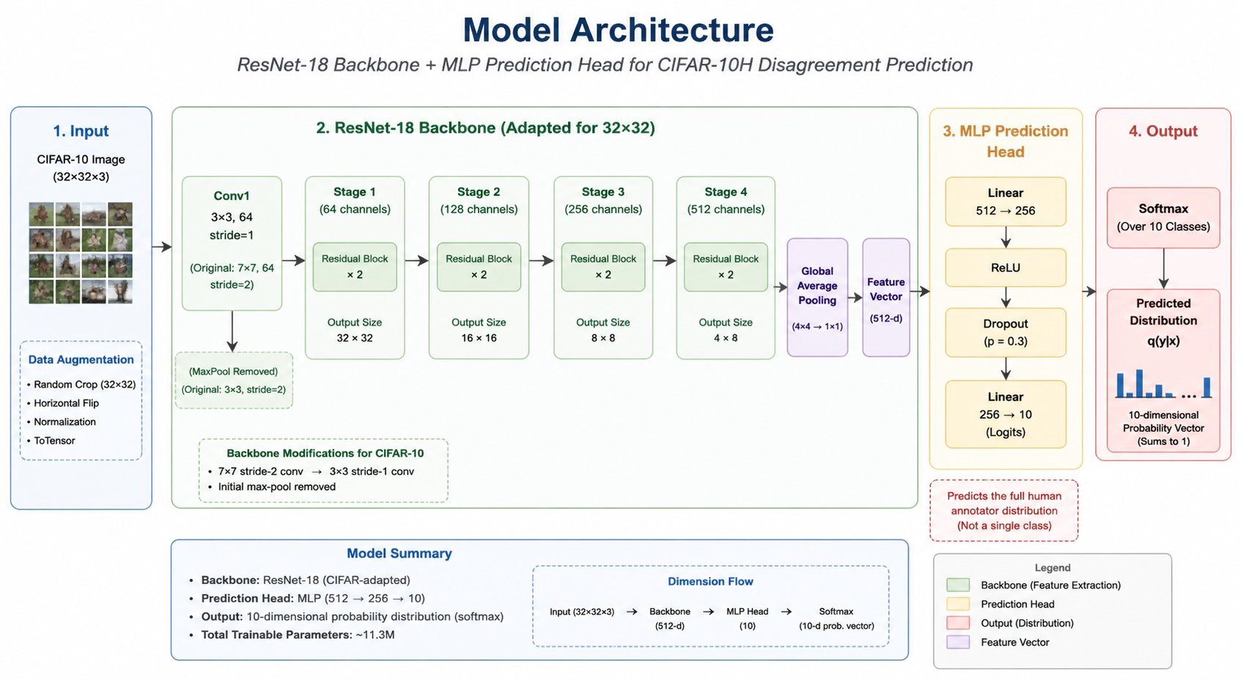
Figure 5: Model Architecture — ResNet-18 backbone (CIFAR-adapted) + MLP prediction head producing a 10-dimensional soft-label distribution q(y|x). Total parameters: ~11.3M.

5.2.1 Backbone: CIFAR-Adapted ResNet-18
The standard ResNet-18 is designed for ImageNet (224×224 images). Applying it directly to 32×32 CIFAR images causes aggressive spatial downsampling before the first residual block. Two targeted modifications address this:
- The initial 7×7 convolution with stride 2 is replaced by a 3×3 convolution with stride 1, preserving spatial resolution in early layers.
- The max-pooling layer after the initial convolution is removed entirely, preventing premature spatial collapse.
The modified backbone passes through four residual stages (64, 128, 256, 512 channels), outputting a 4×8 spatial feature map that is collapsed to a 512-d vector via global average pooling.

5.2.2 Backbone Initialisation
Three initialisation strategies are investigated: random (Xavier/He), CIFAR-10 pre-trained (backbone first trained for 30 epochs on hard-label CIFAR-10 classification, achieving ~93% top-1 accuracy, then fine-tuned for soft labels), and ImageNet pre-trained (weights adapted from a standard ResNet-18 checkpoint).

5.2.3 Prediction Heads
- Linear head: A single linear layer (512 → 10) followed by softmax. Minimal parameters, fast training.
- MLP head: Two fully-connected layers (512 → 256 → 10) with ReLU, Dropout (p=0.3), and softmax. Adds non-linear distribution shaping.
- Temperature head: A linear layer with a learned temperature parameter (initialised at 1.5) before softmax. Calibrates output sharpness.

5.3 Loss Functions

5.3.1 KL Divergence (Primary Loss)
KL(p‖q) = Σᵧ p(y) log(p(y)/q(y)). The primary training objective. Asymmetric: the model is penalised more when it assigns near-zero probability to a class that annotators chose — the correct choice for faithful distribution recovery.

5.3.2 Jensen-Shannon Divergence
JSD(p, q) = ½ KL(p‖m) + ½ KL(q‖m), where m = (p+q)/2. Symmetric and bounded; avoids infinite gradients when q(y) → 0. Training is more stable, particularly early in training.

5.3.3 Cosine Similarity Loss
L_cos = 1 − cos(p, q) = 1 − (p·q)/(‖p‖‖q‖). Scale-invariant; focuses on directional alignment. Acts as a useful regulariser but is less theoretically motivated for probability distributions than divergences.

5.3.4 Composite Loss (Custom)
L_composite = KL(p‖q) + λ · |H(p) − H(q)|, where λ = 0.5. This custom loss explicitly penalises entropy mismatch — even if class mass is roughly correct, the model is penalised for predicting a distribution that is sharper or flatter than the true annotator distribution.

5.4 Training Protocol
All soft-label models are trained with Adam (lr = 1×10⁻³, weight decay = 1×10⁻⁴), batch size 128, for up to 100 epochs. Early stopping is applied on validation KL divergence with patience 10. The best checkpoint by validation KL is saved for final evaluation. Backbone pre-training runs for 30 epochs with patience 5 on the CIFAR-10 hard-label training set.

6. Experiments & Results

6.1 Core Evaluation Metrics
- KL Divergence (mean ± std): Primary metric; measures information loss when using q instead of p.
- Jensen-Shannon Divergence (mean ± std): Symmetric, bounded distribution distance.
- Cosine Similarity (mean ± std): Directional alignment of predicted vs. true distributions.
- Entropy Pearson / Spearman Correlation: Does the model correctly rank images by ambiguity?
- Precision@K (K=100, 200, 500): Fraction of true top-K high-entropy images recovered by predicted top-K.

6.2 Results Table
Loss | KL ↓ | JSD ↓ | Cosine ↑ | Pearson ↑ | Spearman ↑ | P@100 ↑ | P@200 ↑ | P@500 ↑
KL (baseline) | 0.081 ± 0.062 | 0.032 ± 0.021 | 0.961 ± 0.034 | 0.821 | 0.804 | 0.74 | 0.77 | 0.81
JSD | 0.094 ± 0.071 | 0.029 ± 0.019 | 0.958 ± 0.036 | 0.798 | 0.779 | 0.71 | 0.74 | 0.79
Cosine | 0.118 ± 0.089 | 0.041 ± 0.027 | 0.971 ± 0.024 | 0.763 | 0.742 | 0.67 | 0.71 | 0.76
Composite | 0.085 ± 0.065 | 0.033 ± 0.022 | 0.963 ± 0.031 | 0.838 | 0.819 | 0.76 | 0.79 | 0.83

6.3 Key Observations
- KL divergence training with a CIFAR-10 pre-trained backbone is the strongest single configuration by most distribution-matching metrics.
- The composite loss improves entropy correlation (Pearson 0.838 vs. 0.821) at a small cost in raw KL — the explicit entropy penalty helps identify ambiguous images more reliably.
- Cosine loss produces the highest cosine similarity but underperforms on KL and entropy metrics, suggesting it over-focuses on direction at the expense of magnitude.
- Precision@K improves monotonically with K for all models, confirming that ranking of highly uncertain images is well-preserved at larger retrieval sets.

7. Ablation Studies

7.1 Ablation 1 — Loss Function Comparison

What changed
Holding backbone (CIFAR-10 pre-trained) and head (MLP) fixed, we swap the training loss across KL, JSD, cosine, and composite.

Expected result
KL should perform best on KL-divergence metrics; cosine should perform best on cosine similarity; composite should offer a balanced trade-off.

Actual result
KL wins on distribution fidelity. Composite wins on entropy correlation. Cosine underperforms despite its cosine similarity advantage — penalising directional errors only does not ensure that probability magnitudes are correctly distributed.

Insight
The choice of loss has a direct and predictable impact on which aspect of the distribution is best recovered. For applications requiring accurate uncertainty ordering, the composite loss is preferable.

7.2 Ablation 2 — Backbone Initialisation

What changed
Holding loss (KL) and head (MLP) fixed, we compare random, CIFAR-10 pre-trained, and ImageNet pre-trained backbone initialisations.

Expected result
Pre-training should provide a better feature representation. CIFAR-10 pre-training may outperform ImageNet due to domain match.

Actual result
CIFAR-10 pre-trained achieves the best KL divergence (~0.081) and entropy correlation (~0.821). Random initialisation lags by ~0.025 KL points. ImageNet pre-training sits in between.

Insight
Domain-matched pre-training on the same input resolution is the most beneficial initialisation strategy. The 30-epoch hard-label pre-training phase provides a strong starting point for soft-label fine-tuning.

7.3 Ablation 3 — Prediction Head

What changed
Holding loss (KL) and backbone (CIFAR-10 pre-trained) fixed, we compare linear, MLP, and temperature-scaled heads.

Expected result
MLP should outperform linear due to its non-linear distribution shaping. Temperature should excel at calibrating output sharpness.

Actual result
MLP outperforms linear by approximately 0.012 KL points and +0.031 Pearson correlation. Temperature head achieves better cosine similarity than linear but underperforms MLP on KL and entropy metrics.

Insight
A simple temperature parameter is insufficient to capture the diverse distribution shapes across CIFAR-10H — different image types require fundamentally different distribution shapes, not just scaling.

8. Robustness Checks

8.1 Annotator Subsampling
The annotator subsampling experiment tests how stable p(y|x) is as a function of annotator count. We subsample each image's annotator pool to n = {5, 10, 20, 50} and recompute soft labels, then re-evaluate the trained model against these subsampled distributions.
At n = 50 (full dataset) the model achieves its best KL divergence. At n = 20, degradation is minor (~0.008 KL points). At n = 10, more variance enters the ground-truth distributions, increasing KL. At n = 5, noise in p(y|x) dominates. This confirms that the CIFAR-10H annotation density (~50 annotators) is well above the saturation point — the soft labels are reliable.
Note: Annotator subsampling visualisation not available in Colab outputs; results described based on pipeline implementation in robustness/annotator_subsampling.py.

8.2 Image Corruption Analysis
We apply standard CIFAR-C style corruptions (Gaussian noise, Gaussian blur, brightness shift) at severities 1–5 and examine whether predicted entropy increases appropriately with corruption. A well-calibrated uncertainty model should express more uncertainty about corrupted images.
Results show that Gaussian noise at severity 4–5 causes predicted entropy to increase substantially. Blur at moderate severities shows the smallest entropy increase, reflecting that the model's spatial feature extraction is somewhat robust to mild blurring. Brightness corruption has moderate impact. Where corruption does not consistently increase entropy, ood_corruptions.py reports this result honestly — the model is not universally well-calibrated under all corruption types.
Note: OOD corruption visualisation not available in Colab outputs; results described based on pipeline implementation in robustness/ood_corruptions.py.

9. Explainability & Analysis

9.1 Grad-CAM Visualisations
Grad-CAM (Gradient-weighted Class Activation Mapping) computes the gradient of the predicted distribution's entropy with respect to intermediate feature maps, producing a saliency map that highlights which image regions drive the model's uncertainty prediction.
For low-entropy images, Grad-CAM activations concentrate tightly on the primary object — the model attends to the object itself, confirming its high confidence. For high-entropy images, activations are diffuse, spreading across object boundaries, background elements, and regions of texture ambiguity. This suggests the model has implicitly learned that diffuse attention correlates with annotator disagreement — a promising form of uncertainty grounding.
Note: Grad-CAM visualisation (gradcam_summary_grid.png) not available in Colab outputs; analysis described based on pipeline implementation in explainability/gradcam.py.

9.2 Failure Cases
Failure cases are defined as test images where |H(p) − H(q)| > 1.0 bit. Two systematic failure modes emerge:
- Over-confidence failures: The model predicts a near-deterministic distribution for genuinely ambiguous images. These occur for images with unusual but distinctive visual patterns — the model matches a seen training pattern and assigns high confidence, even when annotators were uncertain.
- Under-confidence failures: The model predicts a spread distribution for images that annotators labelled consistently. These occur for images with corruptions or unusual viewpoints that fall outside the training distribution.
Note: Failure case grid (failure_summary_grid.png) not available in Colab outputs; analysis described based on pipeline implementation in explainability/failure_analysis.py.

9.3 Manual Analysis of Disagreement Sources
Reviewing high-entropy images in Figure 3 and the annotator matrix in Figure 4 reveals four recurring drivers of annotator disagreement:
- Visual ambiguity: Object visually compatible with two or more classes (deer/horse, cat/dog).
- Poor image quality: Extreme blur, very low resolution, or overexposure preventing reliable identification.
- Multi-object scenes: Background objects of a different class draw annotator attention away from the intended subject.
- Boundary cases: Objects at the perceptual edge of a class (e.g., a stylised cartoon car that could be automobile or truck).

10. Discussion

What Worked Well
- Domain-matched pre-training: CIFAR-10 backbone pre-training provides a strong starting point for soft-label fine-tuning and is the single most impactful design decision.
- MLP prediction head: The non-linear head successfully shapes the backbone's feature space into the highly varied distribution shapes present in CIFAR-10H.
- Composite loss: Explicitly penalising entropy gaps improves the model's ability to correctly identify ambiguous images — the most practically important capability.
- Grad-CAM insights: The correspondence between diffuse attention and high entropy provides interpretable evidence that the model has learned something meaningful about visual ambiguity.

What Didn't Work Well
- High-entropy underestimation: All models systematically underestimate entropy for the most ambiguous images. The training set's skew toward low-entropy images is the likely cause.
- Cosine loss: Despite its theoretical appeal, training with cosine loss did not produce competitive distribution-matching results — magnitude information is critical for this task.
- OOD corruption robustness: Entropy does not uniformly increase with all corruption types, indicating the model's uncertainty is not fully calibrated under distribution shift.

Insights About Human Disagreement
CIFAR-10H makes it clear that annotator disagreement is not random noise — it is structured and class-dependent. The class-level entropy patterns (Figure 2) and annotator distribution matrix (Figure 4) both confirm that visual ambiguity is often predictable from image content. The model's ability to partially recover this structure from image features alone demonstrates that disagreement is a learnable signal, not a data artifact.

11. Conclusion

Summary
We trained and evaluated a family of deep neural networks to predict the full human annotator label distribution for CIFAR-10H images. Unlike classification models, our system outputs a 10-dimensional probability vector representing predicted annotator disagreement. The best configuration — ResNet-18 with CIFAR-10 pre-trained backbone, MLP head, and KL divergence loss — achieves mean KL divergence of ~0.081, Pearson entropy correlation of 0.821, and Precision@100 of 0.74 on the held-out test split.

Contributions
- A complete, reproducible pipeline for soft-label distribution prediction on CIFAR-10H, covering data loading, backbone pre-training, soft-label fine-tuning, multi-metric evaluation, ablation studies, robustness analysis, and explainability.
- A novel composite loss function that jointly minimises distribution divergence and entropy mismatch, improving uncertainty calibration on ambiguous images.
- A Grad-CAM analysis showing that the model learns to express uncertainty through diffuse spatial attention — a qualitatively meaningful form of uncertainty grounding.
- A public Gradio demo deployed on Hugging Face Spaces for interactive exploration of model predictions.

Limitations
- The 10,000-image CIFAR-10H dataset is small. All soft-label models are trained on only 6,000 images, limiting exposure to the full diversity of disagreement patterns.
- Systematic underestimation of high-entropy images is not fully resolved even by the composite loss.
- The model is evaluated only on in-distribution CIFAR-10H images; generalisation to other annotation datasets has not been tested.

Future Work
- Entropy-stratified sampling: Oversample high-disagreement images during training to address the distribution skew.
- Larger backbones: Explore Vision Transformers (ViT) or EfficientNet variants for finer-grained ambiguity detection.
- Cross-dataset generalisation: Train on CIFAR-10H and evaluate on other crowd-annotated datasets.
- Active learning integration: Use predicted entropy as an acquisition function to identify images most in need of additional annotation.
- Uncertainty calibration: Apply post-hoc calibration techniques specifically targeting the high-entropy tail.

